ID Number: _________________________

Gore High School

Achievement Standard 90923
Agricultural and horticultural science 1.9

Version 1

Internal

Demonstrate knowledge of basic plant propagation techniques

Credits: 4

“Knowing Growing”

____________________________________________________________________

Student Instructions Sheet

Conditions: In class, silent, individual assessment.
Time Allowed: One hour
Answer ALL parts to ALL questions
Achievement | Merit | Excellence
Demonstrate knowledge of basic plant propagation techniques. | Demonstrate in-depth knowledge of basic plant propagation techniques. | Demonstrate comprehensive knowledge of basic plant propagation techniques.
Overall Level of Performance
In completing this assessment you must consider conditions important for successful propagation. You will need to refer to:
Environmental conditions which could include water, warmth, bottom heat, high humidity, time of year and light
Biological conditions which could include viable seed, plant type, plant material and plant health.
Question One: Seeds
- Describe FOUR important steps in the order that should be taken to sow seeds in containers and explain how each of the steps affects germination
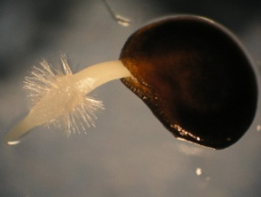

rate.
Justify why each step is important considering biological and
environmental conditions needed for successful germination.
You may draw labelled diagrams as part of your description.

Description of step | Diagram of step
Step 1.

Biological conditions | Environmental conditions

Description of step | Diagram of step
Step 2.

Biological conditions | Environmental conditions
Description of step | Diagram of step
Step 3.

Biological conditions | Environmental conditions
Description of step | Diagram of step
Step 4.

Biological conditions | Environmental conditions

- A gardener wanted to grow dwarf beans in early spring to make sure they had fresh beans for Christmas dinner. They had the option of two techniques of propagation:
- sowing the seeds in containers and placing them in a glasshouse and then planting them out into the garden when they have germinated and started growing
- planting the seeds directly in the ground.
The gardener decides to start the seeds off in containers
Justify the choice by comparing and contrasting the two techniques.
Include in your answer:
- how the steps taken in the two techniques are different
- how environmental conditions may affect the choice if an early crop is required.
___________________________________________________________________________
___________________________________________________________________________
___________________________________________________________________________
___________________________________________________________________________
___________________________________________________________________________
___________________________________________________________________________
___________________________________________________________________________
___________________________________________________________________________
___________________________________________________________________________
___________________________________________________________________________
___________________________________________________________________________
___________________________________________________________________________
___________________________________________________________________________
___________________________________________________________________________
___________________________________________________________________________
___________________________________________________________________________
___________________________________________________________________________
___________________________________________________________________________
___________________________________________________________________________
___________________________________________________________________________
___________________________________________________________________________
___________________________________________________________________________
___________________________________________________________________________
___________________________________________________________________________
___________________________________________________________________________
___________________________________________________________________________
___________________________________________________________________________
___________________________________________________________________________
___________________________________________________________________________

Question Two: Cuttings and division
Environmental conditions could include water, warmth, bottom heat, high humidity, time of year and light
Biological conditions could include, plant type, cells involved, plant material and plant health.
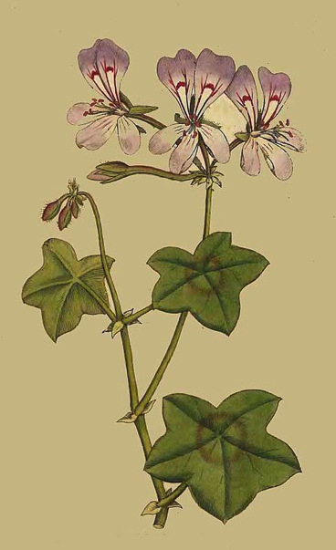
The diagram shows a Pelagonium stem which can be prepared for a
softwood cutting.

- Describe THREE steps that you would take to make softwood cuttings and explain how each step affects the biological conditions.

You may draw labelled diagrams as part of your description.

Step One:

______________________________________________
______________________________________________
______________________________________________
______________________________________________
______________________________________________
______________________________________________________________________________________
______________________________________________________________________________________
Step Two:
______________________________________________

______________________________________________
______________________________________________
______________________________________________
______________________________________________
______________________________________________________________________________________
______________________________________________________________________________________
______________________________________________________________________________________
______________________________________________________________________________________
Step Three:

______________________________________________
______________________________________________
______________________________________________
______________________________________________
______________________________________________
______________________________________________________________________________________
______________________________________________________________________________________
______________________________________________________________________________________
______________________________________________________________________________________

(b) Describe TWO environmental conditions and what equipment can be used to provide the condition that would help speed up root production in leaf cuttings. Explain how these conditions will help the cuttings produce roots.
Description of environmental conditions and the equipment used to provide the condition | Explanation of how the environmental conditions will help the cuttings produce roots.

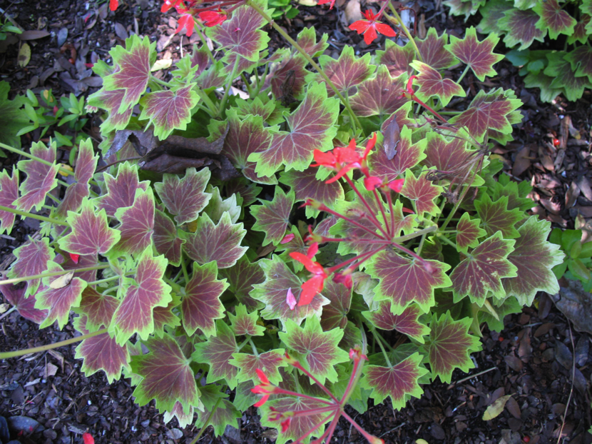
(c)

Many people have admired the rare and prize winning Pelagonium shown in the photo and there is a demand for large numbers of this plant.
Select EITHER of the following techniques which could be used to propagate from the plant.
- Division
- Softwood cuttings

Justify your selection by comparing and contrasting with those of the other option.
Include in your answer:
- numbers of plants which can be grown from one plant
- survival rate and speed to maturity
- survival of the original plant
___________________________________________________________________________
___________________________________________________________________________
___________________________________________________________________________
___________________________________________________________________________
___________________________________________________________________________
___________________________________________________________________________
___________________________________________________________________________
___________________________________________________________________________
___________________________________________________________________________
___________________________________________________________________________
___________________________________________________________________________
___________________________________________________________________________
___________________________________________________________________________
___________________________________________________________________________
___________________________________________________________________________
___________________________________________________________________________
___________________________________________________________________________
___________________________________________________________________________
___________________________________________________________________________
___________________________________________________________________________
___________________________________________________________________________
___________________________________________________________________________
___________________________________________________________________________
___________________________________________________________________________
___________________________________________________________________________
___________________________________________________________________________
___________________________________________________________________________
___________________________________________________________________________
___________________________________________________________________________
___________________________________________________________________________
___________________________________________________________________________
___________________________________________________________________________
___________________________________________________________________________
___________________________________________________________________________
___________________________________________________________________________
___________________________________________________________________________
___________________________________________________________________________
Question Three: Layering and cuttings

The picture shows a ground layered plant.

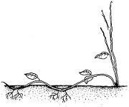

(a) Describe THREE steps that you would take to produce new plants from ground layering.
You may include labelled diagrams.
Description of step | Diagram of step
Step 1.

Description of step | Diagram of step
Step 2.

Description of step | Diagram of step
Step 3.

(b) Explain how ground layering will affect root production in the new plant.
Your explanation should include TWO biological conditions and ONE environmental condition that will affect successful root production in the offspring provided in the steps which you have described in (a) Page 11.
Environmental conditions could include water, warmth, bottom heat, high humidity, time of year and light
Biological conditions could include, plant type, cells involved, plant material and plant health.
Biological condition: Explanation of how this is provided in the steps described in (a) Page 11 | Explanation of how this condition will affect successful root production in the offspring
1.

2.

Environmental condition: Explanation of how this is provided in the steps described in (a) Page 11 | Explanation of how this condition will affect successful root production in the offspring

- A nurseryman has a very attractive rosemary bush with long flexible stems, shown in the photo below, which can be propagated by either semi-hardwood heel cuttings or ground layering. An order is received to produce 50 mature plants ready for sale in six months.

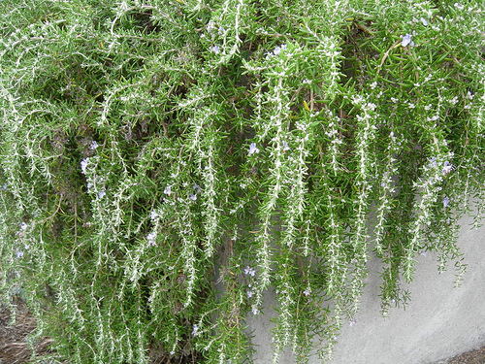
Compare and contrast the use of semi-hardwood heel cuttings and ground layering for this order.
Your comparison should include:
- Numbers of plants produced from one parent
- Speed to maturity
___________________________________________________________________________
___________________________________________________________________________
___________________________________________________________________________
___________________________________________________________________________
___________________________________________________________________________
___________________________________________________________________________
___________________________________________________________________________
___________________________________________________________________________
___________________________________________________________________________
___________________________________________________________________________
___________________________________________________________________________
___________________________________________________________________________
___________________________________________________________________________
___________________________________________________________________________
___________________________________________________________________________
___________________________________________________________________________
___________________________________________________________________________
___________________________________________________________________________
___________________________________________________________________________
___________________________________________________________________________
___________________________________________________________________________
___________________________________________________________________________
___________________________________________________________________________
___________________________________________________________________________
___________________________________________________________________________
___________________________________________________________________________
___________________________________________________________________________
___________________________________________________________________________
___________________________________________________________________________
___________________________________________________________________________
___________________________________________________________________________
___________________________________________________________________________
___________________________________________________________________________
___________________________________________________________________________
___________________________________________________________________________

