Kiwifruit Workbook

Level 3 Horticultural Science

To support students in preparing for

AS91530

AS91531

AS91532

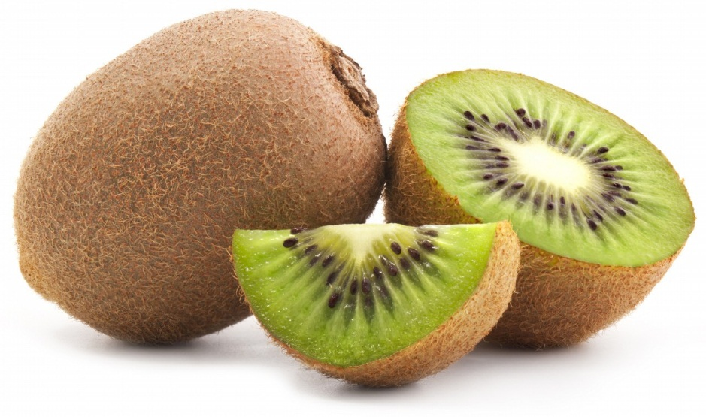

Contents

Kiwifruit 3

Single Point of Entry 6

The Production Calendar 10

Training / pruning 11

Grafting: 14

Pollination 15

Pest and Disease control 17

PSA 18

Frost protection / Irrigation 19

**Frosty reception for noisy frost fans** 21

Harvest/post handling 23

Green vs Gold 24

World competition 25

Promotion 26

Exchange rate 28

Quantity produced data 30

Price data. 32

Markets 35

Future growth/direction. 37

Exam preparation – 3.3 39

Exam preparation – 3.4 40

Useful Links 47

References: 48

This Workbook is written to partner with the New Zealand Kiwifruit book written by NZKGI (contact [kate.longman@nzkgi.org.nz](mailto:kate.longman@nzkgi.org.nz) for the latest updated copy (free of charge)

All suggestions for additions and improvements to this book to [jochemr@pnbhs.school.nz](mailto:jochemr@pnbhs.school.nz).

This workbook is distributed free of charge, please respect the authors moral rights.

# Kiwifruit

Kiwifruit is New Zealand’s highest-earning fresh horticultural export. It has one of the highest per kg prices of all our horticultural exports. In the year to June 2013, New Zealand exported about 350,000 tonnes of kiwifruit, valued at $934 million. This accounted for 48 percent of all fruit and vegetable exports, by value. The 2009/10 Household Economic Survey (HES) estimated our households spent $26 million a year on kiwifruit, an average of $16 a household. (Statistics NZ, 2014)

Learn about kiwifruit through this TERRIBLE song! <https://www.youtube.com/watch?v=SnFt3tIoVpw>

**Let’s get Started**

1. Draw a life size (exterior) diagram of a “perfect kiwifruit”



1. Can you explain why you have drawn it that size and shape? ____________________________________________________________________________________________________________________________________________________________________________________________________________________________________________________________________________________________________________________________________________________
2. How does your diagram compare to other drawings in the class? On the whole, does everyone’s kiwifruit look the same? Why do you think that is?

__________________________________________________________________________________________________________________________________________________________________________­­­­­­­­­­­­­­­­­­­­­­­__________________________________________________________________________________________________________________________________________________________________________

1. On your diagram, draw a blemish (*bruise or scar*) that makes it an imperfect kiwifruit, but a kiwifruit that you would still buy at the supermarket.
2. Estimate as a percentage, how big your blemish is as a part of the whole kiwifruit =_________%, and compare this number with the rest of the class.

Class average blemish size: ________________________%

1. Apart from the visual appearance, what other characteristics of kiwifruit affect how many you would eat?

______________________________________________________________________________________________________________________________________________________________________________

1. What time of the year do you buy kiwifruit? ________________________________________
2. How many different varieties of kiwifruit are commercially grown in New Zealand? _________________
   1. Can you name them? ____________________________________________________________________________________________________________________________________________________
3. Where is kiwifruit native to? __________________________________________________________________________________
4. What is the botanical name for kiwifruit? __________________________________________________________________________________

Watch these videos: (Textbook page 19)

Make note on the main points about Zespri and their marketing emphasis based off these videos:

<https://www.youtube.com/watch?v=UtIwp6DsfXg>

<https://www.youtube.com/watch?v=hKOj_Wikq_A> – 10 min length



Basic Vocabulary:

What do the following botanical terms mean?

Perennial

______________________________________________________________________________________________________________________________________________________________________________

Deciduous

______________________________________________________________________________________________________________________________________________________________________________

Pistillate

______________________________________________________________________________________________________________________________________________________________________________

Staminate

______________________________________________________________________________________________________________________________________________________________________________

SPE: _______________________________________________________________________________________

Graft: ______________________________________________________________________________________________________________________________________________________________________________

Management practice: ______________________________________________________________________________________________________________________________________________________________________________

Environmental factor: ______________________________________________________________________________________________________________________________________________________________________________

# Single Point of Entry

Pages 9 – 16 in the text book discuss the evolution and advantages of Zespri as a Single Point of Entry (SPE) for all kiwifruit exports. In terms of Achievement Standard 3.3, this comes under Market Manipulations and Government Intervention (as it is a legal entity) in terms of supply.

In your most preferred way (bullet points, Mind map or other method) summarise these pages, keeping in mind how the supply of kiwifruit is effected by Zespri.

Kiwifruit from New Zealand are all exported through Zespri as a SPE. There are advantages and disadvantages for this for individual growers. List what some of these maybe.

|  |  |
| --- | --- |
| Advantages | Disadvantages |
|  |  |

Who benefits from SPE the most?

________________________________________________________________________________________________________________________________________________________________________________________________________________________________________________

Growing conditions – NZ distribution

New Zealand has great conditions for growing kiwifruit. What climatic conditions make it so favourable?

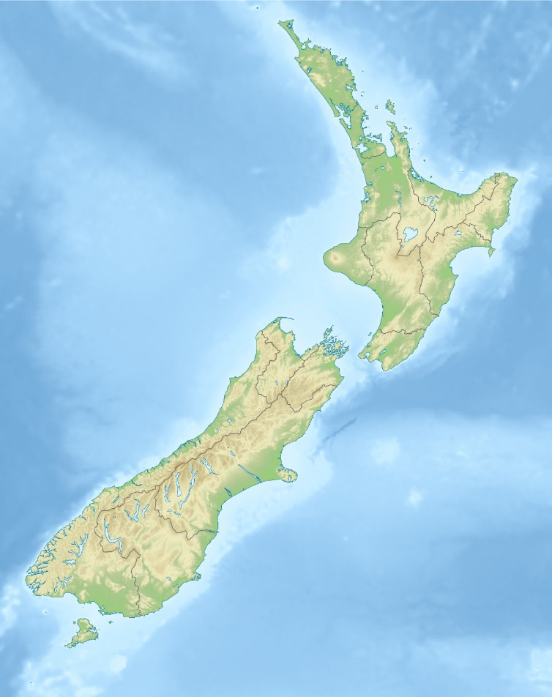

Regional production of Kiwifruit in 2013-2014 season by hectares

Northland 414.2ha

Auckland 485 ha

Bay of Plenty 8571 ha

South Island 489 ha

Lower North Island 77 ha

Poverty Bay 257 ha

Hawkes Bay 174 ha

_______________________________________

_______________________________________

_______________________________________

_______________________________________

_______________________________________

_______________________________________

_______________________________________

_______________________________________

Q. What other factors will a grower consider when looking to establish an orchard in a particular area?

___________________________________________________________________________________________________________________________________________________________________________________________________________________________________________________________________________________________________________________________________________________________________________________________________________________________________________________

Kiwifruit are a perennial plant.

They are ***Deciduous*** which means: ___________________________________________________________

From planting grafted canes, to fruiting takes _____________________ years.

In those first years, what do you think the grower’s main job (management practice) is? ____________________________________________________________________________________________________________________________________________________________________________________________________________________________________________________________________________________________________________________________________________________________

Correct establishment of the crop in this time is critical because ______________________________________________________________________________________________________________________________________________________________________________

The land used for kiwifruit could also be used for… (o*pportunity cost*) _____________________________________________________________________________________________________________________________________________________________________________________________________________________________________________________________________, So the decision to grow kiwifruit is based on… ____________________________________________________________________________________________________________________________________________________________________________________________________________________________________________________________________________________________________________________________________________________________Before we take a close look at the production calendar, have a quick watch of this video to see the range of jobs that occur along the production process (7:30 mins)

<https://www.youtube.com/watch?v=mDeiQd6ZCwU>

# The Production Calendar

Orchard management practices: On pages 10-11 in the kiwifruit book, there are charts showing the different management practices involved in producing kiwifruit. As you work through the book, fill in the Gantt chart below (AKA: Schedule of Operations)

|  |  |  |  |  |  |  |  |  |  |  |  |  |
| --- | --- | --- | --- | --- | --- | --- | --- | --- | --- | --- | --- | --- |
| Dec |  |  |  |  |  |  |  |  |  |  |  |  |
| Nov |  |  |  |  |  |  |  |  |  |  |  |  |
| Oct |  |  |  |  |  |  |  |  |  |  |  |  |
| Sept |  |  |  |  |  |  |  |  |  |  |  |  |
| Aug |  |  |  |  |  |  |  |  |  |  |  |  |
| July |  |  |  |  |  |  |  |  |  |  |  |  |
| June |  |  |  |  |  |  |  |  |  |  |  |  |
| May |  |  |  |  |  |  |  |  |  |  |  |  |
| April |  |  |  |  |  |  |  |  |  |  |  |  |
| March |  |  |  |  |  |  |  |  |  |  |  |  |
| Feb |  |  |  |  |  |  |  |  |  |  |  |  |
| Jan |  |  |  |  |  |  |  |  |  |  |  |  |
| Management practice |  |  |  |  |  |  |  |  |  |  |  |  |

# Training / pruning

Kiwifruit are traditionally grown on pergolas:

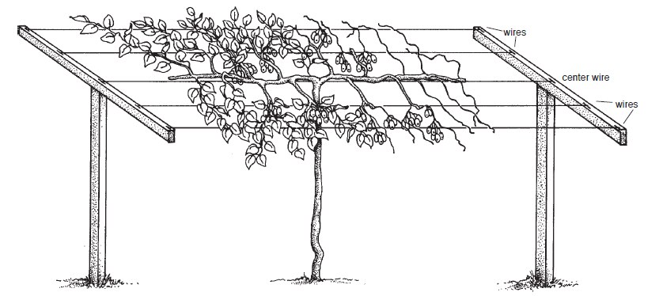

<http://growaukiwi.info/picts/T-Barwvines.png>

This allows sunlight to fall on the leafy canopy, while the fruit hang below where they are easily harvested. Kiwifruit are produced on wood that was grown the previous year (2nd year wood) and so a skilled workforce is required to prune the vines during winter, taking out the wood that has already fruited, and tying down the new wood that will produce the next season’s crop.

Various methods of pergola system have been invented with various success. The video links below are for a system called “Supavine” which held promise, but with PSA, and the need to be able to spray the canopy more thoroughly, it is an almost redundant system now, however, watching these videos will help you understand how kiwifruit need to be pruned.

Supavine - <https://www.youtube.com/watch?v=X10tTTyidlk> (15mins)

<https://www.youtube.com/watch?v=VadUJ6KnQkM> (5 mins)

Comment on the benefits of this system over traditional pergola system. Consider the cost, time and productivity in your answer.

____________________________________________________________________________________________________________________________________________________________________________________________________________________________________________________________________________________________________________________________________

Summer thinning: <https://www.youtube.com/watch?v=K9tDu5nT6HM> (9mins)

When grower are trying to maintain good light levels, to achieve high dry matter - What plant physiological process are growers trying to manage? _____________________________________________________________________________________________________________________________________________________________________________________________________________________________________________________________________

Kiwifruit produce flowers and fruit on wood grown in the previous year, complete the series of diagrams to show the growth, fruit, and prune cycle. (Refer to Supavine video above for help)

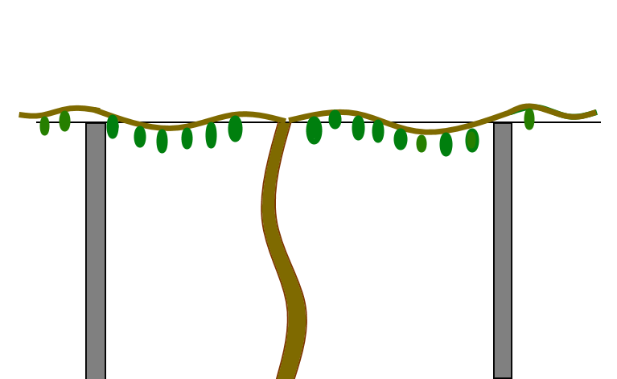

LAST YEAR

This is the vine LAST year, with the 2 year old fruiting wood on it.

Draw the new growth that would have occurred **in green**

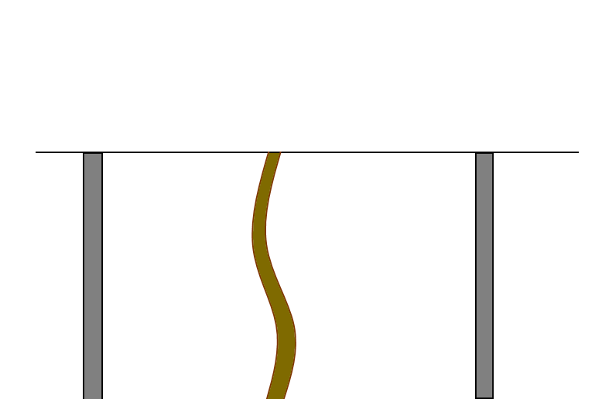THIS YEAR

The old fruiting wood is pruned away, and the new growth is laid onto the pergola (draw your GREEN vines in their new position. They will fruit this year, so draw some fruit too).

Now some new growth will occur while last year’s growth sets fruit. Use BLUE to show the new growth



NEXT YEAR:

What will happen to the vine next year?

___________________________

___________________________

___________________________

___________________________

___________________________

___________________________

What are some advantages of growing kiwifruit on pergolas??

a. _____________________________________________________________________________________________________________________________________________________________________________________________________________________________________________________________________

b. _____________________________________________________________________________________________________________________________________________________________________________________________________________________________________________________________________

c _____________________________________________________________________________________________________________________________________________________________________________________________________________________________________________________________________

What are the main purposes and differences between summer and winter pruning?

________________________________________________________________________________________________________________________________________________________________________________________________________________________________________________________________________________________________________________________________________________________________________________________________________________________________________________________________________________________________________________________________________________________________________________________________________________________________________________________________________________________________________________________

# Grafting:

The links below show some of the grafting methods used in kiwifruit production.

[www.youtube.com/watch?v=4Ikpc7pv41g](http://www.youtube.com/watch?v=4Ikpc7pv41g)

[www.youtube.com/watch?v=QV4AICjPUlE](http://www.youtube.com/watch?v=QV4AICjPUlE)

<http://www.kvh.org.nz/vdb/document/91213>

When grafting, what parts of the scion and the rootstock need to line up to achieve a graft success?

_____________________________________________________________________________________________________________________________________________________________________________________________________________________________________________________________________

What are the financial impacts of a failed graft?

_____________________________________________________________________________________________________________________________________________________________________________________________________________________________________________________________________

What are the benefits of grafting kiwifruit? ___________________________________________________________________________________________________________________________________________________________________________________________________________________________________________________________________________________________________________________________________________________________________________________________________________________________________________________

|  |  |
| --- | --- |
| What stage of production does Grafting fit into:   1. Site selection 2. Establishment 3. Growing 4. Harvest 5. Post-harvest | Grafting kiwifruit will have the greatest effect on   1. Timing 2. Quality 3. Quantity 4. Price   Can you justify your answer? |

_____________________________________________________________________________________________________________________________________________________________________________________________________________________________________________________________________

# Pollination

The size of a kiwifruit is determined by how many seeds are inside it.

ACTIVITY: Buy a normal sized kiwifruit and count the number of seeds inside it (it can be easier to cut it in half, and double the number)

___________________________________

Compare this with another kiwifruit that is not “normal” ________________________________

Kiwifruit are not self-pollinating, so part of each orchard must be devoted to male vines unless pollen is brought in for artificial pollination. Unlike most other fruits, kiwifruit need high levels of pollination (about 13,000 pollen grains per stigma compared to only 12 grains for apple flowers). Growers either place numerous honey-bee hives in the orchards temporarily, or artificially pollinate the flowers. (Te-Ara, 2014)

How many “visits” from a bee does a typical kiwifruit flower need to produce export grade kiwifruit?

___________________________________

Around 2008-2009, the Varroa bee mite was spreading around New Zealand. What impact does this mite have on hives?

______________________________________________________________________________________________________________________________________________________________________________

What is the impact of this on the kiwifruit industry (in fact all fruit production in New Zealand)? ____________________________________________________________________________________________________________________________________________________________________________________________________________________________________________________________________________________________________________________________________________________________

Watch this video:

<http://sciencelearn.org.nz/Contexts/Pollination/Sci-Media/Video/Artificial-pollination>

What artificial pollination options are there? ______________________________________________________________________________________________________________________________________________________________________________

Why would a grower use artificial pollination?

_____________________________________________________________________________________________________________________________________________________________________________________________________________________________________________________________________

Discuss the two options of natural bee, or artificial pollination, and make a recommendation for a grower for your preferred option.

___________________________________________________________________________________________________________________________________________________________________________________________________________________________________________________________________________________________________________________________________________________________________________________________________________________________________________________________________________________________________________________________________________________________________________________________________________________________________________________________________________________________________________________________________________________________________________________________________________________________________________________________________________________________________________________________________________________________________________________________________________________________________________________________________________________________________________________________________________________________________________

Other websites about pollination:

<http://sciencelearn.org.nz/Science-Stories/Seeds-Stems-and-Spores/Pollinating-kiwifruit>

<http://www.eastpack.co.nz/vdb/document/123356>

Cost vs profit: <http://www.pollenplus.co.nz/pollination-benefits.html>

<http://www.kvh.org.nz/vdb/document/94626>

# Pest and Disease control

Research the main pests and diseases for kiwifruit.

|  |  |  |
| --- | --- | --- |
| How do they impact on **quantity** of kiwifruit produced? | How do they impact on the **quality** of kiwifruit? | What are the control options? |
|  |  |  |
|  |  |  |
|  |  |  |
|  |  |  |

What is the best control option for a grower? Consider

* time,
* cost,
* productivity
* and impact on sanitary/phyto-sanitary regulations for export

__________________________________________________________________________________________________________________________________________________________________________________________________________________________________________________________________________________________________________________________________________________________________________________________________________________________________________________________________________________________________________________________________________

# PSA

<https://www.youtube.com/watch?v=KEKlpZVzsL4> (8 mins)

What does PSA stand for?

________________________________________________________________________________

When and where was PSA it was first detected in New Zealand?

_____________________________________________________________________________________________________________________________________________________________________________________________________________________________________________________________________

What are some of the symptoms a grower may see on the vine?

_____________________________________________________________________________________________________________________________________________________________________________________________________________________________________________________________________

Why do you think so regions are more susceptible than others to PSA?

_____________________________________________________________________________________________________________________________________________________________________________________________________________________________________________________________________

At the time of writing this workbook, there is no ‘cure’ for PSA. What is the first treatment for infected orchards? _____________________________________________________________________________________________________________________________________________________________________________________________________________________________________________________________________

If a grower removed infected varieties, how long will it take to re-establish those orchards?

_______________________________________________________________________________________

_______________________________________________________________________________________

_______________________________________________________________________________________

Have a look at the 2014 Zespri annual report <https://www.zespri.com/ZespriInvestorPublications/Annual-Report-2013-14.pdf> to see the financial impact that PSA has had with the reduction in fruit volumes. Make a comment here: ____________________________________________________________________________________________________________________________________________________________________________________________________________________________________________________________________________________________________________________________________________________________

# Frost protection / Irrigation

What are three process that plants need water for?

1. _________________________________________________________________________________
2. _________________________________________________________________________________
3. _________________________________________________________________________________

What two processes use water in the plant?

1. _________________________________________________________________________________
2. _________________________________________________________________________________

Explain how the plant responds from number 8 onwards

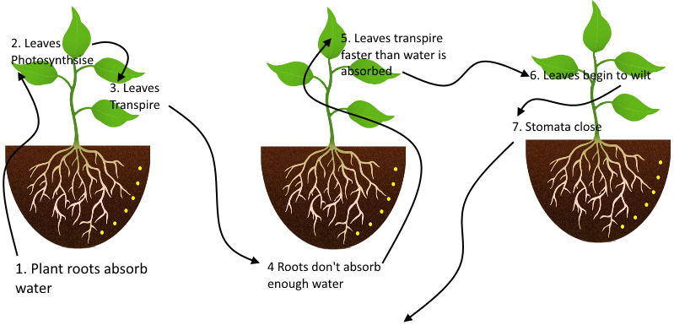

8. (*hint: CO2*) _______________________________________________________________________________

9. *(hint: photosynthesis)*__________________________________________________________________________

10. (*hint: sugars*) _____________________________________________________________________________

What can be done to minimise transpiration? _____________________________________________________________________________________________________________________________________________________________________________________________________________________________________________________________________

What are the main irrigation options for kiwifruit? List the advantages of each system:

* ___________________________________________________________________________________________________________________________________________________________________________________________________________________________________________________
* ___________________________________________________________________________________________________________________________________________________________________________________________________________________________________________________

What conditions are required for a frost to form?

______________________________________________________________________________________________________________________________________________________________________________

How does a frost damage plants, specifically kiwifruit? ______________________________________________________________________________________________________________________________________________________________________________

What are the frost protection options for Horticulture?

* ________________________________________________________________________________
* ________________________________________________________________________________
* ________________________________________________________________________________
* <http://www.stuff.co.nz/business/farming/cropping/8985864/Hamilton-engineer-helps-design-frost-stopper>

There are issues with some forms of frost protection. Read the article below and answer the questions:

# **Frosty reception for noisy frost fans**

BY RACHEL YOUNG

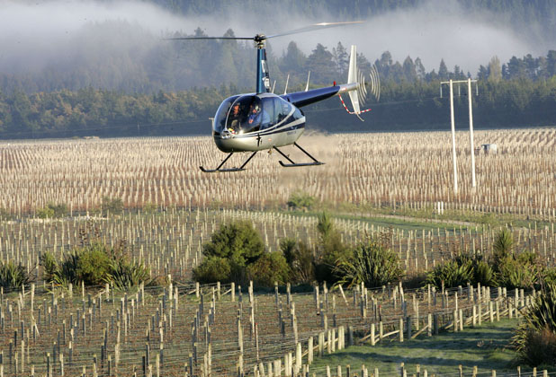

SCOTT HAMMOND

FROST FIGHTING: A helicopter flies low over vineyards early this morning to protect crops from frost near Seresin Estate.

The Marlborough mayor wants the wine industry to help the council find a solution to the on-going issue of noisy frost fans.

During frosts the fans are turned on to protect the region's vines from potential damage, but each year angry residents complain that the noise keeps them awake through the night.

They are one of a number of methods vineyard owners use to protect their crops from potentially damaging frosts.

Marlborough Mayor Alistair Sowman said the council was looking at alternatives to frost fans in areas where their use is prompting complaints, such as in the Wairau Valley, so there would be less noise on frosty nights.

He said council staff were actively researching alternatives such as the use of water for frost protection in areas where fans are used.

Water is already widely used as a frost protection method.

New Zealand Winegrowers chairman Stuart Smith said there had already been research about frost fighting by the industry, with the use of water, helicopters and frost fans found to be the most effective.

He said the industry used a combination of these methods in Marlborough as they had been tested and proven to be efficient.

Mr Smith was happy to talk to anyone about frost fighting.

"In some respects we are doing the work of the wine industry and I would like the industry to work with the council to find a solution."

He said while the industry had a right to farm, it was not normal farm noises people were hearing.

Mr Sowman said the council checked on vineyards if there had been a suggestion they were not complying with the resource management plan.

If it found a vineyard was in breach then it would take action, he said.

For example the council issued Waihopai Holdings with an abatement notice after council-appointed consultant Malcolm Hunt found noise from the wind machines did not comply with the Wairau Awatere resource management plan.

The issue is now heading to the Environment Court, though many cases do not reach this point.

However, if the vineyard was not in breach there was nothing the council could do, he said.

Mr Sowman said it was the cumulative effect of the frost fans that many people were worried about.

Last year, the council received 10 formal complaints from different complainants about frost fans.

However, these do not include phone calls in the middle of the night to councillors or the mayor.

Marlborough District Council principal planner Peter Constantine said the plan promoted rural activity so noise was to be expected.

The council has proposed changes to the Wairau/Awatere and Marlborough Sounds resource management plan rules for frost-fighting wind machines which are available for the public to make submissions on until October 23.

These changes are intended to improve the management of noise effects of frost fans.

The proposed changes would allow the council to assess whether frost fans met noise standards before they were erected.

Other recommendations include:

Lowering the acceptable decibel level from 60 to 55.

A new requirement that the noise standard has to be met at a distance of 300 metres from the device or at the notional boundary of any existing dwelling, visitor accommodation or habitable building, whichever is the least distance.

<http://www.stuff.co.nz/marlborough-express/business/rural/2939915/Frosty-reception-for-noisy-frost-fans>

Although this story relates primarily to grape growers, the noise issue applies to all frost fan users (like kiwifruit growers)

Who are the interested parties (stakeholders) in this story (i.e. who has their opinions mentioned)

1. _____________________________________________________
2. _____________________________________________________
3. _____________________________________________________

The obvious solution is not always possible because of the Resource Management Act (RMA) / neighbours etc. From the article, discuss the position of the three stakeholders (Grower/council/ public) and your view or possible solution.

__________________________________________________________________________________________________________________________________________________________________________________________________________________________________________________________________________________________________________________________________________________________________________________________________________________________________________________________________________________________________________________________________________________________________________________________________________________________________________________________________________________________________________________________________________________________________________________________________________________________________________________________________________________________________________________________________________________________________________________________________________________________________________________________________________________________________________________________________________________________________________________________________________________________________________________________________

# Harvest/post handling

*Historically, kiwifruit harvesting was timed using a Brix test to determine the amount of sugar in the fruit. Orchardists now also use dry matter and colour tests to ensure harvested fruit has the desired eating qualities. Most fruit is picked in May…*

*Fruit is picked by hand and put into bags, which when full are emptied into large wooden bins.*

*The bins are taken to pack houses, where most of the kiwifruit is graded, packed into trays then placed in a cool store. A [small] proportion of fruit is kept in bins for cool storage, or in some cases storage in a controlled atmosphere, and is packed later.*

*Kiwifruit is sold from April to the end of December, with supplies taken out of cool storage near the end of the season. (*[*http://www.teara.govt.nz/en/kiwifruit/page-4*](http://www.teara.govt.nz/en/kiwifruit/page-4)*)*

At what Brix level are kiwifruit ideally harvested? ____________________________________________

Take some notes from these two web pages about the harvest attributes of NZ Kiwifruit:

<http://www.zesprikiwi.com/wp-content/uploads/2011/06/Zespri2010_SalesSht_Difference.pdf>

<http://www.zesprikiwi.com/industry-resource/retailers/storage-and-handling-of-kiwifruit>

________________________________________________________________________________________________________________________________________________________________________________________________________________________________________________________________________________________________________________________________________________________________________________________________________________________________________________________________________________________________________________________________________________________________________________________________________________________________________________________________________________________________________________________

Reading Chapter 2 “Market requirements” in the New Zealand kiwifruit book covers the size, taste, colour, appearance and residue criteria that need to be met for Zespri packaging. Read that chapter and make suitable notes as to how these requirements are met during the Harvest, grading and packing stage of production.

# World competition

New Zealand is not the only grower and exporter of Kiwifruit. Our main competitors are Chilli and Italy. We have our southern hemisphere advantage over them… we are exporting fresh kiwifruit during their off season.

In order to maintain an all year marketing presence, New Zealand has growers around the world (read information on page 35) contracted to Zespri, so that we are selling fresh Kiwifruit throughout the year.

A barrier to international trade are the protective strategies imposed by other countries in the form of tariffs and quotas (read article on page 45: <http://www.hea.co.nz/images/Media_Release_Trade_Barriers_Report_2014_Final.pdf>

In Feb 2016, New Zealand signed its acceptance of the TPPA, an international free trade agreement with 12 countries around the Pacific. The major goal will be to gain entry into America, which protects its local industry with high tariffs.

At the time of writing this workbook, so much is happening with the TPPA, I suggest you carefully watch the news, and become well informed as it will have significant on agriculture and horticultural exports in New Zealand’s future.

New Zealand has an FTA (Free Trade Agreement) with Australia called CER (Close Economic Relations). However, Australia has still managed to impose restrictions on New Zealand agriculture and horticultural exports using Sanitary/Phytosanitary reasons for blocking our products. New Zealand has battle through international courts to get some of these restrictions removed. Do an internet search on “NZ apples into Australia WTO” and read up on how tariffs and SPS restrictions are used to protect local industry.

# Promotion

What do you like or not like about the taste of kiwifruit?

______________________________________________________________________________________________________________________________________________________________________________

What variety do you like the best and why? ______________________________________________________________________________________________________________________________________________________________________________

How do consumers benefit from the SPE system? ________________________________________________________________________________________________________________________________________________________________________________________________________________________________________________

Watch this: <https://www.youtube.com/watch?v=1uzojtTtrrk>. Who is this marketed to?

______________________________________________________________________________________________________________________________________________________________________________

Watch these two advertisements for Zespri kiwifruit. Make a comment on the difference in the target market:

|  |  |
| --- | --- |
| Taiwan: <https://www.youtube.com/watch?v=BXm_4mm0d3g> | Malaysia  <https://www.youtube.com/watch?v=Cz9vtY31Wyg> |
|  |  |

Here is a Training video for a “Kiwifruit ambassador”. What are the main points that Zespri wants to promote about its product?

<https://www.youtube.com/watch?v=00GlW-HkkvE>

_______________________________________________________________________________________________________________________________________________________________________________________________________________________________________________________________________________________________________________________________________________________________________________________________________________________________________________________________________________________________________________________________________________________________________________________________________________________________________________________________________________________________________________________________________________________________________________________________________________

# Exchange rate

It will be very important for the External assessment 3.3, that you understand how the exchange rate has changed as it impacts on the supply and demand of all exported products.

Collect data as the year progresses to fill in the table (as associated graphs)

Japanese Yen - JPY

|  |  |  |  |  |  |
| --- | --- | --- | --- | --- | --- |
|  | Month | JPY | USD | Euro | Significant news |
| 2014 | Jan | 81.23 | 0.823 |  |  |
| Feb | 81.74 | 0.822 |  |  |
| March | 82.79 | 0.824 |  |  |
| April | 82.95 | 0.826 |  |  |
| May | 83.24 | 0.829 |  |  |
| June | 84.29 | 0.834 |  |  |
| July | 85.22 | 0.842 |  |  |
| Aug | 85.91 | 0.846 |  |  |
| Sept | 86.48 | 0.846 |  |  |
| Oct | 86.68 | 0.843 |  |  |
| Nov | 87.38 | 0.839 |  |  |
| Dec | 87.88 | 0.835 |  |  |
| 2015 | Jan | 88.19 | 0.831 |  |  |
| Feb | 88.47 | 0.823 |  |  |
| March |  |  |  |  |
| April | 88.87 | 0.805 |  |  |
| May | 88.99 | 0.795 |  |  |
| June | 88.82 | 0.781 |  |  |
| July | 88.18 | 0.763 |  |  |
| Aug | 87.72 | 0.747 |  |  |
| Sept | 86.80 | 0.732 |  |  |
| Oct | 86.54 | 0.722 |  |  |
| Nov | 85.56 | 0.711 |  |  |
| Dec | 84.81 | 0.703 |  |  |
| 2016 | Jan | 83.53 | 0.691 |  |  |
| Feb | 82.50 | 0.685 |  |  |
| March | 81.31 | 0.678 |  |  |
| April |  |  |  |  |
| May |  |  |  |  |
| June |  |  |  |  |
| July |  |  |  |  |
| Aug |  |  |  |  |
| Sept |  |  |  |  |
| Oct |  |  |  |  |
| Nov |  |  |  |  |
| Dec |  |  |  |  |
|  | Jan |  |  |  |  |

Historic data collected from <https://www.ird.govt.nz/how-to/overseas-currency/?id=footer> (These are the Mid-month averages!)

Graph of NZD vs other currencies

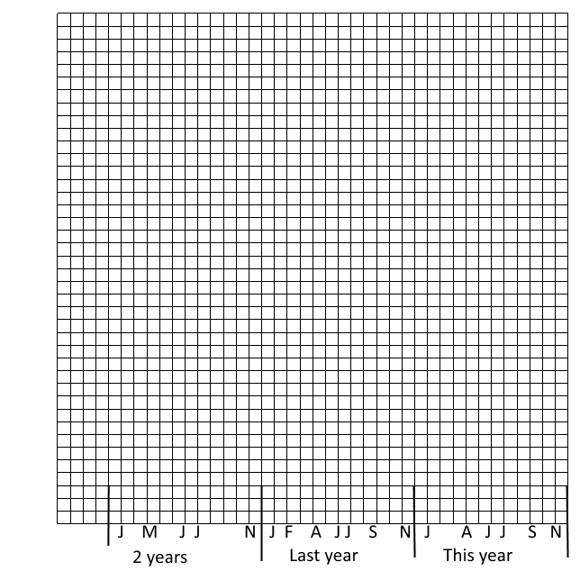

# Quantity produced data

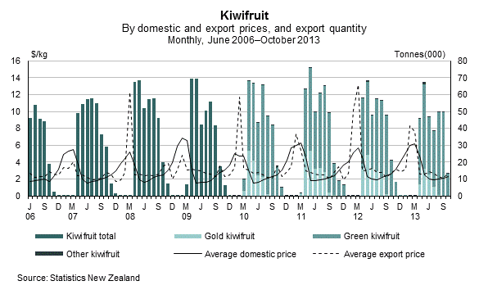

Domestic kiwifruit prices are generally at their lowest in June and July. Both domestic and export prices peak around March each year when domestic supply is short – just before most harvesting begins. Small volumes of higher-valued other kiwifruit exports influence the peaks of the export price. Fruit is supplied from cool storage between December and March to meet demand. About one-third of exports occur in April and May, which corresponds with the bulk of harvesting, and then decrease towards the year’s end. Our biggest export market by volume of kiwifruit is the European Union, while the biggest export market by value is Japan (Statistics NZ, 2014)

From the graph:

During what time of the year are kiwifruit exported? ___________________________________________

If I have kiwifruit on my Pavlova at Christmas. Where do those kiwifruit come from?

__________________________________________________________

From other sources:

What was the quantity of kiwifruit produced in 2014? _______________________________

What is it for 2015? _______________________________

How much has been exported in the last year? ___________________________________

Comment of significant seasonal factors that have contributed to the current volumes of kiwifruit?

______________________________________________________________________________________________________________________________________________________________________________

Graph the data below: (Table supplied by NZKGI)

|  |  |  |
| --- | --- | --- |
|  | **Total Quantity of Zespri Gold kiwifruit supplied by Growers to Zespri (in Tray Equivalents (millions), 1 Tray = approx 3.4kilograms)** | **Total Quantity of Zespri Green kiwifruit supplied by Growers to Zespri (in Tray Equivalents (millions), 1 Tray = approx 3.4kilograms)** |
| 2006/07 | 16.7 | 58.8 |
| 2007/08 | 19.3 | 67.9 |
| 2008/09 | 21.9 | 72.7 |
| 2009/10 | 22 | 71.9 |
| 2010/11 | 21.1 | 69.9 |
| 2011/12 | 29.1 | 73.3 |
| 2012/13 | 24.6 | 70.4 |
| 2013/14 | 11.1 | 68.9 |



# Price data.

(Table supplied by NZKGI)

|  |  |  |
| --- | --- | --- |
|  | **GOLD**  **OGR per Tray $ (Adjusted to 10year Foreign Exchange averages to show returns at a constant FX rate)** | **GREEN**  **OGR per Tray $ (Adjusted to 10year Foreign Exchange averages to show returns at a constant FX rate)** |
| 2006/07 | 4.77 | 3.46 |
| 2007/08 | 5.22 | 3.23 |
| 2008/09 | 5.58 | 3.32 |
| 2009/10 | 6.49 | 2.89 |
| 2010/11 | 7.53 | 3.50 |
| 2011/12 | 6.88 | 3.36 |
| 2012/13 | 9.88 | 4.51 |
| 2013/14 | 11.86 | 5.27 |



Looking at Kiwi GOLD

Draw the following data (all 3 lines) on the same graph: (Table supplied by NZKGI)

|  |  |  |  |
| --- | --- | --- | --- |
|  | **LINE 1** | **LINE 2** | **LINE 3** |
|  | **GOLD**  **OGR per Tray $ (Adjusted to 10year Foreign Exchange averages to show returns at a constant FX rate)** | **Total Quantity of Zespri Gold kiwifruit supplied by Growers to Zespri (in Tray Equivalents (millions), 1 Tray = approx 3.4kilograms)** | **Price received by Gold Kiwifruit Growers before on-orchard costs are subtracted (otherwise known as Orchard Gate Return (OGR)) for conventionally (ie. not organic) grown** |
| 2006/07 | 4.77 | 16.7 | 44,700 |
| 2007/08 | 5.22 | 19.3 | 54,000 |
| 2008/09 | 5.58 | 21.9 | 62,800 |
| 2009/10 | 6.49 | 22 | 69,800 |
| 2010/11 | 7.53 | 21.1 | 71,000 |
| 2011/12 | 6.88 | 29.1 | 81,600 |
| 2012/13 | 9.88 | 24.6 | 96,400 |
| 2013/14 | 11.86 | 11.1 | 83,400 |

See how per tray, more was earned than in previous years. Shortage of Gold kiwifruit in the market place due to PSA (bacterial disease) destroying original Zespri Gold (Hort16A).

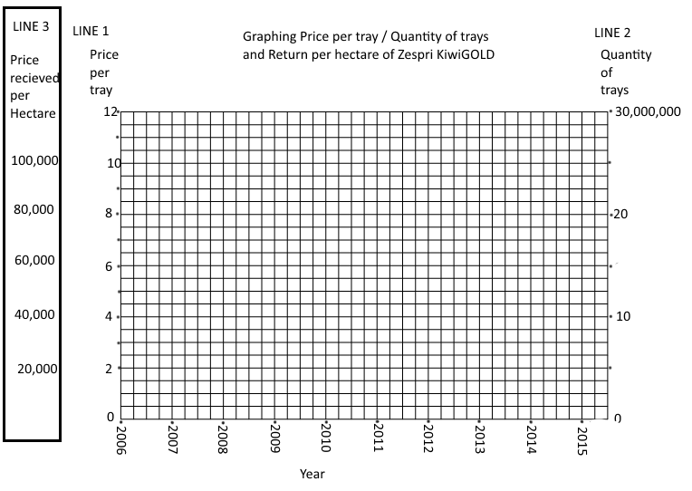

Comment on the shapes of line 1 and line 2

_____________________________________________________________________________________________________________________________________________________________________________________________________________________________________________________________________

Line 3 is the income per Hectare for growers of KiwiGOLD. Considering the loss of KiwiGOLD because of PSA. Why has the grower’s income not significantly decreased in 2012-2013?

_____________________________________________________________________________________________________________________________________________________________________________________________________________________________________________________________________

Look at price and quantity data for 2006 – 2010/11. Comment on the trends you see between these 2 lines.

_____________________________________________________________________________________________________________________________________________________________________________________________________________________________________________________________________

# Markets

All information on this page from: <https://www.zespri.com/companyinformation/faqs>

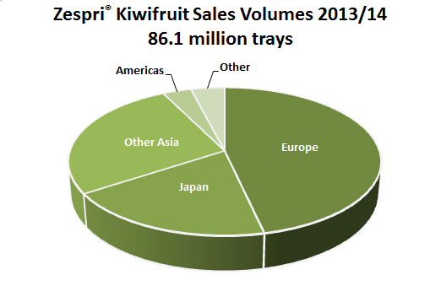 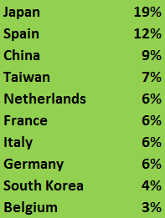

Zespri kiwifruit does not only come from New Zealand. Zespri has partnered with growers around the world to supply premium quality Zespri kiwifruit to our customers and consumers when New Zealand Zespri kiwifruit is not available. Zespri has licensed growers in Italy, France, Japan, South Korea and Australia to grow our exclusive Zespri Gold and Sun Gold kiwifruit. Zespri also has exclusive arrangements and sources Zespri Green kiwifruit from growers who grow premium quality kiwifruit to Zespri's high standards.

New Zealand is not the biggest producer of kiwifruit in the world, but Zespri is the biggest marketer in the world with over 20% of the market share year round.

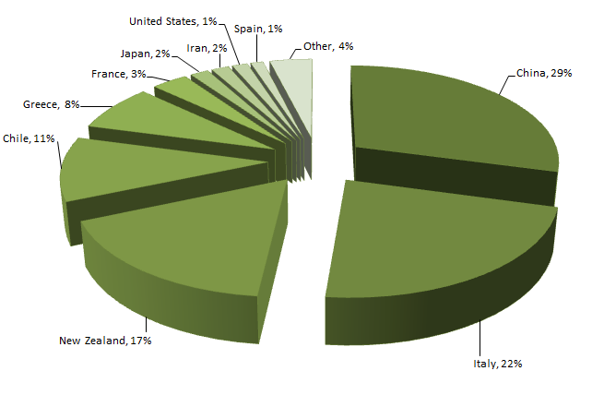This graph show the percentage of kiwifruit each country produces… it does not show the percentage of their export volumes

Research and comment of the different requirements of the Europe and Asian markets

|  |  |
| --- | --- |
| **Europe** | **Asia** |
| Market requirements | Traceability: <https://www.youtube.com/watch?v=Ny_0uHE4EFs> |
| Explanation of requirement |  |

# Future growth/direction.

<http://www.stuff.co.nz/business/farming/cropping/67182698/kiwifruit-on-the-rebound>

Read the following article with a highlighter in your hand. Make notes on:

* Costs vs profits
* Promotion strategies
* Single seller systems

**Kiwifruit on the rebound**

Zespri chief executive Lain Jager is in no doubt about the benefits of the kiwifruit single seller model. He cites the prices New Zealand kiwifruit achieves overseas against other countries, the research gains, the focused marketing, and the investment in research and innovation as some of the bonuses of the sometimes controversial model.

Jager, 46, might feel more defensive about Zespri's role if it was not for the fact the kiwifruit industry has emerged relatively unscathed from the 2010 PSA virus scare, which largely destroyed the valuable Hort16A gold variety, and also damaged the ubiquitous green Haywards hybrid. Fortunately Zespri and government agency Plant and Food Research had been working away together in the background developing new varieties, partly to guard against such a calamity.

Within a year of the virus striking, growers had started to graft on the new Gold3 variety, which has proven to be tolerant to Psa. Not only that, it is 30 per cent more productive than the Hort16 variety. Along with kiwifruit prices, optimism has been restored.

Total export returns for the 2014 season are estimated at $904.6 million; the Ministry for Primary Industries estimates by 2018, total value will rebound to $1.11 billion. Green kiwifruit orchards now sell for $350,000 a hectare, and gold for $500,000 a hectare, higher than before PSA hit. Green growers made more than $50,000 per ha gross profit last year, with growing and harvesting costing $25,000 per ha. Gold growers made $73,000 per ha gross profit, with costs of $30,000.

With a background in hospitality and human resources before joining Zespri in 1999, Jager believes the human dimension is important in horticulture. He became head in 2008. "The fruit industry is characterised by people who spend all their time in it. In the end a lot of business is about achieving outcomes through working with people. As CEO you are only one person, it's about engaging a team, working with them, working out a strategy, making sure it's well articulated and then converting it into objectives," says Jager. Since his arrival in 1999 as Zespri's human resources manager, Jager has seen profound changes in the industry. Back then 80 per cent of Zespri's exports were mainly green kiwifruit to Japan, Korea, Spain, Holland, and Germany. Gold varieties have since been introduced, and research has expanded dramatically, especially in relation to health claims about kiwifruit.

Green kiwifruit production growth per year has been 4 per cent, and gold 6 per cent. Zespri now has orchards in Japan, Korea, Italy and France, so the brand is sold for 12 months a year. About 80 per cent of fruit is sold into the northern hemisphere. "This is an industry which is transforming. We are now doing proof of concept trials for growing in China, which is the biggest global producer. In '99 we didn't sell 100,000 trays into China, whereas now we sell 13 million. South­east Asia, the Middle East, and Brazil are growing rapidly," says Jager. Even though parts of the industry are regulated, others are not. That includes the $3b invested in orchards and the $600m in post­ harvest operations.

Zespri maintains tight control over supply. The Haywards green variety ­ first developed in the 1930s ­ can be planted without restriction. But growers have to buy licences to grow gold, and Zespri releases just enough to cover what it estimates it can sell. At present royalties from licences provide about $11m a year, the sum increasing every season as volumes of Gold3 increase. The money is invested into research and marketing. "What it [the single seller] allows us is significant. It allows us to allocate the crop globally, and not to oversupply markets. Then the conversation isn't about how you can drive down the price from your supplier, but how can you work together to grow the business," Jager says. He cites the case of Chile, which has at least 100 different exporters competing against each other. The result? "Our kiwifruit sells for a premium of between 40 and 100 cents relative to Chile. Why do people pay more? Because ours tastes great, we support it with promotion, and many of our consumers like to eat it [our brand] every day."

Having a certainty of supply also means Zespri can hedge on currency using a rolling three­ year hedging system. And it enables the company to invest for the future. It achieves this with a market cap of less than $100m, and 300 employees. In the southern hemisphere, the three chief growing areas are New Zealand, Chile and South Africa. "But New Zealand has a problem, especially in relation to Chile ­ our land is expensive, our labour is dramatically more expensive and we are not on main shipping lanes, so that is more expensive. "It costs Chilean growers about 30c a kg to supply their fruit to market. It costs New Zealand growers 60c," Jager explains. Hence the need to create a value­ added product, by branding it and investing 6 per cent on promotion. He argues that the single seller system ensures consistently good quality fruit.

Growers are paid on volume, size, sugar levels and on the timeliness of supply to pack houses. Zespri has strict rules about not harvesting the fruit until it is ready. The industry is not without its issues. Several of Zespri's Asian import agents have been implicated in fraud and non- payment of import duties. And a number of growers and pack houses are taking the government to court, seeking compensation for official negligence over the introduction of the PSA virus. Some growers fear the claim, which may drag on for years, has the potential to split the industry. Jager diplomatically says that Zespri respects the rights of the growers to pursue the action. From Chinese gooseberry to Zespri, from a nascent export business 30 years ago to the second most valuable horticultural product after wine today, the kiwifruit industry has come a long way. ­

The Dominion Post

# Exam preparation – 3.3

Barriers to trade: <http://www.hea.co.nz/index.php/2012-05-11-03-05-28/kiwifruit-trade>

# Exam preparation – 3.4

Brainstorm:

What are the management practices that have significant impact on the:

|  |  |
| --- | --- |
| Timing of supply:  1  2  3 | Quantity produced:  1  2  3 |
| Quality of kiwifruit:  1  2  3 | Price of kiwifruit:  1  2  3 |

For each management practice, briefly describe how it impacts on kiwifruit timing, quantity, quality and price:

Timing:

1. ____________________________________________________________________________________________________________________________________________________
2. ____________________________________________________________________________________________________________________________________________________
3. ____________________________________________________________________________________________________________________________________________________

Quantity

1. ____________________________________________________________________________________________________________________________________________________
2. ____________________________________________________________________________________________________________________________________________________
3. ____________________________________________________________________________________________________________________________________________________

Quality

1. ____________________________________________________________________________________________________________________________________________________
2. ____________________________________________________________________________________________________________________________________________________
3. ____________________________________________________________________________________________________________________________________________________

Price

1. ____________________________________________________________________________________________________________________________________________________
2. ____________________________________________________________________________________________________________________________________________________
3. ____________________________________________________________________________________________________________________________________________________

For each section, rank the impact that each management practice has in order of its significance, and briefly justify your decision.

(When you justify yourself, you can’t say “because I think so”. You need to give reasons why you chose your No#1, and then say why it has more impact on timing or quality etc… than the other 2 management practices)

Timing: Your choice for most significant management practice: _______________________________________________________________________________

Why does it have the greatest effect on timing?

________________________________________________________________________________________________________________________________________________________________________________________________________________________________________________

Justify your decision when compared to the impact of the other management practices you chose:

________________________________________________________________________________________________________________________________________________________________________________________________________________________________________________________________________________________________________________________________________________________________________________________________________________________________________________________________________________________________

Quality: Your choice for most significant management practice: _______________________________________________________________________________

Why does it have the greatest effect on quality?

________________________________________________________________________________________________________________________________________________________________________________________________________________________________________________

Justify your decision when compared to the impact of the other management practices you chose:

________________________________________________________________________________________________________________________________________________________________________________________________________________________________________________________________________________________________________________________________________________________________________________________________________________________________________________________________________________________________

Quantity supplied: Your choice for most significant management practice: _______________________________________________________________________________

Why does it have the greatest effect on quantity supplied?

________________________________________________________________________________________________________________________________________________________________________________________________________________________________________________

Justify your decision when compared to the impact of the other management practices you chose:

___________________________________________________________________________________________________________________________________________________________________________________________________________________________________________________________________________________________________________________________________________________________________________________________________________________________________________________________________________________________

Price: Your choice for most significant management practice: _______________________________________________________________________________

Why does it have the greatest effect on price?

________________________________________________________________________________________________________________________________________________________________________________________________________________________________________________

Justify your decision when compared to the impact of the other management practices you chose:

________________________________________________________________________________________________________________________________________________________________________________________________________________________________________________________________________________________________________________________________________________________________________________________________________________________________________________________________________________________________

Media Release: December 4, 2014 <http://www.hea.co.nz/images/Media_Release_Trade_Barriers_Report_2014_Final.pdf>

FTA’s bear fruit for NZ Horticulture in Global Markets

The horticulture industry’s 2014 Trade Barriers Report shows tariffs imposed by other countries on our products cost New Zealand’s 5,000 commercial growers on average $36,000 each, which is a decrease of $8,000 on the 2012 figures. This study, released today, says horticultural produce exporters paid an estimated NZ$181 million in tariffs to importing countries, a reduction of 25% on the 2012 figure of $241 million. At the same time export earnings increased by 4%. The number of growers for export has reduced since 2012. The New Zealand Horticulture Export Authority and Horticulture New Zealand commission the report ‘New Zealand Horticulture – Barriers to Our Export Trade’ every two years, with funding support from the Ministry of Foreign Affairs and Trade. The report, prepared by Wellington-based company Market Access Solutionz, is used extensively by both industry and government agencies for monitoring and negotiating international trade access and helping exporters to develop new markets. About 60% of New Zealand’s total horticultural production of fruit and vegetables is exported, valued at just over $2.4 billion. “It is very pleasing to see the eight free-trade agreements now in effect are bearing fruit as overall trade value increases while the tariff cost drops” Horticulture Export Authority chief executive Simon Hegarty says. “With New Zealand’s free-trade agreements being predominantly in the Asian region where high tariffs are common, this progress on tariff reduction enhances the great opportunities for developing trade in Asian countries,” HortNZ chief executive Peter Silcock says. “That’s why we need to continue our efforts on developing and signing free trade agreements.” As in the previous 2010 & 2012 editions, there is a notable trend for many importing countries to exploit the use of non-tariff trade barriers (NTB’s), in the form of sanitary and phytosanitary (SPS) issues, and other technical compliance barriers. “This NTB threat remains a concern to our horticulture export sectors. Unfortunately, reality tells us a reasoned case backed by sound science rarely prevails when up against politically motivated decision making” Simon states. “It is important that exporters and Government jointly recognise this risk to their business and appropriately resource it to deal with the importing country requirements.” This report does not calculate the SPS costs of not being able to access a particular market. HortNZ and HEA are confident these costs are greater than the costs of tariffs calculated in this report. “Technical barrier costs faced by our exporters include compliance with quota restrictions, grade standards, fumigation requirements, additional product testing, plus labelling and packaging rules. Food security and self-sufficiency are emotive topics and vulnerable to political interference,” Simon says. Our Biggest Markets * The European Union returns as the number 1 market by value, followed by Australia, Japan and the United States of America. * the European Union market is worth NZ$547m, Australia $474m, Japan $405m and the USA $151m. * China ($147m) remains in fifth place while the Republic of Korea 7th. The total value of trade with Korea has dropped almost 40% since 2012 as the very high tariffs applied by to a variety of products continue to impede growers and exporter investment in developing that market. * The Republic of Korea applies an average tariff rate of almost 39%, meaning New Zealand paid $25m in tariffs in this one market. * The value of exports to China continues to rise – up 40% to $147m and when Hong Kong is included, $205m. Kiwifruit exports account for 83% of the direct trade to China trade and 37% of the trade to Hong Kong. * The average tariff on all horticultural exports to all major markets is estimated to be 4.8% of exports by FOB (free on board) value, a significant decrease on the 6.78% reported in 2012.

Some Product Examples

Buttercup Squash: 41 export growers paid an average of $95,000 each in tariffs - 27% in the Republic of Korea – a total cost of $3.9m to the industry.

Kiwifruit: 2556 growers paid an average of $29,000 each - the highest tariff is 45% in the Republic of Korea, which equates to almost $20.0m. The tariff in the EU is 8.8%, a cost of $24.4m.

Onions: In 2014 90 growers paid an average of $50,450 each in tariffs, on exports mostly to the EU (tariff rate 9.6% - Chile pays no tariff on onions into the EU). The Republic of Korea imposes a tariff of 50% on New Zealand onions, and a volume quota of 18,805 tonnes on all imports which is not country specific. Not surprisingly, there has been no trade in NZ onions to Korea since 2010.

Useful Links to watch and learn from:

<http://www.biosecurity.govt.nz/pests/kiwifruit-vine-disease>

<http://www.kvh.org.nz/vdb/document/91146>

<http://www.kvh.org.nz/about_psa>

<http://www.kvh.org.nz/vdb/document/870>

<https://www.zespri.com/storyofzespri/growing>

<http://www.teara.govt.nz/en/kiwifruit/page-3>

<http://www.hea.co.nz/index.php/2012-05-11-03-05-28/kiwifruit-trade>

<http://www.aces.edu/pubs/docs/A/ANR-1084/index2.tmpl>

# References:

Correctly referencing an information source is a required skill for tertiary study, and essential for Internal assessment 3.2.

Referencing information and quotes in your work:

* validates the information you provided as authentic
* gives credit where credit is due (to the original author)
* makes you look brainier

Check with your teacher which system of referencing your school prefers. The common systems are APA (American Psychological Association) and Oxford.

APA:

If you use some information out of this book in your assessment, then after the quote you put “(Jochem & White, 2015)”

And in your reference list copy this (fonterra, n.d.)

“Jochem & White, 2015. Kiwifruit Workbook, a tool for NCEA level 3. NZKGI”

Oxford:

If you use some information out of this book in your assessment, then after the quote you put a number like this xxxxx 3

And at the bottom of the page you put this:

“Jochem & White, 2015. Kiwifruit Workbook, a tool for NCEA level 3. NZKGI”

References used in this workbook:

Statistics NZ - <http://www.stats.govt.nz/tools_and_services/newsletters/price-index-news/jan-14-fruit-and-vege.aspx> (accessed October 2014)

YouTube: multiple videos as linked.

<https://www.youtube.com/watch?v=8r1LTtBCu2U> - (get most recent episode)