
SAMPLE PAPER
1

Level 1 Agricultural and Horticultural Science
90919 (1.3): Demonstrate knowledge of soil
management practices

Credits: Four

You should answer ALL parts of ALL questions in this booklet.

If you need more space for any answer, use the page(s) provided at the back of this booklet and clearly number the question.

Check that this booklet has pages 2–11 in the correct order and that none of these pages is blank.

YOU MUST HAND THIS BOOKLET TO YOUR TEACHER AT THE END OF THE ALLOTTED TIME.

For Assessor’s  use only | Achievement Criteria
Achievement | Achievement  with Merit | Achievement  with Excellence
Demonstrate knowledge of soil management practices. | Demonstrate in-depth knowledge of soil management practices. | Demonstrate comprehensive knowledge of soil management practices.
Overall Level of Performance

You are advised to spend 60 minutes answering the questions in this booklet.
QUESTION ONE: SOIL CULTIVATION

Soil cultivation is carried out in vegetable gardens and on farms to prepare seedbeds for growing plants from seed.

The photographs below show some of the equipment used to cultivate soil in vegetable gardens and on farms.

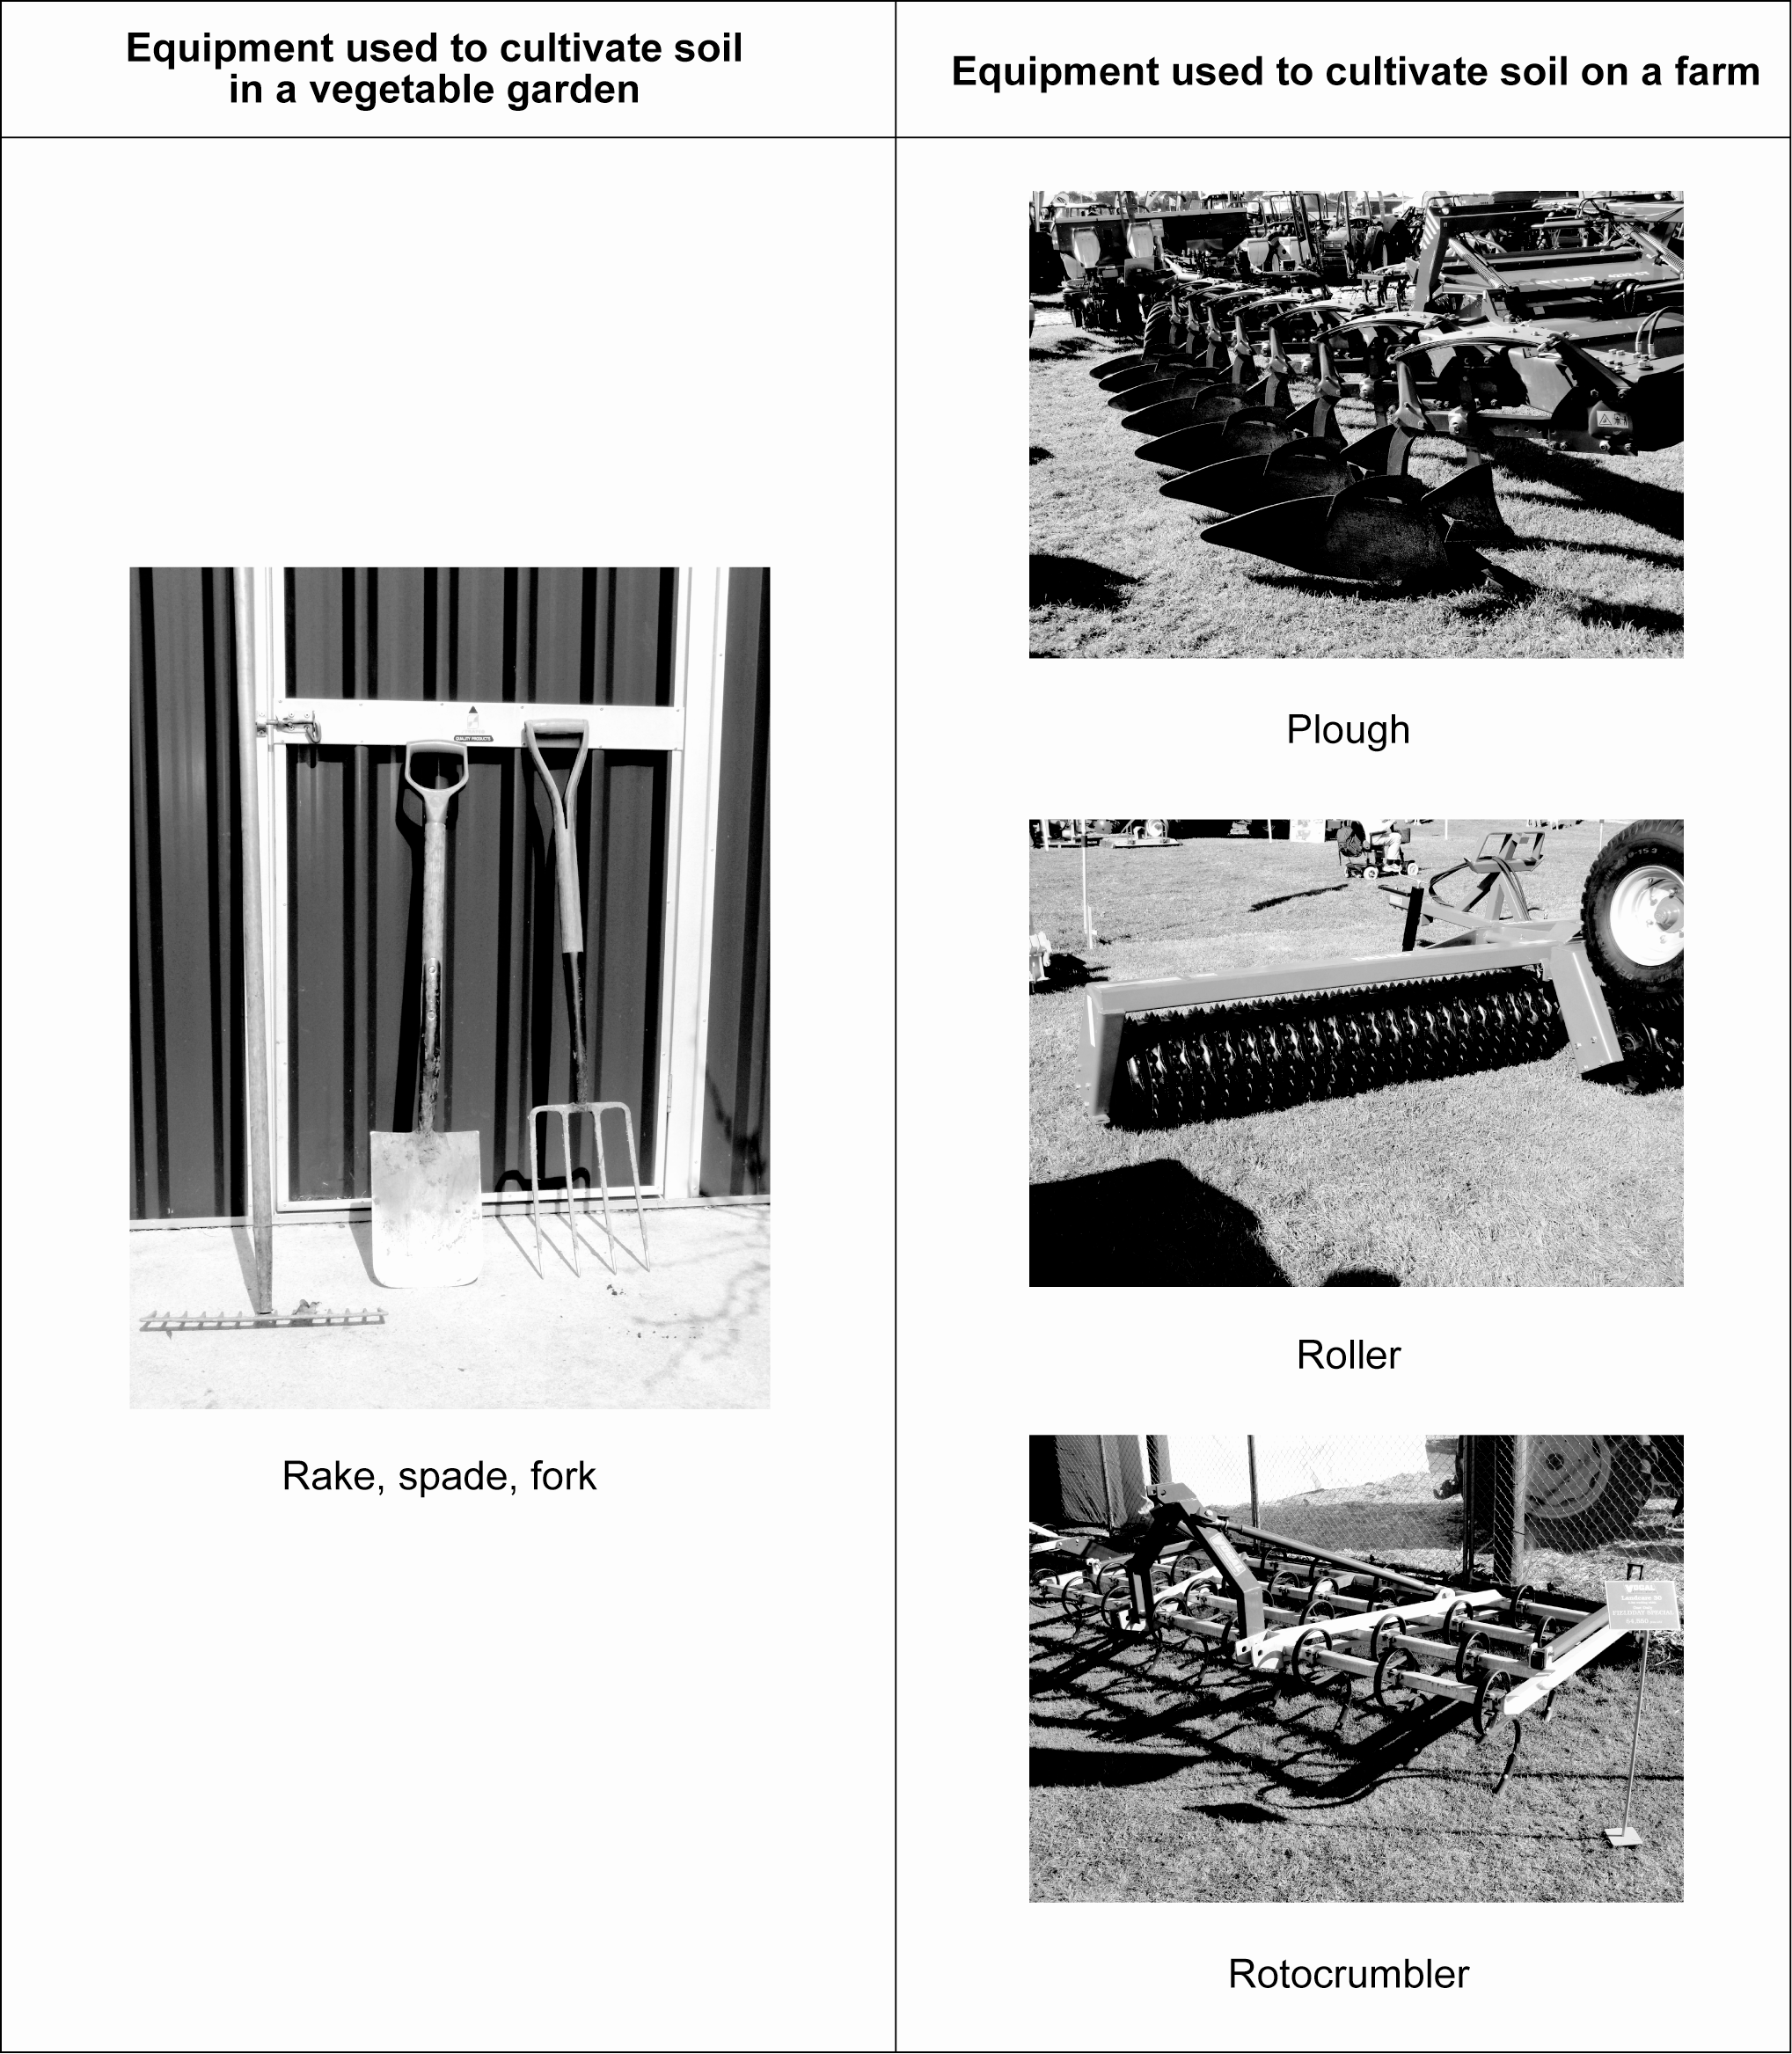
.
Choose the equipment shown in the photographs on the previous page for EITHER a vegetable garden OR a farm.

Write the equipment chosen here:

(a) Describe how the equipment is used to prepare a seedbed for your chosen situation. In your answer, you should cover:
- the function of each item of equipment
- the order in which the equipment is used
- how often each item of equipment is used.

(b) Explain why the use of this equipment helps plants grow from seed. In your answer, you should cover:
- the changes in soil structure resulting from cultivation
- how germination and seedling growth is helped by cultivating the seedbed.

(c) A rotary hoe is sometimes used to cultivate soil.

Justify using the equipment you chose on page 3 instead of a rotary hoe to cultivate soil. In your answer, you should cover:
- soil structure
- the physical properties of the soil
- efficiency and costs.

This page has been deliberately left blank.

QUESTION TWO: SOIL ADDITIVES

Lime and fertilisers are used to improve soil fertility and plant growth.

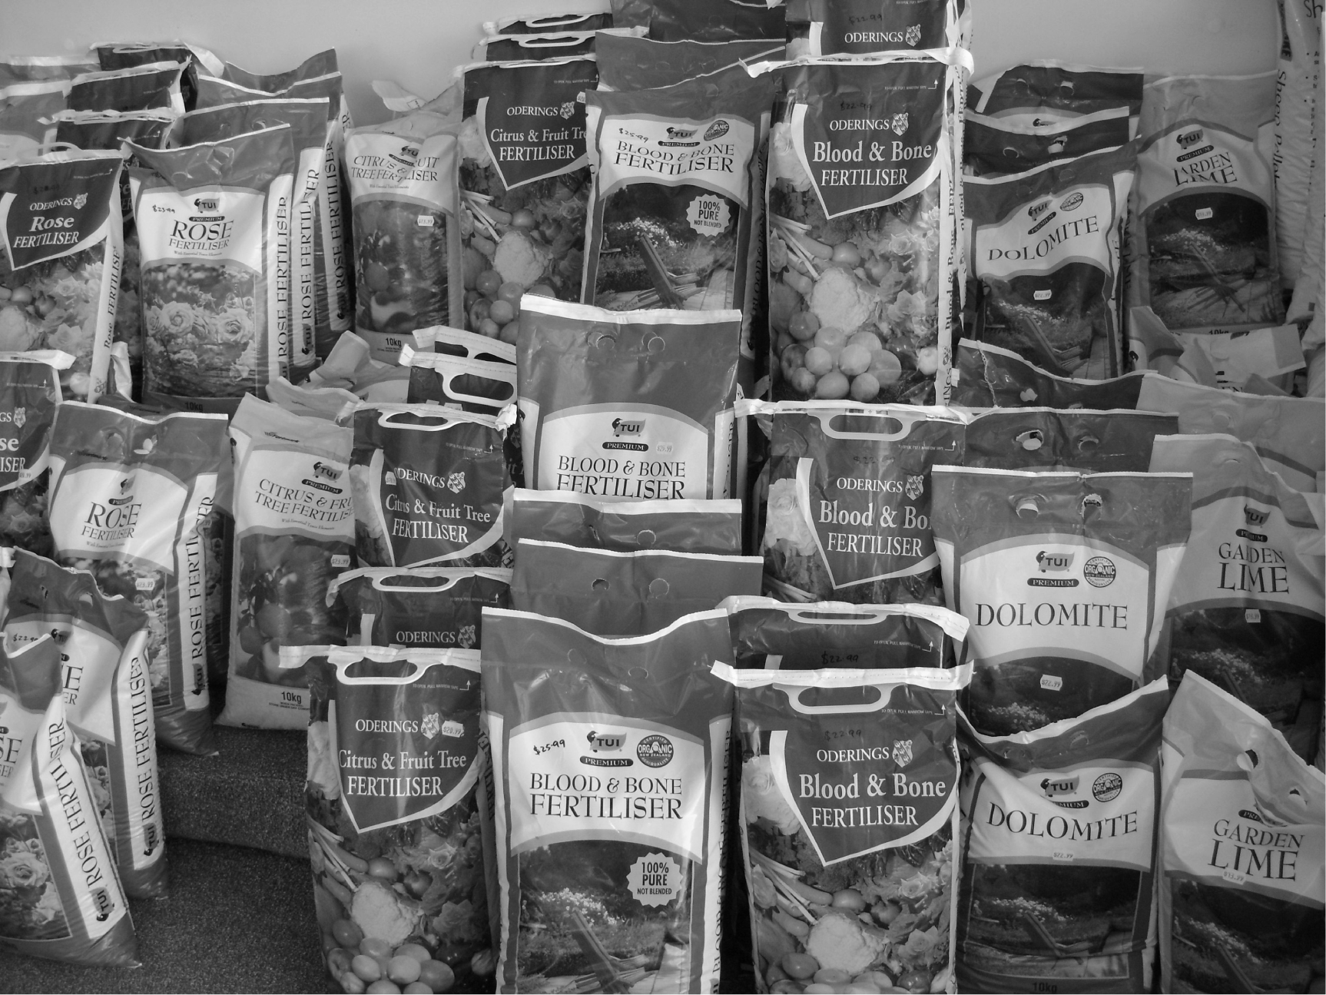

- Describe what a gardener or farmer needs to do to find out how much lime should be applied to the soil.

- Explain how liming soil improves plant growth. In your answer, you should cover the effect liming has on:
- soil nutrients
- soil organisms.

- Fertilisers come in artificial and organic forms. Artificial fertilisers include superphosphate and urea. Organic fertilisers include blood and bone, and animal manures.

A large-scale commercial grower of cabbages, lettuces, carrots, and onions is considering whether to use artificial fertiliser or organic fertiliser.

Select the form of fertiliser that should be used to produce the soil properties required to grow these crops. Write your selection in the box below.

Fertiliser form:

Justify your selection by explaining why it is better than the other form of fertiliser. In your justification, you should cover:
- the availability of different nutrients in the fertilisers
- the ease of using the fertilisers
- the costs of using the fertilisers.

QUESTION THREE: SOIL MOISTURE

Different types of soil hold different amounts of water. Soil may need irrigation or drainage to maintain desirable water levels.

- Describe a drainage system that would suit a clay soil in an area with high rainfall. You may draw a labelled diagram in the box provided to support your answer.

- Explain why the drainage system you described above would improve plant growth. In your answer, you should cover:
- the soil properties
- the plant processes involved.

- Charlie moved to a rural property that has a silt clay soil type. The property is located in an area that has average rainfall except during summer when the weather is usually hot and dry.

Charlie wants to produce salad type crops such as lettuces and has decided that it would be better to install an irrigation system rather than a drainage system.

Justify his decision to use an irrigation system rather than a drainage system for growing salad type crops that will produce a high profit. In you answer, you should:
- compare the irrigation and drainage options for this property
- consider the impact on soil properties, crop quality, and crop yields.

Extra paper for continuing your answers, if required.
Clearly number the question.

Question
number

Extra paper for continuing your answers, if required.
Clearly number the question.

Question
number

