Demonstrate understanding of land use for primary production in New Zealand
91297

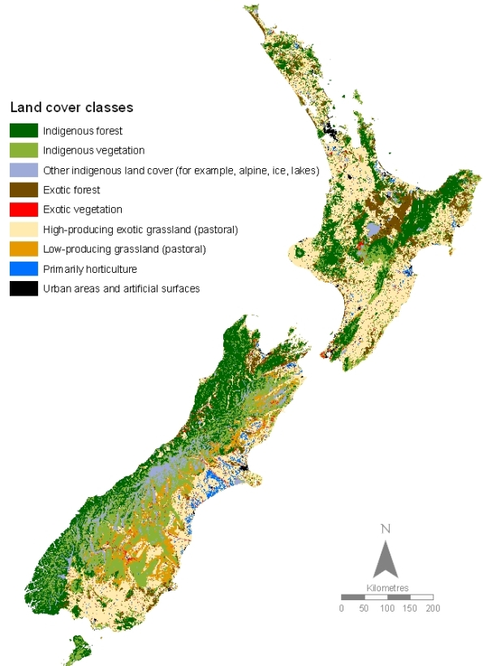

4 credits
External

Achievement Standard
Subject Reference |  |  | Agricultural and Horticultural Science 2.9
Title |  |  | Demonstrate understanding of land use for primary production in New Zealand
Level | 2 |  | Credits | 4 | Assessment |  | External
Subfield | Science
Domain | Agricultural and Horticultural Science
Status |  | Registered |  | Status date |  | 17 November 2011
Planned review date |  | 31 December 2019 |  | Date version published |  | 20 November 2014

This achievement standard involves demonstrating understanding of land use for primary production in New Zealand.
Achievement Criteria
Achievement | Achievement with Merit | Achievement with Excellence
- Demonstrate understanding of land use for primary production in New Zealand. | - Demonstrate in-depth understanding of land use for primary production in New Zealand. | - Demonstrate comprehensive understanding of land use for primary production in New Zealand.
Explanatory Notes
- This achievement standard is aligned with The New Zealand Curriculum, Learning Media, Ministry of Education, 2007, and is related to the material in the Teaching and Learning Guide for Agricultural and Horticultural Science, Ministry of Education, 2010 at http://seniorsecondary.tki.org.nz/.

- Demonstrate understanding involves explaining the factors that determine traditional, current, and future land use for primary production in New Zealand.
Demonstrate in-depth understanding involves a detailed explanation of the factors that determine traditional, current, and future land use for primary production in New Zealand.
Demonstrate comprehensive understanding involves evaluating the factors that determine traditional, current, and future land use for primary production in New Zealand. This may involve justifying, comparing and contrasting, and analysing.
- Traditional land use is that which has been commonly practised in an area for generations.

- The factors that have determined land use include economic, environmental, technological, social, political and workforce considerations.

Contents
Introduction 4
Land Use NZ 10
Horticulture 12
Dairy 17
Sheep and Beef 23
Forestry 29
Other land uses 34
The Regions 45
North Island 45
Northland 45
Auckland 46
Waikato 48
Bay of Plenty 49
East Coast 51
Hawke’s Bay 52
Taranaki 54
Whanganui- Manawatu 55
Wellington-Wairarapa 57
South Island 58
Marlborough-Nelson 58
Canterbury 60
West Coast 61
Otago 63
Southland 64

Introduction

Land includes soil and rock, plant and animal communities in the soil, and the landforms and vegetation that cover it. Our lifestyle and economy, particularly farming, depend on good quality land. Land use decisions require social, economic, and environmental needs to be balanced. A growing population requires more space for housing, recreation, and economic development, but land use changes for these purposes will affect the environment.

There are three main land uses in New Zealand: production, conservation, and urban development. Over one-third of land is legally protected for conservation purposes, with the remaining majority being used for primary production (agriculture, forestry, and horticulture). Urban and rural residential developments, and artificial surfaces such as transport infrastructure, landfills, and mines, cover a small but growing area.

Although it is difficult to predict future needs with certainty, current development decisions should not limit options for future generations. Some activities, such as expanding cities and creating new landfills, may lead to environmental changes that are irreversible over human timescales.

Land use by region
Land use is not spread out evenly across the regions. Due to economic, environmental, technological, social, political, and workforce factors certain land uses are better suited for particular purposes.

What do you know about land use in NZ?
Cut out the next page and label the following regions Northland, Auckland, Waikato, Bay of Plenty, East Coast, Hawke’s Bay, Taranaki, Whanganui-Manawatu, Wellington-Wairarapa,
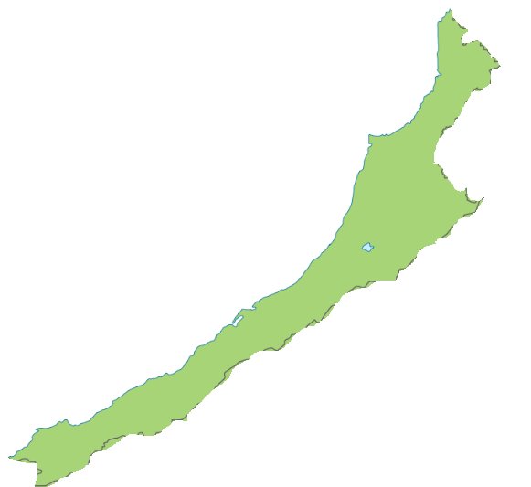
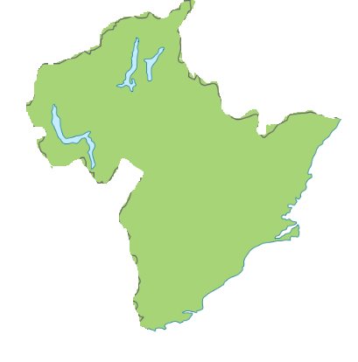
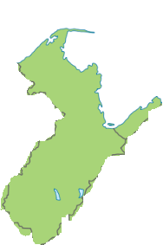

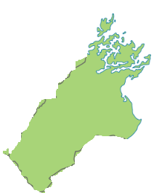
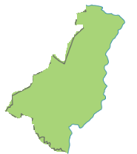

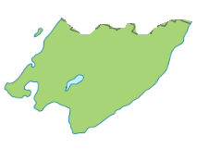
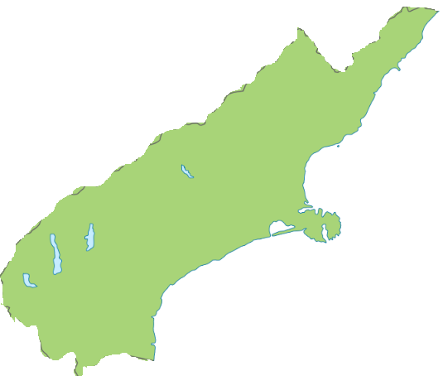
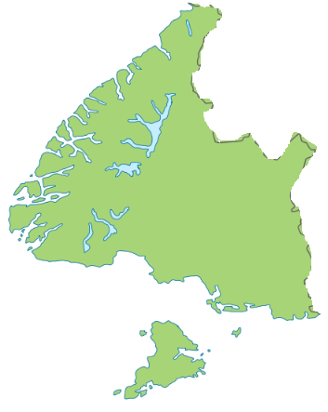
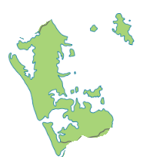

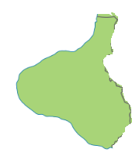

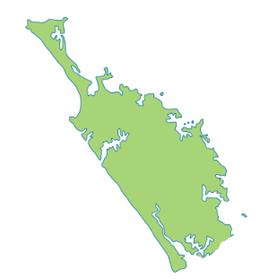
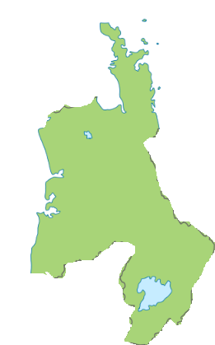

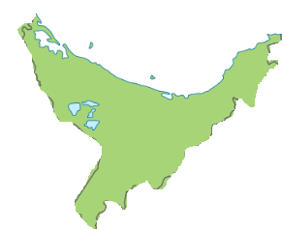

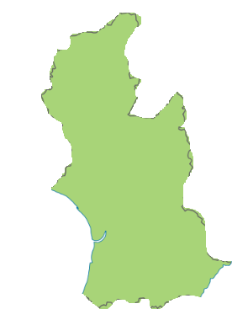

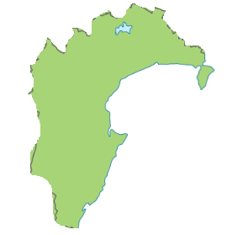

Leave blank

South Island Marlborough Nelson, Canterbury, West Coast, Otago, Southland

Land Use NZ
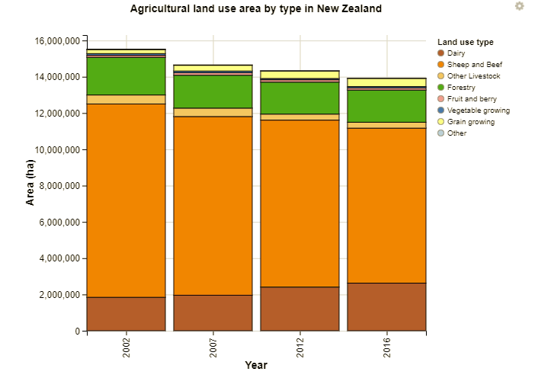

Dominant land uses in New Zealand include conservation (eg national and forestry parks), forestry (eg for timber resources/wood supply), urban (eg built up areas and open parkland), and agriculture and horticulture. Each land use places different pressures on the land and on receiving environments such as waterways. These pressures can be both positive (eg increased productivity) and negative (eg biodiversity loss and reduced functioning of ecosystems).
Nearly half of New Zealand’s total land area is used for horticultural and agricultural purposes.
Between 2002 and 2016:
- The largest increases in land area used for dairying were in Canterbury (up 254, 508 ha or 154.7 percent), Waikato (up 184,817 ha or 35.4 percent), and Southland (up 184,726 ha or 157.5 percent).
- The largest decreases in sheep and beef farming area were in Canterbury (down 828,233 ha or 32.5 percent), followed by Otago (down 237,624 ha or 11.6 percent) and Southland (down 206,001 ha or 22.8 percent).
- Grain growing as a land use increased 101.4 percent from 2002, and in 2016 was 1.7 percent (448,777 ha) of New Zealand’s total land area.
- Canterbury had the largest area increase in grain growing (up 78,621 ha), but the highest percent increase was in Taranaki (up 7,894 ha).
- The total area in fruit and berries increased 13.2 percent (up 14,096 ha); while vegetable growing land decreased 29.2 percent (down 28,766 ha).
At 2016:
- 45.3 percent (12.1 million ha) of New Zealand’s total land area was being farmed for agricultural and horticultural use.
- Otago (64.5 percent), Manawatu-Wanganui (57.9 percent), Hawke’s Bay (55.4 percent), Canterbury (55.3 percent), Waikato (55.2 percent) and Taranaki (55.1 percent) regions all used more than half of their land in this way.
- Waikato and Taranaki had the greatest proportion of their land area in dairying (28.7 percent and 28.1 percent, respectively).
- Sheep and beef farming was the main agricultural use (31.9 percent of total land), followed by dairying (9.8 percent of total land).
- Less than 1 percent of New Zealand’s total land area was used for growing fruit and berries (0.5 percent or 120,894 ha) and vegetables (0.3 percent or 69,686 ha).

Describe the main agricultural land uses in NZ

Explain why these are the main land uses in NZ

Analyse the graph and bullet points above and note any changes shown over time

Horticulture
New Zealand horticulture is big business and growing fast. With an industry value of $5.6 billion (excluding wine), we export 60 percent of what we grow, that is, $3.4 billion in value to 124 countries.
Exports increased by 40 percent from June 2014 to 2016. The 5,500 commercial fruit and vegetable growers employ about 60,000 people and the demand for workers across the skill spectrum is outstripping supply.
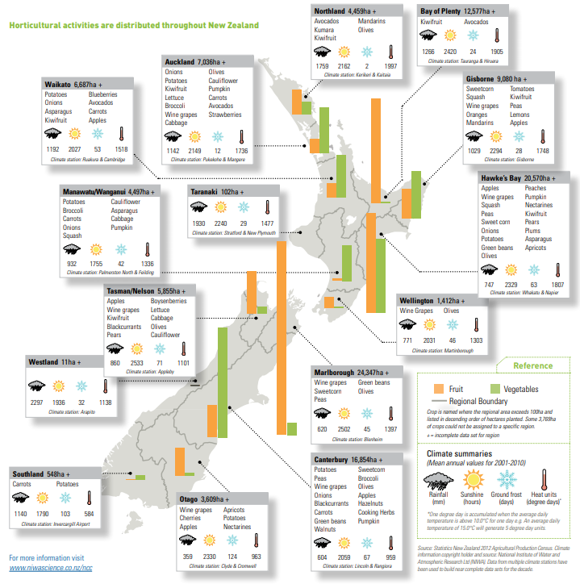

Which regions have the
 | Highest | Lowest
Sunshine hours
Rainfall
Heat units
Ground frost days

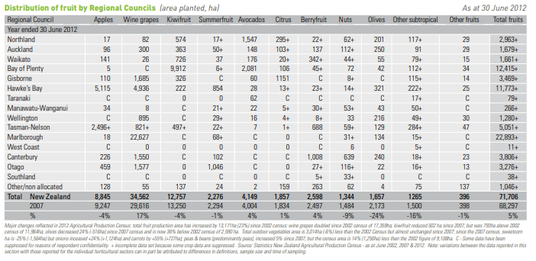

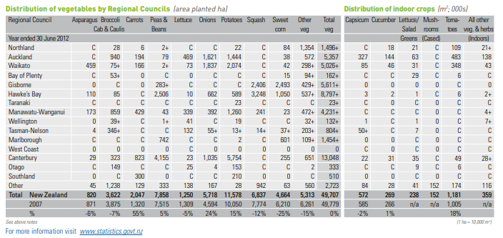

Looking at the diagram and tables above. What are the
Biggest
Fruit regions
Wine regions
Apple regions
Kiwifruit regions
Summer fruit regions
Avocado regions
Citrus regions
Vegetable regions
Potato regions
Pea and bean regions
Corn regions
Broccoli and califlower regions
Carrots

Explain possible reasons why Auckland has the greatest number of indoor crops

Explain possible reasons why Marlborough, Hawke’s Bay and Otago have the greatest number of wine grapes

What are the advantages and disadvantages to having land in horticulture?

Why would a land owner convert land to or from horticulture?

Factors behind Horticultural Land uses
Economic

Environmental
Technological
Social

Political
Workforce

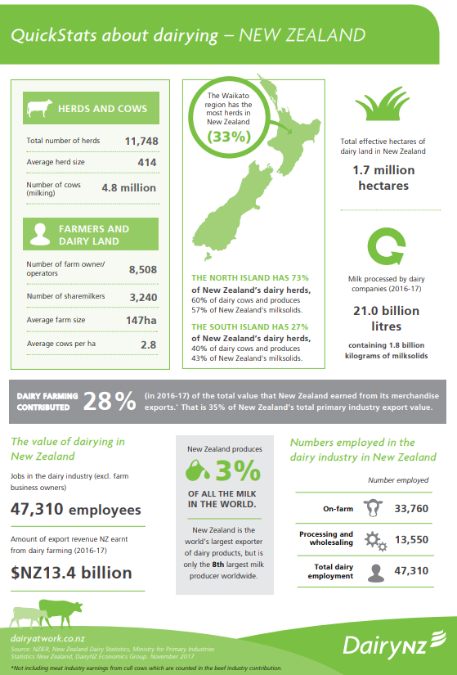
Dairy

Since the early 1800s the dairy industry in New Zealand has gone from farmers keeping a few domestic cows on bush blocks to being a world leader.
Before the advent of refrigeration, almost all of New Zealand’s dairy products were consumed locally, with only a small amount of butter and cheese exported to Australia. From the early 1880s refrigeration made it possible to export more dairy products.
Dairy farms proliferated in the early 20th century as bush was cleared, land drained, and pasture improved with superphosphate fertiliser and faster-growing grasses and clovers. Although dairying required more labour and capital than sheep and beef farming, it provided regular income, and home-bred animals could be added to the herd to either replace culled animals or increase herd size. Farmers could start small and build their herd size comparatively quickly.
Dairying regions
Dairying was developed in regions where rainfall was reliable and winters were warmer, such as Northland, Waikato, Taranaki, Bay of Plenty, Manawatū, Nelson and the West Coast. Farms were small, usually near factories, and could graze two cows per hectare.
Farm and herd size
In the early years of the 21st century dairying expanded onto irrigated farms on the Canterbury Plains and to Southland, where land prices were lower than in the traditional dairy regions of the North Island. By 2006 Waikato and Bay of Plenty had 32% of New Zealand’s dairy cows, Taranaki 12%, Northland 9%, and the South Island 28%.
From the 1970s many South Island farms were joined into bigger farms, which led to a reduction in the number of herds. By 2007, farms were twice as large as they were in the early 1990s, at an average of 118 hectares, with a stocking rate of 2.7 cows per hectare.
In 2007 New Zealand had 5.2 million cows in milk or in calf, with an average herd size of 322 cows. This was twice that of the average herd in the early 1990s and almost twice the number of cows milked in 1980.
In 2017 New Zealand had 6.5 million cows in milk or in calf, with an average herd size of 414 cows.

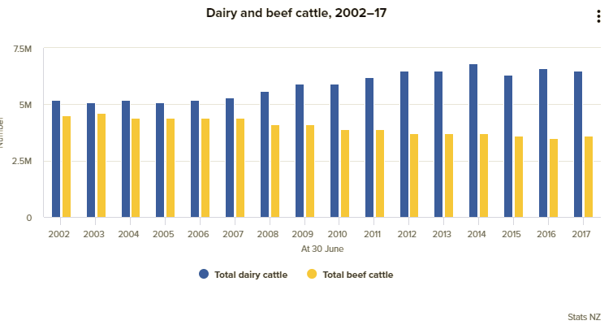

What were the traditional dairy regions?

What are the newer dairy regions?

What technological and economic factors allowed dairy to expand into these regions?

Why was land converted to dairy?

Why has the amount of land being converted to dairy decreased in recent years?

What are the advantages and disadvantages to having land in dairy?

Why would a land owner convert land to or from dairy?

Factors behind dairy land use
Economic

Environmental

Technological

Social

Political

Workforce

Sheep and Beef

After Europeans settled in New Zealand and began farming, wool and then sheep meat were the main exports – at first mostly to Britain.
For many years whole carcasses were exported, but today cuts of meat are more common.
Grading meat and wool
Meat and wool are classified by factors like weight, fatness and muscle (for meat) and thickness, colour and strength (for wool). This means buyers can choose the exact kind of product they want.
Sheep meat
Meat was first sent to Britain in cans, in 1870. In 1882 the first frozen sheep carcasses were shipped on the Dunedin. After this, the industry grew quickly, and farmers began farming sheep that produced good meat, not just good wool. Most meat went to Britain.
Today sheep meat is exported to a wider range of countries. Meat that has been slaughtered to halal standards (a way of killing based on Islamic teachings) is sold to Muslim countries.
Beef
Up till the 1950s all New Zealand beef was sold locally. Since then, beef has been exported to the United States, Europe and to North Asia.
Wool
In 2016-17, New Zealand was the third largest producer of wool in the world and produced 9.0% of world production. Wool is shorn from sheep – around 139,000 tonnes each year. This is down on 1990 where 305,000 tonnes were shorn. Wool from Merino sheep is fine and white, and is dyed and made into fabrics for clothing. Coarser and darker wool from other breeds is used in blankets, curtains and carpets. Wool grease (lanolin) is made into cosmetics.
Most wool is exported in its raw state, to be spun and woven in other countries.
Both sheep and beef cattle numbers have been in decline for a number of years.
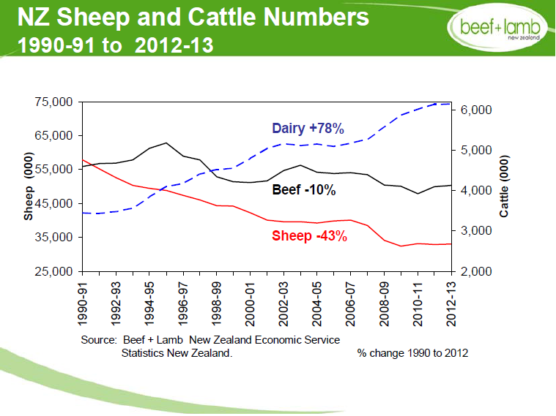

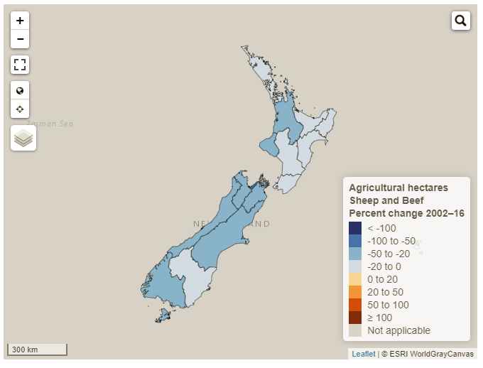
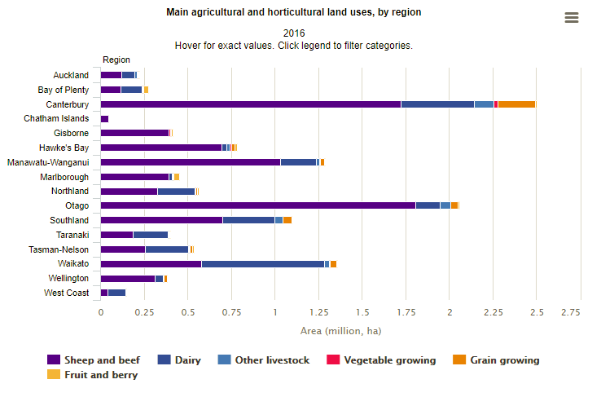
Why has there been a large decrease in sheep numbers over time?
Explain how sheep and beef land use is different from dairy land use.

What regions have the greatest amount of sheep beef farming Why?

What regions have the least? Why?

Why have Canterbury and the Waikato seen large decreases in sheep and beef farming since 2002?

What are the advantages and disadvantages to having land in sheep and beef?

Why would a land owner convert land to or from sheep and beef?

Factors behind sheep and beef land use
Economic

Environmental

Technological

Social

Political

Workforce

Forestry
New Zealand is a small player in the international forestry industry, contributing only 1.1% of the world's total supply of industrial wood and 1.3% of the world's trade in forest products.
However, forestry is a significant industry in New Zealand. It contributes
- an annual gross income of around $5 billion
- 3% of New Zealand's GDP
- directly employs around 20,000 people.
Wood products are New Zealand's third largest export earner – behind dairy and meat.
New Zealand’s native forests were once logged for wood. By the start of the 20th century, the government realised that to have enough wood in the future, they would need to plant new forests.
They planted exotic trees – species from overseas, which are faster and easier to grow than native trees. They included eucalyptus, larch, Douglas fir and different kinds of pine trees, including radiata pine.
The government Forest Service planted new forests, and so did more than 20 companies.
New forests
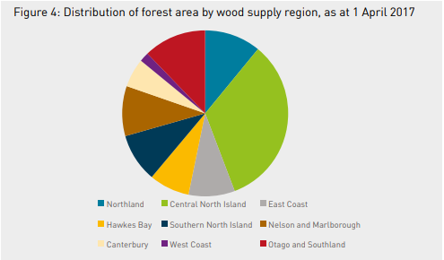
State and private forests were mainly in the central North Island. Although the Forest Service continued to plant sizeable areas to meet regional timber needs at Eyrewell and Balmoral in Canterbury, Karioi on the southern flanks of Mt Ruapehu, and Riverhead in Auckland, most effort was concentrated on the Kāingaroa plains.
The Kāingaroa plains were suited for planting because the land was flattish and covered in grass and scrub, so it was easier to plant than land that had previously been in native forest. More importantly, although the area would normally have been farmed, it was considered unsuitable because stock grazed there suffered from a mysterious wasting disease (called ‘bush sickness’). Agricultural scientists later identified the cause as a cobalt deficiency in the soil.

Exotic plantation forests form the base
The industry is based around sustainably managed exotic plantation forests, covering 1.751 million hectares – about 7% – of New Zealand's land area. Radiata pine (Pinus radiata) makes up 90% of the exotic plantation area, with Douglas-fir (Pseudotsuga menziesii) accounting for 6%, and the rest made up of eucalypts and other species.

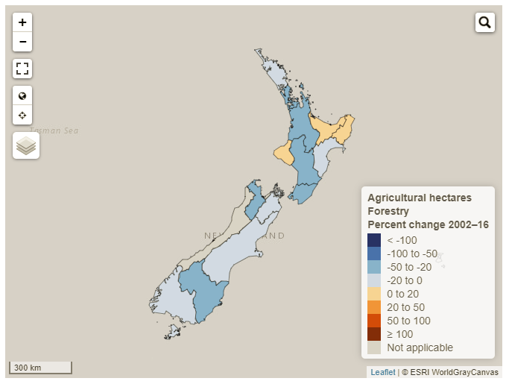

Converting forest land to agriculture
In the early 2000s, harvested forest land was being converted to other uses. Carter Holt Harvey sold about 400 hectares of forest land for small lifestyle blocks in Nelson in 2004. In 2006, in response to high land values and low log prices, forestry companies sold 9,000 hectares in Canterbury and 3,000 hectares in the central North Island for dairy farms. It was estimated that this cost the government $650 million in greenhouse-gas emission liabilities under the Kyoto Protocol.
To combat this, in 2007 the government announced a cap on the amount of land that could be converted from forestry to other land uses without financial penalty – a controversial decision.
What are the main regions for plantation forestry?

Why are these regions suitable for forestry?

What are the advantages and disadvantages to having land in forestry?

Why would a land owner convert land to or from forestry?

Factors behind forestry land use
Economic
Environmental

Technological

Social

Political

Workforce

Other land uses

Arable farming
What is arable farming?
Arable farming is growing crops in fields, which have usually been ploughed before planting.
Arable crops
Some of the main crops grown in New Zealand are:
- wheat
- maize (corn)
- barley
- oats
- peas.
The grains of all of these are made into food for people and animals.
Other crops grown are vegetables such as potatoes and carrots, and plants that can be pressed into oil.
Certain crops grow better in different regions, depending on the temperature and rainfall.
Ploughing
When people first began growing arable crops in New Zealand, it was hard work to prepare land for planting. Usually bush or tussock had to be cut or burnt, and the stumps removed. The land was very hard when it was first ploughed.
Ploughing breaks up the soil so it is ready for further cultivation and planting. Teams of bullocks or horses used to pull the ploughs, but these days they are towed behind tractors.
Planting and growing
Seeds are planted in the soil by a machine with a drill, usually in autumn or spring.
Fertiliser is added to help the plants grow. In drier areas, the crops need to be watered.
Pests and diseases are sometimes controlled by spraying with chemicals, and some plants have been bred to be resistant to diseases.
Harvest
Crops are usually harvested in late summer or autumn. It used to take hundreds of people to harvest a grain crop, like wheat or barley. Now only one person is needed to drive a combine harvester, which cuts the crop and separates the grain from the straw. The grain is loaded into trucks and taken away to be stored or processed.
Seed crops
The main seed crops produced by the New Zealand arable industry in the early 2000s are:
- cereals, such as wheat, oats, barley and maize
- pulses, such as peas and lentils
- brassicas, such as oil-seed rape (also known as canola)
- herbage, forage and vegetable crops, such as ryegrass and white clover, which are grown as annual crops to harvest the seed.
The grain harvested from seed crops has many uses, including milling, malting, manufacturing animal feed and pressing for oil. Milling involves crushing the grain and separating the tough outer husk from the flour. Malting is a process where the grain, usually barley, is germinated, then heated and crushed, before being fermented and made into products such as beer or vinegar.

Other crops
Some arable crops are grown as forage for grazing animals rather than for grain. These include cereals such as oats and maize, and brassicas like swedes, turnips, rape and kale.
Other arable crops, such as potatoes, carrots and broccoli, are grown as vegetables for human consumption.
In the past, arable crops like sugar beet have been used as biofuels. This application may become more important in the future, with renewed interest in alternative fuels.
Regional production 2002
In 2002, 68% of New Zealand’s arable production land area was in Canterbury, which yielded 90% of the milling wheat and 80% of wheat used as feed. Other wheat-growing regions were Southland, Otago and Manawatū–Wanganui.
Canterbury produced 68% of New Zealand’s barley, but significant volumes were also grown in Southland (10%) and Otago (10%), and also in the Wairarapa and Manawatū.
Oats were grown in Canterbury (60%), Southland (24%) and Otago (9%).
Peas were produced mainly in Canterbury (76%), with smaller volumes coming from Hawke’s Bay, Manawatū–Wanganui, Wellington, Marlborough, Otago and Southland.
In contrast to the other crops, 97% of maize grain was grown in the North Island. Major maize-growing regions were Waikato (25%), Gisborne (19%), Manawatū–Wanganui (16%), Bay of Plenty (14%) and Hawke’s Bay (14%).
Area under grain cultivation
 | Region | 2002 | 2007 | 2012 | 2016
1 | Northland | 2158 | 4056 | 7014 | 8943
2 | Auckland | 1488 | 3929 | 6982 | 4138
3 | Waikato | 11584 | 28555 | 36243 | 36382
4 | Bay of Plenty | 5109 | 4946 | 10456 | 6408
5 | Gisborne | 3469 | 6649 | 3842 | 6024
6 | Hawke's Bay | 3634 | 7231 | 9549 | 16060
7 | Taranaki | 767 | 8361 | 7244 | 8661
8 | Manawatu-Wanganui | 8159 | 12624 | 24267 | 23113
9 | Wellington | 3554 | 3418 | 8754 | 15459
12 | West Coast |  | 2508 | 4205 | 4431
13 | Canterbury | 137723 | 194363 | 228887 | 216344
14 | Otago | 19825 | 18429 | 26950 | 43311
15 | Southland | 23365 | 19099 | 30440 | 51802
16 | Tasman | 1956 |  | 2133 | 5114
17 | Nelson
18 | Marlborough |  | 2350 | 3552 | 2587

Select the 5 biggest grain producing regions in 2016 and graph the area under cultivation since 2002

Title:_____________________________________

What type of land is required for arable farming?

How have workforce requirements for arable farming changed?

Urban
Approximately 86 percent of New Zealand’s population lives in an urban centre, based on estimates from Stats NZ. As at 30 June 2013, around 73 percent lived in a city or a major urban area of over 30,000, 6 percent in a large regional centre between 10,000 and 29,999, and 8 percent in smaller towns of between 1,000 and 9,999. The concentration of people in urban areas intensifies pressure on the environment. The impact is often on fresh water and the marine environment, as well as on air and atmosphere. Direct impacts on land include the loss of high-value agricultural soils, and negative effects of waste and soil contamination
The greatest expansion of urban areas was in Auckland (up 4,211 hectares), Waikato (up 3,900 hectares) and Canterbury (up 3,829 hectares).13 For comparison, a full-size rugby field is just over one hectare in size (including 22 metre in-goal areas, it is 10,080 square metres)
There is another land use change that can impact the productivity of the land outside cities. This is the creation of lifestyle blocks – where larger commercial agricultural areas are subdivided into smaller lifestyle blocks and units with housing on the fringes of urban areas. Creation of lifestyle blocks may pose a greater risk to the availability of high quality soil resources for the primary sector than does urban expansion. While the outward growth of urban centres in New Zealand between 1990 and 2008 consumed 0.5 percent of high-class land, analysis in the same 2013 study shows that lifestyle blocks had already occupied 10 percent of high-class land (data to 2011).
There has been a sharp increase in the number of lifestyle blocks in recent decades. The 2013 study shows that of the 175,000 lifestyle blocks that occupied 873,000 hectares of land in 2011, over 40 percent had been established since 1998 (an average of 5,800 new blocks a year).
The same study found that 35 percent of Auckland’s most versatile land was used as lifestyle blocks. Changing land use on the urban fringes can also result in fragmentation of land parcels. This is well demonstrated in the wider rural Auckland region. In the Pukekohe area, the number of property parcels increased 58 percent between 1998 and 2015 (Curran-Cournane et al, 2016). Most lifestyle blocks were created on the urban fringe; by 2015 most land parcels in the Pukekohe area were less than 8 hectares.
Fragmentation of land ownership is legally reversible, but it is not often practical to do so, because a property’s value increases when it is converted to a lifestyle block. The impact of this fragmentation is hard to quantify, as there is no information on the productivity of lifestyle blocks and their actual impact on food production.
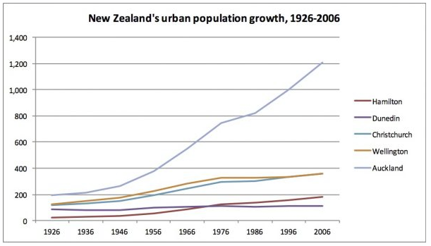
Lifestylers
After the 1980s the growth of lifestyle blocks – small rural properties owned by current or former townies – blurred old city–country distinctions, but created new tensions. Lifestylers’ complaints about country noises and smells – including bird-scaring devices and silage – both bemused and incensed local farmers, curbing traditional country hospitality to newcomers. While most areas have not seen the scale of conflict experienced in the Auckland area – where one lifestyler moved a herd of cows from the next-door farm because he was having a barbecue and the smell of cows ruined the ambience – there has been opposition to what some call ‘rural sprawl’. On the other hand, lifestylers have re-energised flagging rural economies by starting wineries and orchards, running home-based businesses, and creating demand for café culture and non-farm employment.

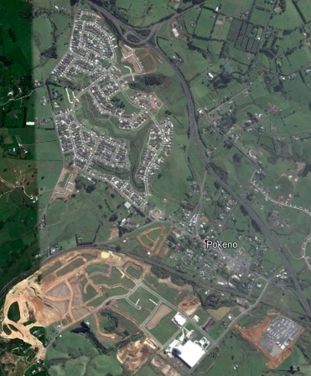
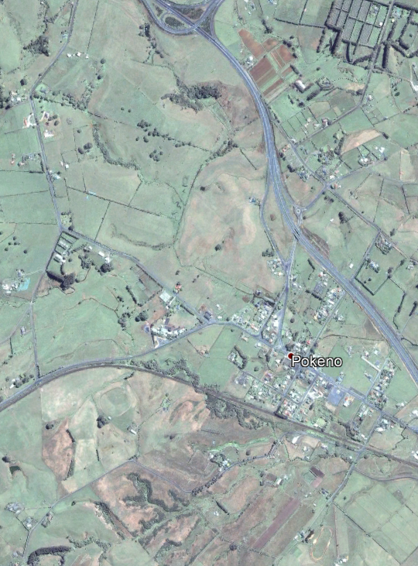

Pokeno 2001 Pokeno 2017
Where are the main areas in NZ being converted to urban use?

Explain why urban sprawl an issue.

Choose a city and draw its urban boundary now and 20 years ago
City: ___________________________

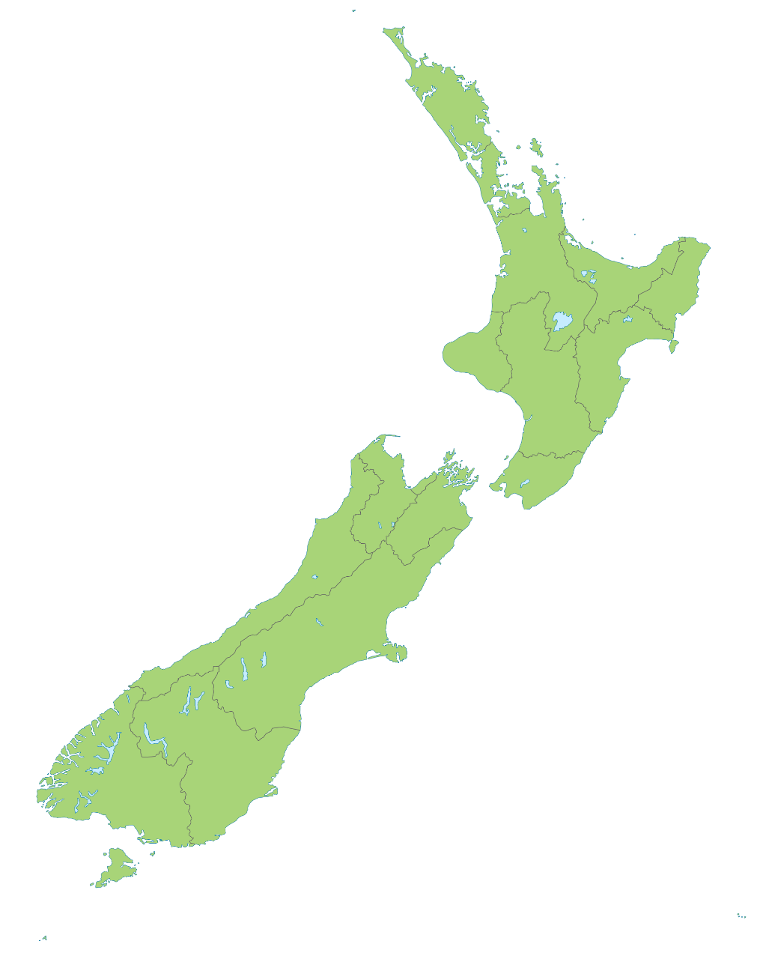
Locate and draw the following cities and towns on the map above.
Auckland, Wellington, Christchurch, Hamilton, Tauranga, Napier-Hastings, Dunedin, Palmerston North, Nelson, Rotorua, Whangarei, New Plymouth, Invercargill, Whanganui, Gisborne

Conservation
What are protected areas?
Protected areas are places where natural or cultural resources and biodiversity are protected, maintained and managed, usually by law. New Zealand’s best known protected areas are its 13 national parks and a large number of reserves.
The country has more than 10,000 protected areas, covering more than 8.6 million hectares (around 32% of the total land area).
Developing a protected areas network
New Zealand’s first national park, Tongariro, was formally established in 1894, after the central North Island peaks were gifted to the nation by chief Horonuku Te Heuheu in 1887. After that, a comprehensive network of national parks and reserves developed, mostly managed by the Department of Lands. A parallel system of forest reserves and parks was also introduced by the Forest Service.
In 1987 the government’s land management agencies were restructured, and the Department of Conservation was set up. It now manages most public protected areas.
Types of protected area
There are around 60 different types of protected area. The most important are:
- national parks
- conservation parks
- nature reserves
- scientific reserves
- scenic reserves
- historic reserves
- other conservation land
- recreation (and other) reserves.
What are national parks?
National parks are large areas that protect iconic landscapes. Many hundreds have been created worldwide since the first national park, Yellowstone in Wyoming, USA, was set up in 1872.
New Zealand national parks management was first consolidated under the National Parks Act 1952. Its successor, the National Parks Act 1980, states that national parks contain ‘scenery of such distinctive quality, ecological systems, or natural features so beautiful, unique, or scientifically important that their preservation is in the national interest’.
New Zealand’s national parks
At 31 May 2015 New Zealand had 13 national parks, covering 2,882,878 hectares – about 10.7% of the country’s total land area. Three are in the North Island, nine in the South Island, and one, Rakiura, covers most of Stewart Island. Many of the parks are the result of decades of campaigning by conservationists and recreational groups.
The first park was Tongariro (1894); the most recent is Rakiura (2002). The largest is Fiordland, which at 1,260,288 hectares is one of the world’s great wilderness landscapes; the smallest is Abel Tasman (23,703 hectares), between Tasman Bay and Golden Bay. Most are in mountainous and forested areas.
Conservation parks
Like national parks, New Zealand’s conservation parks are generally large areas (50,000–150,000 hectares).
Most are forest parks. They include the Ruahine and Remutaka forest parks in the North Island’s central ranges, and the Richmond, Victoria and Lake Sumner forest parks in the low-altitude ranges of the northern South Island. These parks were set aside to protect water and soil conservation values and provide opportunities for outdoor recreation.
High-country conservation parks
In the early 2000s, conservation parks were created in the high-country tussocklands of the eastern South Island. They included the 20,328-hectare Korowai/Torlesse Tussocklands Park, near the Waimakariri River in Canterbury, and Te Papanui Conservation Park, 21,000 hectares of rolling tussock plateaus, patterned wetlands and string bogs in Otago’s Lammerlaw and Lammermoor ranges.
Parts of large high-country sheep runs leased to farmers by the Crown were seen to have high conservation value. Some were voluntarily retired from grazing through a process called tenure review, and added to the conservation estate. The government also bought some properties. There are plans to develop a network of parks in the high country east of the Southern Alps, from Marlborough to Southland.
Most conservation parks have a lower profile than national parks, and are less popular with tourists. Their tracks are often more rugged, and their huts more basic.
Nature reserves
Nature reserves are generally smaller than conservation parks (mostly 100–1,000 hectares). They protect habitats of threatened plants and animals. Many nature reserves have access restrictions and permit systems.
Tenure review of pastoral lands
Since 1992 the government has been reviewing tenure of pastoral leases in the eastern South Island ranges. These 353 leases covered 2.4 million hectares – 9% of New Zealand. By mid-2017, 126 leases had been reviewed and 330,000 hectares had been protected, in an area that previously had few reserves.

What are the economic impacts of locking up land in conservation estate?

Where is most of NZ’s conservation estate located?

Self-research topic -Tenure review

Factors behind other land use
Economic

Environmental

Technological

Social

Political

Workforce

The Regions

North Island

Northland

Facts and figures
Land area
% of NZ
Population
% Unemployment
Major industries
Major transport links
Average temperature summer/winter
Average rainfall
Interesting facts and figures
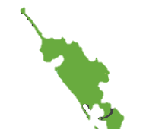
Label Kerikeri, Whāngārei, Kaitāia

About
Livestock farming developed in the early 20th century – first to supplement natural resources such as timber and kauri gum, and then to replace them. Although much of the north was not ideal for farming, many areas were gradually brought into use for sheep and cattle. Small dairy factories had been established by 1910. But progress was held back by the region’s remoteness, poor access, infertile soils and the uneconomic size of holdings.
After the Second World War, state subsidies and grasslands research assisted farming. For those farmers who could afford it, aerial topdressing increased productivity from the late 1950s.
Dairying expanded on fertile lowlands, and by 1960 Northland had 22.6% of the country’s dairy cows, making it New Zealand’s second-most important dairying area. Over 30% of the region’s cows were milked in herds of less than 50, on small land blocks known as ‘billycan farms’. Improved roads and new technology in the 1960s led to closure of many smaller dairy factories, leaving two centralised processing plants at Kaitāia and Moerewa.
By the 1960s sheep numbers had increased markedly. A trend towards larger farms, diversification of farm stock, and cattle farming was evident by the 1970s.
In 2012 the region’s farms covered 765,155 hectares, only about 5% of the total area farmed in New Zealand. Beef cattle outnumbered dairy cattle, and sheep predominated, though to a far lesser degree than in previous years. The small dairy farm had long gone. There were major dairy processing plants, including one at Kauri, north of Whāngārei, and one at Maungaturoto.
Horticulture, particularly fruit farming, has always been a distinctive feature of the region. For years before 1900, Whāngārei was one of the country’s most important fruit-growing districts, particularly for citrus fruit. Kerikeri developed as a citrus-producing area from the 1920s and later diversified into tamarillos and kiwifruit. Grapes were grown for wine by Dalmatians as early as 1899, and more vineyards were planted in the later 20th century. Avocados are now an important crop.

Main land uses
Traditional
Current
Future

Auckland

Facts and figures
Land area
% of NZ
Population
% Unemployment
Major industries
Major transport links
Average temperature summer/winter
Average rainfall
Interesting facts and figures
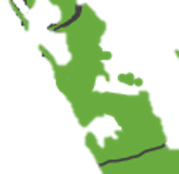
Label Auckland CBD, Pukekohe, Matakana, Kumeu

About

Main land uses
Traditional
Current

Future

Waikato
Waikato, Kings Country, Coromandel, Central Plateau

Facts and figures
Land area
% of NZ
Population
% Unemployment
Major industries
Major transport links
Average temperature summer/winter
Average rainfall
Interesting facts and figures
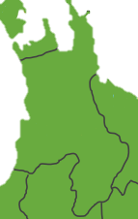
Label Hamilton, Taupo. Central Plateau, Tokoroa, Te Kuti, Matamata

About

Main land uses
Traditional
Current
Future

Bay of Plenty

Facts and figures
Land area
% of NZ
Population
% Unemployment
Major industries
Major transport links
Average temperature summer/winter
Average rainfall
Interesting facts and figures

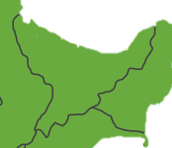
Label Tauranga, Rotorua, Whakatane, Te Puke, Kaingaroa

About

Main land uses
Traditional
Current
Future

East Coast

Facts and figures
Land area
% of NZ
Population
% Unemployment
Major industries
Major transport links
Average temperature summer/winter
Average rainfall
Interesting facts and figures

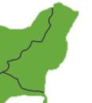
Label Gisborne, Mahia

About

Main land uses
Traditional
Current
Future

Hawke’s Bay

Facts and figures
Land area
% of NZ
Population
% Unemployment
Major industries
Major transport links
Average temperature summer/winter
Average rainfall
Interesting facts and figures

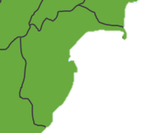
Label Napier, Hastings,

About

Main land uses
Traditional
Current
Future

Taranaki

Facts and figures
Land area
% of NZ
Population
% Unemployment
Major industries
Major transport links
Average temperature summer/winter
Average rainfall
Interesting facts and figures
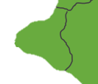
Label New Plymouth, Mt Taranaki, Hawera

About

Main land uses
Traditional
Current
Future

Whanganui- Manawatu

Facts and figures
Land area
% of NZ
Population
% Unemployment
Major industries
Major transport links
Average temperature summer/winter
Average rainfall
Interesting facts and figures
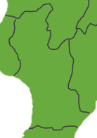
Label Whanganui, Palmerston North, Taumarunui, Ohakune, Dannevirk

About

Main land uses
Traditional
Current
Future

Wellington-Wairarapa
Land area
% of NZ
Population
% Unemployment
Major industries
Major transport links
Average temperature summer/winter
Average rainfall
Interesting facts and figures
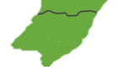
Label Wellington, Martinborough, Masterton, Pararaumu

About

Main land uses
Traditional
Current
Future

South Island

Marlborough-Nelson

Facts and figures
Land area
% of NZ
Population
% Unemployment
Major industries
Major transport links
Average temperature summer/winter
Average rainfall
Interesting facts and figures

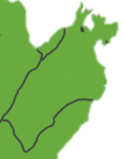
Label Nelson, Blenheim,

About

Main land uses
Traditional
Current
Future

Canterbury

Facts and figures
Land area
% of NZ
Population
% Unemployment
Major industries
Major transport links
Average temperature summer/winter
Average rainfall
Interesting facts and figures

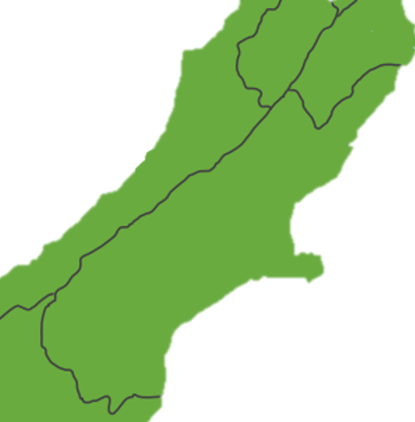
Label Christchurch, Kaikoura, Methven, Akaroa, Timaru, Tekapo, Twizel

About

Main land uses
Traditional
Current
Future

West Coast

Facts and figures
Land area
% of NZ
Population
% Unemployment
Major industries
Major transport links
Average temperature summer/winter
Average rainfall
Interesting facts and figures
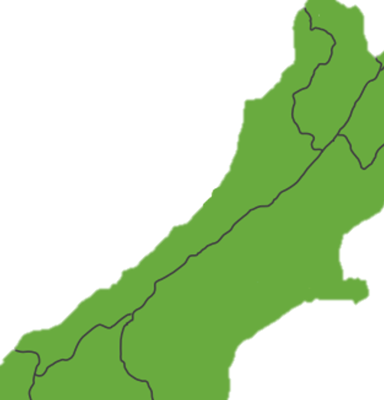
Label Greymouth, Haast, Hokitika, West Port

About

Main land uses
Traditional
Current
Future

Otago

Facts and figures
Land area
% of NZ
Population
% Unemployment
Major industries
Major transport links
Average temperature summer/winter
Average rainfall
Interesting facts and figures
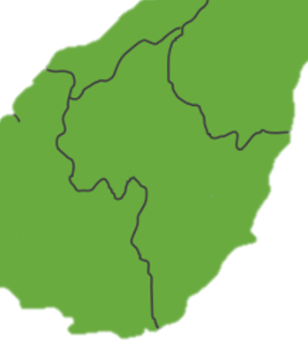
Label Dunedin, Alexandra, Queenstown, Wanaka, Oamaru

About

Main land uses
Traditional
Current
Future

Southland

Facts and figures
Land area
% of NZ
Population
% Unemployment
Major industries
Major transport links
Average temperature summer/winter
Average rainfall
Interesting facts and figures

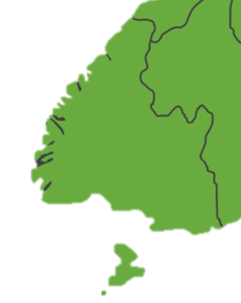
Label Invercargill, Bluff, Stewart Island, Manapouri, Balclutha.

About

Main land uses
Traditional
Current
Future

