Value Chain of Gallagher Products
Introduction
In this report I will discuss the value chain of a selected Gallagher product. Gallagher is a New Zealand company that produces animal management equipment. A large number of their products are to do with fencing tools and equipment, but they also produce weighing tools, farm software, water monitoring technology and many others. (see their product list at https://am.gallagher.com/nz/products). Gallagher employs a number of researchers to continue to develop new products for new markets.
What is a Value Chain?
A value chain is a series of processes of growing a product from raw or undeveloped materials into a product which consumers will pay more for than what it costs to produce. A value chain can be made more efficient by improving one or all of the following 5 stages, Inbound logistics, operations, outbound logistics, marketing and sales, service. A value chain may encompass multiple businesses. The most important member of a value chain is the consumer, who dictates how a product is made. This is difference from a supply chain which is producer orientated and tends to be less efficient and therefore profitable.
Why adding value is important
Profit is absolutely critical to the survival of any business. A business that produces a product needs to add value to that product in some way or another to make a profit. A company like Gallagher aims to manipulate raw materials into a desirable product which consumers will buy at a higher price than what the raw materials, labour, packaging, and transport cost. Farmers will not want to buy the raw materials to make themselves, because they do not have the tools or time. Gallagher knows this, so takes a raw material, e.g. plastic, and forms it into something useful. They will then calculate the total cost of production of the product, including the cost of raw materials, transport, labour, energy, and packaging costs. They will then a wee bit on top which is the profit. The profit is the amount of value added.
How Gallagher can add value through smart packaging
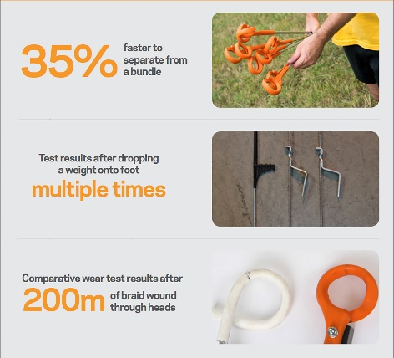
Packaging is a major part of getting a businesses name out into the public. A company needs to promote their brand in order to lift sales, so by packaging their products in a way that shows off their brand name and the unique qualities of their product that makes them more desirable over other similar products. People will always pay more for a superior product, so by packaging it in a way that makes it seem like the dominant product, Gallagher can charge more for it. An example of how Gallagher has used smart packaging is the ring top standard, with it’s packaging/advertising to the right. It shows off the features of Gallagher’s product that make it more desirable than the other similar product (in this case the traditional pigtail standard). If a farmer comes into a store and see’s the standards packaged in this way, they can quickly see what makes that product superior, the tangle-free design, foot strength and abrasion resistant plastic. Simplicity and to the point are key, and Gallagher have nailed this.
Gallagher Value Chain
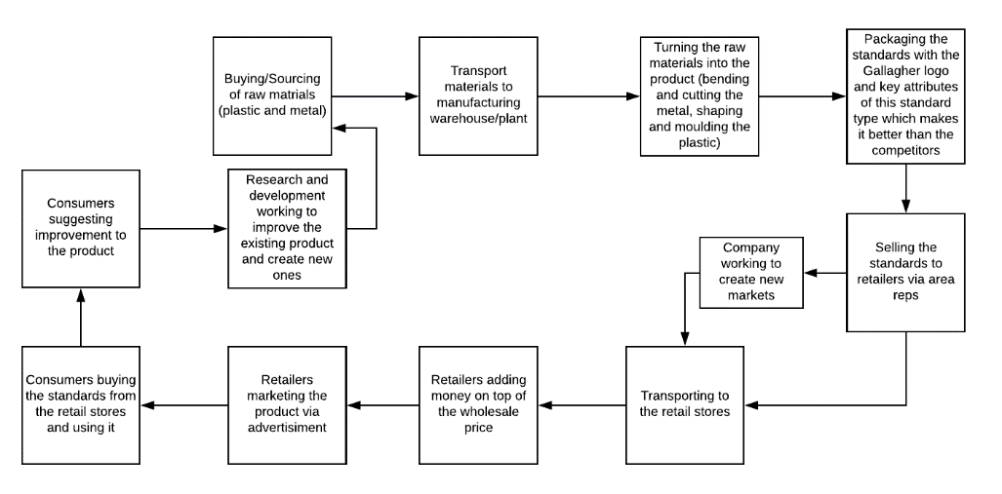
The value chain starts off by Gallagher sourcing and buying in raw materials. This would be plastic, metal etc. These raw materials are sourced as cheaply as possible to increase profit margin/decrease product cost to make the product more competitive.
This is transported to the Gallagher warehouse where it is stored ready to be manufactured. Transport is a cost and no value is added during this stage.
The raw materials are then shaped and combined to create a product that the consumer wants. This is produced on a large scale. In this stage the metal rod is cut to the correct length and bent. The fibreglass-nylon foot and ring is moulded and put on. This is where the main value is added to the product.
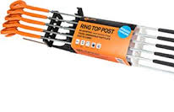
The new product is then packaged in groups of ten with a label wrapped around. It may also be sold in boxes. The label clearly shows the Gallagher logo, and includes some facts/proof that this is a premium product, not just a commodity. Consumers can see this label and associate Gallagher products they see in the future as high quality. This is another stage where value is added to the product.

Gallagher employs area reps to sell their products to the various retailers such as Farmlands or Farmsource. These area reps help to advertise Gallagher’s products, especially the newly developed ones. Gallagher reps also work on creating new markets for their products, such as other farm equipment stores, both in New Zealand and overseas. Price negotiation may occur at this point, another important part of the value added cycle.
Once the quantity and store are worked out, the rep will organise for the products to be transported to the store.
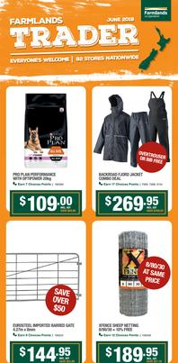
Once the products arrive, the retailers add a bit on top of the wholesale price, adding to the value. Sometimes the retailers will advertise the products in a flier such as the farmlands trader (left) or on their website to increase the knowledge of the product to boost sales.
From the store the consumer comes in or perhaps buys online and the product is shipped to the farmers address. How the farmer’s experience of using the product goes determines whether he buys more of that product or if they go to a competitor’s product. This type of standard was invented due to farmers submitting their frustrations with the old pigtail style standards.
Some consumers will give feedback to the company in a better way of making the product which makes it more user friendly. Consumers may also suggest new products to Gallagher that will fix a problem they are experiencing. This is a vital part of Gallagher’s research and development. The original standards
Product innovation
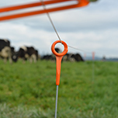
An innovation that occurs during the value chain is research and development. Research and development is fundamental to a growing business. Gallagher needs to keep coming up with new or better products to stay ahead of it’s competitors, and to suit farmers needs. An example of an innovation Gallagher came up with was in 2014, when they created the ring top standard. This fitted the need of dairy and cattle farmers who chose to break feed pasture or crop. The new design came about due to farmers complaining about the traditional pigtail standards getting tangled during transportation. This new design eliminates that as the gap for the wire to slip into the ring is much smaller, so the standards can’t get interlinked nearly as easily. This new design is also made out of different material to the traditional pigtail standard, meaning there is less chance of the livestrand shorting on the standard than the old ones and also making it stronger to put up with abrasion. The foot of the standard is more robust than old standards and again designed in a way that minimises the chances of the standards getting tangled in transportation and storage. These standards come in different sizes as well, higher ones for larger animals such as full-grown cows and bulls and shorter ones for calves.
How value has been added
Value has been added to this product by increasing the usability of the product and increasing its strength. The product started out as glass-fibre nylon and metal, cheap and unusable to the farmer. It was then shaped and moulded into the standard. Because of the innovations that make it better than other types of standards, people view it is as a premium product, and therefore, will pay extra for it. At Farmsource a 10 pack of the traditional pigtail standards costs $33.99. A 10 pack of Gallagher’s new ringtop standards costs $47.99, nearly a whole dollar more expensive per standard [2]. There is more value in the new product than the old one.
How this product fits market needs
As I stated earlier, farmers had been asking Gallagher to create a new type of standard that doesn’t get tangled when transporting and storing [1]. Farmers asked for this product innovation, making it a ‘market need’. This product meets the need and has been praised for doing so, receiving multiple awards, including a highly commended at the NZ Innovators Awards, an international innovation award at the New Zealand Fieldays and a gold award from the Design Institute of New Zealand. This product meets market needs perfectly because it does what farmers asked it to do.
How this innovation affects the value chain
This product has an effect on the whole value chain. Firstly, it effects the sourcing of raw materials because consumers are buying it, so more raw materials have to be purchased to be made into the product to fill the demand. If the type of material being purchased is not already being used in any of Gallagher’s other products, Gallagher will have to get quotes for prices and select the best price. Because there are more raw materials being purchased, there will be an effect on transport needs and costs. The new type of standard will affect the manufacturing process because it will require testing of new production methods in order to figure out the most efficient way possible so that it can be produced at the lowest possible cost. New packaging will have to be designed to show off the new standards qualities that make it so desirable, and to make it easy to handle and transport. The reps will have to alert the stores of the new product, so that they know that it exists and can then stock it. The new product may create opportunities for new markets as it may appeal to different store owners who want to stock it. It will then have to be shipped to the stores. The retailer will add money to the wholesale price of the standards. Because the value of the new product is more than the traditional type, the size of the price increase the store adds on may differ, depending on the stores policy, e.g. if it adds a percent of the wholesale price, or just has a flat rate that it adds on. The retailer may choose to advertise the new product as they know it is an improved product which makes it easier for farmers to do their job. This new product will have an effect on the consumers because it is a better product than what was previously available, so they will buy it. Because the product solves an existing problem, people who have experienced the problem will buy it. Consumers will then suggest new improvement on the new product to continue the product development, affecting the product development part of the value chain.
How this product affects other competing products
This product has an effect on the pigtail standard because it has a more dominant competitor. This may affect the pricing of the pigtail standard as the price will have to be lowered in order to make it more competitive. The company that produces them may try and make the production chain more efficient so the profit margin is higher so they can charge less and still make a profit.
Does this product fit future needs?
I do not think this product fits future needs, but I believe it fits a need for now. This product is something farmers asked for, they wanted something that was stronger and saved time. This has been achieved. The major reason why I think this product fits future needs is because it saves time. Farming is an industry where jobs are never-ending. Any time saved doing one job can be put towards another. I do not believe that this fits future needs as I do not believe that break feeding is going to be allowed in the future. A major push is being made from the public to improve the environmental sustainability of farming. The proposed Southland land and water plan is restricting the amount of stock allowed to be wintered on crop. At this point it states that a maximum of 100ha or 15% of the landholding, whichever the smallest, is allowed to be put into crop. There are other restrictions on the whereabouts of crop paddocks regarding waterways and size of mobs in a paddock. Break feeding is not very environmentally friendly, as the paddock gets turned to porridge, causing soli loss and nutrient runoff. As time goes on and the public becomes more and more conscientious of how their food is produced, I can imagine break feeding being phased out in order to improve environmental sustainability. Wintering barns are also becoming common on dairy farms, as they tend to be the most sustainable way to winter animals. These law changes and other wintering innovations has the possibility of making these standards useless in the future. There is a possibility that farmers will still choose to use electric break fencing in a techno grazing system, however new technology such as Halter’s collar are being developed as new methods of doing this. This new technology eliminates the need for a traditional literal fence, instead replacing them with virtual ones. The collar has a GPS tracker that gives voice controls to the cow when it gets close to a boundary. Farmers would no longer need to break fence with electricity. However, until this technology arrives, I think these standards will fit the farmers needs as it makes electric fencing far more time and efficient, something that farmers like and want. As
- https://am.gallagher.com/global/news-and-events/news/gallagher-ring-top-post-sets-new-standard-in-portable-fencing
- https://store.nzfarmsource.co.nz/store/fencing/electric/standards

