Animal Health
- Importance of animal health
- Classification of diseases
- Symptoms of disease
- Planned approach to animal health
- Vaccination
- Drenching

Signs and symptoms of disease

Importance

- increases production, therefore more animals and or animals products to sell.
- better quality products eg less wool breaks
- reduced deaths
- reduced human illness
- reduced vet costs.

ANIMAL HEALTH

A planned approach to animal health includes
- Vaccination programme
- Drenching programme
- Dipping programme
- Keeping good records of stock management
- Drenching all new stock coming onto a farm
- Keeping new stock separate from others until sure no health problems exist.
- Breed and buy disease resistant stock.
- Buy animals which are not drench resistant
- Quarantine sick animals
- Providing a suitable environment to achieve maximum animal production.
- cleanliness and hygiene are maintained
- NZ quarantine regulations are followed

Describe and explain how the management practices prevent diseases
Predisposing/indirect causes

- bad weather
- poor nutrition
- lameness, injuries
- high level of production
- age
- pregnancy
- hereditary
- sex
- other diseases

Direct causes of disease

- Infectious(fungi, bacteria and viruses)
- Parasitic:
- Metabolic:
- Nutrient deficiencies:

Importance of animal health
There are several reason why farmers need to be concerned about animal health. These include:

- Loss of farm income due to:
1. replacement cost of dead animals.
2. loss of production
3. cost of stopping the disease

- Ill health of the farmer such as:
1. infection from stock
2. stress related to lowered moral because of sick stock.

- Loss of export markets and overseas earnings.

The benefits of good animal health are:
1. Increases production, therefore more animals and or animal’s products to sell.
2. Better quality products eg less wool breaks
3. Reduced deaths
4. Reduced human illness
- Reduced vet costs.

Exercise
- Draw a star diagram to show the importance of animal health.

2. Explain the importance of animal health on farm financial returns.
Classification of diseases

Diseases are usually classified according to the causal agent.

Infectious:
These diseases are contagious and can be passed from one animal to another. They are caused by microorganisms (fungi, bacteria and viruses).
Examples
Fungal diseases: Ringworm, Facial Eczema
Bacterial disease: Footrot, Mastitis, Tetanus
Viral disease: Scabby Mouth, Foot and Mouth, Canine Distemper.

Parasitic:
These diseases are cause from a range on internal and external parasites.
Examples
Internal parasites: roundworms, liver fluke, lungworm, tapeworms, hydatids
External parasites: ticks, lice, fleas, keds, blowfly.

Metabolic:
These diseases upset the normal functions of an animal.
Examples Sleepy sickness, Grass staggers, Milk fever, Bloat

Nutrient deficiencies:
These diseases are caused by a lack of a particular nutrient.
Examples Selenium, Cobalt, Copper, Iron

Exercise
1 Disease can be classified into groups, infectious and non-infectious. Explain the difference.

- List the causes of infectious diseases and give an example of each.

3 List the causes of non-infectious disease and give an example of each.
Causes of ill health
Causes of ill health can be split into two areas. The actual cause and the predisposing cause.

Actual (Direct) causes of ill health include:
1. Injury: cuts, fractures
2. Poisons: ryegrass staggers, ragwort, nitrate toxicity, macrocarpa, chemicals.
3. micro-organisms: fungi, bacteria, viruses
4. Nutrient deficiencies: magnesium, calcium,
5. Parasites: internal and external
6. Metabolic bloat, grass staggers

Predisposing (Indirect) causes
There are many things that make animals more likely to become diseased e.g. under feeding. These factors are called Predisposing causes because they are indirect causes of ill health. These include:
- bad weather
- poor nutrition
- lameness, injuries
- high level of production
- age
- pregnancy
- hereditary
- sex
- other diseases

Exercise
1 Describe the differences between an actual and a predisposing cause of diseases.

2 Draw a star diagram of actual (direct) causes of disease.

3 Draw a star diagram of predisposing (indirect) causes of disease.
Symptoms of disease
Symptoms of a sick animal compared to a healthy animal.
 | Signs of Good Health | Signs of Ill Health
Stance  Skin/Coat  Eyes  Nose  Ears  Appetite  Dung  Movement  Behaviour  Respiratory  system | - stands well and normally  - alert with head erect.  - clear, shinny  - bright, glistening and bold  - alert and watching  - cool  - moist  - erect, listening to sounds  - turns ears and head to follow source of sounds  - interested in food  - good appetite  - firm  - or soft, dung but holds together | - lethargic  - stands abnormally, unnatural, looks uneasy  - if lying down appears uncomfortable may be cast.  - Dull  - swelling or wounds  - sunken and dull  - or widely excited and alarmed.  - dry  - swelling or wounds  - not interested in sounds  - or alarmed and over -reacts  - poor  - or not eating  - diarrhoea  - or staining as if constipated  -unco-ordinated, loses balance reluctant to move  - falls down easily, collapse  - wanders in circles  - trembles and has fits  - stands apart from flock/herd  - lags behind when moved  - surroundings of no interest  - breathing not natural- laboured and heavy  - may have a discharge from nose.  - may be coughing or sneezing

A planned approach to animal health

To prevent diseases farmers need to develop and use a planned animal health programme. A planned animal health programme aims to produce a high quantity of quality products economically.

Prevention is better than cure because there are
- Less losses
- Less animals affected
- More quality products produced
- Less costs involved in prevention than treatment
- Less stress on farmers
- Better labour management
- Planned sale dates can be achieved

A planned approach to animal health includes
- Vaccination programme
- Drenching programme
- Dipping programme
- Keeping good records of stock management
- Drenching all new stock coming onto a farm
- Keeping new stock separate from others until sure no health problems exist.
- Breed and buy disease resistant stock.
- Buy animals which are not drench resistant
- Quarantine sick animals
- Providing a suitable environment to achieve maximum animal production.
- cleanliness and hygiene are maintained
- NZ quarantine regulations are followed

Exercise
- For four of the above, explain how they would help prevent animal diseases?

- Draw a star diagram to show eight management practices a farmer can use in a planned animal health programme.

3 Rearing calves is important to produce productive adult animals. Describe four management practices you recommend calf rearers use to ensure they produce quality animals.

Vaccination

Animals may be vaccinated to protect them from some diseases. A vaccination is an injection of substances, which produces immunity or resistance to disease.

Steps involved in vaccinating.
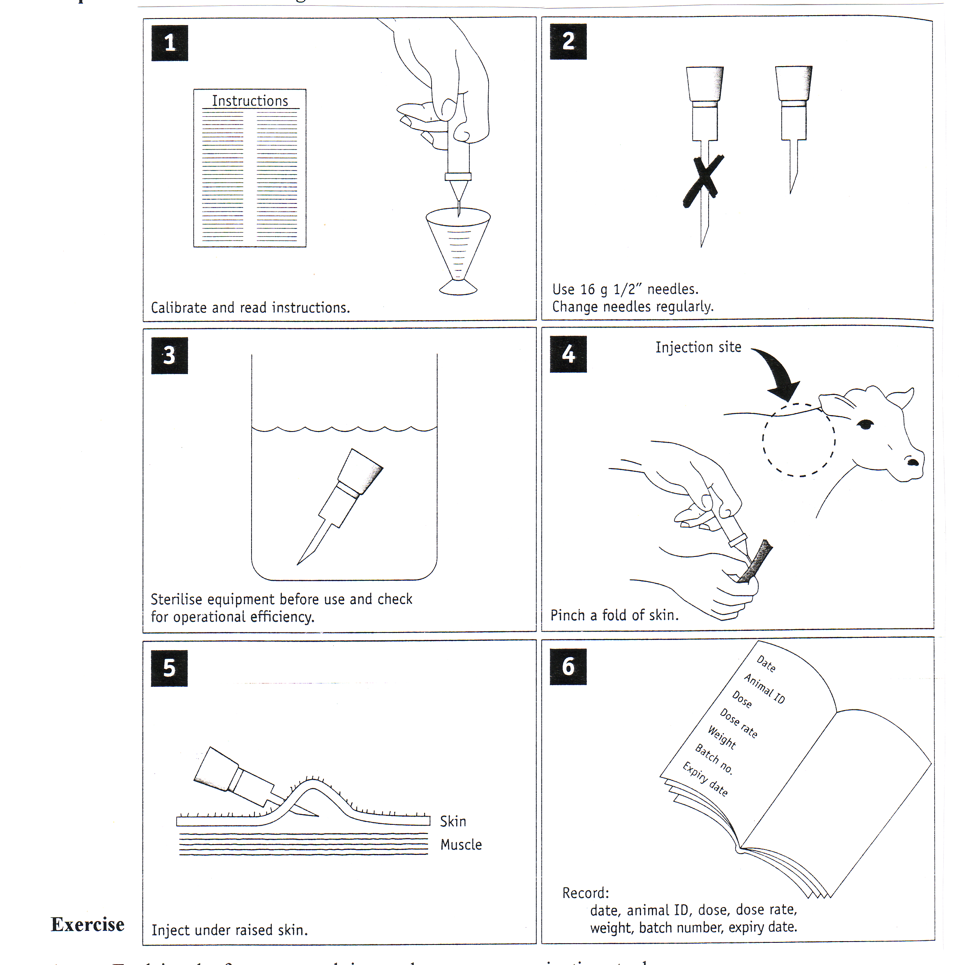

Exercise
- Explain why farmers spend time and money on vaccinating stock?

- Describe the steps involved in vaccinating stock and explain why each step is carried out?
Vaccination Programme

Common diseases sheep vaccinated against
- Pulpy kidney
- Tetanus
- Blackleg
- Malignant oedema
- Black disease

Jan | Feb | Mar | Apr | May | June | July | Aug | Sept | Oct | Nov | Dec
 | Sensitise and boost hoggets. this begins year round protection  Sensitise unvaccinated two-tooth ewe replacements |  |  |  |  | Booster vaccinate for ewes and two-tooths, 2-4 weeks prior to lambing |  | Lambs protected by colostrum for up to 12 weeks after lambing

Note:
- When ewes receive two vaccinations as hoggets they do not need to be vaccinated again until pre-lamb as two-tooths.
- When ewes receive only a single vaccination as a hogget, they should receive a further sensitizing dose pre-tup as a two-tooth and a pre-lamb booster.

Exercise

- What is meant by a sensitising vaccination?

- What is meant by a booster vaccination?

- In sheep, which group should be given a sensitizing vaccination and when should it be given?

- Explain why ewes are given a booster vaccination in July or August?

- List five disease sheep should be vaccinated against.

Drenching
Internal parasites may be controlled by drenching, which is chemical substance given to animals to kill the parasites. The drench is usually administered orally, that is, by the mouth.

Steps involved in drenching

Exercise
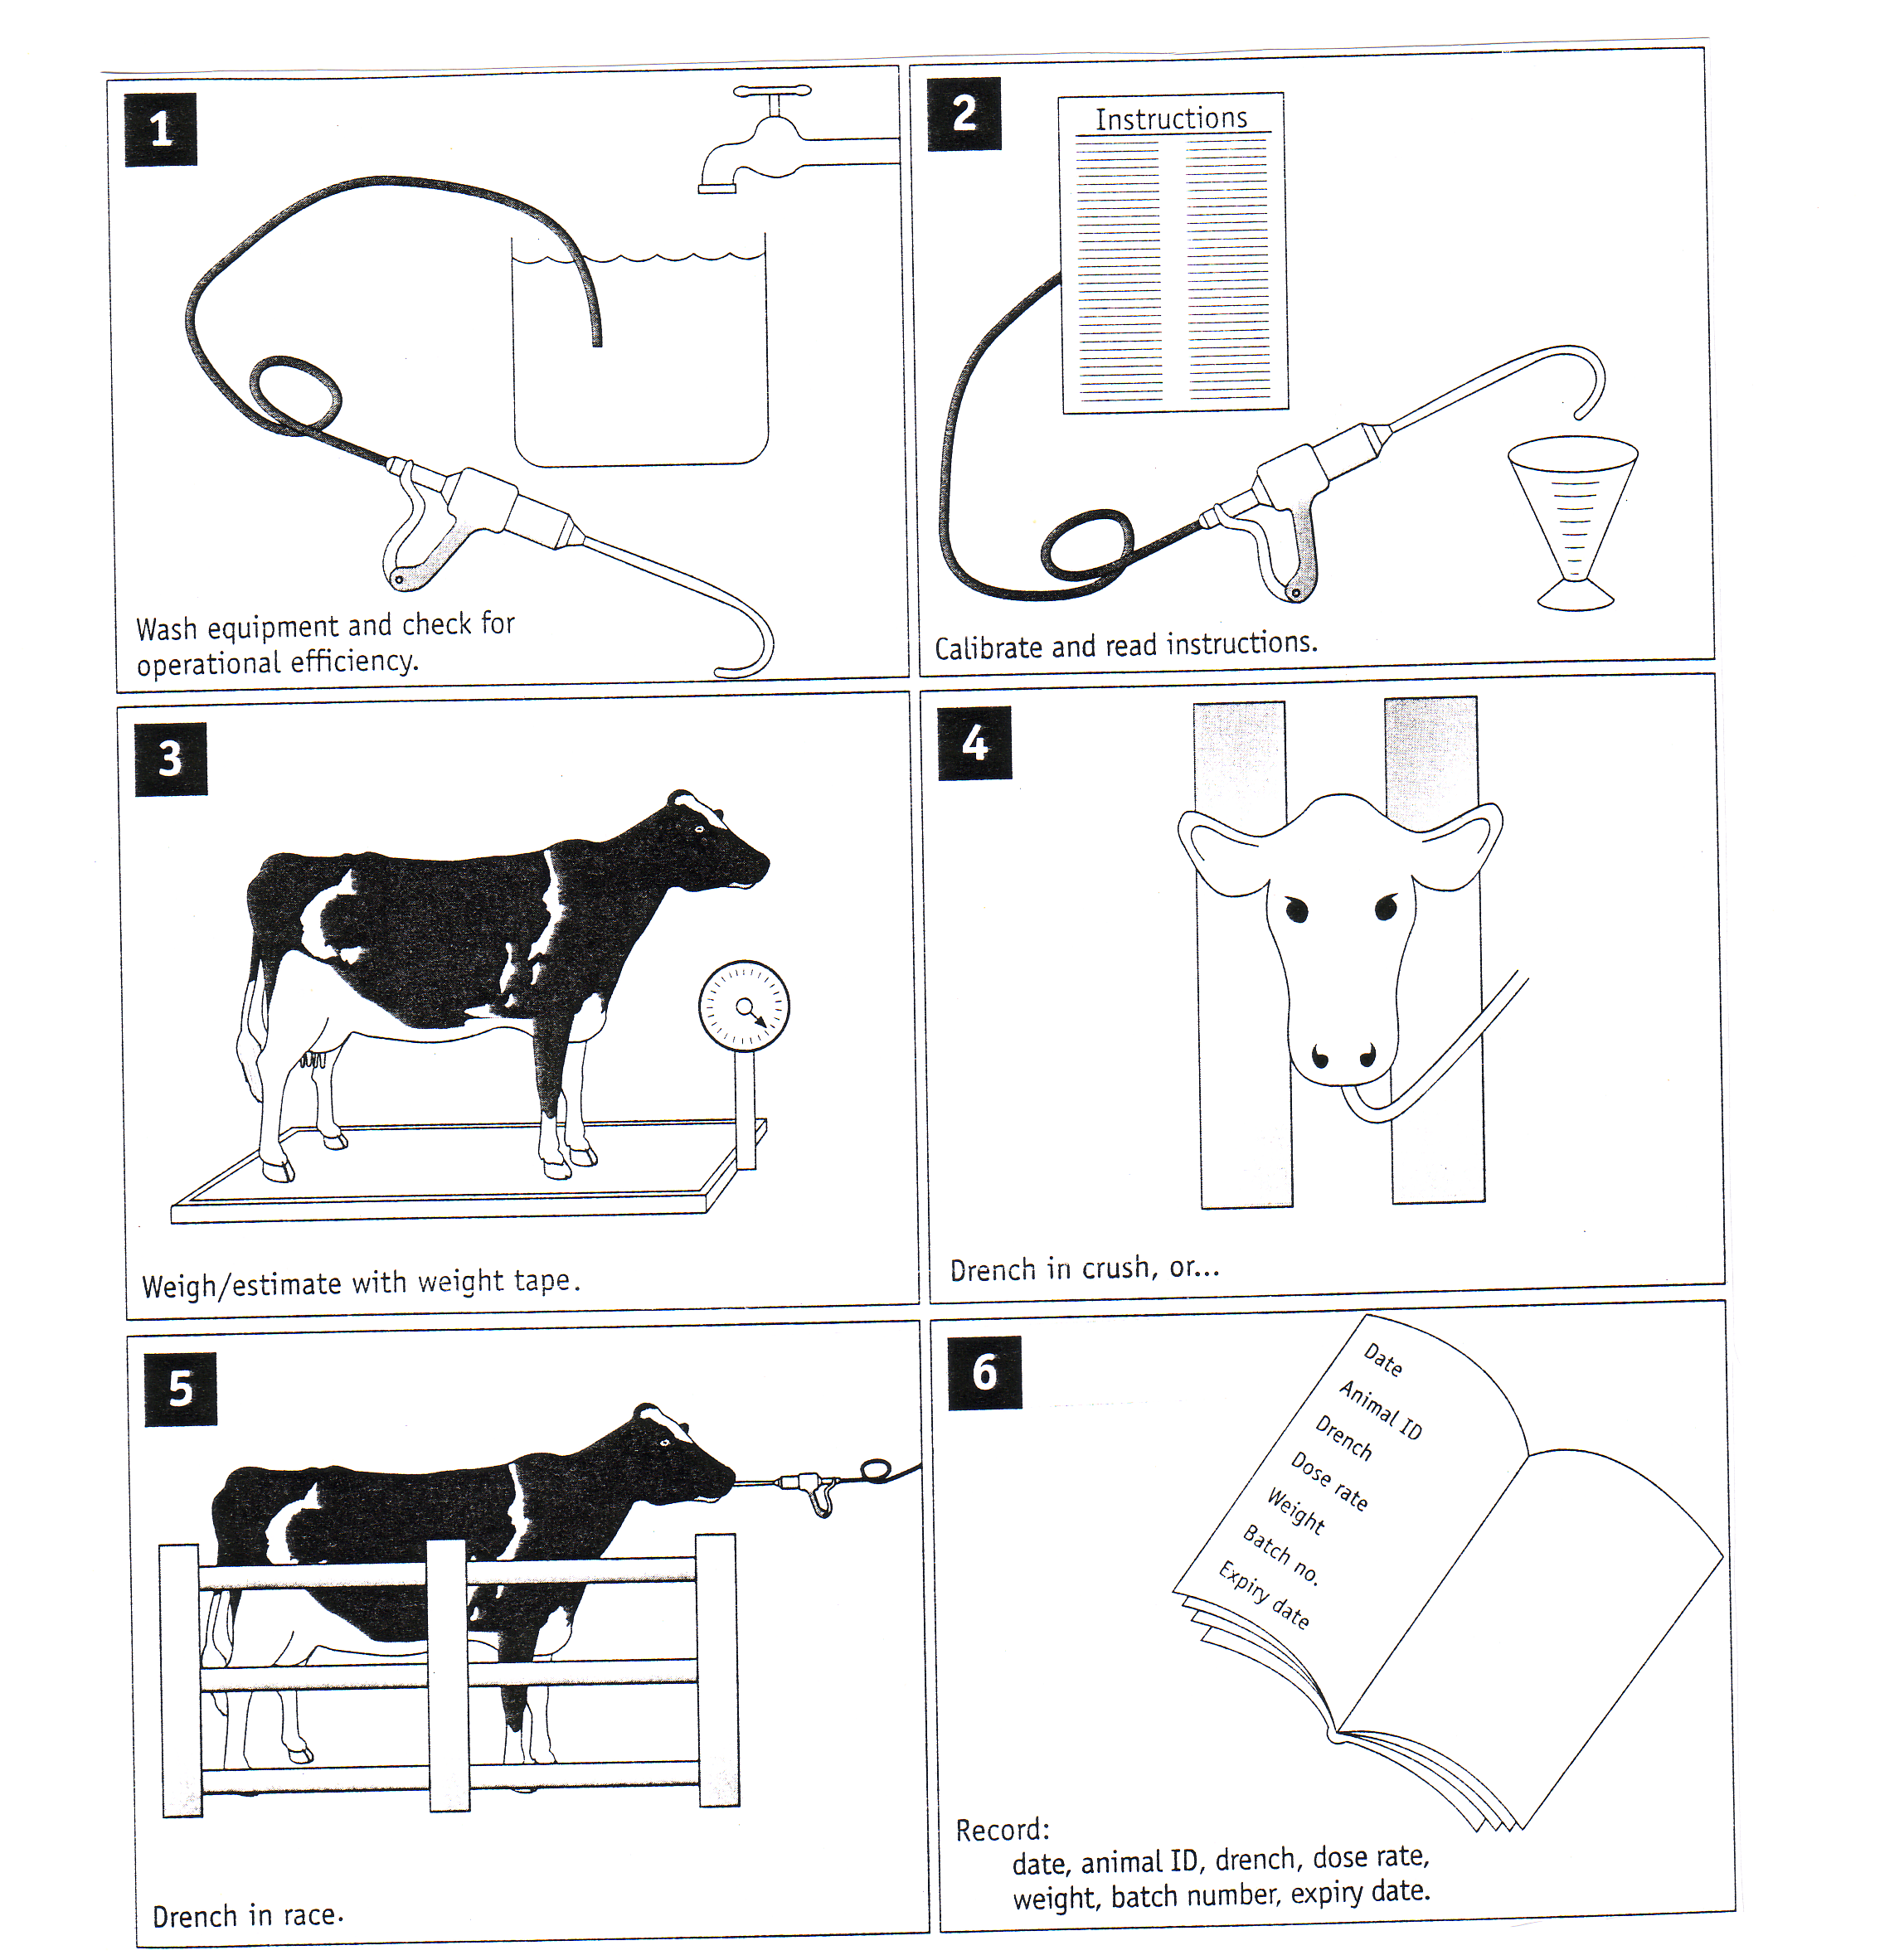

Read the information and answer the following questions

1 List the management don’ts concerning drenching.

2 Explain why each don’t is important?

Describe how to drench sheep and cattle?

Explain how drenching stock affects farm production?

Explain how a farmer would check for drench resistance?

Describe what is meant by a safe pasture?

Describe management practices a farmer can use to provide safe pasture for young stock.

8 Explain how safe pasture improves financial returns?

Other methods used to control Internal Parasites

Drench resistance cost farmers 20m per year on top of 300m annual cost of internal parasites in lost production and drench use. Therefore understanding how to use different methods to control internal parasites is critical.

Internal parasites can be controlled not only by oral drenches but by pour on and controlled release capsule.

Exercise

Using the information on the diagrams above as well as your own knowledge to answer the following questions.

1 Describe how to drench cattle and sheep using a controlled release capsule?

2 Describe how to use pour on drenches on cattle to ensure they control internal parasites?

3 Discuss advantages and disadvantages of 100 day controlled release capsules to control internal parasites.

4 Discuss the advantages and disadvantages of oral drenches compared with 100 capsules to control internal parasites.

Mastitis
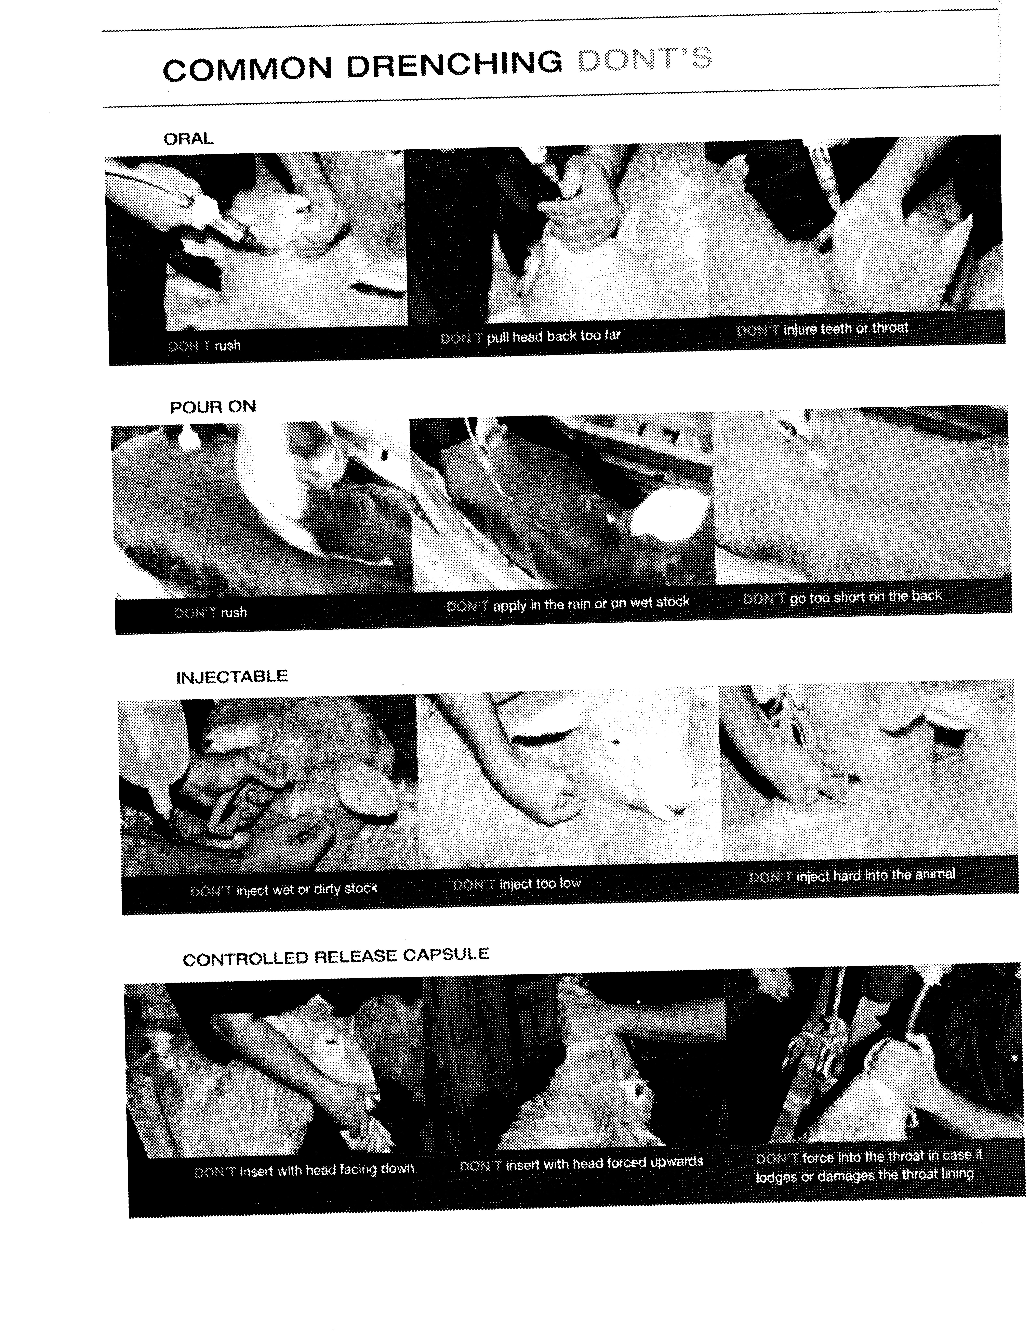
Cause of mastitis
Mastitis is caused by bacteria entering the udder and causing an infection.

Predisposing cause
Environmental:
Wet muddy areas and races soiling the udder, and producing cracks and sores on the teats. These cracks and sores harbour bacteria, which can easily enter the udder when dirty teats are washed.

Rough Handling
Can cause injury to the udder be being knocked. Rough handling can also cause cups to be kicked off during milking, as well as causing cows not to let their milk down.

Poor Milking Techniques
These include over milking, removing caps roughly, and cross infection through not milking mastitis cows last.

Faulty Milking Machines
Milking machines that are not operating efficiently can damage the ends of teats allowing bacteria to enter.

Stress
Any stress is predisposing cause. For example – poor feeding, rapid change in diet, and cold weather.

Hygiene
With dirty cups, hoses, aprons and other surroundings, bacteria are easily transferred to cow’s teats via the milker’s hands.

Symptoms
If the signs of mastitis are clearly visible to the milker, the disease is called clinical mastitis.
If there are no visible signs of the disease but it is known to be present, then the disease is called subclinical mastitis.
- The symptoms of clinical mastitis are:
- swelling, hardening or high temperature
- clots, blood or other abnormalities in the milk

- Subclinical mastitis can be detected only by use of one or more special tests on the milk. The most common one is testing the mix for somatic cell counts. These can be thought of as white cell counts:

White cells in the body rush to sites of infection. In the udder these white cells enter the milk and measurement of the number of these sells give an indication of the degree of infection in the udder.

Treatment
When mastitis is detected in a cow, it is usually in one or two quarters of the udder only. The steps in treatment are:

- Affected cow(s) should be drafted out and milked last to prevent cross infection via the milking machines.
- The milk from the infected quarter(s) should be milked into a bucket and discarded.

Exercise

Using the resource material provided on mastitis

1. Name the causal agent.

2. List the predisposing causes.

3. List the symptoms common to mastitis.

4, Explain how you would treat this disease?

5. Explain methods used to prevent mastitis.

6. Explain its economic importance.

