Beef Cattle Breed Chart –

Important Breeds

of Beef Cattle in

New Zealand

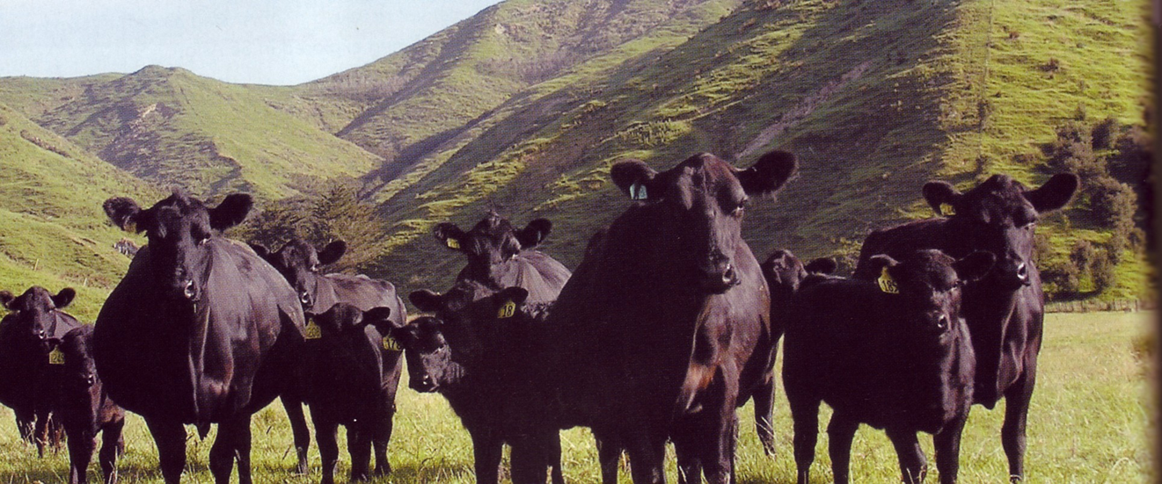

Fill in the relevant information from the PowerPoint

Angus
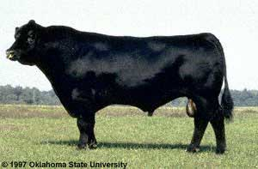

Distinguishing Characteristics: polled, cold tolerant, good mothering & milking ability, calving ease, high fertility, excellent carcass quality (small bones, high muscling, good marbling)

Introduction to NZ.

Origin: Scotland

Colour Pattern: Black

Insert picture here

Origin:

Colour Pattern:
Distinguishing Characteristics:

Insert picture here

Colour Pattern:
Origin:

Distinguishing Characteristics:

Insert picture here

Colour Pattern:
Distinguishing Characteristics:

Origin:

Colour Pattern:
Origin:

Insert picture here

Distinguishing Characteristics:

Insert picture here

Colour Pattern:
Origin:

Distinguishing Characteristics:

Introduction to NZ.

Insert picture here
Distinguishing Characteristics:

Colour Pattern:
Origin:

Insert picture here

Colour Pattern:
Origin:

Distinguishing Characteristics:

Insert picture here

Colour Pattern:
Origin:

Distinguishing Characteristics:

Insert picture here

Colour Pattern:
Distinguishing Characteristics:

Origin:

Insert picture here

Distinguishing Characteristics:

Colour Pattern:
Origin:

Insert picture here

Colour Pattern:
Origin:

Distinguishing Characteristics:

Insert picture here

Colour Pattern:
Origin:

Distinguishing Characteristics:

Insert picture here

Colour Pattern:
Distinguishing Characteristics:

Origin:

