- How animals will be obtained/collected.

Chickens will be collected from Invercargill airport, flown from the Tegal Hatchery in New Plymouth when they are 1 day old, and they are available for collection (sometime in Term 1) by the Agriculture teacher(s).

- How animals will be transported.

They will be transported from the Airport to Māruawai College (Gore) in a cardboard box to create a dark environment, which will reduce stress for the chicks during the transportation process. Trip should take about 1hour

- How animals will be contained/caged.

For purposes of the investigation, chicks will be split into three groups of ten, and kept in these trial groups for the entire of the practical investigation. Each of the three groups of chicks will be housed in large, lined boxes, under heat pads in a shed during the initial stages of the trial. The lining/bedding (made up newspaper on the base and shavings) will be changed daily.

Once the chicks are large enough to go outside, they will be stored in chicken coops in the orchard area of the horticulture plot. These coops will be moved regularly, to provide them with fresh ground/soil regularly. The chicken coops will contain an enclosed area to provide the chicks with shelter and netting to ensure they remain in a certain area.

This assessment will be undertaken during the summer months of Term 1. The temperature should be warm enough outside once they transition to prevent the animals becoming too cold, however teachers will have to be careful that the animals do not get to hot under the heat lamps, and that they are provided with plenty of water.

- How investigations will be carried out.

Students will only be investigating the changes in weight of the chickens over time.

Chicks will be divided into three groups of 10 chicks at the beginning of the investigation.
Chickens will be feed ad-lib and have both feed and water topped up daily.

Students will have to come up with their own method of doing this during the planning stage of their investigation. Students will be required to handle the chicks in order to weigh them but will be taught correct handling procedure. Chickens will be placed on the scales by the students and the weights recorded. As the chickens grow, a way of keeping the chicks stationary may need to be incorporated into the method.

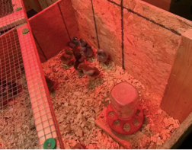
Housing
There will be three sizes of accommodation:
*Day one to three 40 X 50 cm allowing them to settle before introduced
to students (recommendation is about .05sq m/ chick )

*Day four to fourteen 140 X 50 cm (recommendation is about0.05 to .09sq m/ chick )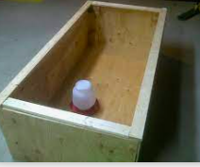

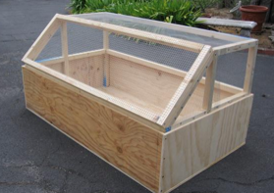
*Day 14 to twenty-eight 2m x .75m A small chicken
coup (recommendation is about .09sq m/ chicken)

Equipment

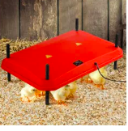
Heat pad with adjustable legs for use with all three units up until day 21, adjusted as they grow. Set at 8cm to start then raising to a maximum of 60cm by day 28 day.
Three of these, one for each group

1L drinker ( Coxiprol will be introduced to control coccidiosis) Three of these, one for each group. This will be changed to a larger size as chicks grow in size

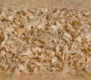
Untreated wood shaving to be replaced at regularly intervals. Three of these, one for each group

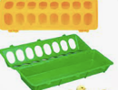
16 hole adlib feeder – checked every day and refilled . Three of these, one for each group
Again feeder will be changed as chicks get bigger

Feed
Main purpose of this investigation, three different chick starters with different protein percentages will be used. Every day the feed will be checked, chicks will have adlib food available. All feeds are a crumble nature and will not change until they are getting closer to pullet age. Then pellet feed will uniformly be feed.
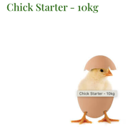
By golden grains 20%

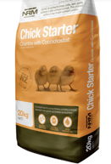
19%

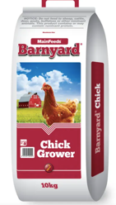

18.5%

Risks to the health or well-being of the animals as a result of the investigations will be identified.
AND
How risks to the health or well-being of the animals will be minimized or avoided.

Risks to the chicks are very low. Potential incidents could include:
- Natural deaths (unpreventable)
- Chicks being dropped by the students: accidental, but will be minimized by showing correct handling techniques, such as holding animals in both hand and staying low to the ground when they are being held. Students who are in the classes during other hours and not part of the investigation will only be allowed to interact with the chicks if allowed, and monitored by their teacher. All classes will be instructed on correct use/care of the chicks.
- Malnutrition/starvation: Chicks will be constantly monitored and checked daily by the year 12 agriculture students. Teachers will oversee the planning of the investigation to ensure that all chicks are receiving enough food to meet their daily requirements. Teachers will also monitor the feeding process to ensure that students are providing sufficient nutrition to all animals.
- Intentional Harm. With the school being a public place, and many students coming into contact with the chickens there is no way to guarantee that someone from within or outside the school won’t harm the chicks intentionally outside school hours. When the chicks are young, they will be housed in the classrooms. Both the blocks, and the classrooms are locked outside school hours. When the chicks are outside they will be housed in the horticulture plot. There is a locked gate (with barbed wire) separating the chicken coops and the outside of the school.

- How animals will be cared for, including housing, feeding, cleaning and weekend care.

Students will be responsible for feeding the chickens during the school week.

As stated previously, chicks will be housed inside while they are young, under heat pads to ensure that they are provided with sufficient warmth. Fresh water and food will be available to them at all times. Once they are ready to transition outside they will be housed in purpose-built chicken coops in the school horticulture plots. They will have an enclosed area to ensure they are provided with sufficient shelter and will be moved regularly to give them access to fresh ground/soil.

The area the chicks are being kept is under security camera, and all housed and covered with mesh(not open to predators) at all stages of their raising

During the weekend/holiday times a roster is drawn up with students and parents ( all have experience with poultry- one a poultry farmer( who is also on-call as help) will be responsible for feeding the chickens daily and cleaning out their cages.

How will chicks be handled?
Chicks will not be handled in the first three days by students, and then only once a week.

The best way to pick up a chick is to circle its body with your hand, your fingers loosely around the underside of its body and your thumb across its back, holding the wings in place, or by scooping the chick up from underneath, gently cradling its belly in one hand and placing your other hand over its back.
The method will be gone over with students and instruction clearly noted on wall of brooder room.

- How you will care for any animals that become unwell or distressed.

Seek veterinarian advice. Veterinarian are readily available

Animals that do not improve ( due to disease or injury- and are not improving and to protect the other chicks) will be euthanized humanly. This will be carried out by a vet

- How animals will be dealt with at the end of the investigation e.g. kept in or returned to their original environment, returned to a similar environment, (please explain where) or kept else where (please explain where). If the animals need to be killed at the end of the project, explain why this is necessary, how this will be done humanely, and who will undertake it and what experience have they with the procedure.

All chickens at the end of this investigation will be sold on to staff or parents, at point of lay (16 weeks of age) One reason we are using an egg-laying breed of chicken rather than meat chickens is so that more staff/parents would be willing to take chickens for their own farms/properties.
We do as a back-up have a farm that will be able to take all 30 chickens if necessary

- How has your investigation design considered the ‘three Rs’?

In terms of reduction, using fewer animals, 10 chicks per trail or 30 chicks all ups is really the smallest number, to gain any statistical significance. So using less than this number would make it less valid. The experimental design, especially the brooders will be designed so that individually the chicks will not suffer for space, warmth, food or water, and be able to behave in normal ways.

The chicks should not experience any level of pain as a result of this assessment. But students will be taught correct handling techniques by their teachers, and the time spent being picked up and moved will be kept to a minimum to reduce any stress, or harm on the animals. It will also be ensured that all three trials are receiving enough food to grow, and carry out maintenance functions to reduce stress, or pain, from malnutrition. All animals will be housed in a warm environment when young, and once outside will have access to shelter.

Practical investigations are an importance aspect of agriculture as it provides the students with an opportunity to learn, and use practical skills. In agriculture, there are very few experiments that are not animals based, and therefore don’t require animals. Other options for practical investigations include aspects of plant/pasture growth, or looking at irrigation but they do not provide the same level of interest for the students, nor do they teach them animal handling/care skills. This is a relatively low risk investigation, and the number of deaths or harm to the animals should be low, if not non-existent.

