Farming in New Zealand.

- Walk around the different posters, collecting three bits of information
on

- Mixed Hill Country Farming
1.
2.
3.

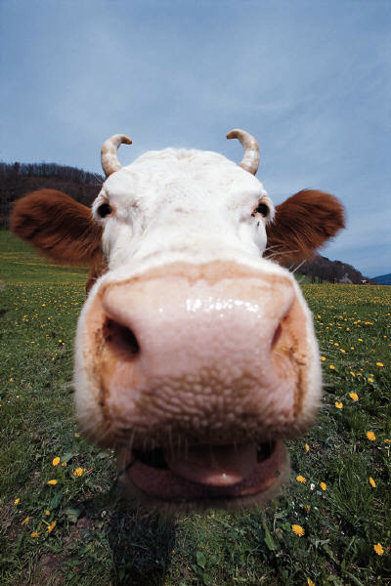
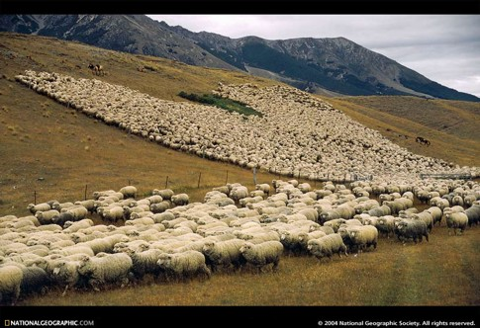
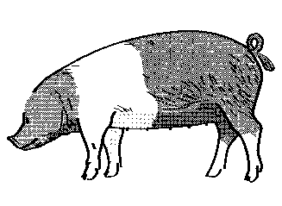
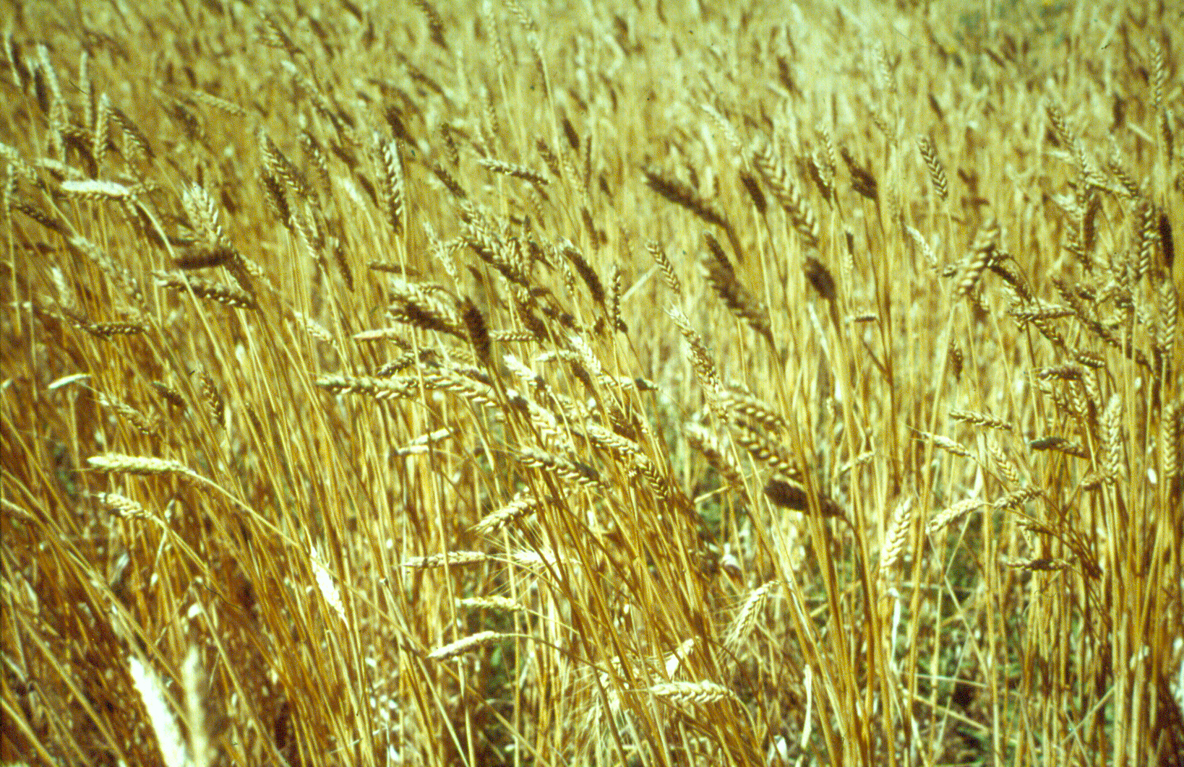
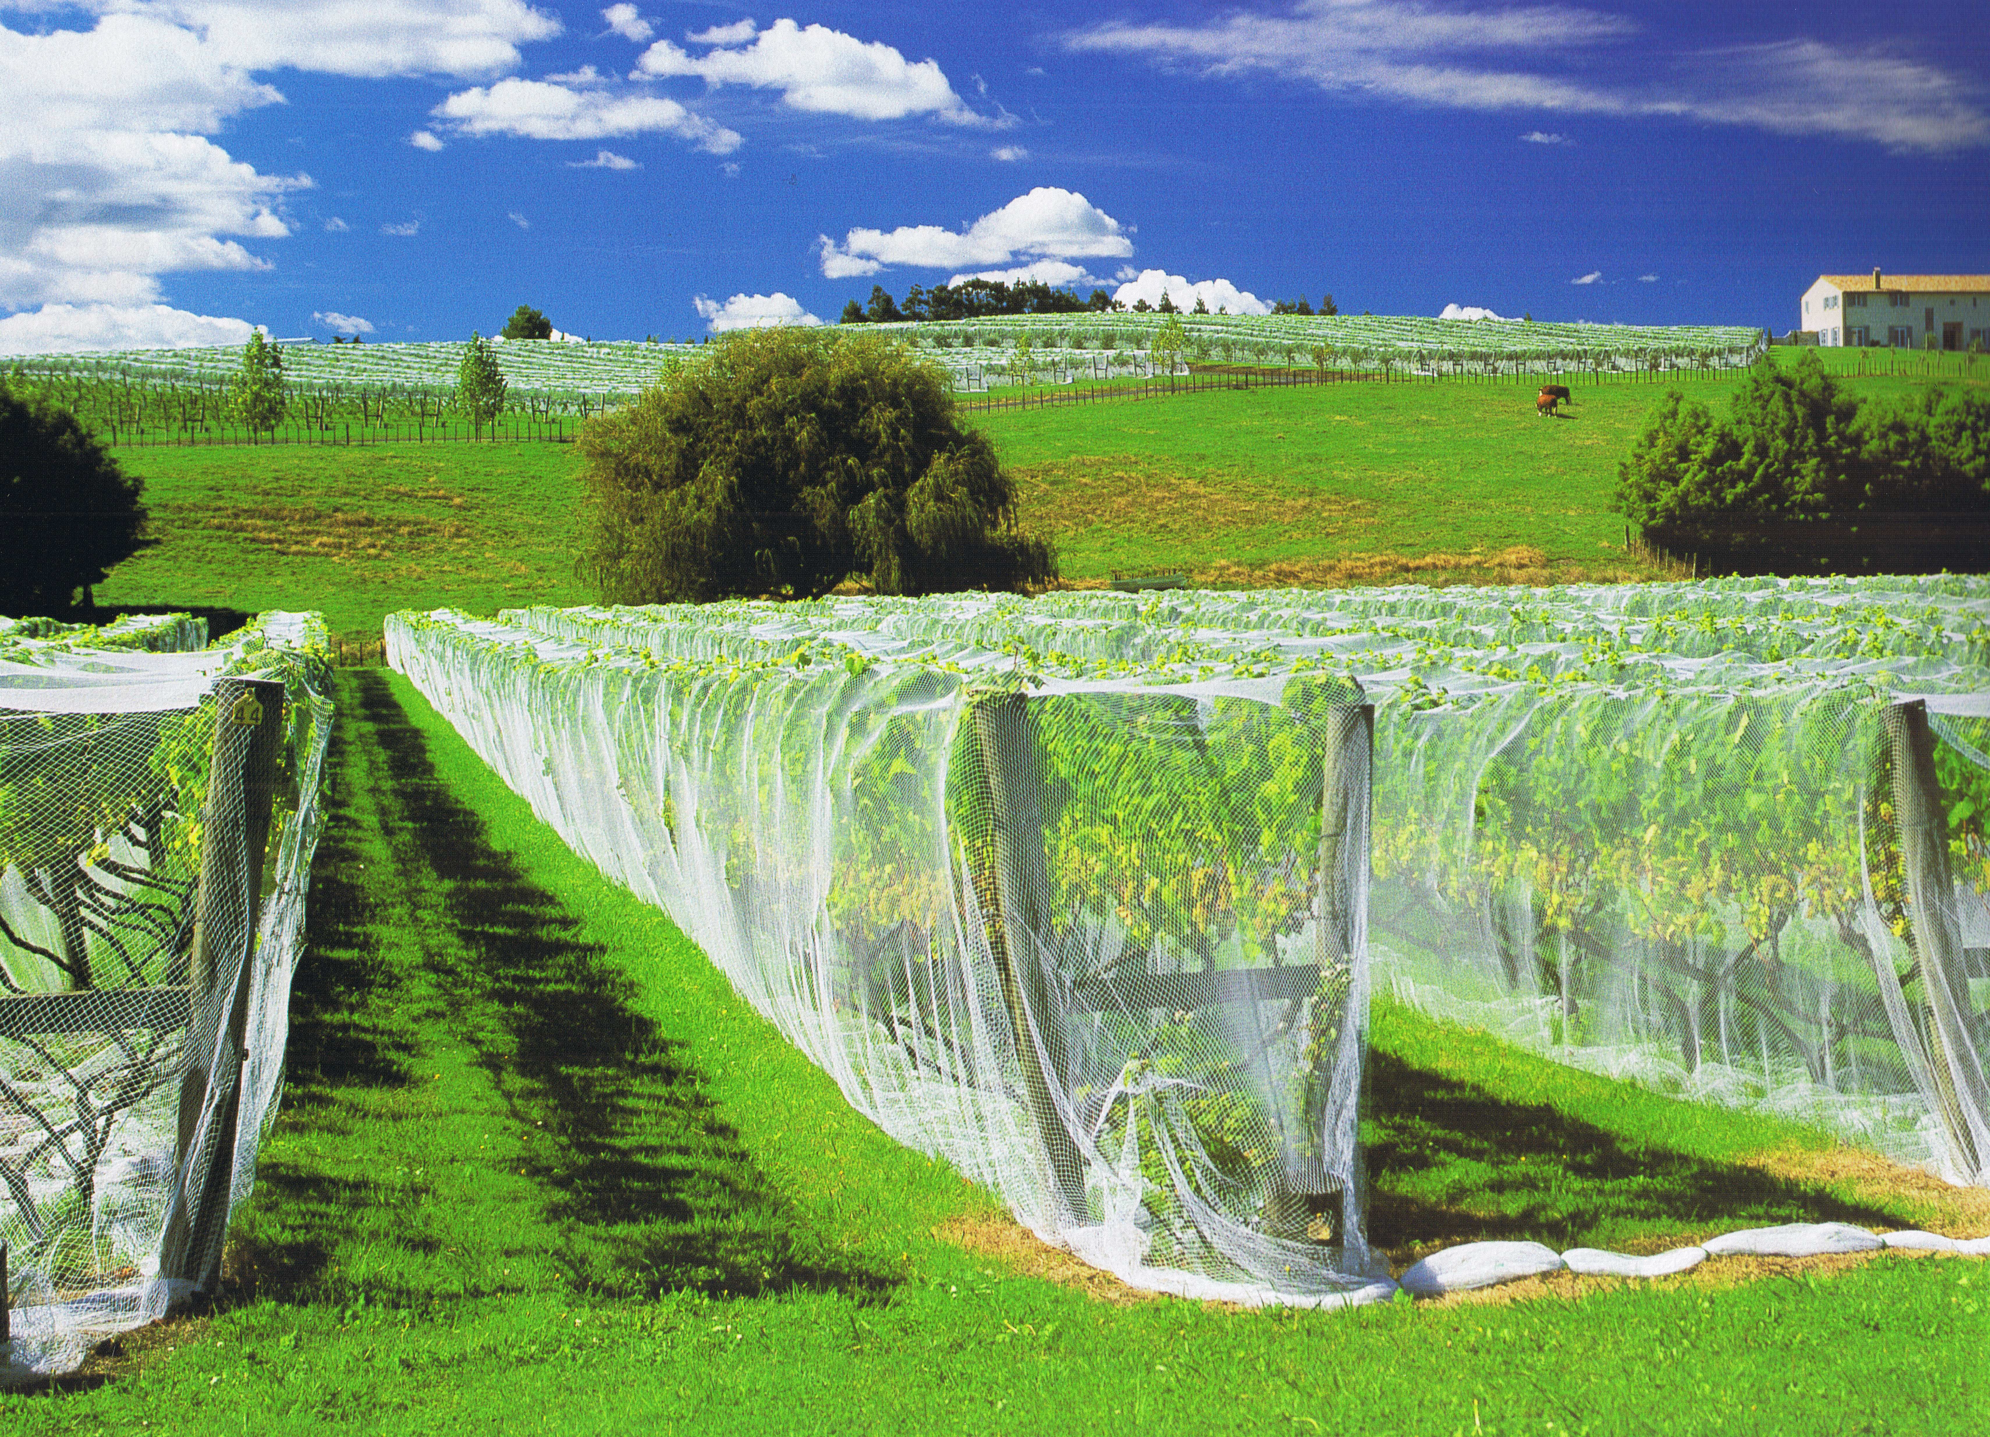
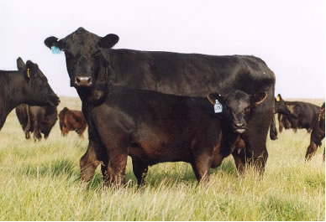
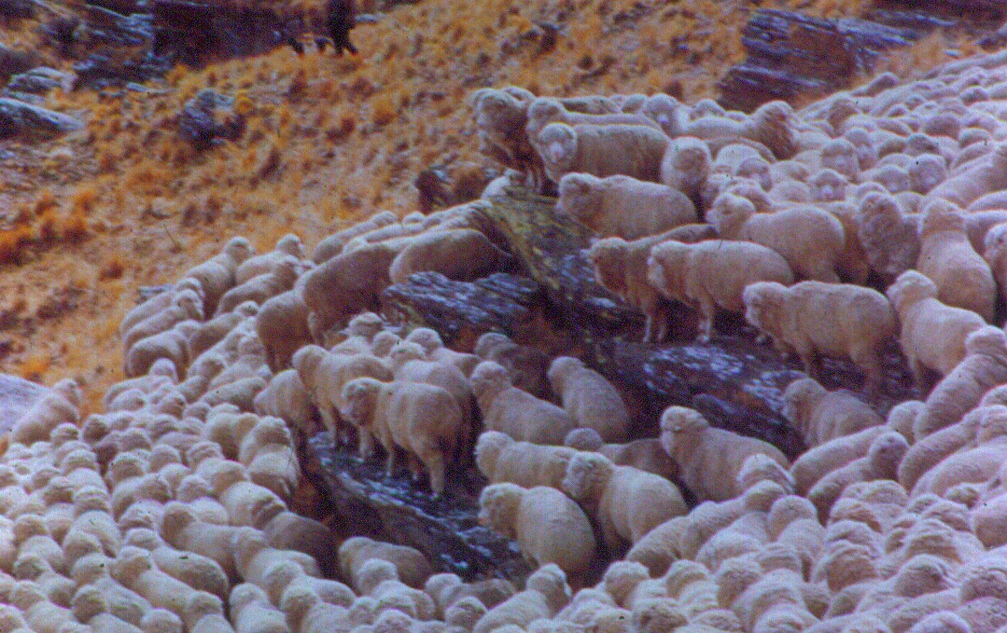
- Intensive Pig Farming
1.
2.
3.

- High Country farming
1.
2.
3.

- Mixed Arable farming
1.
2.
3.

- Dairy farming
1.
2.
3.

- Orcharding
1.
2.
3.

