Name:

Objective: To use your knowledge of Irrigation techniques to answer problems found on farms.

Irrigation systems.

Task 1.
For each of the examples below, use your notes and your groups ideas to -

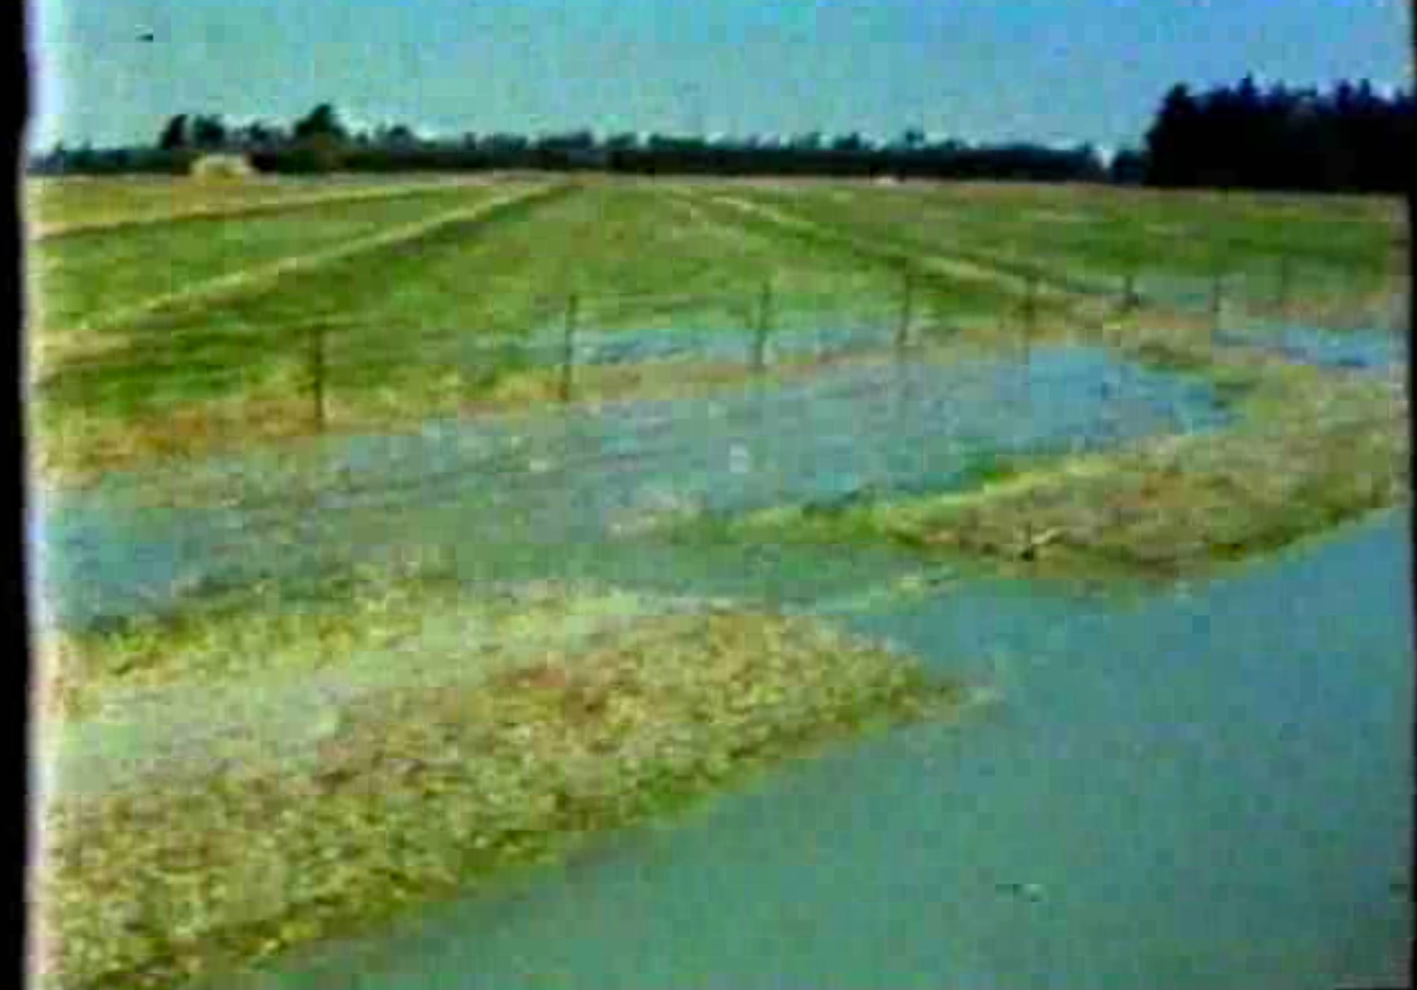
Border dyke
Describe one advantage of this system
Describe one disadvantage of this system

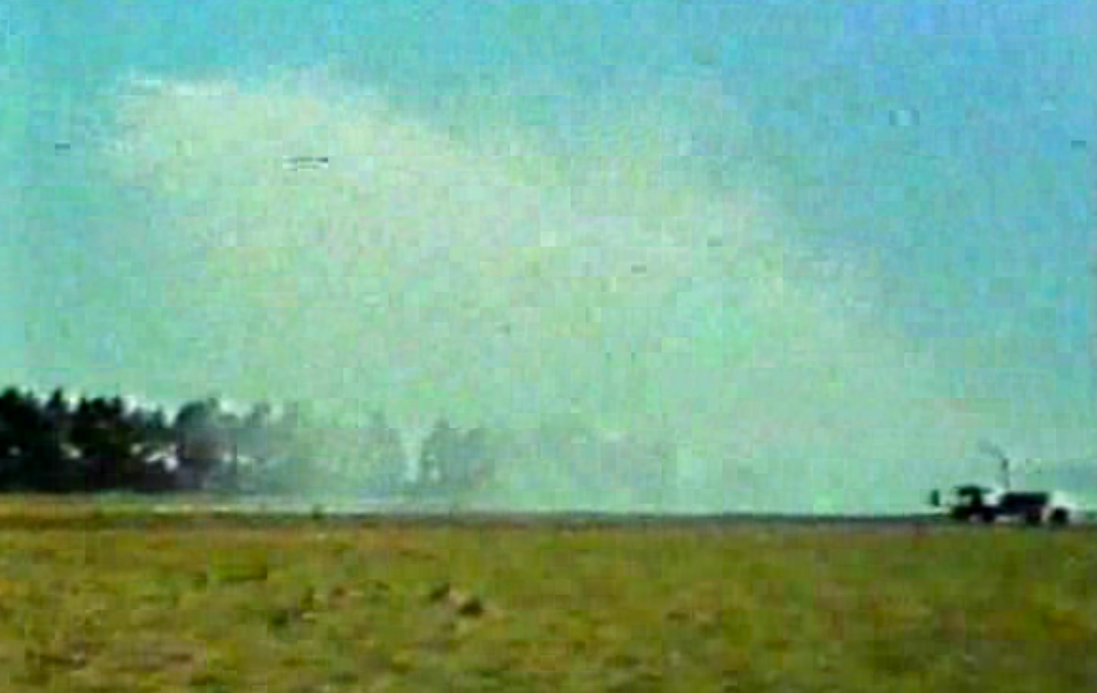
Rain Gun
Describe one advantage of this system
Describe one disadvantage of this system

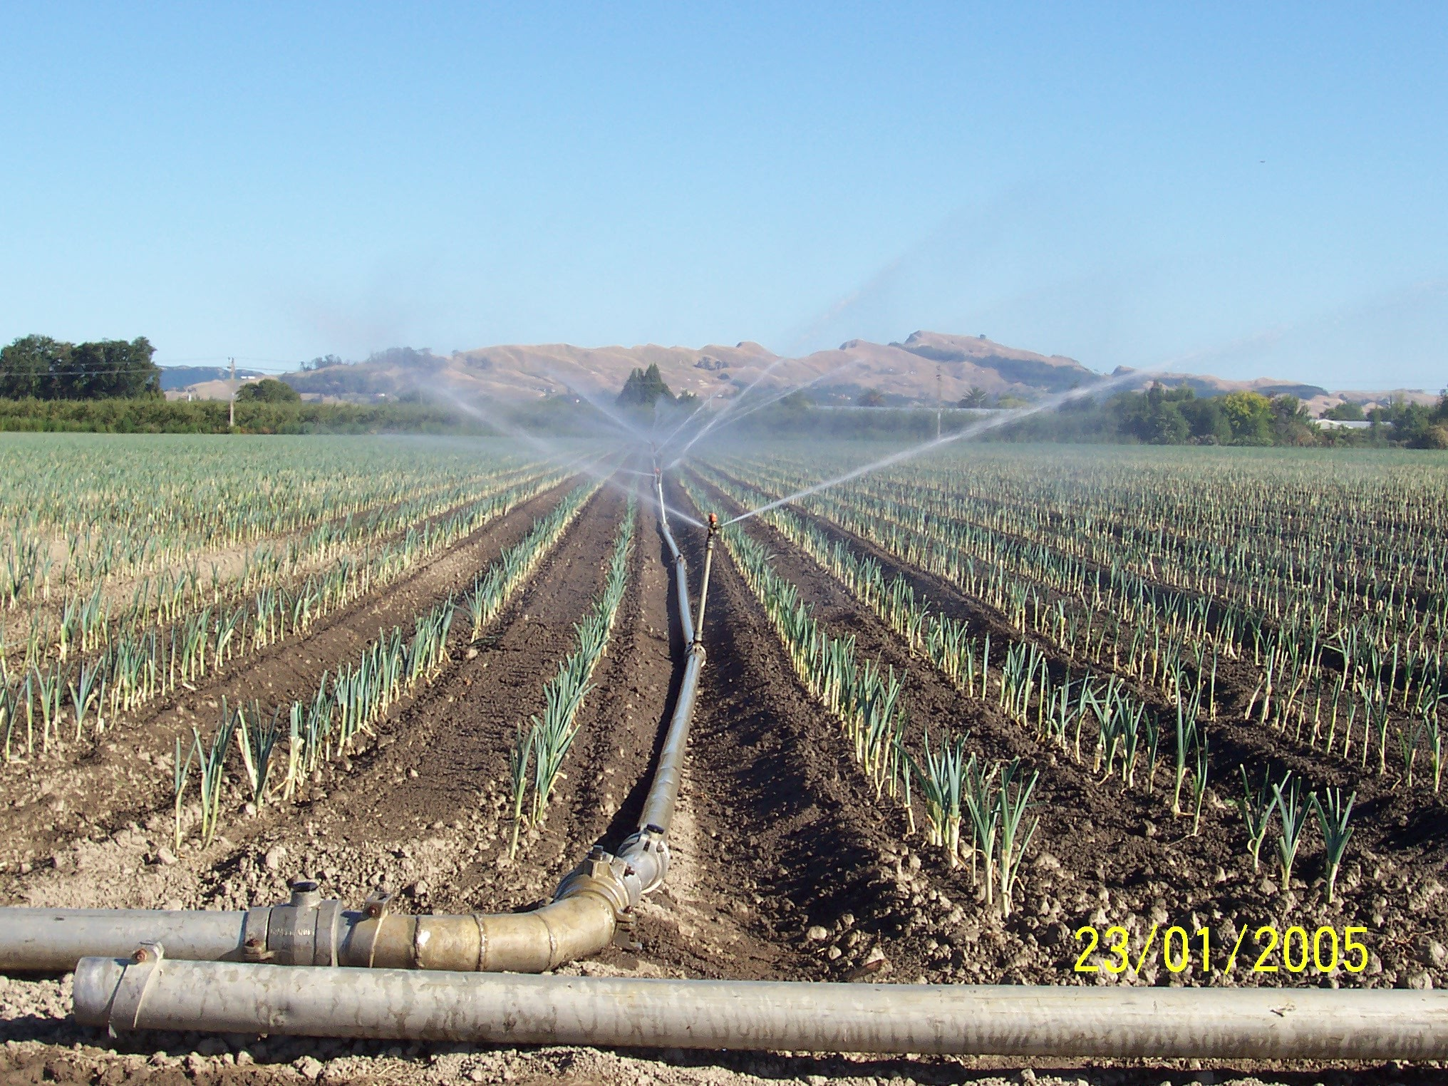
Pipe and Sprinkler
Describe one advantage of this system
Describe one disadvantage of this system

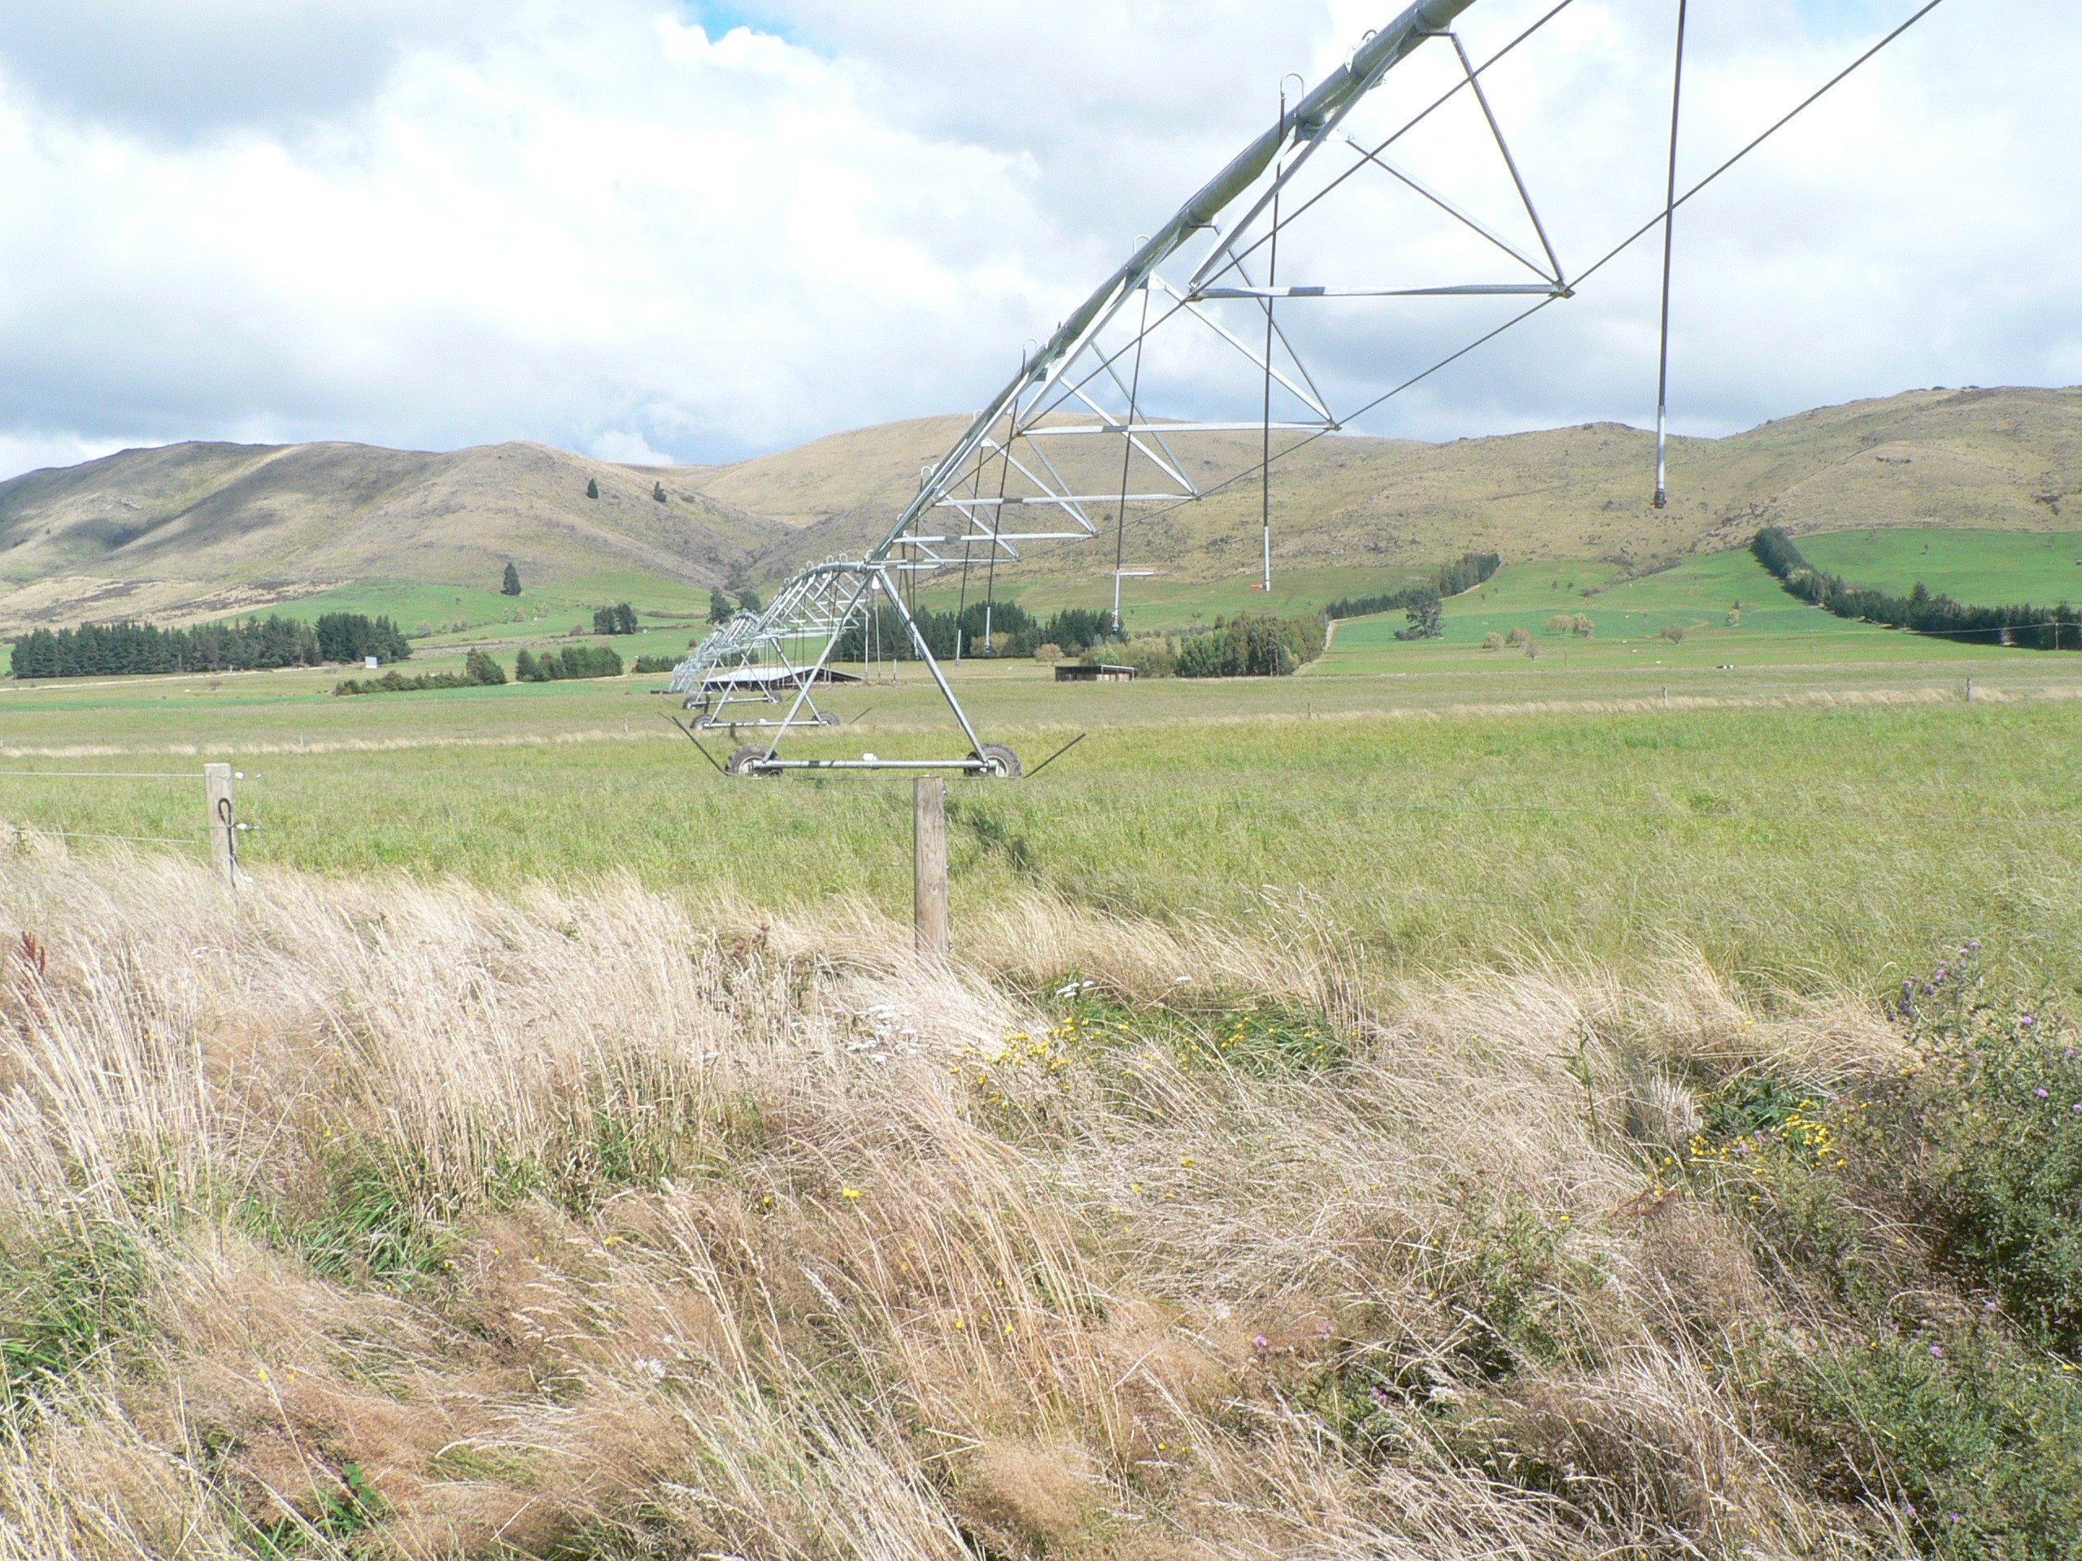
Center Pivot
Describe one advantage of this system
Describe one disadvantage of this system

Flat with a clay loam soil
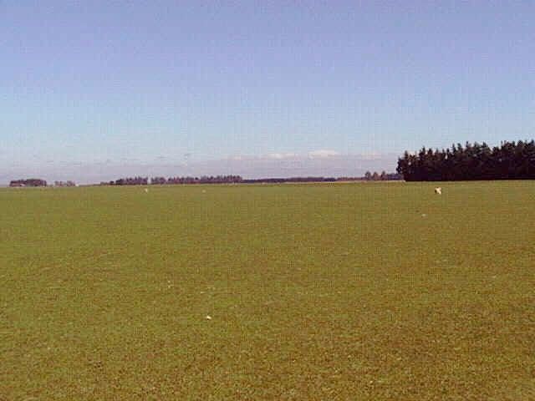
Name which system you would use on this farm = .
Explain why this is the best system.

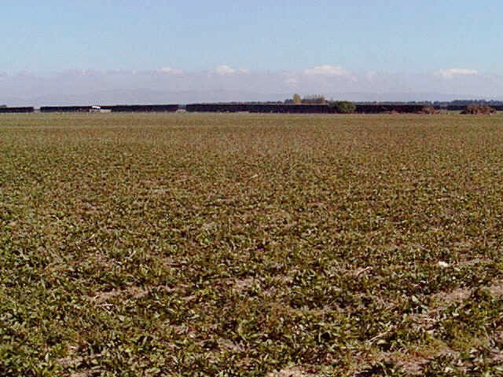
Flat with a sandy loam soil
Name which system you would use on this farm = .
Explain why this is the best system.

Flat but growing tulips.
Name which system you would use on this farm = .
Explain why this is the best system.

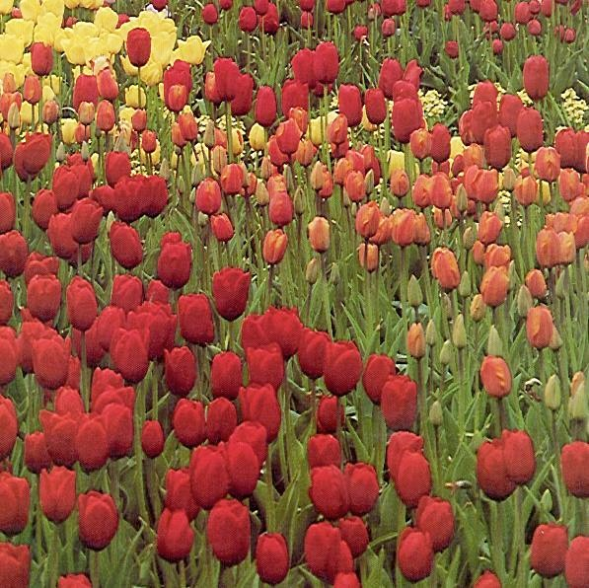

Lastly, collect your soil analysis sheet. With your knowledge of the soil and where it came from, choose the best system to irrigate
this soil, assuming that it will dry out in summer. Explain why you think this choice is the best.

