Can You Make Money from Venison Production?
Purpose
I am investigating whether or not venison production is viable economically in 2018. This will involve the analysing of production costs, inputs and the price per kilo of meat.
Key Findings
- For every 1mjme/kgdm the food quality increases the animal growth rate will increase by 100g/day which results in an extra 55c per day per animal for the farmers profits
- For every 0.1-0.3kgdm/day the farmer provides his stock with each individual animal will grow 50g/day more than before, a 27c per animal per day gain on profit
- For a 5% increase in growth rate the farmer will profit $22.26 per animal if he culls it at the same time as the other animals
- For every death the farmer misses out on $530 profit and has to cover the cost of the dead animal in the profit of the other
- The deer industry started off due to live capture of wild deer in the 70s and 80s. It has had some tough times recently, but the outlook for the industry is strong with the venison schedule continuing to increase

Background to the New Zealand Deer Industry
New Zealand had a large deer culling industry due to the number of wild animals causing damage to the environment. From the late 50’s into the 60’s there was a large quantity of venison being exported to Germany. In the mid to late 1960’s people started realising that farming deer may be a more economical way of producing venison. A few innovative people started attempting to capture the deer as opposed to killing them in the late 60’s and early 70’s. The deer were captured using tranquilizer guns and nets, usually shot from a helicopter and transported to holding pens. Red deer were the main species targeted for farming, with smaller populations of wapiti and fallow also captured. The deer farming industry grew quickly with many farmers building the necessary infrastructure to farm them, despite licenses for deer farming being a lengthy process. In 1969 there was one deer farm in New Zealand, which became 1540 in 1980. These animals were wild, so required special handling and infrastructure to farm them. The domestication of the deer is described as being a remarkable event, with some people calling it the first full domestication of an animal in 5000 years. Recently there has been a decline in the number of deer farms, largely attributed to the unstable nature of the venison price in the mid 2000’s and the strong dairy milk prices.
Venison is a very lean meat, being low in fat but high in protein and minerals, especially iron, zinc and vitamin b12. Venison is a sought-after meat in the European market because of this, particularly in Germany where much of the first exports went to. Premium New Zealand venison is marketed under the ‘Cervena’ brand, a brand created by a collaboration of New Zealand meat companies. The aim was to make Cervena a global brand which is viewed as the best of the best by consumers. Despite a few hiccups in its creation, Cervena has successfully entered the US restaurant market.
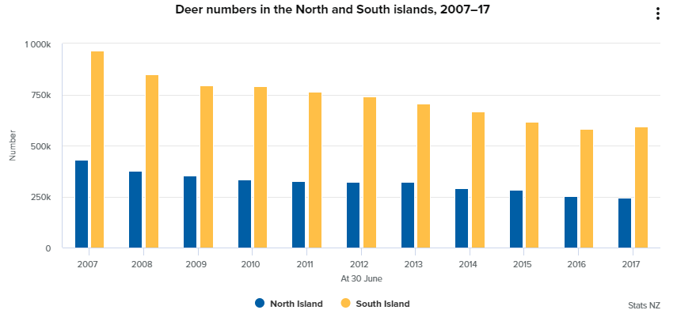
The New Zealand venison industry has experienced some highs and lows, especially in the early 2000’s. Over the last 7 or 8 years however, the venison industry has remained relatively stable, with growth in the last few years, with a nearly $11 per kilo of meat payout in the 2017/18 season. These sorts of payouts are encouraging people who left the industry previously to restock their deer blocks.
ref 4

NZ Deer Faming Systems
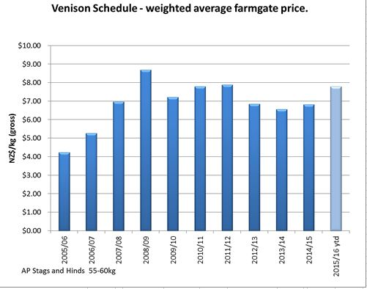
There are two main farming systems for a deer farming. Traditionally it was venison production, but there has been a shift to velvet recently with the consistently high velvet prices. If a farmer was to focus purely on venison production, there are a few different ways they can go about it. One way is to buy in weaners in the April and finish them, selling them in the May. The farmer has little control over the genetics of the animals, so has no way to add value to the animals other than by adding weight. This business method is reliant on the venison schedule being higher than their inputs, so the farmer has no control over profitability. This business model is usually seen by farmers who farm mainly other animals like sheep and beef and have a small deer unit which they buy animals in when the schedule is looking good. Another farming system is to breed fawns from a large mob of hinds. These animals are grown out to a weaner or yearling stage, so sold in the may if their liveweight weight allows. In this system the farmer can also choose to cull the old hinds and stags.
ref 3
Markets
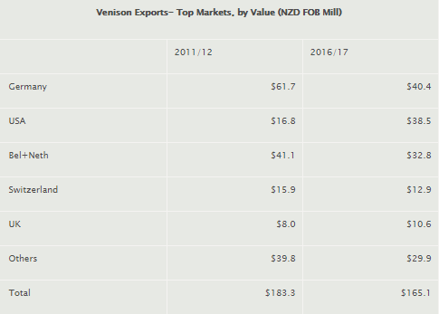
New Zealand traditionally sold all of its product to Europe into the game markets. However, with the development of the Cervena brand, which has focussed on the US market, has increased the amount of product being sold there. Germany still buys the most venison. The reason perhaps for the decreasing volume in exports is the drop in supply in the mid 2000’s. More people have gotten out of the market than have come in, so we have had to drop the amount we export.
ref 2

Assumptions
My calculations will be based on the following assumptions
- Carcass weight is 53% of liveweight
- There is a $10.50 payout per kilo of carcass
- The deer grows at the same rate as the large hind intensive finishing on table 1
- The weaner deer start grazing on the 1st of February and are culled on the 15th November, a total of 288 days
Investigation
The ability of a venison farmer to make a profit is dictated by a range of factors. Some of these are the schedule price, feed availability and cost, breeding, handling, and schedule price. Profit is the amount of money earnt minus the input costs, so farmers can work to minimise costs or improve production or both, however usually improved production leads to higher costs. Some of the factors are out of the farmers control, such as weather conditions which have an effect on the ability to grow enough feed to allow for the required liveweight gain. Schedule price is another factor the farmer has little control over.
How breeding affects profitability
Breeding is an important part of profitability because it can improve animal performance. The aim of breeding is to improve the performance of individual animals. Mob improvement via breeding tends to be slow and can take multiple generations to make any semi-significant difference to production. With venison production there are three main things that good genetics can help to improve to improve profitability. Most farmers will focus on increasing the genetic worth of their animals by using a proven sire stag. It is easier and cheaper to improve mob genetics with a stag rather than hinds as a stag will mate with up to 100 hinds, so passes their genes onto 100 fawns a year. A hind can only pass on its genes to one fawn a year. A farmer who is wanting to improve his venison production will buy sire stags that lift liveweight gain rate (efficiency of food conversion), size when they stop growing, and the right birthweight. A farmer needs to keep improving his mob by breeding from the good animals and culling the poorer animals to continue to improve it, or else it may go backwards, and production reduced. By putting a sire stag out with the hinds during the rut with a proven good growth rate, the fawns will inherit the genes which allow them to do also. As long as there is the food to fuel the growth, the fawns from the sire stag will show a superior growth rate to the ones that did not have a sire stag as their father.
Evidence of effect on profitability
The maths behind breeding proves how profitable it is. For example, a December born weaner will usually reach market weight of 95kg in around mid-November/December. In order to achieve this, they must grow at an average of 242 grams a day, (assuming a 10kg birthweight). As a rule, the carcass weight is 53% of the liveweight. So a 95kg liveweight deer will have a carcass weight of 50.35kg, times that by a $10.50 per kilo carcass weight and the farmer is making $528.67 per animal (95x0.53x10.5). If that deer that had been bred to grow at a faster rate was to grow at 5% faster per day then an average deer, it would grow at an average of 254g/day. This means at the same time as the average deer on the 15th of November it would weigh nearly 4kg heavier. If that animal was 4kg liveweight heavier, it would make $550.93 (99x0.53x10.5). The farmer would make $22.26 more per animal. That’s $2226 per 100 animals. Considering that large venison specific operations will finish over 1000 animals, increasing the growth rate could increase the profit of the operation by $22260 per 1000 animals. Instead of holding on to the deer and allowing it to grow heavier, a farmer may choose to sell them at an earlier date in order to conserve feed going into the summer dry period where grass growth dips. This may turn out to be more profitable than keeping them on as it allows the hinds to eat well during calving, which will help the fawns to get a good start. A deer growing at an average of 254g/day would reach market weight of 95kg in 335 days, 15 days sooner than before.
How Nutrition affects profitability:
Nutrition is very important to improve profitability. A farmer can manipulate two factors in nutrition, quality and quantity.

Quality
Quality of feed is measured in megajoules of metabolizable energy per kilogram of drymatter, MJME/kgdm. Different types of feed have different MJME values.
Feed type | Dry matter % | Metabolizable energy/kgdm
Pasture, spring | 12-15 | 11.5-12.5
Pasture, summer | 15-20 | 9.5-10.5
Pasture, summer dry | 20-30 | 9.0-10.0
Pasture, autumn/winter | 13-18 | 11.0-11.5
Kale | 11-15 | 11-13.5
Swedes | 9-12 | 11-13
Turnips | 9-11 | 12
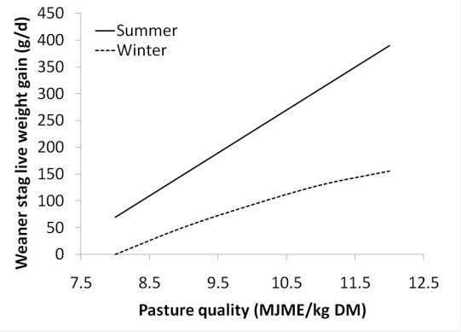
The higher the MJME/kgdm the faster the animal will put on weight. The cheapest food source per kg of drymatter is pasture. The farmer needs to keep his pasture in the best condition to allow the animals to put on weight. Topping seed head in the spring and proper grazing management are some of the ways a farmer can intervene to improve pasture quality. It is important that the farmer keeps the quantity of grass below 3000kg/ha as above this the quality declines. During the summer months pasture quality drops off due to the lack of soil moisture. Supplements may have to be fed out at this time in order to keep production ticking over. The table to the left shows the gain in liveweight relative to pasture quality. The higher the pasture quality the faster the rate of liveweight gain.
ref 1

Evidence of effect on profitability
If the animal is provided with higher quality feed the faster it will grow, meaning it reaches market weight sooner, or is heavier and drafting time. For every 1mjme/kgdm the pasture increases the growth rate of the animal increases by 100g. For every 100g a deer gains the farmer earns $0.557, so he earns over 50c per animal per day if he can increase the food quality by 1mjme/kgdm

Quantity
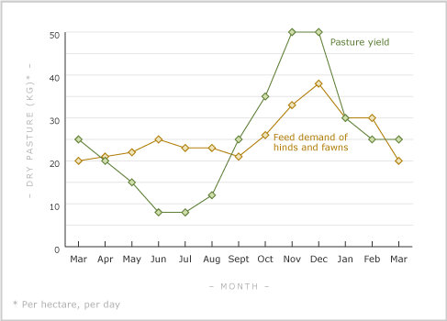
Quantity of feed is very important to the growth rate of an animal. A farmer can control the quantity of feed a deer receives by using fertilisers to promote pasture growth, feeding supplements and mange grazing by feeding priority stock well and feeding lesser priority stock a maintenance level. Unfortunately, deer do not fit the pasture supply curve (see left). Pasture supply is less than feed demand in winter and summer, so a farmer must feed supplements or drop animal numbers to keep everything putting on weight. Of course, any supplement is an extra expense that takes away from the profit. The table below shows the weight gain of a stag and hind depending on the feed available. As the amount of drymatter available increases, so does the rate at which liveweight is gained. According to table 2 For every 0.1-0.3 kgdm/day the deer will grow 50g/day faster. For every kg of liveweight the deer gains it gains about 0.53 carcass weight. With a $10.50 payout per kilo of liveweight that’s $5.65 per kilo of liveweight.
ref 5

Evidence of effect on profitability
If the farmer provides the deer with an extra 0.1 to 0.3kgdm/day the deer will grow 50g a day faster. This is would add 27.8c per day per animal, so if the deer grazed on the property from 1st February to the 15th of November (288 days) the farmer would gain $80 per animal, a massive difference, there will however be an increase in cost due to the increased feed consumption.
How handling/welfare affects profitability
Handling encompasses anything health related. Vaccination and drenching of animals is important to keep the animals healthy. Animal health is important in any agricultural business, but especially in deer farming. This is because red deer and the other farmed species of deer in New Zealand are by and large inefficient feed converters, its takes a long time for them to get to a market weight. If an animal gets an infection or disease it can knock the animal’s production back greatly. Sick animals do not put on weight as quickly as healthy animals, and so do not reach the required liveweight as soon. In a slow producing animal such as deer, this is critical to profitability as they will have to be on the property for longer, eating more food than they would have, increasing cost and affecting other areas of the farming business. Even if the disease doesn’t kill the animal straight away, the animal will typically lose condition and die as a result. No profit can be gained from dead animal, every death is a cost to the business, especially if the animal was purchased. The farmer must work to minimise the deaths to make his business more profitable.

Evidence of effect on profitability
For every death a farmer has he loses money. A weaner at 95kg liveweight will sell for $530. If one weaner dies the farmer misses out on $530 profit and has to cover the cost of purchasing/feeding the animal in the sale of others. The $6 a kilo liveweight the farmer paid for the weaner in the autumn is cost ($420 if the animal is 70kg)

Schedule Price
The deer schedule price (price per kg of meat) has a huge impact on the profitability of a venison farm. A farmer who focusses on venison production typically buys in weaners with the intention of finishing them. With this business model the farmer is reliant on getting a good price at the works to cover his costs and make a profit. In the early 2000s the volatility of the venison market pushed many deer farmers out of the business because they were getting hit with large losses in the poor years. The deer industry is similar to the dairy industry, in that deer produce two products. Venison being one and velvet the other. If the outlook for one industry is particularly poor the farmer can focus on that one, like buying more velveting stags. The schedule price is controlled by multiple factors, the exchange rate, demand, tariffs, and quality of the product. The farmer has very little control over the schedule price, only the choice of which meat company he supplies. There are several meat companies that buy venison, Silver Fern farms, Alliance, Duncan & Co, Mountain River and First Light. There is little difference in price per kilo between the companies (see tables 3 and 4 in appendices). Maximum price per kilo of meat is achieved when the animal is between 45.1 and 85 kgs and fits into the AP grade. The animal needs to be culled between 85.09kg and 160.37kg liveweight to fit the weight criteria. The grades are determined by the fat levels, AP is the ideal amount, any more or less than ideal the farmer is penalised for it. The farmer can manage the level of fat on the carcass by culling at the right time, e.g. avoiding killing adult stags during the summer when they are overly fat.
Ability to profit
I think of the three factors listed above, nutrition is the most important factor that affects the farmers ability to profit that he can manage. By feeding the animals well through out the year they can grow at their maximum rate, meaning they reach market weight sooner. Feeding animals can be a vicious cycle in that in order to feed one mob of animals well to put on weight quickly it can eat into the other mobs feed supply, putting their production back requiring extra feeding down the track or requiring purchasing expensive feeds like grains or baleage to get them to where they need to be. It is important that feeding is done well to keep ahead and get the animals off the property as soon as possible.
Nutrition has a bigger impact on profitability than breeding because an animal with good genetics can only grow as fast as the food availability allows. If there is not enough food to sustain the growth rate that genetic improvement has worked to achieve, the animal won’t grow at that rate. Good genetics are important, they are the difference between a good mob and a bad mob, but good nutrition is the difference between a good farmer and a bad farmer. Genetic potential can only be taken advantage of if there is the feed to support it. Nutrition will always have a bigger effect on liveweight gain than genetics, which is why I believe it is more important. As well as this by increasing the quantity of drymatter by only 100 to 300 grams a day to each animal they will grow 50g a day faster earning the farmer 27c more per day per animal. If the farmer increases the quality of feed by 1mjme/day then the deer will grow 100g faster per day, earning the farmer 55c more per day per animal. Breeding cannot achieve these sorts of profit gains. If the genetic growth potential is increased by 5% than the animal will only earn the farmer 6c per animal per day (feed availability dependent)
Nutrition is also more important than handling as animals in good body condition are much more resistant to diseases than poor condition ones. Of course, choosing to just feed the animals well and not using any drench/vaccines is a bad idea but feeding them well help stop the onset of diseases anyway. Underweight animals may still die of diseases vaccinated for as they can become so weak that no energy can be spared to fight off the disease. Handling doesn’t help to improve production, so therefore doesn’t help to improve profitability, rather it minimises the amount of production capability lost to sick/dead animals.
Appendices
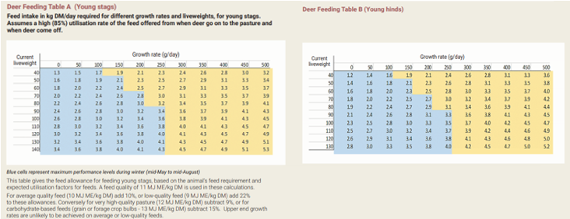
Table 1 (ref 6)
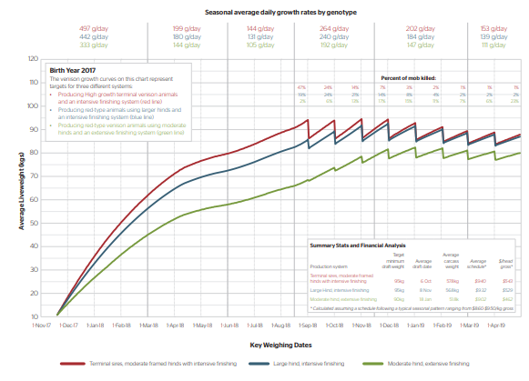
Table 2 (ref 7)
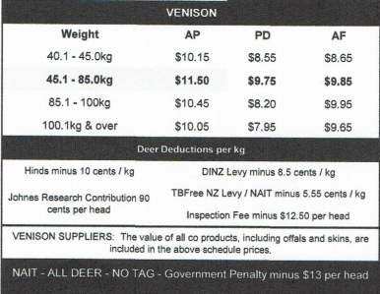
Table 3 Silver Fern Farm schedule (September 2018)
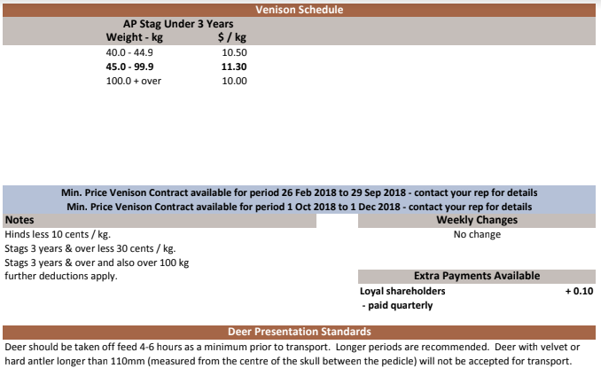
Table 4 Alliance Venison schedule (September 2018)

Calendar of events
Below is a calendar of events of a deer farm. Some of the tasks are not necessary or done on a large scale. Events such as Johne’s testing, CIDRs, artificial insemination. Others like facial eczema control are not necessary in all parts of the country, as it is not humid or warm enough for it. This was sourced from reference 8
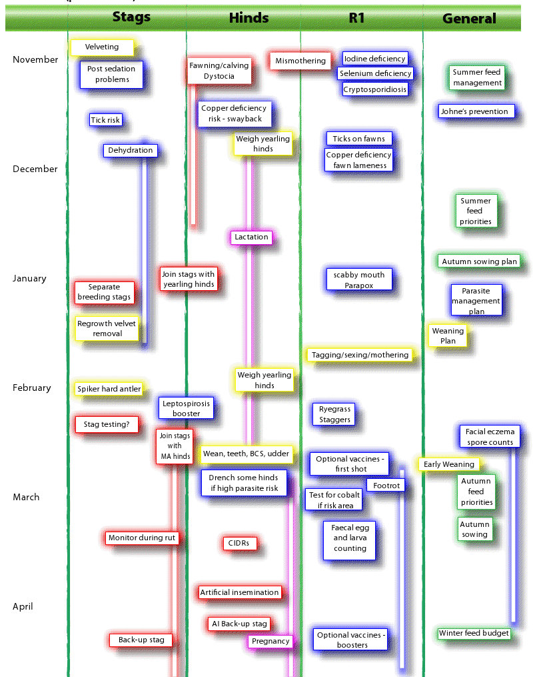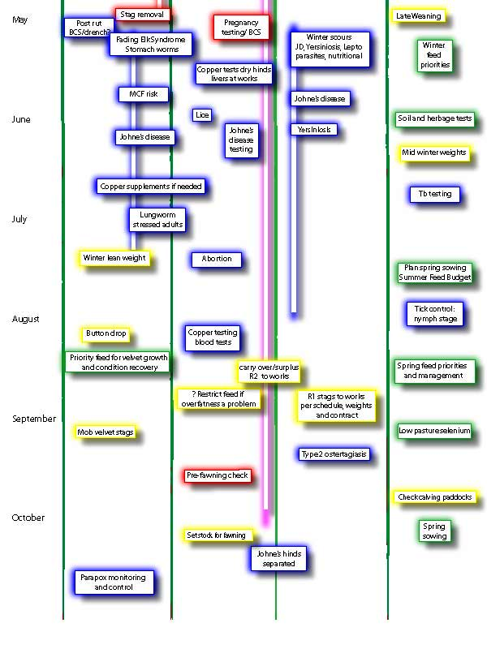
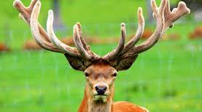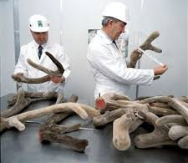
Velvet is another source of income for deer farmers, with a growing price per kilo of velvet
References
- https://www.deernz.org/deerhub/feeding/feeding-deer/feed-quality#.W6mLKmgzbIU
- https://www.deernz.org/about-deer-industry/deer-industry-new-zealand/deer-industry-statistics/industry-exports-destination#.W6mLoGgzbIU
- https://www.deernz.org/about-deer-industry/deer-industry-new-zealand/deer-industry-statistics/venison-production#.W6mL9WgzbIU
- https://www.stats.govt.nz/information-releases/agricultural-production-statistics-june-2017-final
- https://www.deernz.org/deerhub/feeding/feeding-deer/balancing-supply-demand#.W6mNDmgzbIU
- https://www.deernz.org/sites/dinz/files/2018%20Venison%20production%20Poster%20v7_2p.pdf
- https://www.deernz.org/sites/dinz/files/DeerFeedingTables_V9.pdf
- https://www.deernz.org/deerhub/deer-information/health/management-calendar-0#.W6rEj2gzbIU

