Jobs in Agriculture

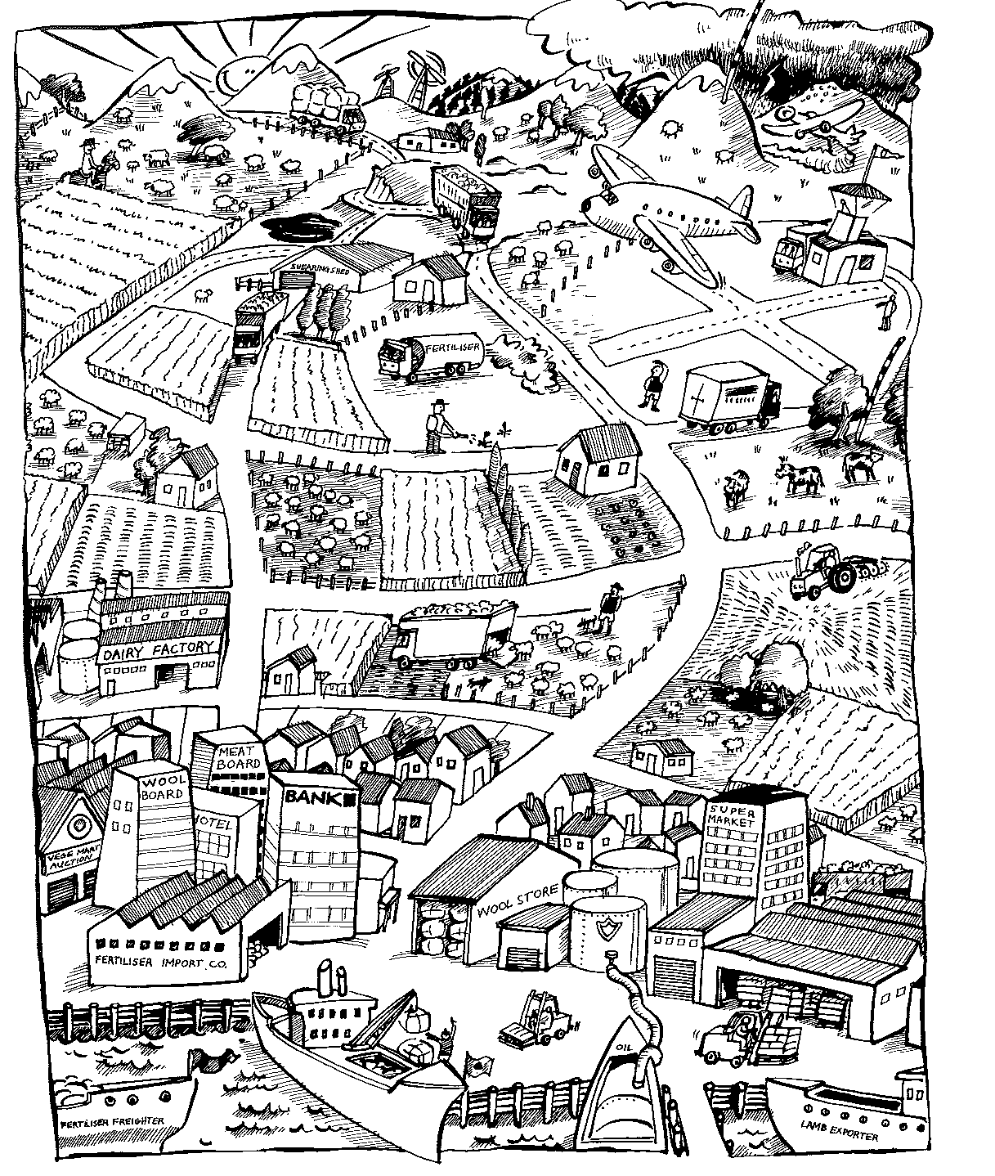

Look at this diagram

Make a List of 50 to 100 jobs associated with agriculture that are shown in the diagram or that you know of.

