Kiwifruit

TYPES:

Green varieties

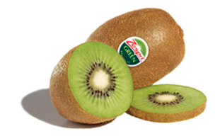
There are two varieties of ZESPRI® GREEN Kiwifruit, distinguished by their labels.
The classic ZESPRI® GREEN Kiwifruit is also known as the Hayward variety and is the most commonly recognised and popular kiwifruit worldwide.
ZESPRI® GREEN Kiwifruit was first developed in New Zealand by Hayward Wright in the 1920’s. It is oval-shaped with brown, fuzzy skin. The vibrant, green flesh contrasts with a white core and small, black seeds. ZESPRI® GREEN Kiwifruit is a tangy, sweet and sour combination of invigorating flavours.
ZESPRI® GREEN Kiwifruit contain:
• twice the amount of vitamin C as an orange
• more potassium than a banana
• more fibre than a bowl of bran.
Regarded as a superfruit, ZESPRI® GREEN Kiwifruit is also high in trace minerals, vitamins, is naturally low in sodium, fat and has a low GI (glycaemic index). This ‘powerhouse’ fruit is one of the most nutrient-dense fruits available.
The second green variety which forms part of the ZESPRI suite of products is the ZESPRI® SWEET GREEN Kiwifruit. It has a similar shape and visual appeal but offers a smoother, sweeter taste.
The new ZESPRI® SWEET GREEN Kiwifruit will primarily be sold in Japan in 2011. As production volumes increase in 2012, ZESPRI® SWEET GREEN Kiwifruit will be more widely available.

Gold varieties

There are two brands of gold fruit under the ZESPRI banner, distinguished by their labels.
The innovative ZESPRI® GOLD Kiwifruit was naturally bred from one seedling planted in 1992. Now, over 4,000 hectares of GOLD vines are planted around the world exclusively for ZESPRI under assigned Plant Variety Rights.
ZESPRI® GOLD Kiwifruit has smooth, hairless skin which is bronze in colour. The golden flesh has a sweet, tropical taste and is a real favourite with both children and adults.
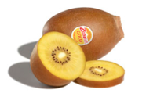
ZESPRI® GOLD Kiwifruit has excellent health promoting properties that assist the body’s uptake of iron and vitamin C. Even better, it contains many of the same vitamins and minerals as ZESPRI® GREEN Kiwifruit, but with slightly higher levels of vitamin E and folate.
ZESPRI® SUNGOLD Kiwifruit offers all the health benefits of ZESPRI® GOLD Kiwifruit and extends the time period that GOLD fruit is available in the market.
Growing Kiwifruit

New Zealand’s global kiwifruit success has been built through marketing and innovation, but the story starts and ends with growing delicious, healthy and nutritious fruit.
ZESPRI harnesses a wealth of experience from our long standing New Zealand kiwifruit growers and shares this knowledge and expertise with the younger industry members. Together, are driven by a passion to innovate and deliver the best quality kiwifruit to the world.
As the most experienced and longest-serving kiwifruit industry, New Zealand growers will proudly affirm that producing high quality kiwifruit requires a number of key ingredients:
Experience: Over 100 years of growing kiwifruit in New Zealand has resulted in tested and proven ZESPRI orchard management practices that consistently deliver the best fruit possible. The ZESPRI® System is based on key learnings from these years of experience. Our evaluation process demonstrates our commitment to continuous quality improvement.
Climate and Environment: Kiwifruit vines thrive in fertile, moist soils that are free draining and contain pH levels between 5.0 and 6.8. New Zealand’s favourable temperate climate and volcanic soils produces ideal growing conditions, in an environment that growers respect and protect.
Passion: Behind every success story is a group of people who have a genuine belief, commitment and passion for what they do. ZESPRI growers are innovative, dedicated and relentless in their pursuit of quality, so that the world can enjoy the benefits of ZESPRI Kiwifruit.

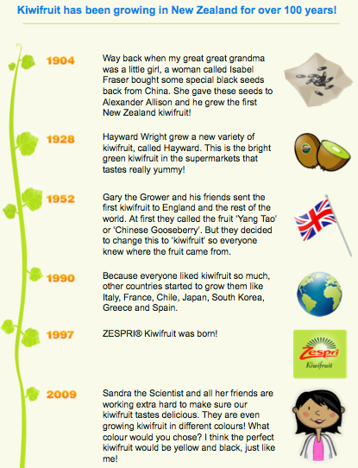

http://www.zespri.com/zespri-kiwifruit.html

