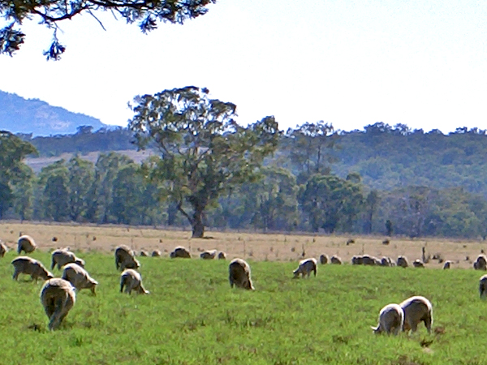
Gore High School
Yr 13 Agriculture

Explain market requirements and the production process for a nationally significant primary product
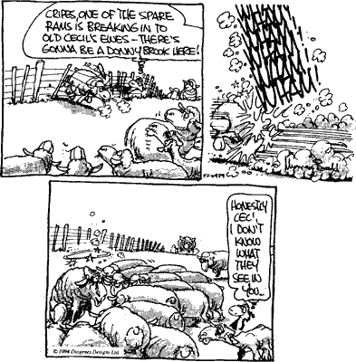
NAME___________________________________
INDEX
Achievement Standard | 3
The Production Process | 5
Annual Production Cycles | 9
Environmental Inputs | 14
Establishment Inputs | 20
Biological Inputs | 27
Husbandry Inputs | 37
Grapes | 37
Lambs | 45
Grape Yields | 56
Calendar of events/  schedule of operations | 57
Fitting events into the  Calendar | 61
crops | 61
lambs | 62
Exams
2004 | 64
2005 | 67
2006 | 70
2007 | 75

Achievement Standard

Subject Reference |  |  | Agricultural and Horticultural Science 3.4
Title |  |  | Explain market requirements and the production process for a nationally significant primary product
Level | 3 |  | Credits | 6 | Assessment |  | External
Subfield | Science
Domain | Agricultural and Horticultural Science
Registration date |  | 23 November 2005 |  | Date version published |  | 23 November 2005

This achievement standard requires explaining market requirements of market opportunities, and the production process needed to meet the market requirements of a specified market opportunity for a nationally significant agricultural or horticultural primary product.

Achievement Criteria

Achievement | Achievement with Merit | Achievement with Excellence
For a nationally significant primary product:  - Explain the market requirements of market opportunities. | For a nationally significant primary product:  - Explain, in detail, the market requirements of market opportunities. | For a nationally significant primary product:  - Explain, in detail, the market requirements of market opportunities.
- Explain the production process needed to meet the market requirements of a specified market opportunity. | - Explain in detail the production process needed to meet the market requirements of a specified market opportunity. | - Explain in detail the production process needed to meet the market requirements of a specified market opportunity.
 |  | - Justify the most significant manipulation(s) of management practice(s) used in the production process to meet the market requirements of a specified market opportunity.

Explanatory Notes

- A nationally significant primary product is an agricultural or horticultural product that earns significant export earnings in unprocessed or processed form, or allows for self-sufficiency within New Zealand, or employs a significant workforce during production and processing. It could be:

Agricultural products:
  - wool, velvet
  - meat: beef, lamb, chicken, pork, venison
  - eggs
  - honey
  - crops: maize, wheat, barley, white clover seed
  - milk
  - saw logs.

Horticultural products:
- fruit: apples, kiwifruit, apricots, cherries, nectarines, avocados, persimmons, strawberries, blueberries, mandarins, lemons, melons, grapes
- vegetables: onions, tomatoes, pumpkin, potatoes, asparagus, carrots, kūmara
- cut flowers: orchids, calla lilies, roses, sandersonia.

- Market requirements could include: product attributes; quantity; timing; price; quality which relates to product attributes and/or other considerations such as consistency, uniformity, or presentation.

- A market opportunity relates to the point of sale and/or end use of the primary product (provided that the primary product is still essentially in its raw form).

- Explain the market requirements of market opportunities means to describe each market opportunity and its requirements, and to give reasons why each market has these specific market requirements.

- The production process means the ordered sequence of management practices, defined by a calendar of operations from establishment until harvest, used in the production of an agricultural or horticultural primary product.

- Management practices could include but are not limited to: fertiliser application, irrigation, pest and/or weed control, pruning, thinning, harvesting, grazing management, dipping, drenching, shearing. Management practices may be manipulated through grower-initiated changes, eg the choice of fertiliser, the rate, method and/or timing of its application.

- Explain the production process means giving reasons/accounting for/comparing management practices and manipulations.

- In detail relates to the depth or breadth of the explanation, and can be quantitative and/or qualitative.

- Justify means to demonstrate, by explanation and comparison, why the most significant manipulation(s) of the management practice(s) chosen are better at meeting the requirements of the specified market opportunity than the alternatives available to the producer.

What is a production process?

Production is like following a recipe to make a cake.
1) Ingredients --Inputs
2)
  - Beating
  - Mixing
  - Cooking

3) Cooked cake -- output (or product).

Inputs | Production processes | Outputs
Seeds  Breeding stock  Vaccines  Fertilisers | How the inputs are used to get a product sowing, transplanting, mating, birth | Lamb meat  Tomatoes  grapes

Stages in process
There are three main stages in the production process
- establishment
- growth
- harvest.
We will study two products (apples and lamb meat).

Establishment from cultivar or breed selection up to grafted
plants ready for planting out or birth of the lamb.

- Growth from planting until harvest of grapes and birth to slaughter for lamb.

- Harvest from picking or slaughter plus any post harvest treatment before supply to the market.
Inputs are all the conditions, activities and materials necessary for the production of a product for a particular market opportunity.

Any production process can be manipulated or changed by inputsand their effects.
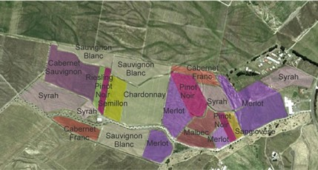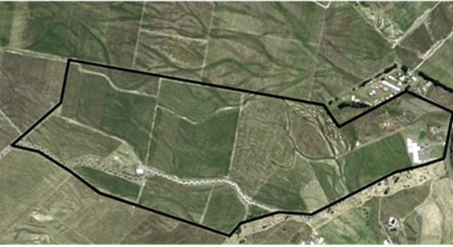
Matariki Wines
Gimblett Gravels Vineyard

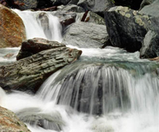
Inputs can be categorised into
environmental – This covers physical factors like heat light and water.

biological -- These are influences from living organisms like pests, diseases, competition and the genetic makeup of the product.

husbandry – These are the activities involved in tending or looking after the product to give a marketable product.

management -- This involves making decisions on which inputs to use or manipulate and when to apply the husbandry activities.

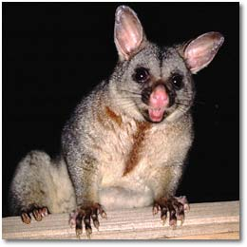

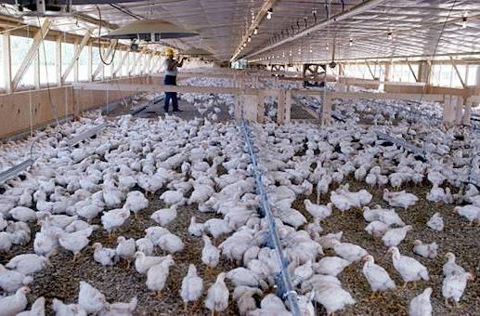


Wheat Inputs

Establishment
Environmental- moist soil for germination-
Biological- paddock weed free
Husbandry -- farmer drills appropriate amount of seed
Managerial – make decision on cultivar to sow

Growth
Environmental- humid weather for good growth
Biological- humid weather encourages diseases & pests
Husbandry – pesticide sprayed on crop
Managerial – decision on best time to apply pesticide

Harvest
Environmental- hot dry weather
Biological- grain mature & ripe
Husbandry – harvested at correct moisture level (14% or less)
Managerial – securing alternative market if quality problems

Effect of inputs
The combined effect of environmental, biological and husbandry inputs produces a marketable product.

How the inputs are managed affects the yield, quality, market opportunity and profitability of the product.

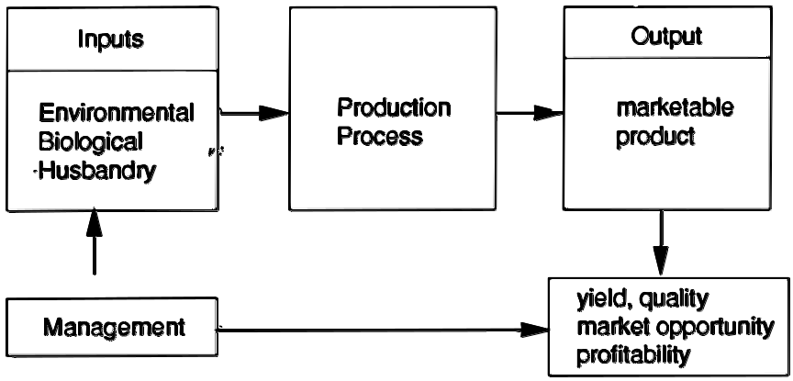
Schedule of operations
A schedule of operations is a management plan of when to apply husbandry inputs into the production process.

e.g. timing the planting of outdoor tomatoes to avoid late frosts will affect yield and the timing of pest control will affect quality.

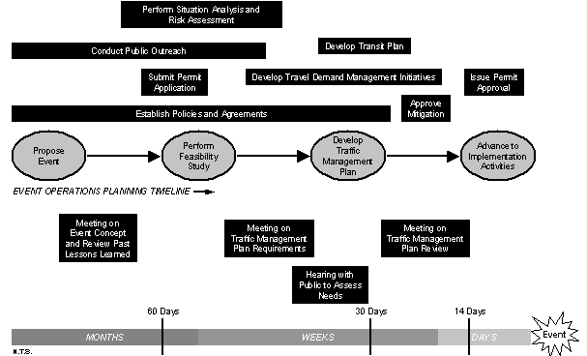

Annual Production Cycles
Cycles can
  - be illustrated by a flow chart
  - involve a time line
  - be manipulated

Flow charts
Flow charts are a useful way of illustrating what can be a complex series of events.
Using the stages establishment ---> growth ---> harvest

Linear
Growing one product on an annual basis like wheat can be shown as
Sowing ---germination ---flowering --- ripening --- maturity
(Establishment) ____ (Growth)_____ (Harvest)
Branched
Where there is more than one end product or market opportunity flow charts may be branched. Lamb production could be shown as.

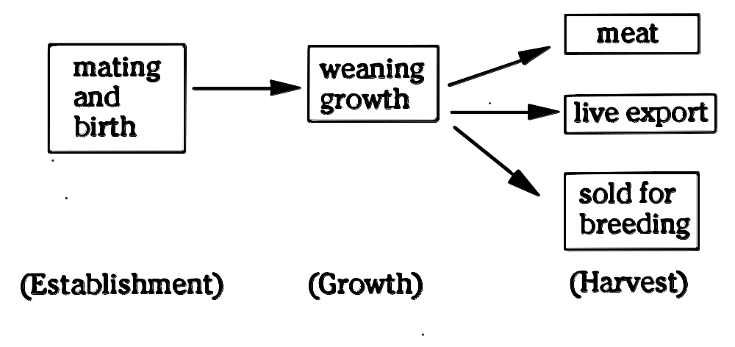

Circular
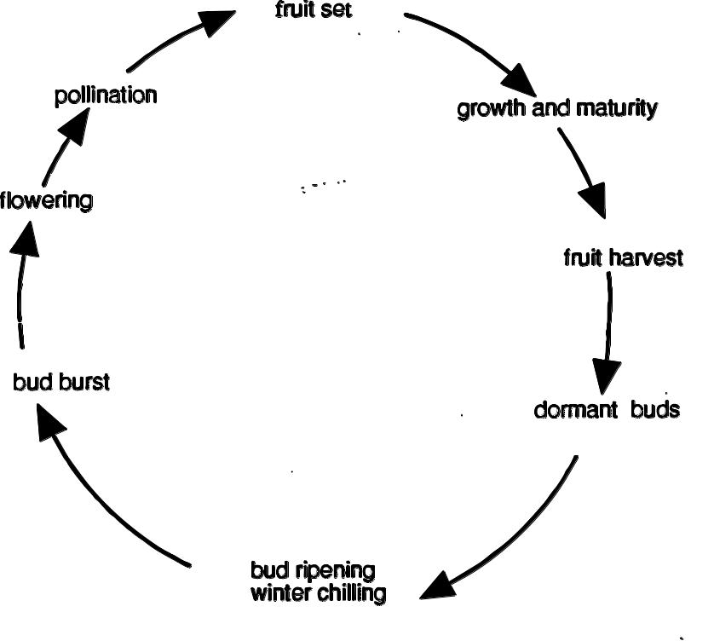
This circular flow chart shows stages in annual fruit
production (e.g. apples or kiwifruit)

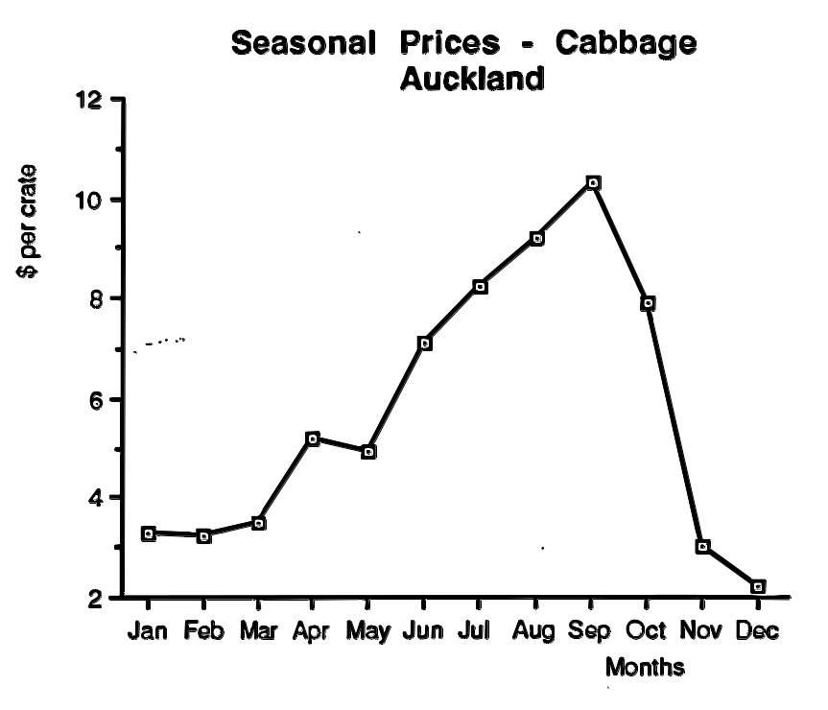
Timing
A production cycle takes time so a time line can help with planning when you consider sowing times, growth rates and harvest times and how each is affected by seasonal, processing or market requirements..

This time line from January - December shows periods of high market prices
You would need to time the production stages of your crop to target better prices in September for cabbages .

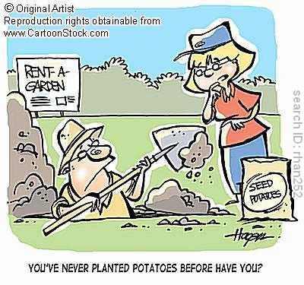
Timing and processing
Processing plants need a continual supply of known volume and quality during production runs.

This involves detailed preplanning of sowing dates and area to be planted technical knowledge relating timing to possible seasonal variations

A wet summer can cause major production difficulties.

Start point
For beginning a time line or flow chart you need a start point and a sensible sequence of events. For products which have an annual production cycle like tomatoes and lamb, sowing and mating are obvious start points. In cycles like fruit production it can take years to establish plants which will crop annually. In kiwifruit for example you can choose a full cycle (a) or annual cycle (b).

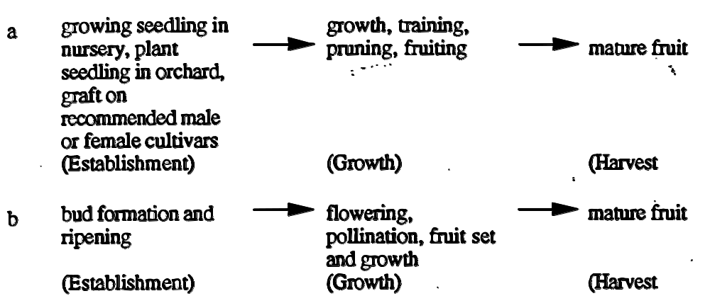

Manipulations
Environmental, biological and husbandry inputs produce a marketable product. Managerial decisions on the timing and type of input can manipulate the production.

Remember this link between management and husbandry is called a schedule of operations designed to affect yield market opportunities and profit.
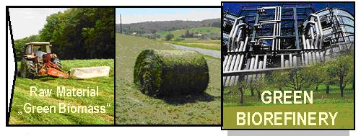
Interaction of inputs
This table shows some of the inputs in producing export kiwifruit and how they can be manipulated. It shows how interrelated these inputs are.

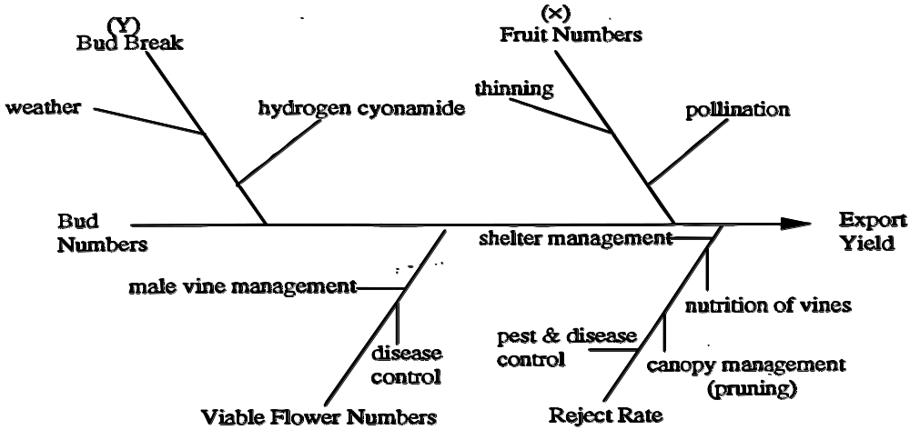

Notice
- Fruit numbers (X) are influenced by the pollination rate and the amount of thinning of small or imperfect fruit to give the best export yield.

- Bud break (Y) is the beginning of the annual production cycle. The more buds that break (develop) the greater the potential number of flowers and fruit. Buds need a specific amount of natural winter chilling or they can be artificially stimulated to develop by chemical application.

This example shows how inputs cannot be regarded in isolation (more buds - more flowers - more pollination - more thinning - higher export yield) and can vary from year to year (warm winter - insufficient chilling - fewer buds).
Environmental Inputs
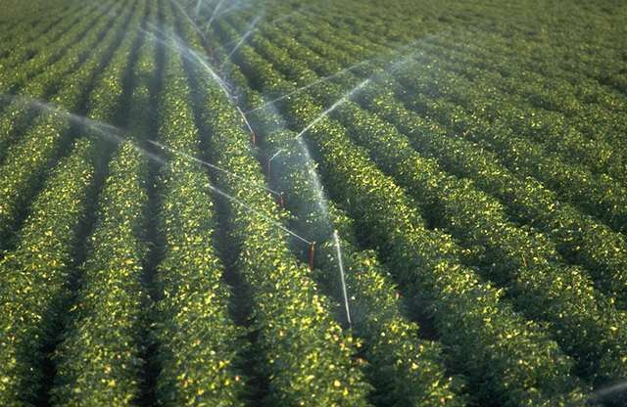
The previous lessons covered production cycles in general. In this lesson you will see how environmental inputs can be controlled in a protected growing environment like a greenhouse for tomatoes, compared with farmland for lamb production. The inputs you will look at are
- growing media
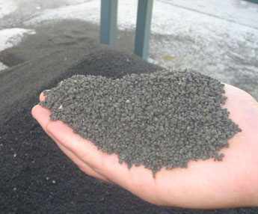
- heat
- light
- air/C02
- water
- fertiliser

Heat
Heat and temperature control is the main input for growing out of season produce in a protected environment. Greenhouse tomato production enables a year round supply of fruit from a frost sensitive plant.

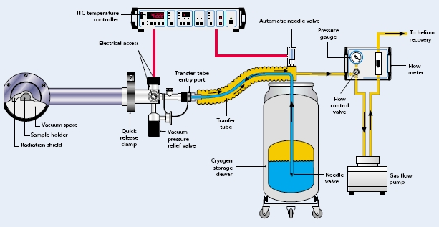
Heat Exchange
Unit

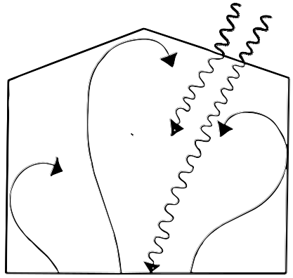
Solar Radiation
Sunshine contains radiation of many kinds. Some radiation is light you can see, but much is invisible short wave length Infrared radiation or heat energy which passes easily through glass or plastic film.

The soil and water vapour is warmed and radiates longer wave length infra red which cannot pass through the glass or plastic. Heat is trapped and temperatures rise.

short wave lengths enter through glass or plastic

longer wave lengths emitted by soil, plants, water vapour cannot escape.

Controlled Heat
Alternative sources of heat are used in cooler conditions for frost prevention and to provide optimum conditions not only of temperature but also humidity.

The illustration shows a 50 kW electric heater which provides hot air. Heating systems can be run or sources like electricity, diesel, gas and coal and heat air or water for circulation.

Heating units can be thermostatically controlled and heat from solar radiation can build up air temperatures of 40'C plus. Greenhouses have vents (often automated) usually along their sides and along the roof ridge with convection currents causing air movement. That is hot air rising and cooler air being drawn in to replace it.
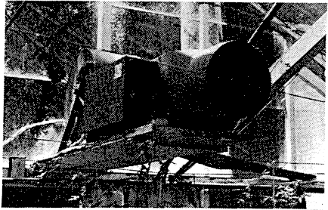
Electric heater

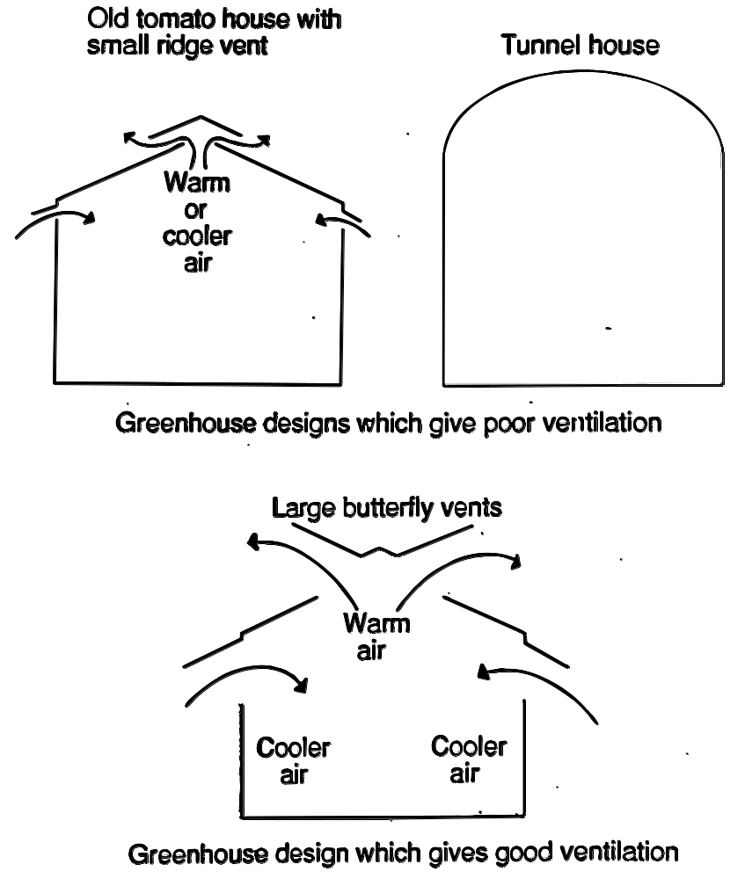
Screens or whitewash can reduce summer temperatures

Temperatures
There are well defined temperature ranges for the growing phases.
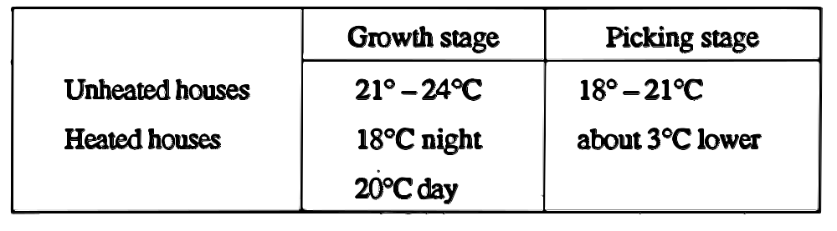

The temperatures mentioned are-air temperatures but soil or growing medium temperatures affect root activity and consequently growth. At 12'C plants show no growth, 12'-16' good growth, >16"C excessive growth particularly if light levels are low.

Light
Light levels affect not only the photosynthetic rate but in combination with other factors (like temperature and water) affect the growth form and initiation of flowers.

Low light and high temperatures or excess water cause the tomato plant to elongate and produce more leaves before a flower truss is formed.

As tomatoes are day neutral (day and night length does not affect flowering) extra lighting is not needed in greenhouses.

Greenhouses rows generally run N-S to allow light penetration along rows.
Air/C02
Air circulation by vents and/or fans helps control temperature, humidity and 02/C02 levels. Increased C02 levels raises photosynthetic activity and production. Extra C02 can be supplied from cylinders or as a by product by burning a fuel like kerosene.

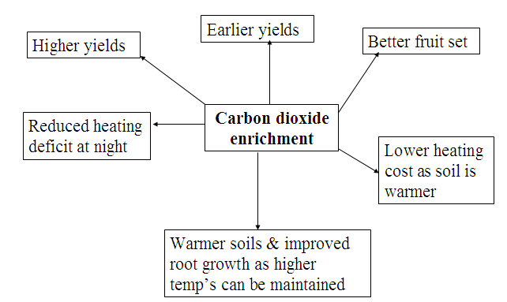

Water
Water usage in glasshouses is high with plants using approximately 300 1 each per season.
In hydroponics systems the roots are continually bathed in water.
Those in a solid soil less growing medium or soil receive water from "trickle" irrigation systems.

Water is directed by
plastic microtubing,
drip emitters
permeable plastic pipe along the plant rows.

Grower skill determines the average daily needs of the plants. Water inputs vary with the age of plants, light, temperature and humidity levels.
Growing Medium
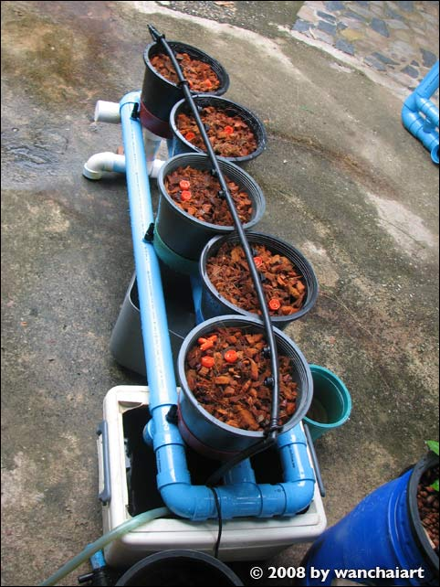
The growing medium in a protected environment needs to provide conditions for active roots to support high production above ground. It must have good aeration and oxygen supply, optimum water retention and be disease free.

To provide all of these, soil needs regular sterilisation and the addition of organic matter.

Organic matter can be added by sowing a "green crop". This is a leafy crop like oats, mustard or lupin grown in the greenhouse and then dug into the soil to add organic matter.

Trends are to soil less media like -
  - Peat or bark modules: Factory made or grower filled modules with fertilised peat or bark, or occasionally peat +sawdust mixtures.
  - Planter bags filled with fertilised sawdust.
  - Planter bags filled with unfertilised sawdust.
  - Nutrient film technique (NFT): Plants are grown in gullies which contain flowing nutrient solutions.
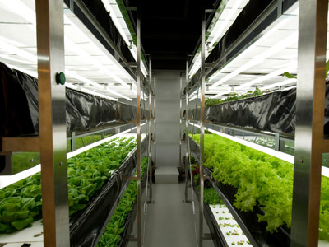
The common characteristic of all these systems is that they offer the grower improved control of the root environment in terms of water supply, nutrition, aeration and temperature. All systems are considered to be pest and pathogen (disease) free at planting time.
Fertiliser
For soil and some planter bags a 'base' dressing of solid fertiliser is used to supply phosphorus, lime for PH correction to pH 6.0-6.5 and trace elements if needed.

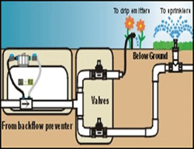
More soluble nutrients to supply nitrogen (N), potassium (K) and magnesium (Mg) are added to the irrigation system.

Fertigation -- Supplying soluble fertiliser and irrigation simultaneously

Pasture environment
In a protected environment like greenhouses inputs can be manipulated to a greater degree than farmland.

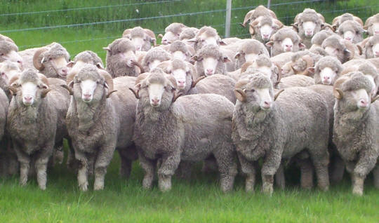
4 Establishment Inputs
In this period you will look at environmental and other inputs needed to begin production of grapes and lamb meat. To get started you will consider
  - Grape plants - type and quantity
  - Getting ewes and rams ready.
http://nz.youtube.com/watch?v=DwgLMObgU6w
grafting video

Grape Plants
Grafted plants of the cultivar you require are purchased from a reputable supplier such as Riversun in Gisborne who can provide specialist advice on currently popular or promising new varieties.

Grape plants are purchased usually grafted onto a rootstock. This rootstock is primarily to provide resistance to the aphid disease phylloxera and also controls the vigour of the vine ie how quickly and profusely the vine grows.

Vines that grow too vigorously don’t produce much fruit or the fruit does not ripen.

How many to plant
Grapes are planted from 2.0m to 3.0m apart. The distance depends on the fertility of the soil.
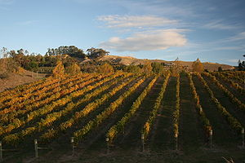
In particularly fertile soil plants should be closer together (competition) in an attempt to reduce the effects of vigour.

In less fertile soil, such as the Gimlett Gravels at Fernhill, plants can be further apart.

The distance between rows is decided by the mechanical equipment being used. This can be from 2.0m to 3.0m as well.

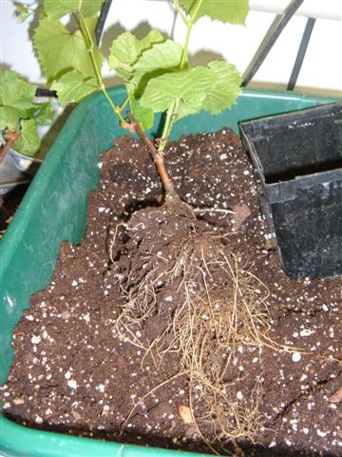
Producing grape plants
Grape plants can be produced by hardwood cuttings or through grafting. Hardwood cuttings are produced by cutting thick healthy canes into 45-60cm lengths and placing directly into the soil in the autumn.

Roots form at the base of the cutting and it can be potted up in the early summer. Grape plants produced in this way will be susceptible to phylloxera and the root system may not be suitable for the soil in that location.
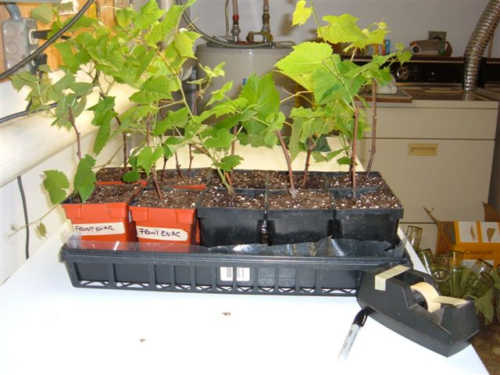
It is more common to graft grapes onto a known rootstock that gives certain qualities to the resulting grape plant.
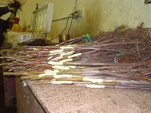
Grafting is usually carried out using a special machine which cuts a pattern into the end of the rootstock and a corresponding pattern into the scion. The two are then pushed together and taped. The join is then sealed with molten wax to minimize water loss.
The resulting plant is placed into a warmed container of moist sawdust to allow the two plant parts to grow together and join.
When properly joined the resulting plant material which resembles a hardwood cutting is placed out into the soil for the roots to develop. In early autumn the plants are lifted and the roots trimmed and the plants are stored in cool storage for planting out the following spring.

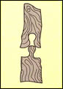
Rootstock. Will give characteristics such as disease resistance, low or high vigour, drought resistance.

Scion, the grape variety e.g. Chardonnay

Getting the Ewes and Rams ready.
Prior to mating environmental inputs influenced by the season
and the farmer have a major influence on lamb production.
Two major factors are
- the effect of light on ram and ewe fertility
- nutrition on ovulation in ewes.

Effect of light on fertility
Natural mating is seasonal, mating in autumn and lambing in spring. In both ewes and rams there is an hormonal response to decreasing amounts of daylight. In rams semen volume and quality increases and ewes begin 'cycling'. Each cycle consists of a brief period of oestrus or 'heat' (ovulation or egg release) when mating can occur.The graph shows the relationship between decreasing day light and breeding activity.

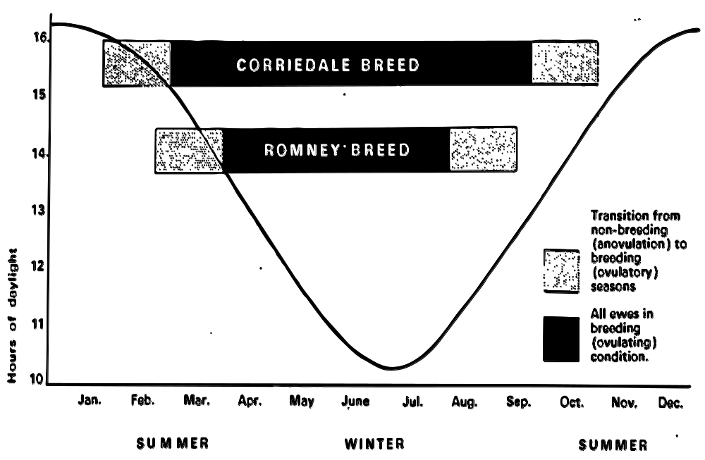

Nutrition
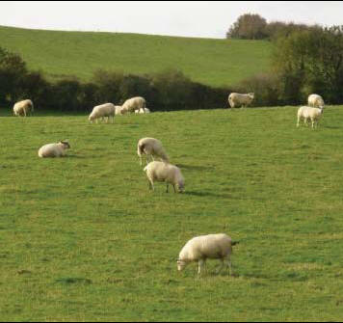
The amount and quality of feed is the end result of environmental inputs. Stock nutrition has a major influence on flock productivity and lambing %. Well fed rams perform better. It takes approximately 50 days for sperm to develop and mature. So when preparing for mating improved feeding should start about 2 months before.

Ovulation in ewes can be affected by long term feeding levels and also changes in feeding levels. In general the higher the liveweight the higher the twinning rate.

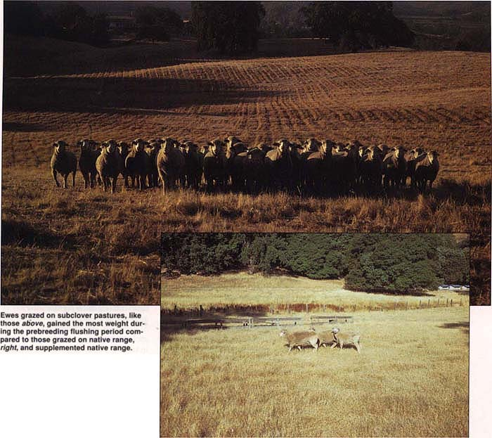

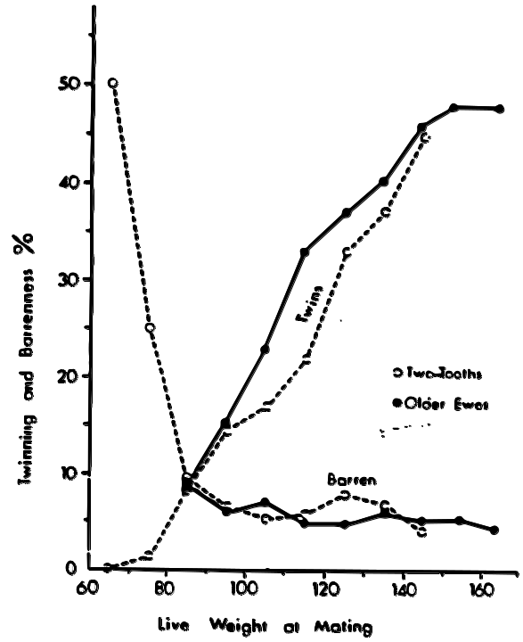
The graph shows a similar response in different aged sheep.
Environmental conditions in Autumn can be variable and while ewe weights may be below optimum an improving level of nutrition has a positive effect on ovulation and lambing %.
(Rising Plane of Nutrition)

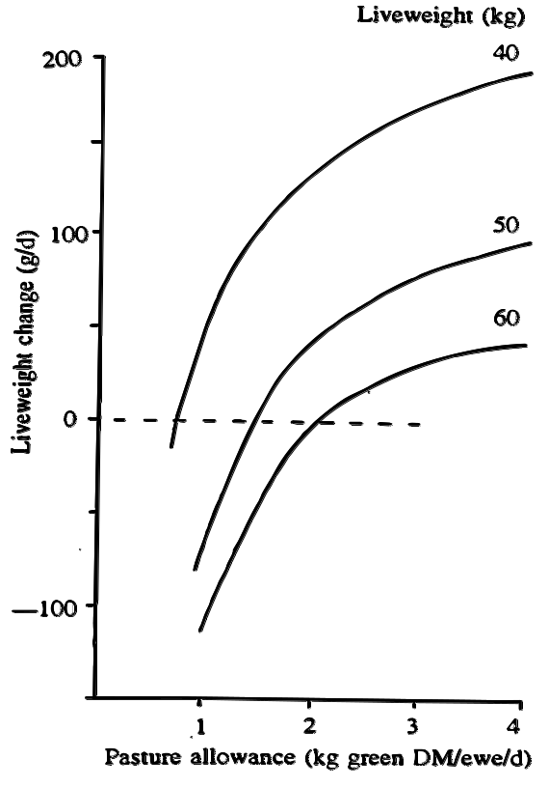
This graph shows that the more feed available increases the change in liveweight and that the response is greater in lighter ewes.

As available feed increases ovulation rate increases as well.
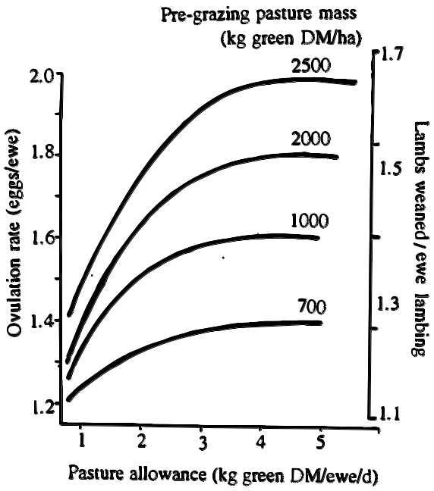
Increasing feed levels is called flushing.
It is carried out for 2-3 weeks prior to mating and may continue for a month after the rams are running with the ewes depending on feed availability.
The type of feed affects ovulation too as it can be depressed by grazing ewes on some legume cultivars. (Lucerne)

Biological Inputs-- Lamb
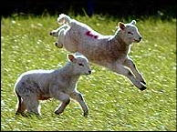
Lambs, grass and sunshine present a healthy green image. Stock health is important for high production and profitability. In the establishment or pre lambing stage there are biological inputs to help ensure a lamb crop and its future health.

You'll look at inputs necessary for
- healthy rams
- protecting ewe and lamb health.
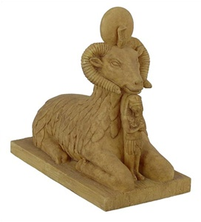
Rams
Rams need to be fit, healthy and keen as tupping or mating ewes is physically demanding work. Rams must be physically and reproductively sound.

Fertility
  - Veterinarians can check ram fertility.
  - Infertility can be temporary or permanent.
  - Temporary infertility can be caused by stress from treatments like dipping and shearing or conditions like footrot.
Egyptian Ram God Amun-Ra,
  - All treatments should be completed well before mating.
  - Permanent infertility can be caused by a bacterium Brucella ovis.

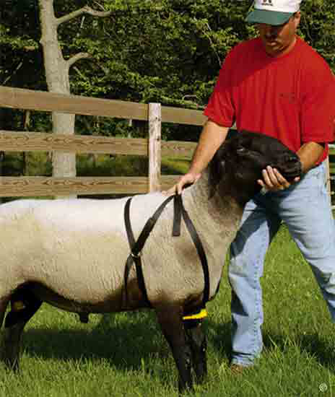
Healthy ewes and lambs
In ewes there is no infectious cause of infertility.

However there may be lack of fertilisation due to --
- no tupping or mating at all
- ewes having extremely low live weight
- rams being put out too early.
Other reasons for not producing a lamb may be due to death of a fertilised egg or embryo.

This can happen when
- multiple ovulations occur in very young or very old ewes due to disease like Brucella
- stress from things like high temperatures
- poor nutrition
- shearing.

Ewes that fall to produce a lamb are called 'dry' ewes.

While reproductive health is important in rams and ewes for high production, losses due to disease can be prevented by vaccination to protect both ewes and lambs from bacterial diseases like tetanus and blood poisoning.

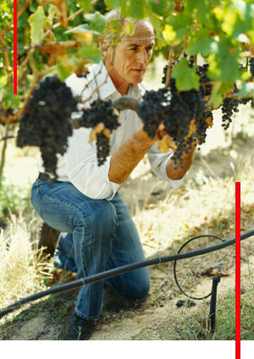
Biological inputs-Grapes
In the last period you saw some precautions that are important in producing healthy lambs.

For grapes you need not only healthy grafted plants but you also need to be careful when planting out as the graft union is still weak.

Watering should be maintained for several days to reduce transplant shock and a spray programme started to reduce the chances of pest and disease.

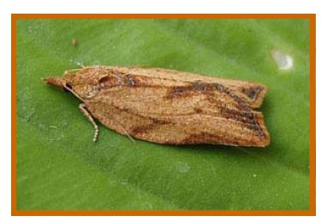
Plant Health
Grapes have a number of pests that attack the vine. These include:
- Phylloxera and aphid
- Mealy Bugs
- Lightbrown Apple Moth
- Grapevine moth
Apple Moth

- Leafroller Caterpillars
- Citrus Borer

The following notes are about the Phylloxera aphid which is well established in NZ in all the major grape growing regions. It arrived more than 100 years ago.
The above ground stages are rare in New Zealand being found only on the American vines and in mid to late summer

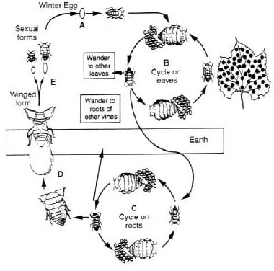
Eggs hatching giving rise to nymphs which pass through several stages. This cycle can be repeated depending on environmental temperature and humidity

The crawler stage which occurs in late spring early summer. Warm humid conditions and root quality hasten development

Phylloxera life cycle
The life cycle differs depending on what grape variety is infected. Vinifera vines do not have the winged adults forming while the American vines do.

The Phylloxera life cycle in the soil is the same for both grape varieties. The winged adults and consequent gall damage to leaves is not common in NZ as most of our grapes are of the Vinifera variety. Eggs are laid by adults that live on the roots of the plant during late autumn/early winter. These eggs hatch and go through several larval stages before finally emerging as an adult form called a crawler.
Crawlers emerge in late spring and are able to move through suitable soil (clays) and in this way can spread from one vine to another in a vineyard.
How does this pest spread?
- Infected soil will contain the organism. This soil can be introduced into another vineyard via the tyres of machinery that has come from an infected vineyard. The soil could come on the boots of people who have been on an infected vineyard. The soil could be surrounding rooted cuttings from an infected vineyard.
- The pest can spread from vine to vine through the movement of ‘crawlers’ from November to April. These crawlers are able to pass through suitable soils, and can also crawl above the ground. Crawlers can also spread through the foliage of individual vines.
- The winged adult form can fly from one vine to another or from one vineyard to another. The winged adult form is rare in New Zealand but is common in the United States.

What is the potential impact that a severe infection of this pest would have on the productivity (both quality and quantity) or health of grapevines?

A severe infection of this pest has a profound effect on the productivity of the vine in terms of both quantity and quality. Root damage due to feeding results in galls that may allow pathogens to enter causing rots. The simple loss of sap from the roots means that the vine may not be able to store enough carbohydrates for over-wintering. The consequent spring growth is weaker which will mean less photosynthesis and the problem then intensifies and the quantity of grapes becomes less and less. Quality is also compromised with less leaves available for photosynthesis either through premature leaf yellowing or through the leaf galls having reduced amounts of chlorophyll (up to 90%). This reduced photosynthesis will result in less fruit sugars at harvest.

Prevention and control methods for this pest.
i) Chemical
Chemicals can be used to control the leaf feeding cycle of this pest. Systemic insecticides such as Thiodan are effective if applied at bloom and again 10-14 days later. Late season treatment is not effective.

The soil cycle of this pest can be controlled to some degree using the insecticide Carbofuran. Tests in Australia show this insectide to be effective when compared with a control but the yields when compared to a non infected vine were still poor. Soil insecticides are not recommended.

Non Chemical
The most effective control is a biological one, the use of resistant rootstocks. These rootstocks work in one of three ways. They may not be a suitable food source, they may have antibiotic properties or they may be tolerant an able to support the pest without significant losses to yield.

Other methods to partly control the symptoms of the disease include methods that will compensate for the loss of roots by an infected plant. These include foliar application of nutrients, frequent watering, weed control and reducing the fruit load.

Hygienic practices are designed to prevent the pest from entering the vineyard via infected soil. This includes the sterilisation of nursery plant material, tyres, footwear and mechanical harvesters.
Diseases of Grapes:
Grapes are susceptible to a number of diseases particularly fungal. These include:
- Botrytis Rot
- Downey Mildew
- Powdery Mildew
- Blackspot
- Eutypa

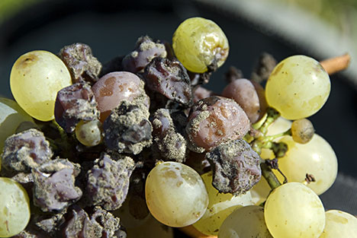
Botrytis Rot

Eutypa Dieback or ‘Dying Arm’

 | Symptoms | Time of Year
1 | Stunted Spring growth, yellowed and cupped newly emerged leaves. | Spring
2 | Stunted shoots, leaves tattered and scorched. Clusters on infected shoots are poorly developed and often wither and drop. | Early to late summer
3 | Cankers will develop on the trunk and when seen in a cross-sectional cut show a wedge shaped area of dead wood. | This symptom is able to be seen in a plant that has been infected for several years at any time of the year.

Fungal Life Cycle
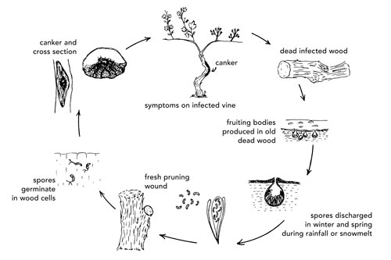
Fresh pruning cuts are another favourable condition for infection

Rain, a favourable condition for infection

The fungus will survive in infected trunks for long periods. This is true of vines still growing and of those that are dead and may be stacked in the vineyard for later use as firewood, a good reason why this practice should cease.

Reproductive structures are eventually produced on the surface of infected wood and spores are produced from these. These spores are discharged into the air during wet weather, usually during the winter. This is the same time pruning is being carried out and these spores, which are easily carried by air currents, enter these pruning wounds.

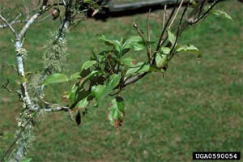
The spores germinate and infect woody cells. A canker forms and infected canes are stunted, this being one of the first visible symptoms of the disease. Eventually severe dieback of infected canes occurs and at this stage new spores can be produced by reproductive structures.

It should be noted that this disease may have a long incubation period and symptoms may not show for several years.

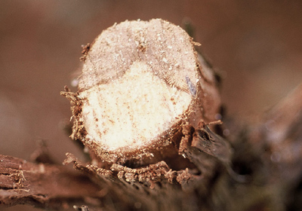
Disease Spread
- Windblown spores during winter are the most common method by which this disease would spread both within a vineyard and between vineyards some distance apart (up to 100 km). The spores are easily carried by the wind.
- The practice of storing infected wood in the vineyard as a source of firewood for later use. The infected wood will continue to produce spores.
3. The introduction of infected material into the vineyard for propagation. Symptoms only appear in older vines.

What is the potential impact that a severe infection of this disease would have on the productivity (both quality and quantity) or health of grapevines?

This disease would have a significant effect on productivity in instances of severe infection. The disease is invasive, spreading throughout the vine and as it spreads, affected parts have a reduced yield with clusters falling prematurely. ‘Moderately infected vineyards can lose 19 to 50% of yield, severely affected vineyards 62 to 94%’. Eventually an entire cordon or arm may be lost. The overall quality of grapes produced is also compromised as the same vine may be producing both quality grapes from an uninfected arm, and poor quality grapes from an infected cordon, arm or cane.
Prevention and Control methods
1) Chemical
A bioactive herbicide called Vitae has been developed which helps infected plants fight off the disease and stop it taking hold. The herbicide matches a fungus-fighting substance produced naturally by the vine but in too smaller quantities.

The chemical is applied by stem injection at 1200 psi into the heartwood. Trials have been conducted in Australia, California and France with growers being enthusiastic.

Another product called Prev-Am containing borax may be used against the disease based on preliminary research.

Other chemicals are useful for painting pruning cuts to prevent spores from entering.

Non Chemical
There are a number of cultural controls these inlude:
- Marking diseased vines in spring when symptoms are obvious, for future removal.
- Removing diseased wood 10-15cm below the canker and training a new healthy shoot into position.
- Avoiding large pruning cuts when possible.
- Avoid pruning in the rain or when rain is expected.
- Prune in early winter when spore production is low
- Burn all pruning material older then one year.

A bio control agent is also available.
Trichoderma viride is a naturally occuring soil fungus that is effective in inhibiting the growth of Eutypa lata. T. viride is able to survive in the vine following innoculation for up to five years.

Husbandry Inputs
These are all the "activities" that need to be done to produce a marketable crop.

Inputs into the production process are all interrelated and should be viewed as part of an integrated ongoing process.

In this section you will review activities needed to complete the establishment stage for grapes and lambs.

Grapes
You've considered preparations beginning with production of grafted plants, care when planting out, in row and between row spacing and pest and disease control.
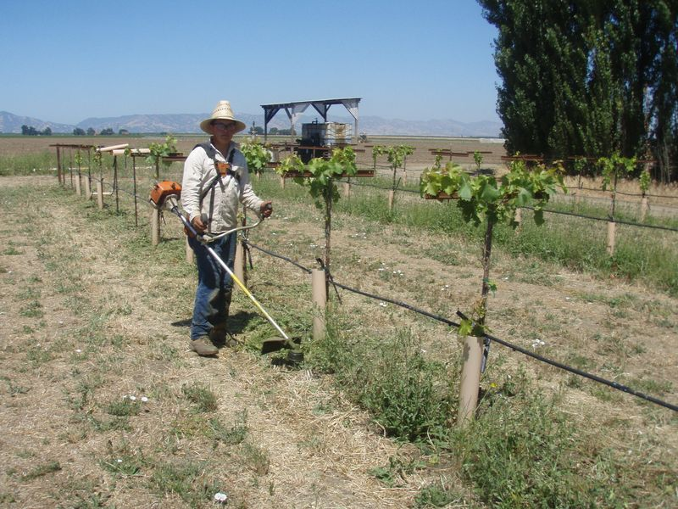
Husbandry techniques or activities used to produce a marketable crop include:
- Vine Training
- Pruning
- Leaf plucking
- Irrigation
- Fertilising

Vine Training (Trellis System)
The grape vine is a natural climbing plant that in the wild grows and is supported by trees. When domesticated the vine needed a structure to grow upon or it would have simply grown along the ground. Today vines grow on a support system consisting of posts and wires. There are many ways that this support structure is constructed and the vine trained to grow on it.

These include the following training systems:
- VSP or vertical shoot positioned
- Scott Henry
- Smart Dyson
- Sylvoz
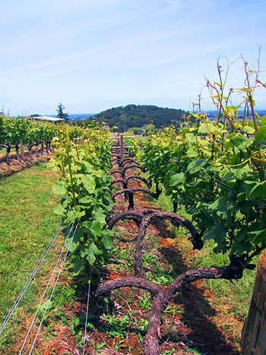
- Te Kauwhata Two Tier System
- T Trellis.

We will concern ourselves with the two most popular systems found in New Zealand, VSP and Scott Henry.
What are the aims of training and trellising?

  - Optimize quantity and quality of grapes produced
  - Allow for all cultural operations to be carried out e.g. pruning, irrigation, weed control.
  - Reduce the incidence of disease
  - Support the mechanical load of the grapevine
  - Result in an economically viable vineyard

Vertical shoot positioning
This consists of posts with one but usually two fruiting wires. These are at 100cm and 120cm. In addition there are one, two or three pairs of moveable foliage wires. These wires are used to keep the shoots confined within a narrow vertical canopy. This will allow light exposure to the grape bunches situated around the fruiting wire.

This system is suitable for cane or spur pruning and is very cost efficient. It is suitable for low to moderate vigour sites. In high vigour sites, shoot crowding may occur. This may lead to shading of the fruit and a consequent loss in quality. ‘Leaf plucking’ is a means of overcoming shoot crowding. Another way around this is to use a different trellis system, Scott Henry.

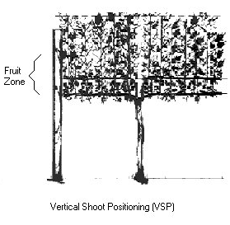
Foliage wire

Fruiting wire

Scott Henry
This is an adaption of the VSP system.

It consists of two fruiting wires at 100cm and 120cm and the 2 pairs of foliage wires.

There is an additional pair of foliage wires to allow the shoots growing off the cane on the lower fruiting wire to be trained downwards while those on the top fruiting wire grow upwards as normal.

Yield increases of up to 30% compared to VSP are possible. There is also better fruit exposure to light and fruit composition.

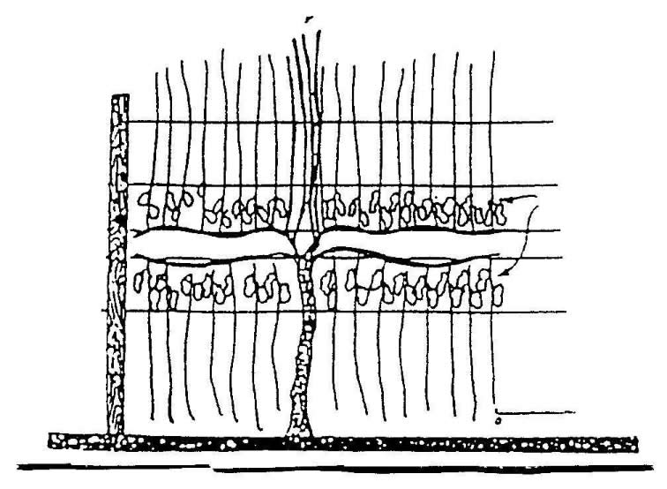
Foliage wire

Fruiting wire

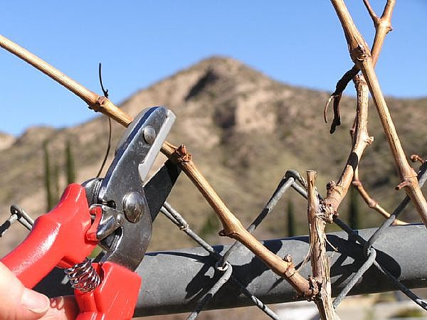
Pruning
Pruning is the removal of shoots, canes, leaves and other vegetative parts of the vine. It is NOT the removal of flowers (thinning) or bunches (harvesting).

A cane is a shoot having more than six nodes or buds on it. A spur is a cane cut back to 1 or 2 nodes.

There are two types of pruning:
- Spur
- Cane

Spur Pruning
Spur pruning generally has a permanent vine structure (cordon) supported by the trellis wires from which the short bearers (spurs) arise. The canes are cut back to leave a spur with one or two nodes from which the new cane will grow.

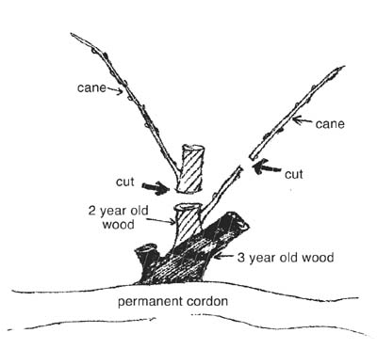
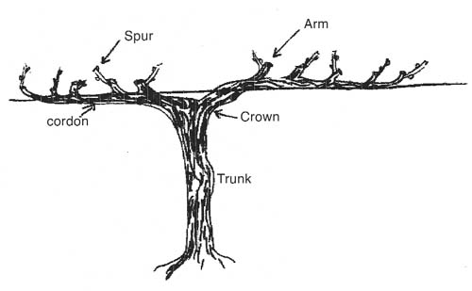

Spur pruning. At pruning the mature shoot most distant from the permanent cordon is generally removed and the closest one cut back to a 2-node spur
Advantages of spur pruning:
- Reduced pruning costs as it is quicker and less skilled
- Shorter pruning time
- Easier to train people to spur prune rather the cane prune.
- Allows mechanical pre-pruning http://nz.youtube.com/watch?v=_-OUrOdQs7k
- YouTube - vineyards winter pruning and cane stripes from IMECA
- More even bud break compared to cane pruning
- Fruit evenly spread along the fruiting wire
- Small berries and clusters with a high skin to pulp ratio favoured by wine makers.

Disadvantages
- Increased wood pests and disease such as mealy bugs.
- Cordon replacement may be necessary if the cordon becomes diseased.
- Fruitfulness may be reduced. In general basal nodes are not as fruitful as nodes in the centre of a cane.
- Spur sites may be lost if not carefully managed resulting in gaps in the canopy.http://nz.youtube.com/watch?v=FBK2qDO-srE
spur pruning

Cane pruning
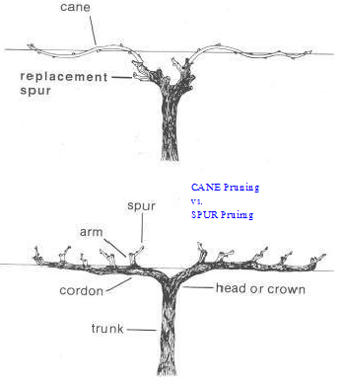
Cane pruned grape vines have a number of canes that are generally supported (usually wrapped and/or tied) by the trellis wires.

Each year new canes are selected that have grown from the replacement spur. The old cane(s) are removed and the replacement canes are wrapped and tied onto the trellis wire.

Advantages of cane pruning
  - Higher fruitfulness. Nodes tend to be higher up on the cane compared to spur pruning and bear more fruit thus increased yields.
  - Thin canopy base. This allows better exposure to light, spray penetration and mechanisation (ie trimming, leaf plucking, harvesting)
  - Decreased pest and disease problems as canes are replaced each year, unlike cordons. Sprays also penetrate better into the thin canopy and there is more air movement so less risk of fungal diseases.
  - Easy to downwards shoot position. Some trellising systems such as Scott Henry have canes facing downwards. This is easier to accomplish with canes rotating easily.
  - Easy to fill up the allotted space with fruit bearing wood as canes are laid down each year. Spur pruned cordons sometimes have dead spur sites and thus gaps in the canopy.

Cane selection cane also be carried out each year to give good healthy,
fruitful replacement wood.

Disadvantages of cane pruning
- Uneven budbreak along canes. Buds along a cane break unevenly with those near the head and the tip breaking first. This will lead to uneven shoot growth.
- Uneven shoot distribution. The ideal canopy has 15 shoots (buds) per metre. With different growth conditions the number of buds will vary as it will with vines with high and low vigour. (A high vigour vine cane will have less then 15 shoots per metre and a low vigour vine cane more than 15 shoots per metre)
- Harder to train staff to cane prune. They need to select suitable canes and leave suitable spurs for replacement canes for the following season.
- Expensive. Cane pruning takes longer so pruners are paid more.
- Not suitable for big vines that are spaced more than two metres apart as canes will not be big enough to fill up the trellis wires.
Leaf plucking
Episode 5 Leaf removal and berry development
During summer, if the canopy is too dense, leaves are plucked to allow more light and air to enter the canopy.

This better air circulation reduces risk of fungal diseases as they prefer a warm damp environment.

Light exposure of canes, and warm temperatures, are needed for fruit bud initiation for the following year.

Light is also needed for the grape clusters to ripen.

Shaded grapes produce an inferior wine quality due to:
- Decreased sugar
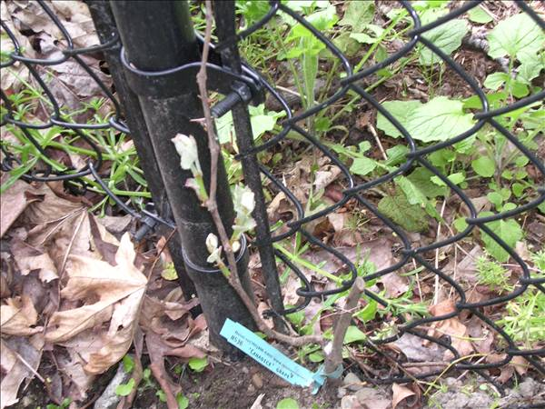
- Increased acid levels
- Increased potassium concentration
- Increased pH
- Decreased tannins
- Decreased colour pigments
- Increased green unripe characters
- Decreased flavour.

Lambs
You have already prepared the rams, vaccinated against disease risk and had the ewes on a rising plane of nutrition (flushing) to raise the ovulation rate.

Now its time to
- put out the rams and manage mating
- manage feed levels
- lamb the ewes

Rams and mating
Provided rains have a proven production record using fewer quality rams can increase production. A ram / ewe ratio of 1:50 is excessive while ratios of 1:200 with mature rams and ewes in intensive situations does not decrease performance as shown by trial figures below.
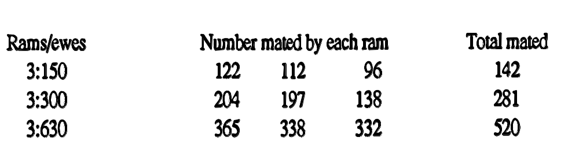

Ratios for rams and ewes (2 tooths) mating for the first time are often more conservative but for older sheep a ratio of 1:100 is common.

Cycling
Ewes normally cycle every 16-20-days for about 3 months. The rams are left in for two cycles so a ewe not tupped in the first cycle has a second opportunity.
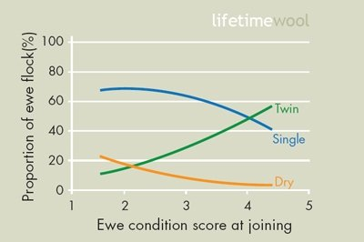

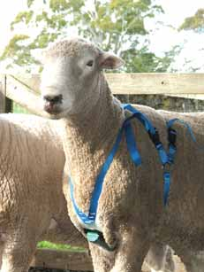

Leaving rams for 3 cycles results in an extended lambing period. To identify ewes which have taken the ram, (tupped) harnesses with coloured crayon are put on the rams. The crayon rubs off on the ewe showing whether she has been tupped or not and by using different colours each cycle, in which cycle.

This is useful for identifying groups for lambing and dry (non pregnant) ewes.

Feeding
After flushing, ewe weight and condition is maintained throughout mating. After 2 cycles a winter feed programme begins.
There are many variables –
- seasonal growth, weather
- supplementary feed
- farm practices like slowing down the speed of rotational grazing and break feeding.

In early pregnancy the energy requirements of the foetus are small and useful food or metabolisable energy (ME) requirements are suitable to a non pregnant ewe.

Severe underfeeding can cause embryonic death and birthweights can be lowered if underfeeding continues into mid pregnancy.

In late pregnancy (50 days prior to birth) energy demands of the foetus may increase by 50-100% over the maintenance requirements of the ewe.
Ewes especially those with more then one lamb often cannot eat sufficient to meet their energy requirements as their gut space is restricted.
Body reserves of the ewe itself are used up and pregnancy toxaemia or "sleepy sickness" can result from sudden or severe under nutrition. Lack of nutrients like magnesium and calcium cause metabolic diseases like milk fever.
Over feeding in late pregnancy can cause problems too. Large lambs can have a difficult birth and sometimes ewes straining to empty out can force out the vagina or even uterus to the outside causing a 'bearing' or prolapsed uterus.
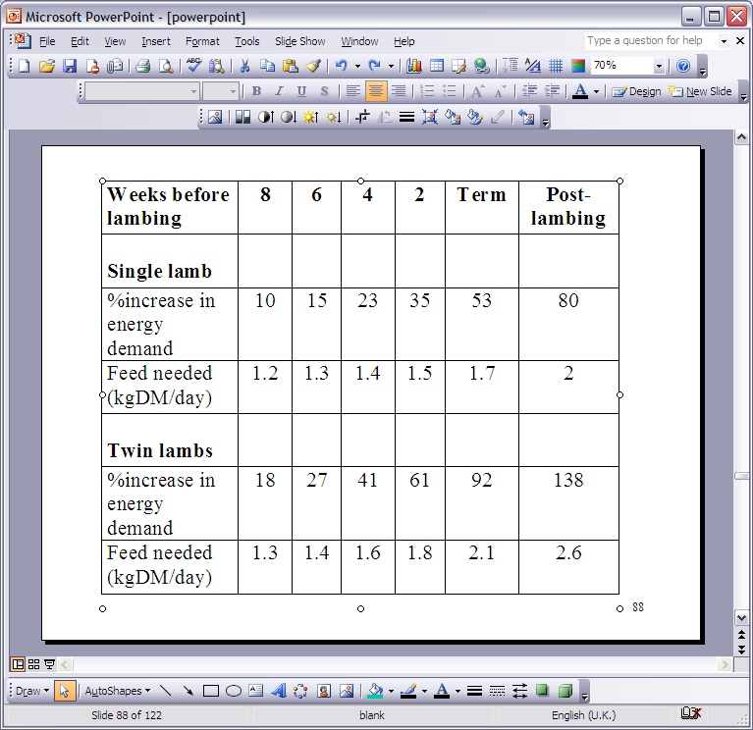

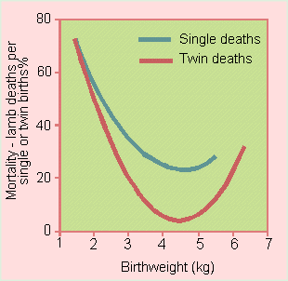

Lamb fatalities and weight at birth

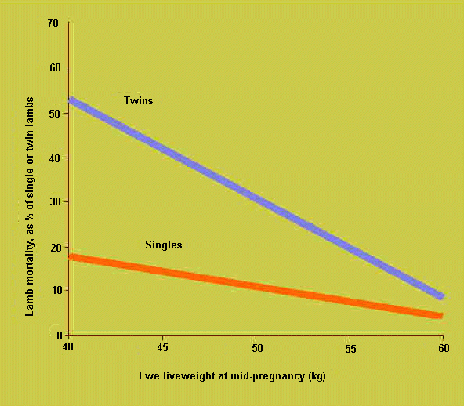
How feeding affects livestock production

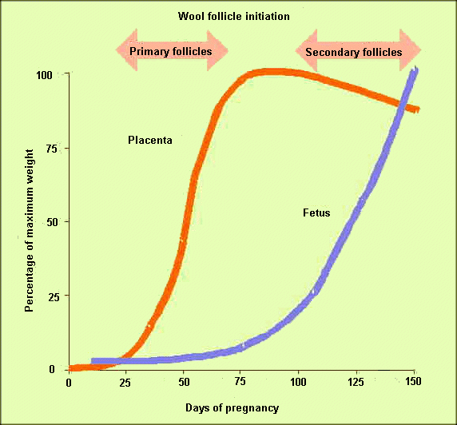

How feeding affects wool production

Lambing
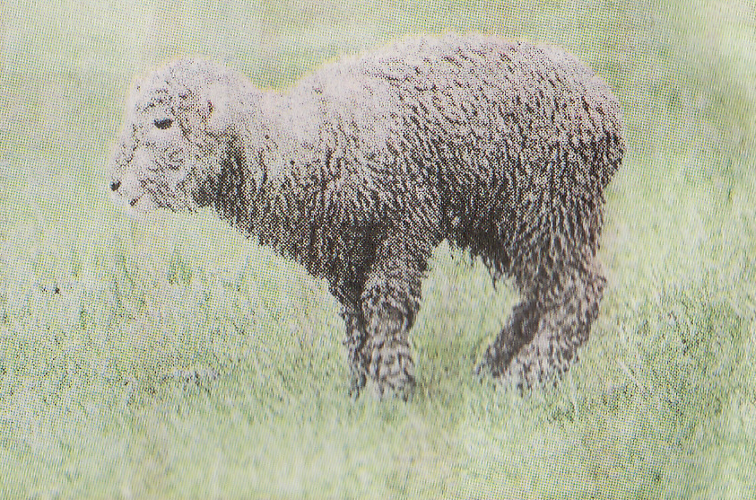
Husbandry inputs can range from intensive shepherding with 'lambing beats ‘twice daily to 'easy care' where lambing ewes are left undisturbed.

Over time easy care lambing eliminates stock prone to birthing difficulties and increases survival rates.

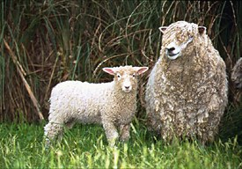
Shelter and weather
Where possible easier, more gently sloping land with shelter is used for lambing. In steep paddocks twins can more easily get mismothered and bad weather can result in lambs losing body heat which reduces the suckling drive.

Suckling soon after birth is important as antibodies in the colostrum milk (milk formed in first few days - rich in protein and antibodies) are absorbed in the first 36 hours.

Smaller lambs lose heat more rapidly and exposure deaths are more common in twins or where birth weights are low

Difficult births
Difficult births or "dystocia" is caused by a pelvic opening too small for the size of the lamb like large single lambs or the lamb being positioned incorrectly.

The illustrations show how problems can occur.
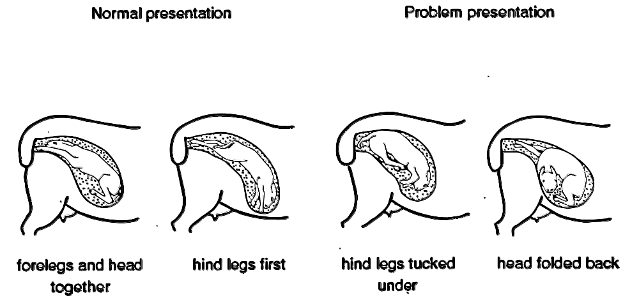
Management inputs (lambs)
Farmers have practical husbandry skills but they also need to make management decisions as to the type and timing of inputs into the production process.

The link between management and husbandry produces a schedule of operations which affects yield, quality and profitability of market opportunities. The farmer will look at some areas for lamb production where their decisions will affect

- yield and quality
- which market you choose
Yield
The number and weight of lambs produced directly influences gross income and potential profit. What are some of the decisions you need to take to improve yield?

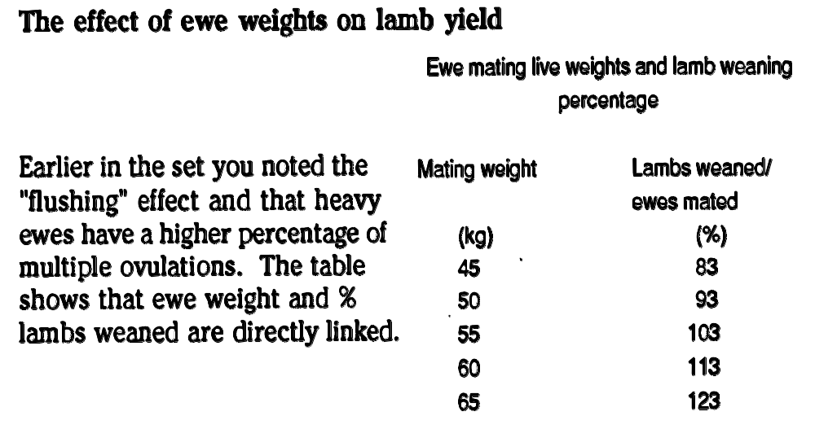

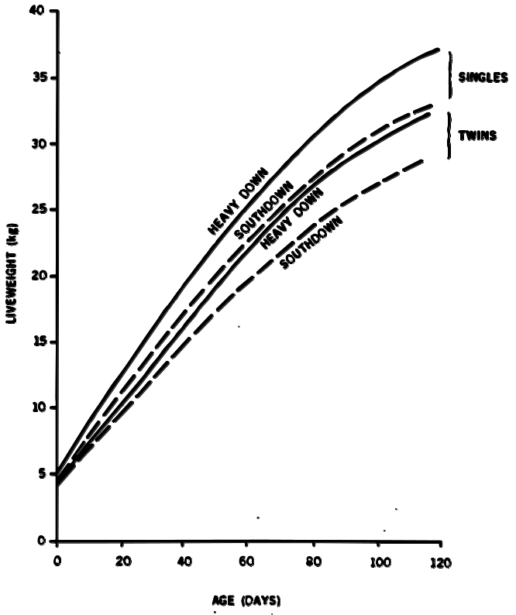
While individual lambs in multiple births may be lighter than single lambs the following graph shows that total production will be higher.

There will be seasonal effect on ewe weights and to achieve
optimum ewe weight you may need to--
- save feed especially for flushing
- irrigate if feasible
- give ewes a larger grazing area
- speed up grazing rotation
- in difficult conditions provide supplementary feed or crops
Choosing breeds
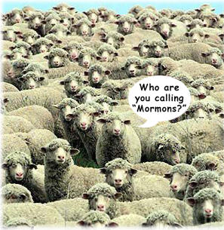
For prime lamb production a major decision is your choice of ram and ewe breed or cross breed.

Farm location and type of country, farm policy (breed own ewe replacements for example), farmer preference and market signals all affect this decision.

While there are breed differences in growth rate and conformation there is also wide variation within breeds too.

This table shows differences due to ram breeds and ewe breeds on carcass weight of lambs-

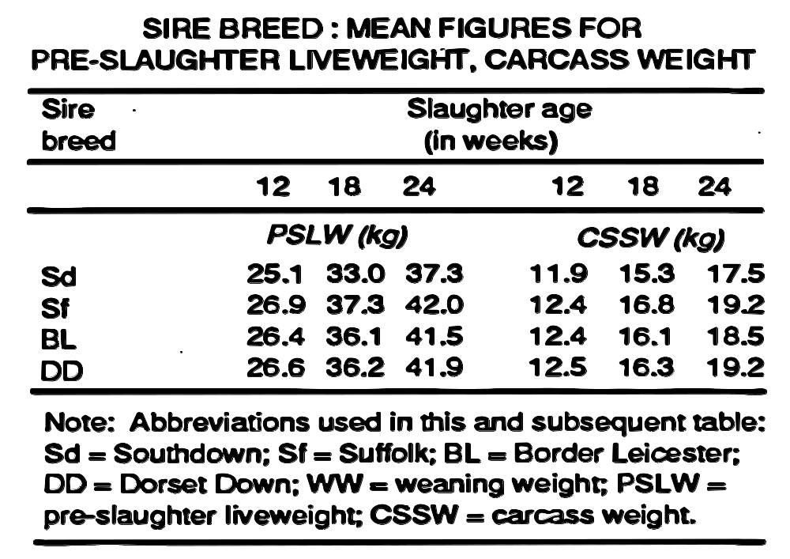

This table below shows increase in yield due to heterosis (or hybrid vigour) from crossbreeding. The Dorset breed in this trial increased lamb weights whether used as a sire or dam.
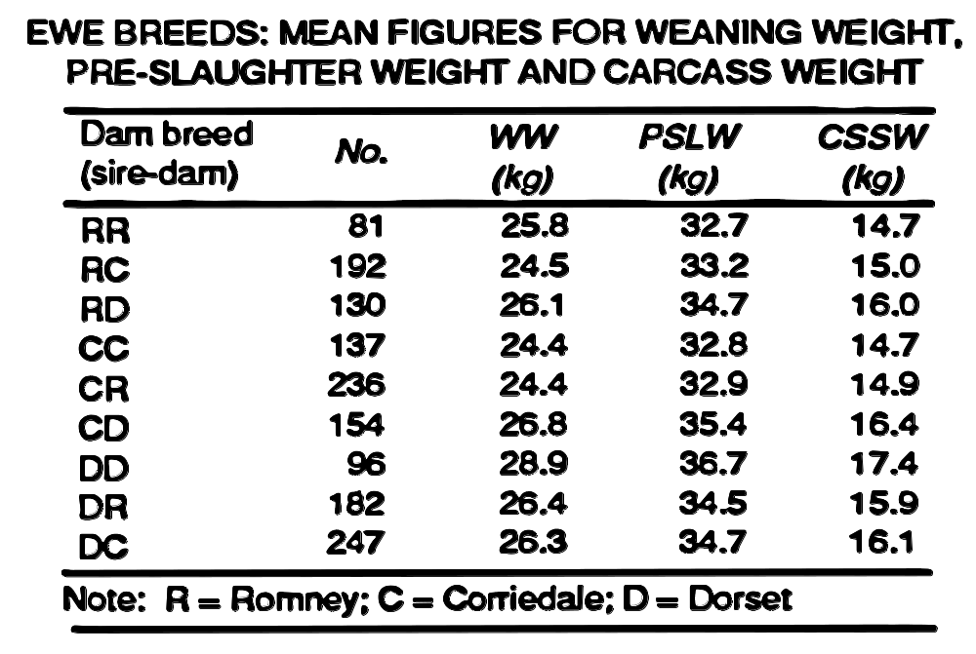

Carcass quality
Increasing emphasis on larger, leaner lambs encourages use of ram breeds with faster growth rates and low fat levels at higher weights.

Choosing a market
The majority of lambs are produced for the summer killing season and are sold on two major markets.

Prime market
Most prime lambs are sold direct from farm to meat processing companies. Export lambs are paid according to a schedule of prices announced weekly for export weights and grades.

Local sales in main centres sell prime stock by auction. The meat may be bought for export or NZ consumption but these sales help set market values. Weekly stock sale values are reported in the newspapers.
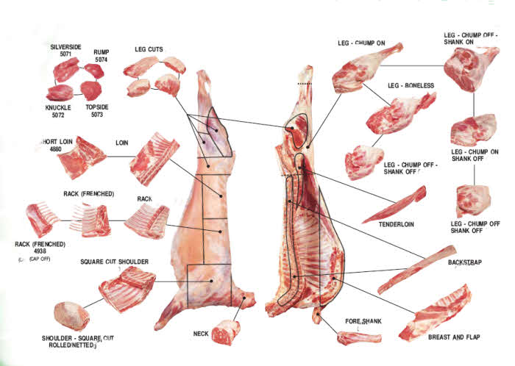
Store market
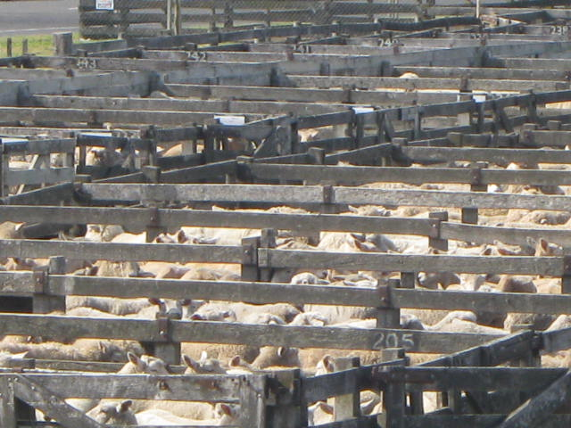
The 'store' market is part of the weekly auction sale in the main centres.

Store stock (which is not in prime killable condition) is bought by farmers who can finish or grow them on to prime condition.

Prices for store stock vary markedly during the season and from district to district. The prices are affected by supply, grass availability, market prospects but are lower than prime prices to give a profit margin. (grass market)

Alternative markets
Management decisions can lead to other markets like

Live Trade.
This involves shipments of live sheep to the Middle East and contracts are let for autumn delivery particularly for heavy lambs and long tailed lambs. Decisions have to be taken about suitable late maturing sires and profitability compared to schedule or auction prices operating in the future. Live shipments from NZ have now ceased but licenses are issued from time to time.

Out of season market.

With increasing use of meat works and year round markets for chilled product, contracts are offered for out of season lambs.

For example premiums can be paid for lambs available from July-October before traditional killing begins. To achieve early lambs hormone treatments can be used so that ewes can be mated outside their normal breeding season.

Breeds like Dorset and Finn have naturally extended breeding seasons which can be used to advantage too. This early lambing can have advantages for areas with dry summers but adequate autumn/winter feed is essential.

Grape Yields.
The grape yield directly affects the gross income and potential profits.

Management decisions that have a direct affect on yield include:
- Pruning system. In most varieties spur pruning has reduced yield.

- Trellis system. A system that reduces the canopy width and allows good air movement will have reduced pest and disease problems increasing yield and also improve grape ripening with the additional light reaching the grapes.

- Selection of clone/rootstock. This selection will result in a better chance of achieving an ideal canopy. An ideal canopy allows for optimum yield without compromising quality. The selection of a vigorous rootstock on a fertile soil will result in vigorous vine with a low yield and poor quality grapes. Fertile soils should use low vigour rootstocks such as Riparia Gloire.

- Leaf plucking. Vigorous vines with a thick canopy lead to problems with the ripening of the grapes and therefore the quality of the grapes produced. Leaf plucking increases exposure to sunlight which is necessary for proper ripening and the production of the chemicals that will produce a quality wine. Without sunlight, problems may include decreased sugar, decreased tannins, decreased colour pigments and increased green unripe characters.

Calendar of Events and Schedule of Operations
The timing of activities gives a calendar of events and the addition of manipulations to the inputs gives a schedule of operations.

For grapes and lamb you'll look at
- time lines and a calendar of events for the overall process
- producing a schedule of operations.
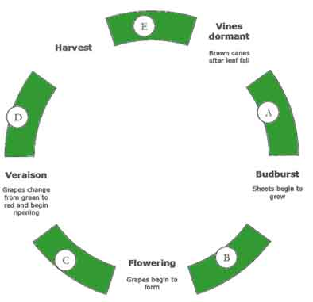

GRAPES
Growing grapes follows an annual cycle with vineyard operations timed around these events.
The main stages in grapes are --
- budburst (when dormant vines begin the sprout new shoots)
- flowering, set (beginning of fruit development)
- veraison (beginning of fruit ripening) and leaf fall.

Over winter vines are dormant and during this time they are pruned to the required number of buds for the coming growing season.

Budburst announces the beginning of the new growing season and for the next 4 months the shoots will grow and need to be trained to produce a full, open canopy.

During this time flowering occurs followed closely by set (beginning of berry development) and although the vine is concentrating most of its energy on shoot growth, the small berries are beginning to grow.

By mid January the canopies are full and need to be trimmed, and around this time, the crop load is assessed to determine whether fruit will need to be removed.

March is the time for the next stage, known as veraison. The berries are nearly full size and over the period of one week will turn from green to red (red varieties) and this transition allows a brief glimpse at the comparative advancement of individual vines, and indeed individual bunches.

Veraison indicates the beginning of ripening, with the vine now focusing on moving sugar to the berries.

After the grapes have reached optimal ripeness, they are harvested. The vine then prepares for the winter and begins to store carbohydrate in the woody parts of the vine.

The passing of each event announces the beginning of a new stage in the vineyard management cycle. These stages (represented by the letters A-E) have an associated set of vineyard operations
  - Winter - vines dormant
Pruning

B. Spring management
Cover crop management, Budrubbing, Shoot thinning, Lifting wires, Canopy management, Undervine weed management

C. Summer management
Cover crop management, Lifting wires, Vine trimming, Canopy management, Leaf plucking, Yield assessment, Yield adjustment

D. Ripening
Yield adjustment, Net application

E. Autumn management
Net removal, Winterization of plant and equipment, Planting cover crops

Fitting events into the calendar
Take a single crop planted in March, picking starts 12 weeks later and ceases at the end of December.

The end of season clean up takes two weeks and sterilisation and fertilisation 6 weeks.

From seed sowing to ready for planting takes 6 weeks. Individual time lines would be
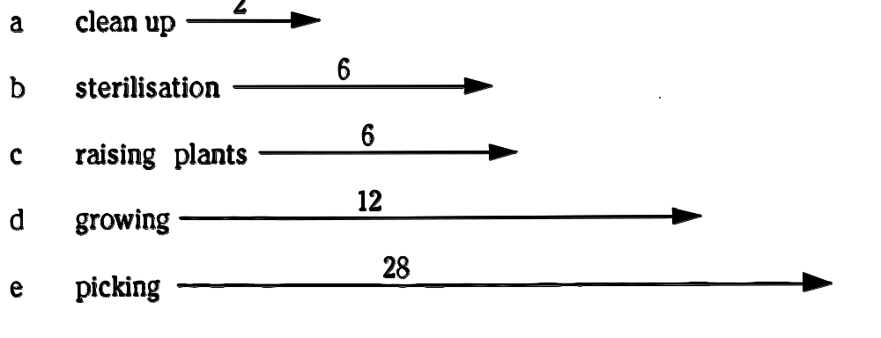

Allow sterilisation and raising the plants to run concurrently and use the March 1st the date as the planting point on the time line. Your calendar could look like this—

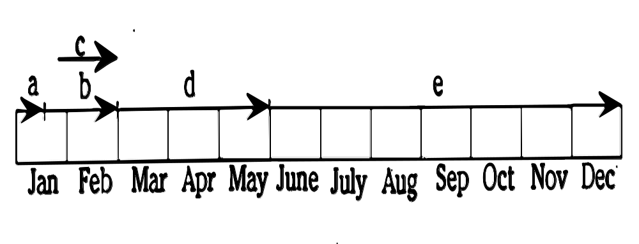

Schedule of operations
Now you have a calendar of events and time intervals for the overall process.
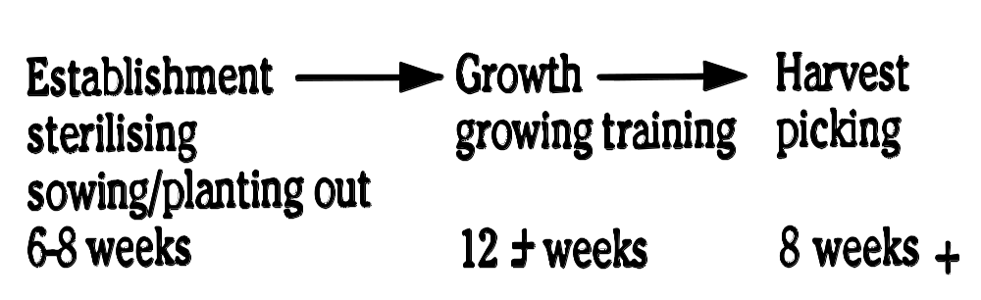

Establishment phase

For the establishment stage husbandry inputs control the environmental and biological factors.
Your management decisions which affect yield, profit, market and quality would at this stage be cultivar choice and crop timing. When would you apply these to the calendar of events?

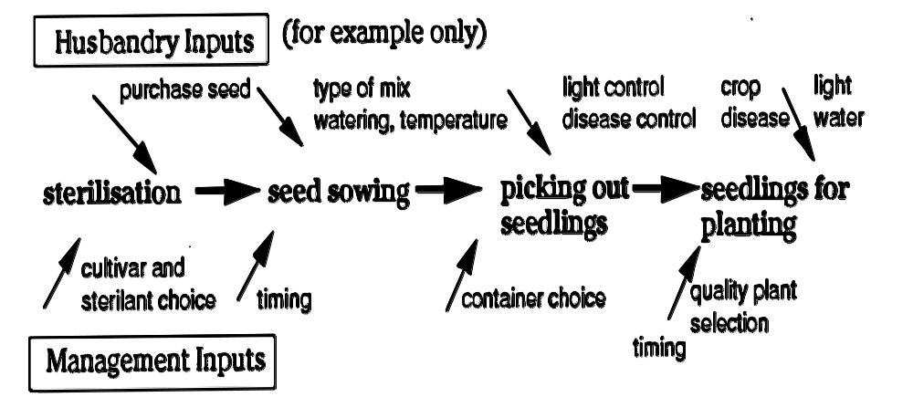

Linking management inputs to husbandry inputs gives a schedule of operations which will be added to when growth and harvest are covered.

Lambs
To produce the traditional spring lamb let’s look at the
main activities and timing of events
- calendar of events
- schedule of operations

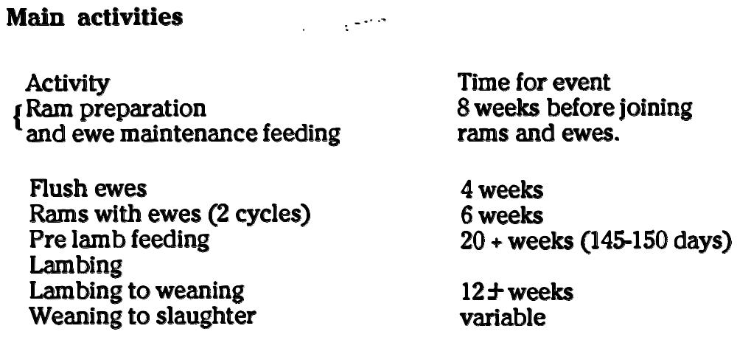
Calendar of events
Remember that optimum feed conditions and stock weights are not always attainable. Events may not follow at exact dates but the sequence remains the same. Putting these stages onto a time line could look something like this.

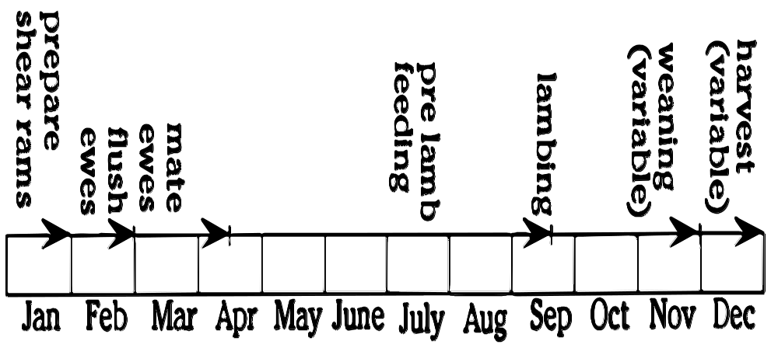

Schedule of operations
Compared to annual production of 1 or more crops in a protected greenhouse environment in farming anticipation of prices and making changes of breed or performance are longer term and growing seasons are variable.

For example yield increases from lambing % or change in breed for larger leaner lambs can be reduced by lambing losses due to weather or reduced pasture growth rates from a poor season.

Lets look at a possible schedule for establishment in lambs.



