Lesson 1 :

Lesson 1
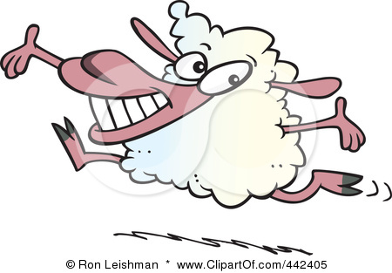
In this Lesson you will

look at some definitions of the key terms to do with growth and development

How we measure some aspects of growth and development

and list and explain the benefits of high animal growth rates/productivity.

The worksheets in the sub-pages can be added to your one note document.

The rate at which animals grow and reproduce, and the size,shape and composition of their carcasses are all aspects of growth and development that affect the profitability of a farming business. The following sequence of events covers the normal growth patter in all mammals: conception, development of the embyro, development of the foetus, birth, puberty, reproduction, old age and finally death. Farm animals can be slaughtered at different stages depending on the markets available.

Discuss the benefits of having animals attain target slaughter weights earlier or in less time(High Growth rates – more efficient use of feed, lower fat content)
Financial benefits of greater yields of ‘harvested’ products (e.g. wool, milk).
Farm management benefits should also be discussed.
list and explain the benefits of high animal growth rates/productivity.
Submit your answer

Measurements of Growth & Productivity

There are a variety of methods and measurements used for growth and productivity in New Zealand farming systems.

[A] Fill in the following table to show what is measured for each agricultural product.

Wool | Milk | Meat (lamb, beef, pork)

[B] Fill in the following table to show the unit that each of these products is measured in.

Product | Unit of measurement | Product | Unit of measurement
Wool |  | Chicken meat
Beef meat |  | Deer velvet
Milk |  | Deer meat
Lamb meat |  | Pig meat
Pasture |  | Sows

[C] Select the correct measuring devices/methods used to measure these products.

Weight band electronic scales ultra sound herd testing GR measurement

Pigs

Beef and sheep meat

Beef, sheep and pig meat

Milk

Pigs (pregnant)

Animal Production Pair Definition W/S

Word | Definition | Word
Growth | l | l
Development

Production

GR

Maintenance
Feed

Production
Feed

