Glue this page into your book and then fill in the missing words. The answers are provided.

absorbed, digested, breaking, down, blood

Livestock Digestion

Digestion is the process of b___________

d_____________ feed into simple substances

that can be a______________ by the body.

Absorption is the taking of the d___________

parts of the feed into the b______________.

large, chewing, food, absorbed, breakdown, saliva, blood, small, faeces, Digestion, digests,
chewing, Ingestion, sugar, blood

Stages of Digestion

1. I_________________ ripping grass and c__________ mixing with

s_______________ which d______________ sugars in the grass.

2. D __________________ is the b______________ down of feed into s__________

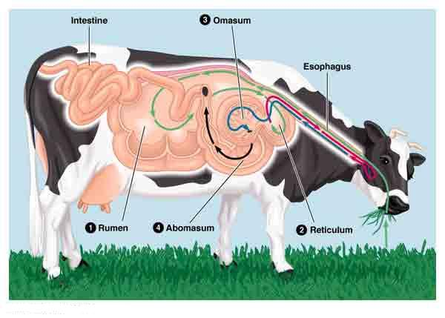
units that can be a______________ into the b________________.

3. Absorption – digested f____________ enters the b_______________ through the

s_________ intestine. Water is then absorbed through the l_______________ intestine.

4. Elimination – undigested food not absorbed is passed out of the anus as f___________.

stomach, sheep, deer, enzymes, digestion, grass, four, fibrous, Mono-gastric, acids, cows,
balage

Types of Digestion

1. M______________ d________________. A single s____________ which uses

a______________ and secretes e______________ which digests feed.

2. Ruminant digestion – f__________ chambered stomach in s__________,

c__________, goats and d__________. This type of digestion allows the animal to eat

tough f____________ food like g_________, hay, silage or b______________.

farm, wire, enzymes, fibrous, Chewing the Cud, reticulum, Omasum, water, Abomasum,
stomach, grinding, plastic, Mono-gastric, protein, acid, bacteria.

Ruminant Digestion

1. Rumen – used to f b and other micro-organisms that ferment the grass.
- These are then digested and are the source of p , fatty acids and other carbohydrates.

- The R is a small pouch on the side of the rumen that traps f
materials which are sent back into the mouth to be further broken down by the teeth.
This is called C .
Other materials such as w and p are trapped here.

3. Omasum - produces a g____________ action on the feed and removes some of the

w__________ from the feed.
4. A_______________ - is also referred to as the true s___________ because it is

similar to the stomach in m________________ animals. Hydrochloric a and
digestive e are mixed with microorganisms to kill and digest them and any

remaining feed.

Intestine, Small Intestine, water, bile, blood, villi, toxins, sugar

5. S I - Digested food is absorbed here into the b system.

All along the small intestine are tiny projections call v which help the intestine
absorb more food into the blood.
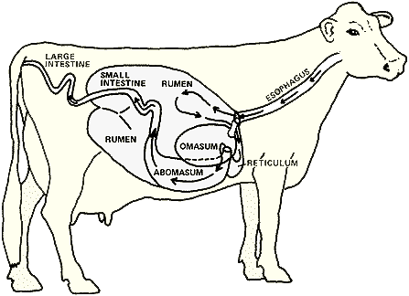
6. Large I - Nearly all the remaining
w is absorbed into the blood system.

7. Liver – has many functions: Produces b
which digests fats

It regulates blood s .
Removes t from the blood and many others.

