Marketing Audit
A marketing audit is basically a situation analysis of the business’s marketing strategies. This includes the current marketing plan, advertising, research, 4 Ps, financials, analysis of the product, its features and how it is selling and so on. In other words, what the business is currently doing in terms of marketing their particular product.

Marketing Audit (http://www.marketingteacher.com/lesson-store/lesson-marketing-audit.html)

How to conduct a marketing audit
The marketing audit is a fundamental part of the marketing planning process. It is conducted not only at the beginning of the process, but also at a series of points during the implementation of the plan. The marketing audit considers both internal and external influences on marketing planning, as well as a review of the plan itself.
There are a number of tools and audits that can be used, for example SWOT analysis for the internal environment, as well as the external environment. Other examples include PEST and Five Forces Analyses, which focus solely on the external environment.
In many ways the marketing audit clarifies opportunities and threats, and allows the marketing manager to make alterations to the plan if necessary.
This lesson considers the basics of the marketing audit, and introduces a marketing audit checklist. The checklist is designed to answer the question, what is the current marketing situation? Lets consider the marketing audit under three key headings:
- The Internal Marketing Environment.
- The External Marketing Environment.
- A Review of Our Current Marketing Plan.

1. The Internal Marketing Environment.
What resources do we have at hand? (i.e. The FIVE 'M's):
- MEN (Labor/Labour).
- MONEY (Finances).
- MACHINERY (Equipment).
- MINUTES (Time).
- MATERIALS (Factors of Production).
- How is our marketing team organised?
- How efficient is our marketing team?
- How effective is our marketing team?
- How does our marketing team interface with other organisations and internal functions?
- How effective are we at Customer Relationship Management (CRM)?
- What is the state of our marketing planning process?
- Is our marketing planning information current and accurate?
- What is the current state of New Product Development? (Product)
- How profitable is our product portfolio? (Product)
- Are we pricing in the right way? (Price)
- How effective and efficient is distribution? (Place)
- Are we getting our marketing communications right? (Promotion)
- Do we have the right people facing our customers? (People)
- How effective are our customer facing processes? (Process)
- What is the state of our business's physical evidence? (Physical Evidence)

2. The External Marketing Environment.
As a market orientated organisation, we must start by asking - What is the nature of our 'customer?' Such as:
- Their needs and how we satisfy them.
- Their buyer decision process and consumer behaviour.
- Their perception of our brand, and loyalty to it.
- The nature of segmentation, targeting and positioning in our markets.
- What customers 'value' and how we provide that 'value.'
What is the nature of competition in our target markets?
- Our competitors' level of profitability.
- Their number/concentration.
- The relative strengths and weaknesses of competition.
- The marketing plans and strategies of our competition.
What is the cultural nature of the environment(s)?
- Beliefs and religions.
- The standards and average levels of education.
- The evolving lifestyles of our target consumers.
- The nature of consumerism in our target markets.
What is the demography of our consumers? Such as average age, levels of population, gender make up, and so on. How does technology play a part?
- The level of adoption of mobile and Internet technologies.
- The way in which goods are manufactured.
- Information systems.
- Marketing communications uses of technology and media.
What is the economic condition of our markets?
- Levels of average disposable income.
- Taxation policy in the target market.
- Economic indicators such as inflation levels, interest rates, exchange rates and unemployment.
Is the political and legal landscape changing in any way?
- Laws, for example, copyright and patents.
- Levels of regulation such as quotas or tariffs.
- Labour/labor laws such as minimum wage legislation.

3. A Review of Our Current Marketing Plan
- What are our current objectives for marketing?
- What are our current marketing strategies?
- How do we apply the marketing mix? (Including factors covered above in (a))
- Is the marketing process being controlled effectively?
- Are we achieving our marketing budget?
- Are we realising our SMART objectives?
- Are our marketing team implementing the marketing plan effectively?
- Levels of staffing.
- Staff training and development.
- Experience and learning.
What is our market share? (total sales/trends/sales by product or customer or channel) Are we achieving financial targets? (profit and margins/ liquidity and cash flow/ debt: equity ratio/ using financial ratio analysis)
http://www.marketingteacher.com/lesson-store/lesson-marketing-audit.html

Boston Matrix
One of the tools the business might use to analyse the business or its product’s growth and market share while conducting a marketing audit is the Boston Matrix.
Definition: The Boston Matrix is a measurement of how successful a business is or where a business's products compare to competitors' products, calculated by looking at the business as a whole or each product's share of sales in its particular market and that market's rate of growth. The following image is a diagram of the Boston Matrix (taken from cowanglobal.com). The different parts of the matrix will be explained below.

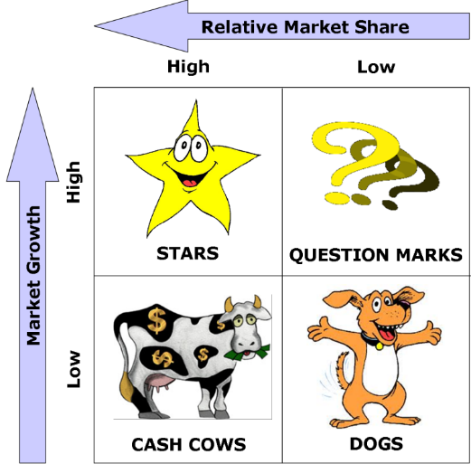
There are four different sections of the matrix as shown above. The top left hand section displays high market share and high market growth and is known as the Star (as mentioned above this could refer to the business or one or more of its products). The bottom left shows high market share but low market growth and is depicted as the Cash Cow. Top right is the Question Mark (also sometimes known as the Problem Child) which is a high growth business or product but with low market share. And in the bottom right hand corner of the matrix is the Dog which has low market share and low market growth.
Star – Stars are similar to Cash Cows in that they generate lots of revenue, but due to their growth market a lot of money is spent on them unlike Cash Cows. Stars require a lot of investment, in terms of resourcing, to keep it achieving and growing in the market. Often when growth slows down Stars are more recognised as Cash Cows.
Cash Cow – Cash Cows experiences high market share but have stopped growing in the market. They are a steady earner and typically should generate more income than they consume. The income from Cash Cows is used to prop up and grow the Question Mark which is a high growth product or business without much market share. Cash Cow income also supports the Stars of the business.
Dog – Dogs have a low market share and a low growth rate. They don’t bring in much income, or use much income to keep them going. Some theorists believe businesses should get rid of Dogs and use the income spent on them for the Star product of the business. Other theorists believe if enough income and care is put into a Dog it can turn into a Cash Cow.
Question Mark –Also known as the Problem Child have a high growth factor but a low share of their particular market. They are the most difficult products or businesses to deal with. They consume income to fund growth but generate little in return. They are known as Question Marks because they do have potential but there is often a question about how much income to invest in them to make them a Star.
Boston Matrix Activity
Select a few well known consumer brands (with different product lines), e.g. Coca Cola, Apple, Covergirl, Xbox, Samsung, etc and get the students to identify which quadrant of the Boston Matrix the different products might belong to – students should be able to support their answers. This could be completed in small groups with students relaying their findings back to the class. Outcomes could be discussed in class as some students will have different ideas.

Product Life Cycle
The Product Life Cycle (PLC) consists of four stages. They are the Introduction stage, the growth stage, the maturity stage and the decline stage. Analysing the PLC is useful for businesses so they can evaluate the sales of their products and decide what they want to do with them.
In the introduction stage sales are slow but climbing. The business is spending a lot of money making consumers aware of their product. The growth stage sees stronger sales and profits occurring with the business using the extra revenue to further promote the product. In the maturity stage sales are steady and the business questions whether there is a need to differentiate their product in order to maintain a competitive advantage. The decline stage is when sales start to taper off. This can be due to many other similar products entering the market or consumers choosing to buy other products.
Assessing where the product sits on the life cycle in conjunction with other tools such as the Boston Matrix will paint a clearer picture for the business about their product and what to do with it.

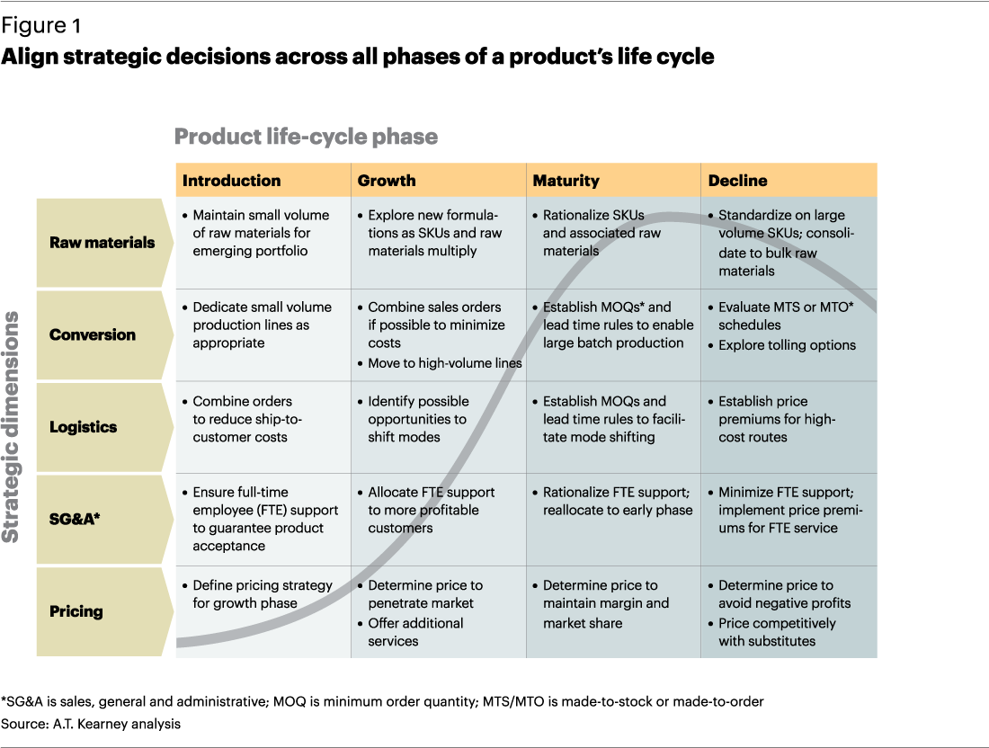
The Product Life Cycle (www.atkearney.com)

