GORE HIGH SCHOOL

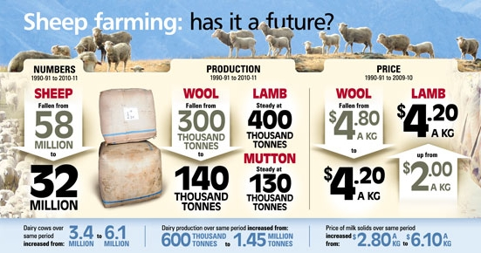

NCEA Level 3 Agricultural and Horticultural Science

Student Handbook 2020

Name: ___________________________

NAME : __________________________________________________________________________________

Level 3 Agricultural/Horticultural Science

COURSE OUTLINE

Aims
• Develop student knowledge of marketing and production factors; and how market forces affect supply and demand of primary products
• Enable students to apply this knowledge to research and report on the profitability of a NZ primary product. Students will also investigate an aspect of a NZ primary product or its production
• Increase student awareness of human responsibilities in managing resources and the environment by analysing a primary production environmental issue

Course Outline and Assessment
The Year 13 Agriculture/Horticulture course contributes 43 credits towards the National Certificate of Educational Achievement (NCEA), and these are based around the Achievement Objectives specified in The New Zealand Curriculum, 2007(NZC).
Name and number | Title | Credit weighting | Assessment
Ag & Hort Science 3.1 AS 91528 | Carry out an investigation into an aspect of a New Zealand primary product or its production. | 4 | Internal
Ag & Hort Science 3.2 AS 91529 | Research and report on the impact of factors on the profitability of a New Zealand primary product. | 6 | Internal
Ag & Hort Science 3.3 AS 91530 | Demonstrate understanding of how market forces affect supply of and demand for New Zealand primary products | 5 | External
Ag & Hort Science 3.4 AS 91531 | Demonstrate understanding  of how the production process meets market requirements for a New Zealand primary product(s) | 4 | External
 |  | 19
The two internally assessed AS will be assessed as follows:
3.1 An investigation followed by in-class processing towards the middle
of Term 3.
3.2 A research task followed by in-class processing towards the end of Term 2.
Assessment results are expressed as:
N Not Achieved (did not meet required standard)
A Achieved (meets the required standard)
M Merit (meets the required standard demonstrating good work)
E Excellent

Unit Standards
This Course May Cover
Std No | Title | Level | Credit
19054 | Ride a motorcycle on hilly terrain | 3 | 3
37 | Install fencing wire | 3 | 6
19131 | Demonstrate knowledge of fencing assemblies | 3 | 3
24821 | Locate the position of, and install, primary and intermediate posts for fencing | 3 | 6
19115 | Handle and move livestock | 3 | 6

GORE HIGH SCHOOL
AGRICULTURE AND HORTICULTURAL SCIENCE DEPARTMENT
ASSESSMENT POLICY AND PROCEDURES
The Ag/Hort Department will operate the following policies in 2020

Student Information
Each Student will be issued with a course handbook at the beginning of the year, including:
• Titles of the Achievement Standards in the course, their credit values
and assessment methods
• A course outline
• An assessment statement detailing the approximate dates and types
of assessment

Authenticity
All work submitted for assessment must be the student’s own work. All resources used must be copied and submitted with assignments. Where appropriate, the sections of these references that were used should be highlighted.
Students and caregivers will be requested to sign authenticity declarations.
Where evidence indicates that work submitted is not authentic in these terms, Gore High School policy will be followed.

Appeals against Internal Assessments
Appeals must be made within two school days of work being returned. Initial approaches should be to the teacher, but if agreement cannot be reached, the HOD or the Dean should be consulted within the same time frame.

Deadlines
School policy is clear on submission dates, and will be strictly adhered to.

Reassessment
It is School policy that reassessment will be available only for those students who did not achieve credit or better in the initial assessment.

STUDENT RESPONSIBILITIES

- Students should be familiar with the assessment program and policy in the Department.
- Students should make sure they understand the approach to assessment in each case.
- Students should take the responsibility for checking the accuracy and completeness of the assessment when work is returned.
- Having checked the assessment, students should verify the sighting and acceptance of the grade by signing the cover sheet for each item of assessed work.
- If there is a problem or concern with an assessment, it is the student’s responsibility to discuss this with the teacher in the first instance, or the HOD or Dean.
- Where compassionate consideration is requested, such requests must be made in a timely way. Under normal circumstances, this must be before the submission date, but where there are special circumstances these must be brought to the attention of the Department as soon as possible.
For internal assessments, compassionate consideration may take the form of an estimated mark based on work with similar skill or knowledge content.
For external assessments, NZQA guidelines will be followed.
- Students should be aware that student work may be retained by the Department until it is no longer needed for assessment purposes. Under these circumstances, the work may be copied for student use.

DECLARATION
I/We have read the student information and fully understand the requirements and obligations they describe. I understand that part of my responsibility in this course will be to attempt ALL external Achievement Standards during NCEA examinations.

Student Signature: _______________________________ Date: ____________

Caregiver Signature: _____________________________ Date: ____________

