**1. Pests**

***Refer to the power point “plant pests and their control” on weebly***

A ***pest*** is an animal which ***damages plants***, usually by ***feeding*** on them.

Pests may be ***large*** for example, possums, rabbits and birds or ***small***, for example insects and snails.

You need to find out ***what*** pests are attacking plants so that we can decide the ***best way to control*** them. The easiest way to do this is to look at the ***main clues:***

1. The ***sort*** of ***damage*** that it has caused
2. The ***sort*** of ***plant*** that is being attacked.

The main ways plants are damaged are:

* + ***Chewing*** which causes holes in fruit, flowers and leaves
  + ***Sucking*** which causes stunted growth, leaf curl and spread of disease

Once a pest has been ***identified*** it can be targeted with a ***control method*** or ***prevention practice***: A ***control method*** is used to control the numbers of weeds, pests or diseases

A ***prevention practice*** prevents them becoming a problem

**Sort the following practices into control and prevention in the table below.**

|  |  |  |  |  |
| --- | --- | --- | --- | --- |
| Removal of dead material | trapping | weed free | harvesting times | pruning |
| use of natural enemies | planting times | burning infected material | plant resistant varieties | mulching |
| prevent plant injury | companion planting | hygienic growing | using herbicides | crop succession |
| soil fertility | clean tools | insecticides | spacing | drain soil |
| sterilisation | crop rotation | nematicides | repellents | low humidity |
| train | clean seed | pesticides | compost | shelter |
| spraying fungicide | poison baits | cultivation | clean planting material |  |

|  |  |
| --- | --- |
| Control practice of weeds, pests and diseases | Prevention practice for weeds, pests and diseases |
|  |  |

***Prevention***:

Methods that prevent pests:

* + keep ***weeds*** away because they are hiding places for pests
  + Burn or compost all ***rubbish*** so that it does not attract pests.
  + Keep ***tools*** and ***containers*** clean when not in use.

***Control***

**Natural** control – methods not using chemicals

*Fill in the below table using page 105 of Growing On and the powerpoint “pests and their control*”

|  |  |
| --- | --- |
| ***Method*** | ***Pest controlled*** |
| **A Beer trap** |  |
| **Soapy water** |  |
| **Derris dust made from the *pyrethrum* daisy** |  |
| **Yellow plastic sheeting painted with oil** |  |

**Biological control** – control using ***natural enemies*** of the pest

|  |  |
| --- | --- |
| ***Method*** | ***Pest controlled*** |
| **Lady Birds** |  |
| **Hedgehogs** |  |
| **Wasps** |  |

**Recognise the best time in a lifecycle to try to control a pest**

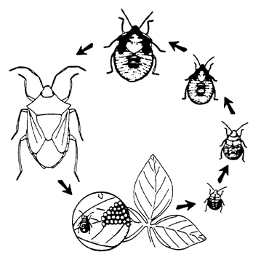

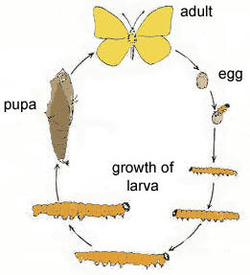

*On the above life cycles circle the best stages for control.*

*Explain your choice:*

*In your explanation you should:*

* *Describe the stages of your choice*
* *Explain why these stages are the best for control*

_______________________________________________________________________________________________________________________________________________________________________________________________________________________________________________________________________________________________________________________________________________________________________________________________________________________________________________________________________________________________________________________________________________________________________________________________________________________________________________________________________________________________________________________________________

**Chemical** **control** - the use of ***pesticides*** / ***insecticides***

|  |  |  |  |
| --- | --- | --- | --- |
| ***Pesticides*** | | | |
| ***Type*** | ***How it works*** | ***Examples*** | ***Pest controlled*** |
| Repellent | Makes plant unattractive to predators because of smell or taste | Nicotine  Mesurol (slug bait) | Slugs and snails |
| Systemic | Absorbed by plant and translocated making the whole plant toxic | Benlate | Aphids |
| Non-systemic (protective chemicals) | Coats plant with a toxic substance. Fungicides prevent germination of fungal spores | Copper oxychloride  Captan | Bacteria |
| Contact poisons | Penetrate insect body, use against sucking insects | Carbaryl | Aphids, scales |
| Stomach poisons | Taken in by chewing insects | Derris dust | caterpillars |

**Sort the following control methods in to the table below**

|  |  |  |  |  |
| --- | --- | --- | --- | --- |
| Steam sterilisation | Trapping | Drain soil | Harvesting times | Shelter |
| Clean planting material | Chemical sterilisation | Burning infected material | Weed free | Pesticides |
| Crop rotation | Insecticides | Spacing | Plant resistant varieties | Mulching |
| Clean tools | Spraying fungicide | Repellents | Good quality growing conditions | Low humidity |
| Compost | Clean seed | Use of natural enemies | Poison baits |  |

|  |  |  |
| --- | --- | --- |
| **Cultural (Physical) Control practices (prevention)** | **Biological control practices** | **Chemical control practices** |
|  |  |  |

Create a double bubble comparing natural versus chemical control of pests

|  |
| --- |
|  |

## 2. Diseases

Diseases are caused by ***fungi***, ***bacteria*** and ***viruses***.

***Fungi*** reproduce by ***spores*** which need ***warmth*** and ***moisture (humid conditions)*** to survive and can be spread in the ***air***.

***Bacteria*** are very ***small cells*** which also need ***warmth*** and ***moisture (humid conditions)*** to survive and can be spread in the ***air***.

***Viruses*** can only survive ***within a host*** (another living organism). They have to be ***spread*** by another ***agent*** e.g. a dirty tool, sucking insects, vegetative propagation.

***Preventing the spread of diseases:***

1. Planting ***disease resistant*** varieties which are unlikely to get the disease
2. ***Removing*** and ***burning*** all plants or plant parts that have the disease
3. Keeping tools and containers ***clean***
4. ***Training***, ***pruning*** and not planting plants ***too close***, to allow ***air*** to ***circulate*** and stop ***spores*** settling
5. Keep greenhouses ***ventilated*** to keep air moving and stop spores settling
6. Making sure soil is ***well drained*** to stop root rot

**Control of diseases:**

***Chemical***

**Fungi and bacteria**

|  |  |  |
| --- | --- | --- |
| ***Method*** | ***Example*** | ***Disease controlled*** |
| **Systemic** (moves through the whole plant) | **Benlate** | **Fungi and bacteria** |
| **Non -systemic** | **captan** | **fungi** |
| **Non-systemic** | **Copper oxychloride** | **Fungi and bacteria** |

**Viruses** have ***no*** known ***controls***, generally the plants are ***pulled out*** and ***burnt***. This is also known as ***rogueing***.

***Insects*** which ***carry*** and ***(humid conditions)*** viruses should also be controlled.

**3. Weeds**

A weed is a plant growing in the ***wrong place***.

Weeds:

* ***Compete*** with other plants for ***light***, ***nutrients*** and ***water***
* Carry ***pests*** and ***diseases***

**Prevention**

1. Be careful ***not*** to ***add soil*** to a garden which may have weeds seeds in it

1. Control weeds ***before*** they produce ***seeds***
2. Keep soil surface ***cultivated*** with a hoe

**Control**

1. ***Physically*** removing the weeds by:

* ***Pulling out*** if the weed is small with fine roots e.g. grass
* ***Digging out*** if the weed has a big tap root e.g. dock

1. Covering the soil with a ***mulch***. This stops small weeds from getting established.

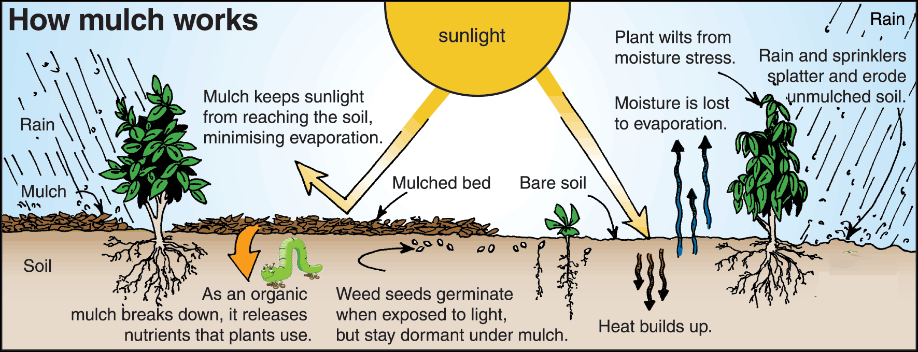

1. ***Digging*** over soil, ***allowing weeds*** to ***germinate*** and then removing them, ***before planting*** a crop.
2. Use of ***herbicides*** which are chemicals that kill the weeds.

***Types of herbicides:***

|  |  |  |
| --- | --- | --- |
| ***Type of herbicide*** | ***Use in a garden*** | ***example*** |
| **Residual** – stays in the soil and kills germinating seedlings | Around paths and places where plants are not wanted | Amitrol |
| **Non-residual** – breaks down rapidly in contact with the soil | Areas which are to be planted | Glyphosate / *Roundup* |

***Safety practices with chemicals***

List the 8 precautions listed in “Growing On” P103

1. _____________________________________________________________________________

2. _____________________________________________________________________________

3. _____________________________________________________________________________

4. _____________________________________________________________________________

5. _____________________________________________________________________________

6. _____________________________________________________________________________

7. _____________________________________________________________________________

8. _____________________________________________________________________________

**Management practices used to solve a Plant Production Problem**

*Grease spot is one of the most serous* ***diseases*** *in Passion fruit in New Zealand. It is caused by bacteria, which infects the leaves, stems and fruit, causing dark green oily spots. This leads to the loss of leaves, cracked lesions (wounds), premature fruit drop and fruit decay which causes crop losses and death of vines.*

*A grower knows considers TWO management practices that could be used to prevent grease spot*

* ***Prune out*** *and* ***burn*** *infected material which also keeps the vines open*
* *Regular* ***spraying*** *with* ***pesticides*** *at monthly intervals*

*They choose to prune and burn the infected material*

*Justify the choice of this management practice:*

*In your justification you should:*

* *Describe how* ***pruning*** *and* ***spraying*** *help control diseases*
* *Explain how these two methods are* **different** *in their* ***approach*** *to controlling diseases*
* *Explain why pruning and burning is a* ***better practice*** *in controlling the disease*

____________________________________________________________________________________________________________________________________________________________________________________________________________________________________________________________________________________________________________________________________________________________________________________________________________________________________________________________________________________________________________________________________________________________________________________________________________________________________________________________________________________________________________________________________________________________________________________________________________________________________________________________________________________________________________________________________________________________________________________________________________________________________________________________________________________________________________________________________________________________________________________________________________________________________________________________________________________________________________________________________________________________________________________________