Physical Factors & Climatic Conditions

- Length of period to production
- Climate
- Environmental factors
- Seasonality

- The length of the production period & product storage

The longer the period of supply & storage the easier it is to:
- Plan to supply when prices are high
- Take advantage of shortages & avoid gluts
- Be less susceptible to fickle weather conditions

Exercise: Compare the length of production cycles & storage potential for mandarins, kiwifruit & your own product.

Mandarins

___________________________________________________________________

___________________________________________________________________

___________________________________________________________________

___________________________________________________________________

Kiwifruit

___________________________________________________________________

___________________________________________________________________

___________________________________________________________________

___________________________________________________________________

Another / Own product

___________________________________________________________________

___________________________________________________________________

___________________________________________________________________

___________________________________________________________________

- Climate

The climate of a production site:

- Determines crop & site selection:
- Where it can be grown in NZ
- Aspect of site (sunny/ sheltered) impacts on timing & meeting market windows
- If shelter is required

- Affects crop production:
- Sunshine - Fruit ripening – brix levels
- Temperatures – Growing degree days available to ensure crop is supplied to meet market demand
- Frost – need for winter chilling &/or frost susceptibility of the crop
- Water supply – need for irrigation or irrigation control

- Environmental factors affecting supply

Products can only be supplied to meet the market if the environment is manipulated to provide optimum productivity of the product.

Exercise: Describe the environment required to provide optimum supply for Satsuma mandarins & kiwifruit.

Satsuma mandarins

___________________________________________________________________

___________________________________________________________________

___________________________________________________________________

___________________________________________________________________

Kiwifruit

___________________________________________________________________

___________________________________________________________________

___________________________________________________________________

___________________________________________________________________

___________________________________________________________________

___________________________________________________________________

___________________________________________________________________

- Seasonality

The variation in seasons affects:
- Timing of production:
Growers plan the production process by developing a Calendar of Operations

This is drawn up by:
- Setting the time of harvest to meet market demand
- Listing the management practices needed to produce a quality product to meet market demand
- Determining the time that these practices have to be used to ensure that the required volume of high quality product is ready at the time of harvest & demands

- Crop physiology
The seasons dictate the biological cycles of crops: e.g.
- Leaf fall
- Flower initiation & production
- Fruit development
- Fruit ripening
These cycles impact on production timing.

- Out of season production – Seasonal advantage
NZ has the opposite growing seasons to the Northern Hemisphere
If the seasonality of NZ production is managed well, crops can be produced to meet the lucrative Northern Hemisphere market window.
Northern Hemisphere growers are contracted to grow NZ varieties when it is the NZ off-season to ensure continuous supply of freshly picked products throughout the year.

Exercise: Explain how seasonality affects the supply of NZ Satsuma mandarins to Japan.
______________________________________________________________________

______________________________________________________________________

______________________________________________________________________

______________________________________________________________________

Seasonality/ Reliability of supply
Production of kiwifruit in NZ is seasonal with gold being produced from April to September & Green May to November. A remarkable 2016/17 season of increased yields & the largest-ever NZ crop helped lift total Zespri sales volume from NZ to a record 137.7 million trays, 18 percent up on the previous year.
Zespri Global Supply (ZGS).
Italy • France • Japan • South Korea • Australia

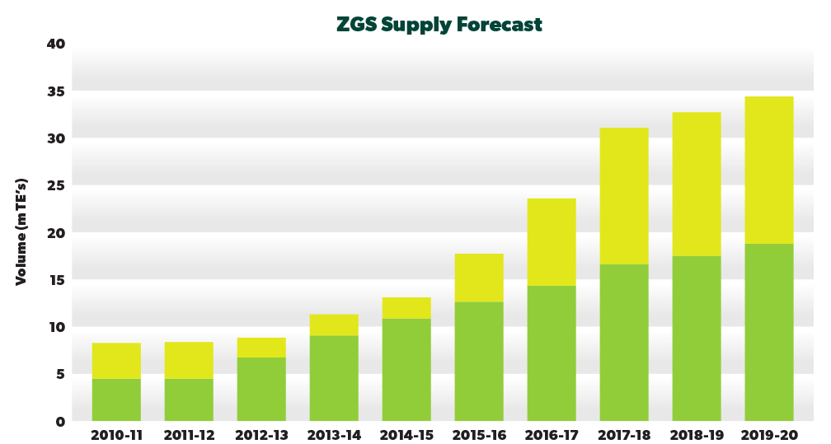
To maintain market share in an increasingly competitive market NZ is producing fresh fruit all the year round by growing kiwifruit in offshore partnerships in Northern hemisphere countries such as Italy, France, South Korea, USA, Japan & also Chile & Australia under Zespri quality standards. Sales of kiwifruit from Zespri’s Northern Hemisphere supplying locations also grew by 14 percent to 16.6 million trays, driven mainly by SunGold vines coming into production in Italy.
Non-NZ supply through the Zespri Global Supply business is a source of Zespri’s competitive advantage & a key part of Zespri’s “category management” work stream. Non-NZ supply is poised for strong growth in the five-year planning horizon, driven predominately by Gold3 recovery in Italy, & Zespri’ s ability to procure Zespri Green from Italy to meet rising global demand.
Zespri are especially looking to increase the volume of Gold Kiwifruit to meet the increasing demand & move into new markets with this product. Zespri Gold has a shorter storage life of four months than six months of Zespri Green & thus growing the variety off shore ensures high quality fruit available for a longer period. Zespri Gold is being grown in eight countries to meet the 12-month demand. The 2016/17 season saw the announcement of 1,800 hectares of SunGold licence allocated for Europe over the next three years, doubling Zespri’s offshore production of the variety to meet growing demand for 12-month supply.
Revenue from the NZ SunGold licence release is a significant driver of Zespri’s corporate income. A further 400 hectares was released through a tender to NZ growers this year & the Zespri Board will decide on a potential three additional tranches of 400 hectares each year up to 2020, subject to an annual review of performance after each selling season.

Exercise: What impact does Zespri’s contract with Northern hemisphere growers have on the year round supply of kiwifruit?
____________________________________________________________________________________________________________________________________________________________________________________________________________________________________________________________________________________________________

