Products of Agriculture

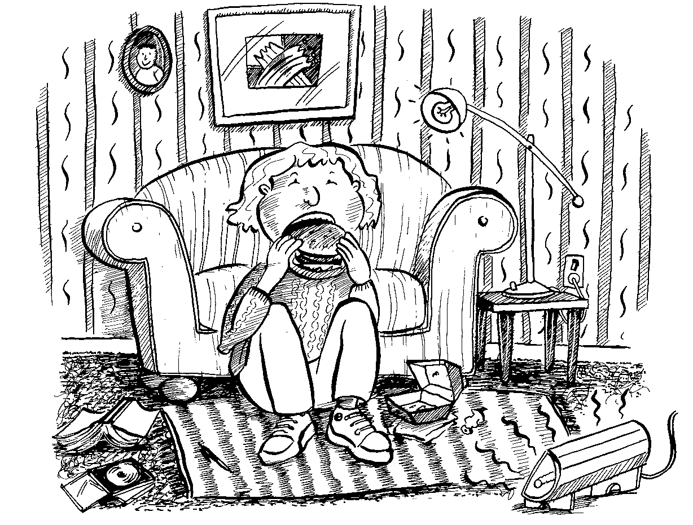

• Use this illustration to identify 20 or more products that come from the land.

• Choose five products and work out
- what is the raw material that was produced on the land

- what has happened to become the product we use or eat

