Promising prospects for venison boosted by US demand
Gerard Hutching16:41, Sep 26 2017
- Facebook
- Twitter
- Google &plus;
- Email
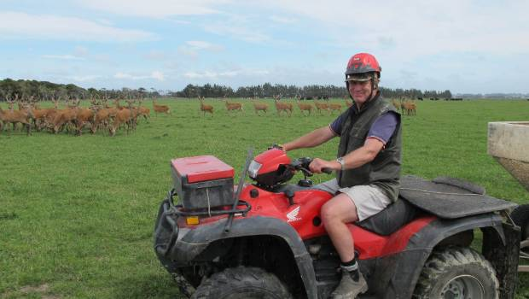
GERARD HUTCHING/STUFF
Tangimoana deer farmer Andy Russell with weaner stags.
Tangimoana deer farmer Andy Russell says venison prices could hit the "magical" $10 per kilogram mark soon, the first time in at least 15 years.
Currently the average price to farmers for a prime venison carcase is $9.67 a kilogram, just above the last price peak of $9.65 set in 2008.
Demand in the United States market for Cervena venison has boosted farmer returns, and more of the animal was being used for a variety of products.
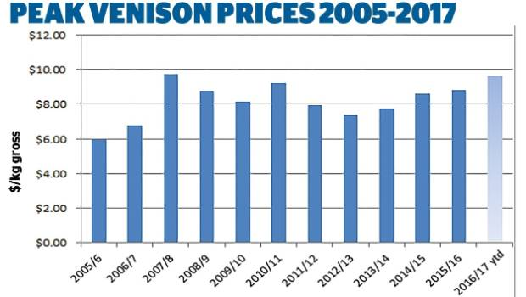
The last time venison prices got close to $10 per kilogram was in 2008.
Russell said that he was selling most of his venison to the Waitrose chain in the United Kingdom, and "our prices are as good as any on the market, I'm very pleased with what we're getting".
A deer finisher, Russell has been in the business for 23 years. He buys in about 1200 stock a year for fattening up.
READ MORE:
Deer industry leaders paint rosy portrait as sector makes gradual comeback
Paleo diet helps push venison prices to record highs
ADVERTISEMENT
He hoped the industry would not repeat the boom-bust pattern of recent years.
"But we are seeing signs of a fundamental shift with more hinds being retained to rebuild herds, which should put it on a more sustainable footing."
Deer Industry NZ chief executive Dan Coup said the US market lifted the value of the total carcass.
"What they have done is to move this quality product from the traditional European game meat market, where it was a reasonably easily substituted ingredient, into North America where it is recognised as a specialty meat, for use in gourmet burgers and ready-to-eat protein bars."
"Another growing source of demand from North America is for venison offals and trim for the ultra-premium pet food market – which is providing a significant premium compared to what has been available in the past," Coup said.
The changes occurring mirrored the market shift with lamb flaps a decade ago and which appeared to be permanent. Exporters now sell the flaps into China for use in hot pot, where previously they had been sold cheaply to a range of small markets.
Coup said it was too soon to say whether prices would crack the $10 mark. In the past they had usually eased back slightly after reaching a high, but when this had occurred in 2009, most of New Zealand's venison was sold into Europe.
Market dynamics were different now with a much smaller proportion of venison sold into the European game trade.
"The growth in year-round demand for chilled cuts and the step change in the value of processing grade venison are likely to have a lasting positive influence on the value of a venison carcass," Coup said.
The most recent Statistics NZ survey showed that at June 2016 deer numbers had fallen by 7.3 per cent to 835,000, a far cry from 2005 when there were 1.7 million. The great financial crisis and conversion of farms to dairy contributed to the reduction.

