Student resources
Resource A: Regions of New Zealand
Names of Regions  - Northland  - Auckland  - Waikato  - Bay of Plenty  - Gisborne / East Coast  - Hawke’s Bay  - Taranaki  - Whanganui  - Manawatu  - Wairarapa  - Wellington  - Nelson & Bays  - Marlborough  - West Coast  - Canterbury  - South Canterbury / North Otago  - Otago  - Southland | 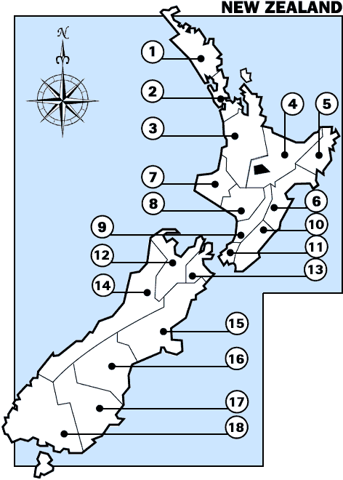  [Source: http://www.yellowpages.co.nz/maps/]
Resource B: Climate information
REGION | MEAN ANNUAL |  |  | Temperature |  | Number of days with frosts
 | Rainfall (mm) | Sunshine (hours) | Temperature (°C)
 |  |  |  | Very highest (°C) | Very lowest (°C)
Northland | 1412 | 2021 | 15.6 | 30.8 | -0.1 | 5
Auckland | 1240 | 2060 | 15.1 | 30.5 | -2.5 | 10
Bay of Plenty | 1198 | 2260 | 14.5 | 33.7 | -5.3 | 42
Waikato | 1190 | 2009 | 13.7 | 34.7 | -9.9 | 63
Gisborne | 1051 | 2180 | 14.3 | 38.1 | -5.3 | 33
Taranaki | 1432 | 2182 | 13.7 | 30.3 | -2.4 | 15
Hawkes Bay | 803 | 2188 | 14.5 | 35.8 | -3.9 | 29
Whanganui | 882 | 2043 | 14.0 | 32.3 | -2.3 | 7
Manawatu | 967 | 1733 | 13.3 | 33.0 | -6.0 | 38
Wairarapa | 979 | 1915 | 12.7 | 35.2 | -6.9 | 60
Wellington | 1249 | 2065 | 12.8 | 31.1 | -1.9 | 10
Nelson | 970 | 2405 | 12.6 | 36.3 | -6.6 | 88
Marlborough | 655 | 2409 | 12.9 | 36.0 | -8.8 | 60
West Coast | 2875 | 1860 | 11.7 | 30.0 | -3.4 | 54
Canterbury | 648 | 2100 | 12.1 | 41.6 | -7.1 | 70
South Canterbury / North Otago | 573 | 1826 | 11.2 | 37.2 | -6.8 | 84
Otago | 812 | 1585 | 11.0 | 35.7 | -8.0 | 58
Southland | 1112 | 1614 | 9.9 | 32.2 | -9.0 | 94

[Source: http://www.niwa.co.nz/education-and-training/schools/resources/climate]
Resource C: New Zealand topography
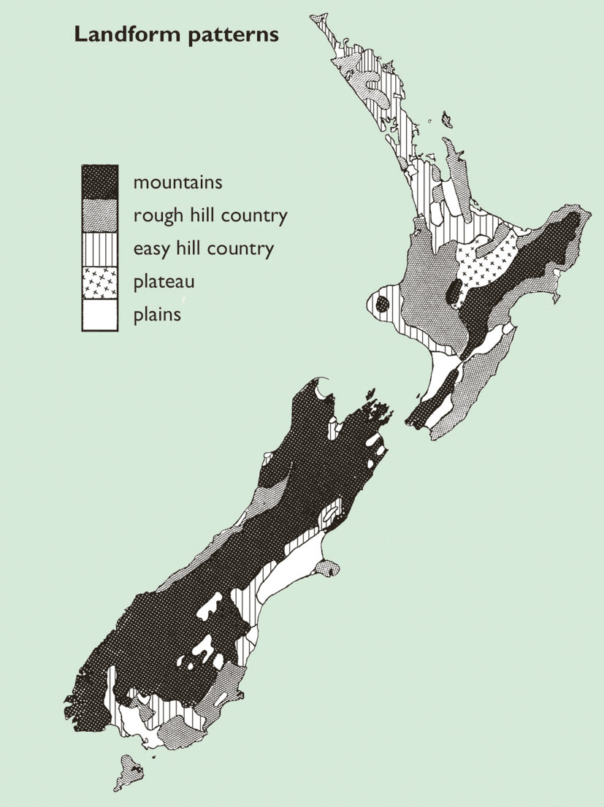
Resource D: Sea ports and airports

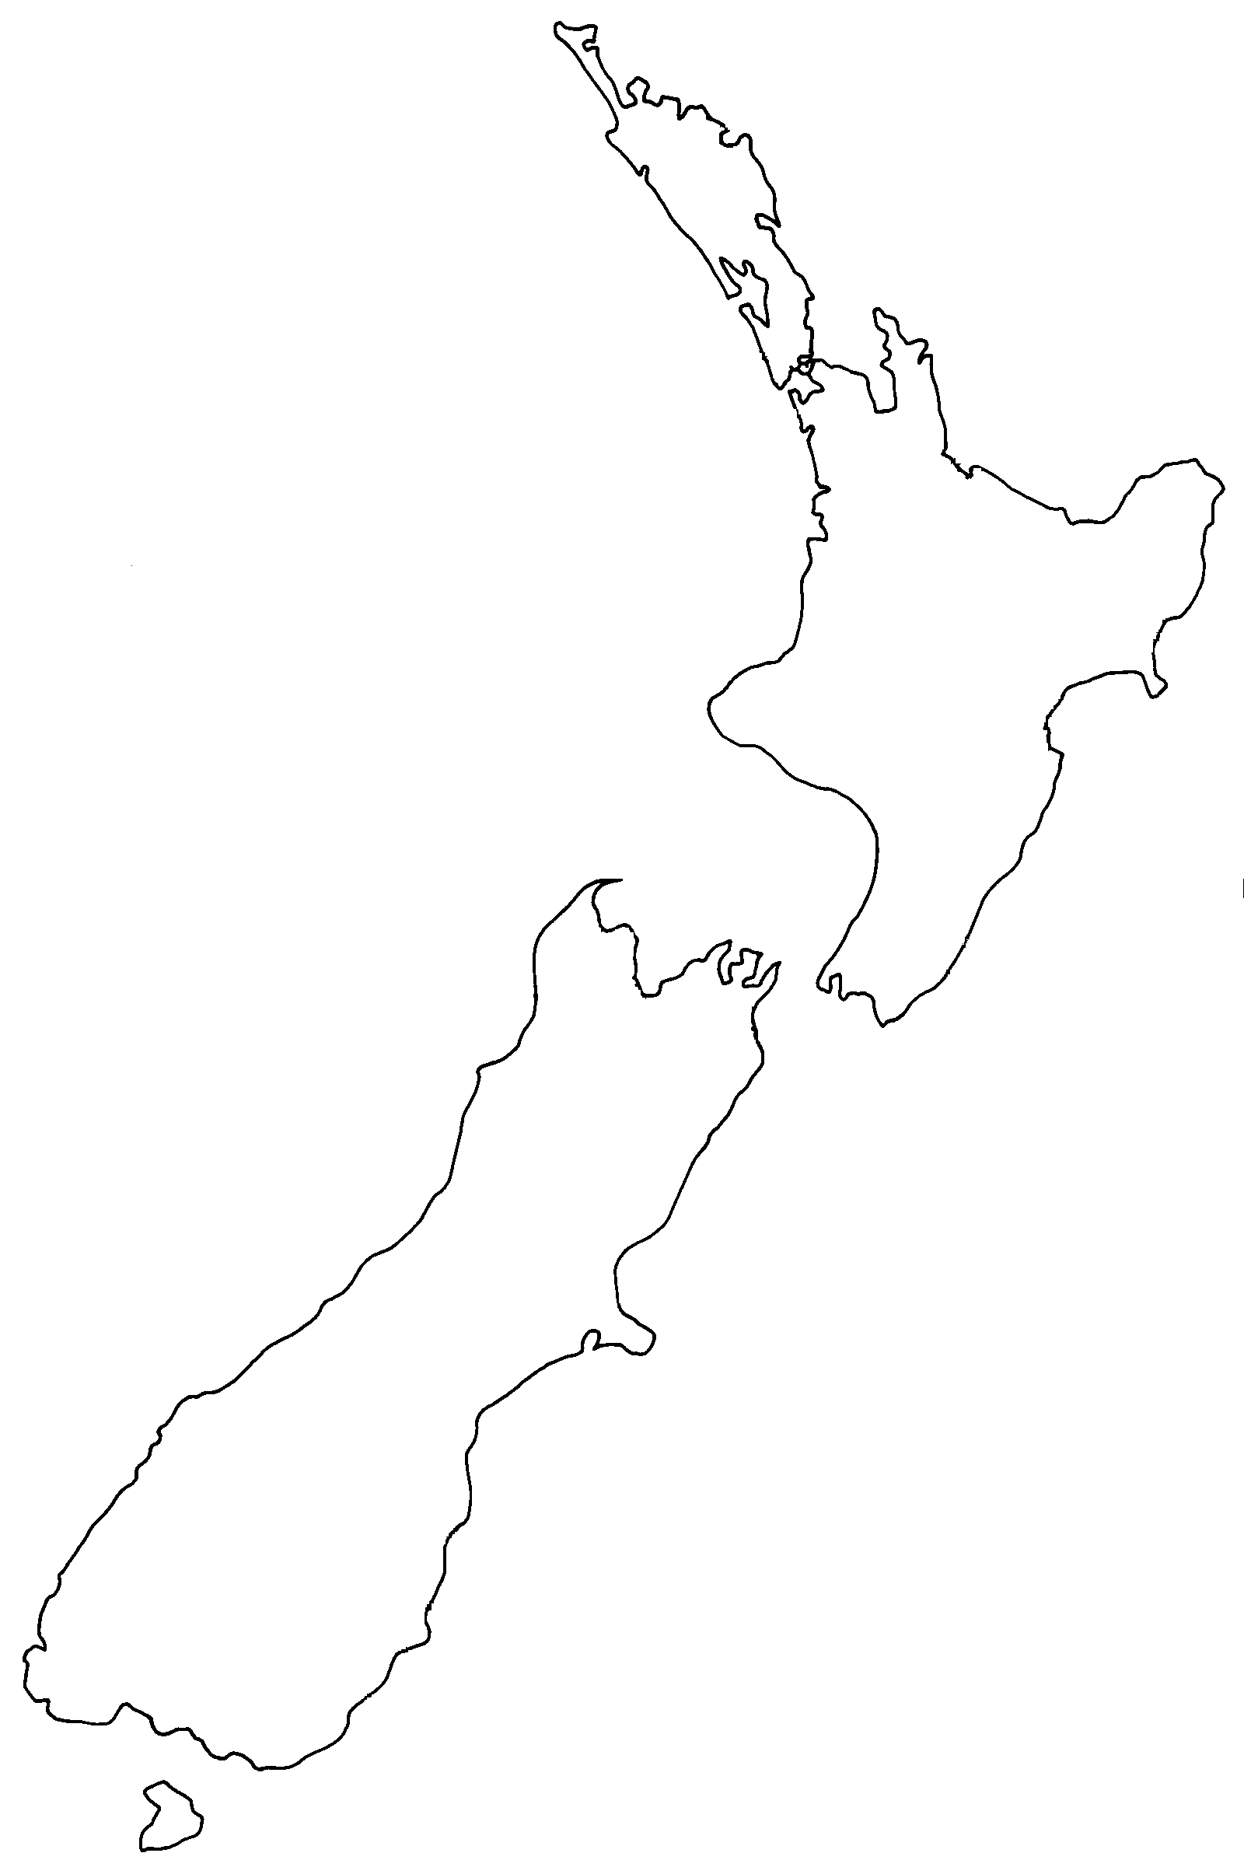
International airport

Sea port

International airport

