The Importance of Farming to New Zealand

Farming is a deeply ingrained part of contemporary New Zealand society. For most of the twentieth century, farming was considered the ‘backbone’ of the economy. New Zealand’s temperate climate and fertile soils have supported almost every kind of farming—from sheep and cattle to cropping, horticulture and forestry. Farming has changed dramatically over time, and with it the shape of many rural communities. Although more than 85 percent of the population now lives in urban areas, the farming sector continues to play a fundamental role in New Zealand’s economy. Farming products, excluding forestry, earn more than 40 percent of New Zealand’s export income. Physically, farming dominates New Zealand’s geography. There are about 70,000 farms in the country and over half New Zealand’s land area is classified as farmland. Farming has also played an influential role in the development of New Zealand’s national identity. Farming has long been associated with the innovative ‘No. 8 wire’ mentality that many people pride themselves on and the rural lowlands and rugged hills of New Zealand are still considered by many people, both urban and rural dwellers alike, to be the ‘heartland’ of this country.
In a global context New Zealand can be described as being in the business of pampering the palates and passions of the world’s more prosperous citizens. We do this through exporting our foods, fibres, wines, films and delivering great visitor experiences in our Gondwanan landscapes. New Zealanders are highly dependent on our natural capital – our waters, soils and biodiversity – for sustaining these wealth-generating capabilities.
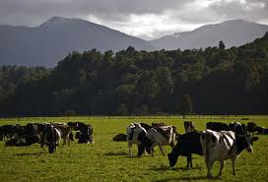
Many farming systems in New Zealand are currently becoming more intensive. Intensification is born out of a drive to produce more from the same amount of land. The most visible manifestation of intensification in New Zealand over recent years has been in the dairy sector, with significant increases in dairy cows per hectare and milk production per cow. Intensive farming has contributed to declining water quality in many regions and challenges for water allocation. A variety of organisations and individuals have raised concerns about these trends. Internationally, there are also growing concerns about the environmental impacts and strategic risks of intensive farming systems.

New Zealand’s Economy
Agriculture directly accounts for around 4% of Gross Domestic Product (GDP), while the processing of food, beverage and tobacco products accounts for a further 4%. Downstream activities, including transportation, rural financing and retailing related to agricultural production, also make important contributions to GDP. Dairy farming is the predominant agricultural activity, followed by beef and sheep farming and horticulture.

New Zealand Dairy Overview
Quick statistics 2019
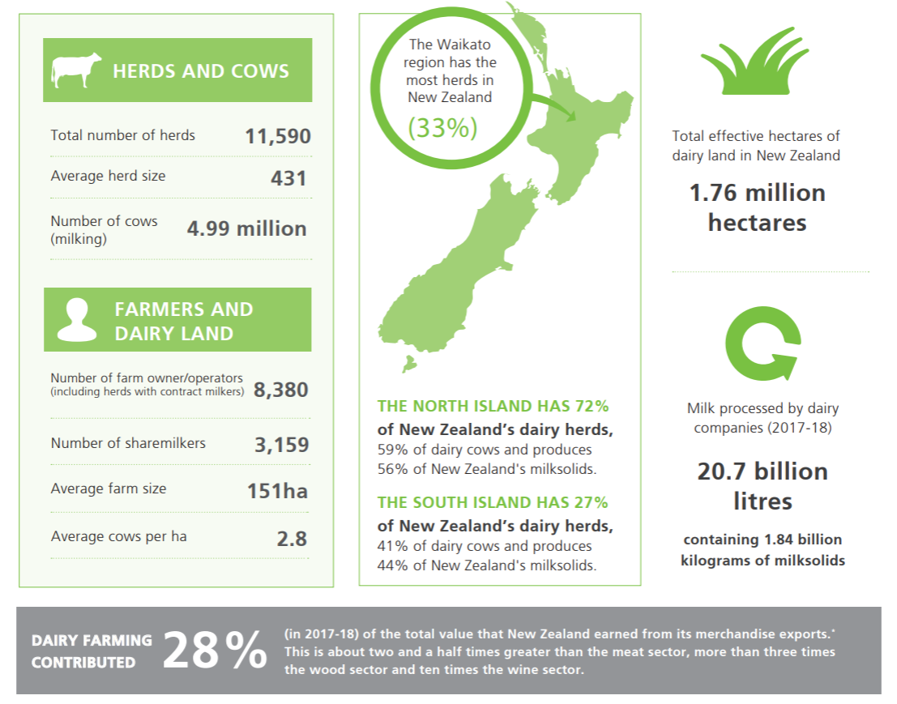
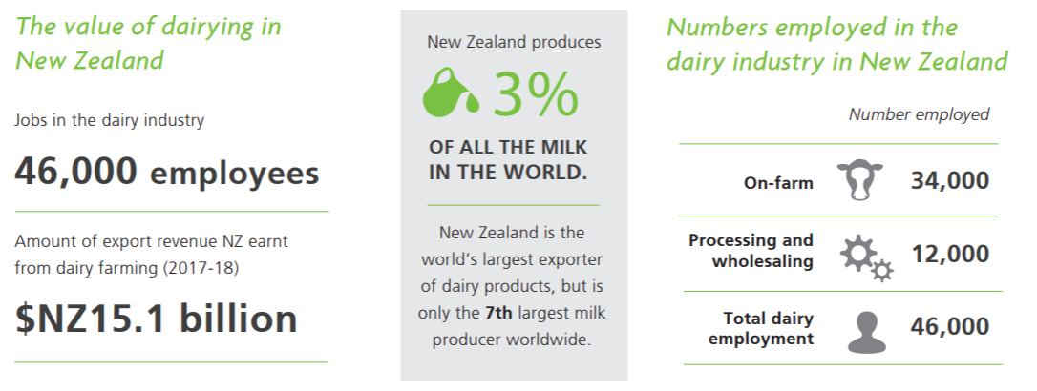

Fast facts:
- New Zealand accounts for 3% of total world production
- New Zealand exports about 95% of its dairy production
- New Zealand is the world’s 8th largest dairy producer
- In the year to June 2016, dairy was New Zealand's largest export sector (18% of total goods and service exports)
- New Zealand exported NZ$12.4 billion worth of dairy products in the year ending June 2016
- The top five markets for New Zealand dairy exports are: China, United States, United Arab Emirates, Australia and Japan.
- In the year to June 2018 New Zealand dairy exports were valued at approximately NZ$16.667 billion.
- The top five dairy export products were: whole milk powder (NZ$5.8 billion), butter (NZ$ 2.18 billion), cheese (NZ$1.9 billion), infant formula (NZ$1.2 billion) and skim milk powder (NZ$1.1 billion).
The New Zealand dairy sector provides direct employment for more than 38,000 people and is a top 10 purchaser of output from a third of all other industries in the New Zealand economy.
Questions: New Zealand was once famous for its sheep. Why has sheep become so much less important in New Zealand?

Could this happen with dairy? And if so what could cause dairy in New Zealand to decline and what can we do as a country to prevent this have happening?

