Venison approaches record prices as US appetite grows
Gerald Piddock16:31, Aug 18 2017
- Facebook
- Twitter
- Google &plus;
- Email
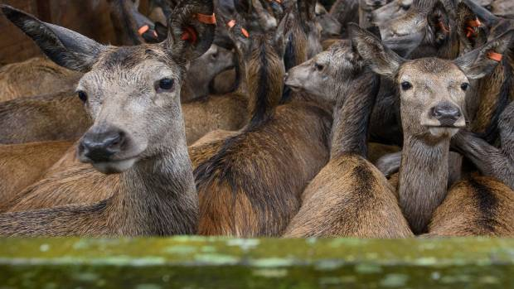
LINDA CHALMERS
Venison dishes are increasing on United States menus and driving up prices.
New Zealand venison prices are reaching record highs on the back of continuing strong demand in the North American market.
Venison schedule prices have lifted 17 per cent from a year ago to reach more than $9 per kilogram, Deer Industry New Zealand P2P programme manager Innes Moffat said.
"The schedule for this time of year is at the highest that it's ever been. Deer farmers are benefiting from their investment and from sticking with the deer industry through some leaner times. We have hoped that we have finally put the industry's reputation as a rollercoaster industry to bed.
"This year, the indicators from the companies that have issued contracts are that currency dependent, it will be in the mid $9/kg to the mid $10 range."
READ MORE:
* Paleo diet helps push venison prices to record highs
* Deer industry leaders paint rosy portrait as sector makes gradual comeback
* Chilled NZ venison in summer: Europeans savour Cervena after export trials
* Velvet season gets off to half-hearted start
ANZ similarly predicted strong prices for venison this year in its AgriFocus report for June. The report said returns should reach all time highs this season and farmgate prices are expected to push towards at least the mid-$9/kg mark during the chilled/game season peak with a stronger euro and pound helping.
ADVERTISEMENT
Over the long term, farmgate prices were expected to settle back toward the low-to-mid $8/kg.
Silver Fern Farms chief executive Dean Hamilton said demand was outstripping supply in their European and North American markets.
"It's in a nice space."
Supply had fallen 25 per cent to about 280,000 head as farmers continued to retain their hinds and build herd numbers. That growth would be gradual rather than sharp, which should keep prices relatively stable, Hamilton said.
Moffat said the number of hinds processed was about 47-48 per cent of total deer killed and that indicated there was some herd rebuilding taking place.
Venison production would reach about 12,000-14,000 tonnes this year, which was down on the 15,000 tonnes consistently produced from 2008-1013.
Deer kill numbers had fallen by 15 per cent compared with last year. Moffat said he knew anecdotally of farmers that were investing in deer fencing and looking to lift their stock numbers while others were lowering their hind numbers but were looking to farm them better and produce heavier progeny.
Moffat said there had been a substantial diversification away from the traditional European market to North America. Venison companies were finding customers traditionally taking a lower value cut were turning it into a much higher value product.
In the past, these cuts would have been made into European venison salami. Instead they were being turned into protein meat bars aimed at health conscious consumers.
"We are also seeing a big increase in the demand for venison for the gourmet burger trade. A number of companies are now manufacturing burgers either for retail or for distribution through food service.
"That's using an increased volume of New Zealand venison that would have been destined for the specialty game sector in Europe."
While it it was generally the higher end to mid-value restaurants that were serving venison, it was also being served in a promotion at North American fast food sandwich chain Arby's earlier this year.
Moffat said that Arby's were stunned at the positive response.
"It certainly showed there was a great deal of interest in a venison item across a number of US states. We understand they are talking about repeating that promotion later this year with a larger volume, but again it would be a limited time, limited promotion."
Chilled venison exports to the US in the past year lifted 23 per cent, totalling 783 tonnes. This was about one quarter off all venison exports to this country with the rest being frozen.
Exports to the traditional German market had dropped by 36 per cent in the past year to 2400 tonnes. As a result, the US was now New Zealand's largest export market for venison.

