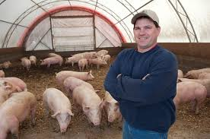

Weaning and Growing in Barns

- When pigs are weaned from the sow on this farm, they are moved into?
straw huts A grower room straw lined barns

- How does this farmer describe his farming system?
- On this farm, in the weaner shed, the piglets… (tick all correct, options)

will spend 5 weeks in the shed

can eat as much food as they want
use the straw-based system to provide warmth

have small kennels for extra warmth

- On this farm, when are the pigs are 9 weeks old they move to the…
Tractor shed finisher shed Outdoor hut

Outdoor

- Describe why straw is such an important part of this environment?

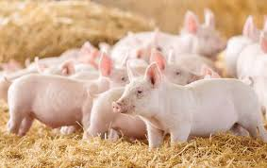

- What happens to the used straw once it is cleared from the shed?

- How do the pigs get food and how often can they access it?

- How long has this pig farmer been involved in the industry for?
Nearly 10 years

Nearly 35 years

Nearly 45 years

- How does this farmer describe how he feels about pig farming in NZ?

- New Zealand pig farmers can farm in many ways. Their goal is to…

