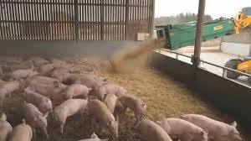
Weaning and Growing Indoors
- A pig has been removed from
and no longer Being fed by its
mother is called ? (Tick one)
A growing pig A piglet A weaner pig
v
v
v

- What is fed to prepare piglets
for solid food rather than sows milk?

- How does the indoor environment
provide for the needs of the pigs?
(tick all that apply)
v
Keeping the pig as healthy as possible
v
Keeping the pigs in a clean environment
v
Protecting them from the elements (rain
v
Farmers ability to access and car for pigs
- True or False On this farm, which of the following
are special features of the weaner room?
v
They are fed three times a day
v
The building is fully insulated against cold and heat
v
A gas heater is used to warm the room when pigs are small
v
The slotted flooring
v
They have as much water as they want
- ‘Ad lib’ feeding means?

- Why are the weaner pigs housed on slotted floors?

- How do you think the urine and dung is collected is used?

- On this farm about how old are the weaner pigs before they leave the weaner room to move to the grower room?
v
5 weeks 7 weeks 10 weeks
v
v
- What has changed about the diet that grower pigs are fed compared to the old days

- This pigfarmer takes special care to provide the right environment and nutritional needs for his pigs because he wants them…
to be well cared for and kept in perfect health
v
to grow up quickly and to be profitable
v
v
to produce high quality lean meat that people like to eat
