Animal health revision.

Mike and Vanessa run a successful farm called Glen Nui.
Animal health is regarded as a very important part of their program.
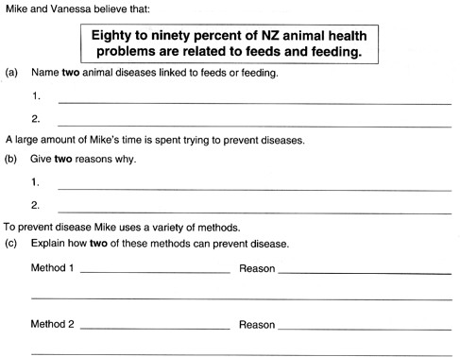

d) Name four of the main causes of a disease or pathogens. and name a disease caused by each.

Pathogen | Animal health problem
Virus
Bacteria
Fungus
Parasite

Vaccination is used to prevent many disease.

What do these words mean Immunity

Colostrum

Toxin

Antibody

Passive immunity

Active immunity

Draw a diagram showing where and how you should inject a sheep.

Vaccines contain a weakened or dead version of the disease. The body can develop its defenses from this.
Why is vaccinating an animal for a disease (ie Black leg) better than letting the animal catch the disease naturally and gain immunity anyway.

Flystrike
Flystrike is a very nasty problem on farms all around New Zealand.
Flies lay eggs on the moist, smelly areas of sheep. These eggs hatch in maggots which “eat” the animals. Effects range from skin and wool damage to death.

There are several ways to minimise this.
a) Dipping.
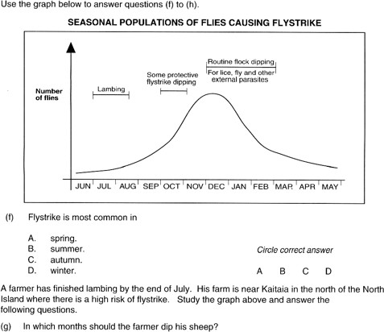

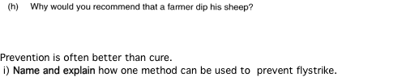

Drenching.

Drenchs are chemicals that kill internal parasites.

Before drenching a mob, there are several jobs that must be done to make sure the animals are drenched correcly and safely.
These are checking the gun, determining the correct dose rate and making sure the animals are clean and dry.

Choose one of these and describe how and explain why this must be done.

Drench resistance is a major problem for farmers everywhere. Why

Describe 3 different ways a farmer must use to prevent drench resistance establishing itself on their farm.

1.

2.

3.

Dipping : Draw a diagram showing one method of correctly dipping sheep.

