Drainage systems.
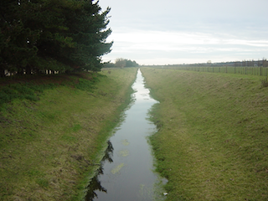
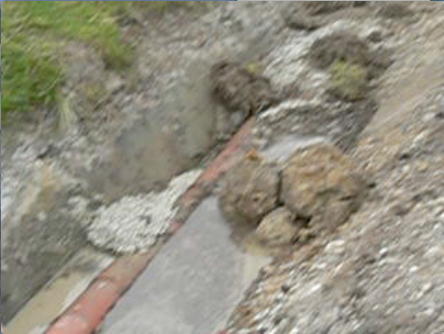
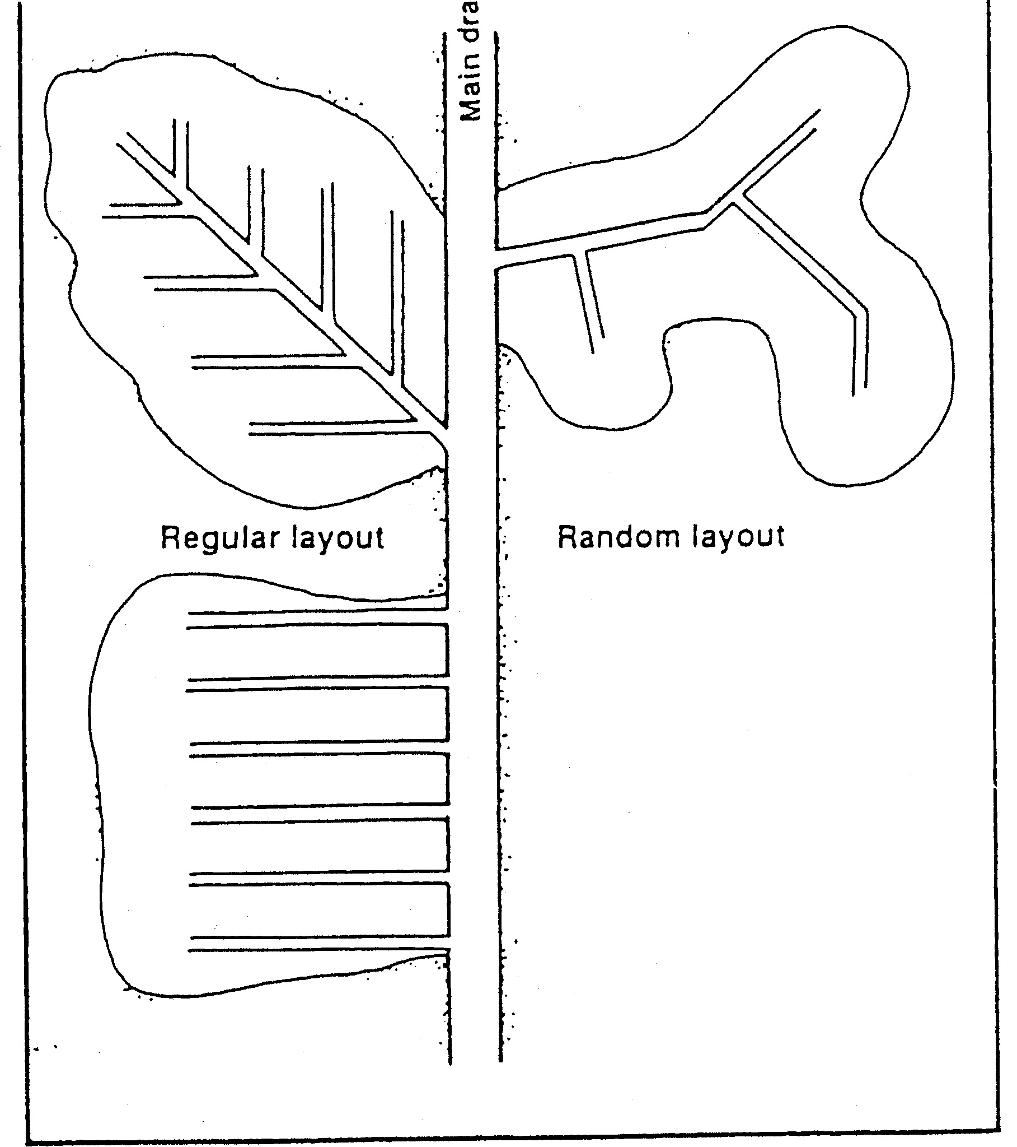
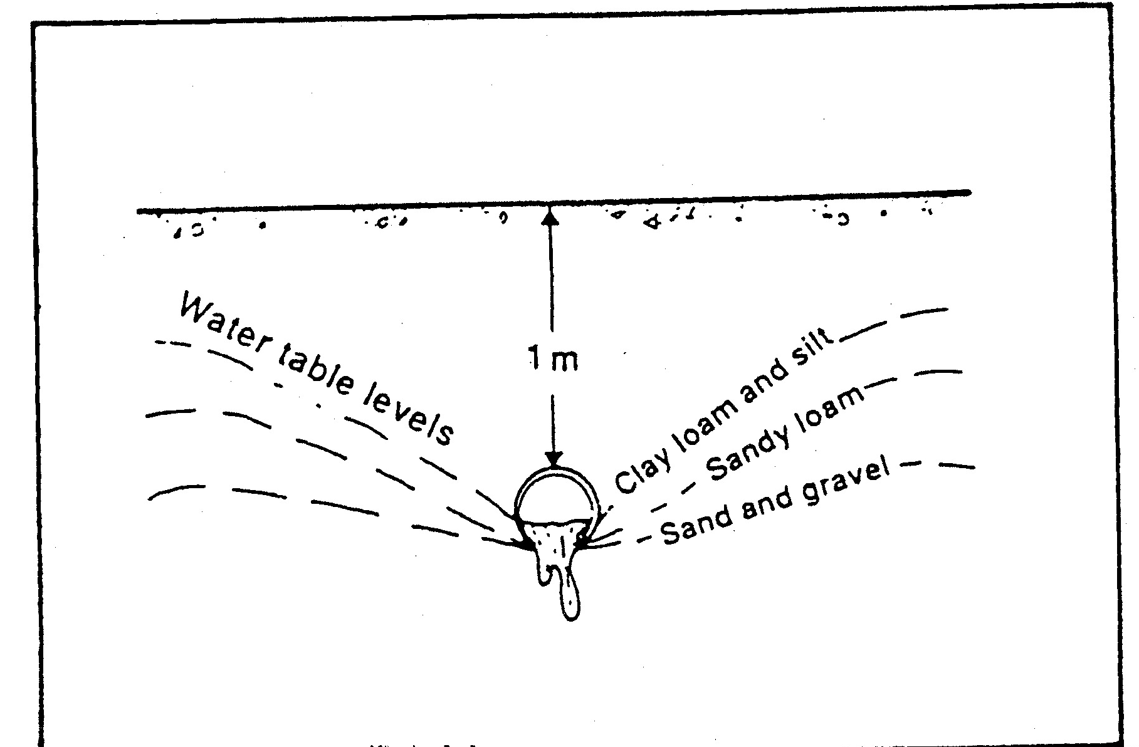
Objective: To understand how each system is designed, its advantages and disadvantages.
Open Drains

Tile Drains

Fill in the tables below.

Draw a diagram showing how it should be designed.
Describe one advantage of this system
Describe one disadvantage of this system

Draw a diagram showing how it should be designed.
Describe one advantage of this system
Describe one disadvantage of this system

Draw a diagram showing how it should be designed.

Describe one advantage of this system
Describe one disadvantage of this system
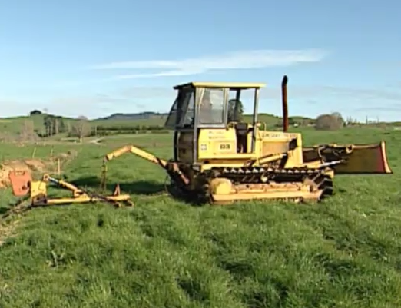
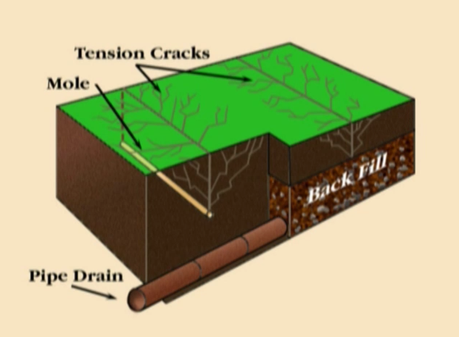
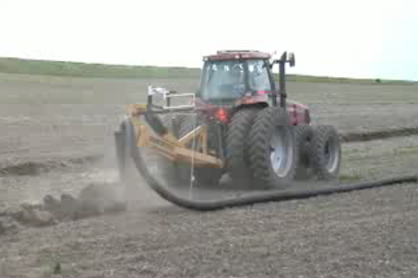
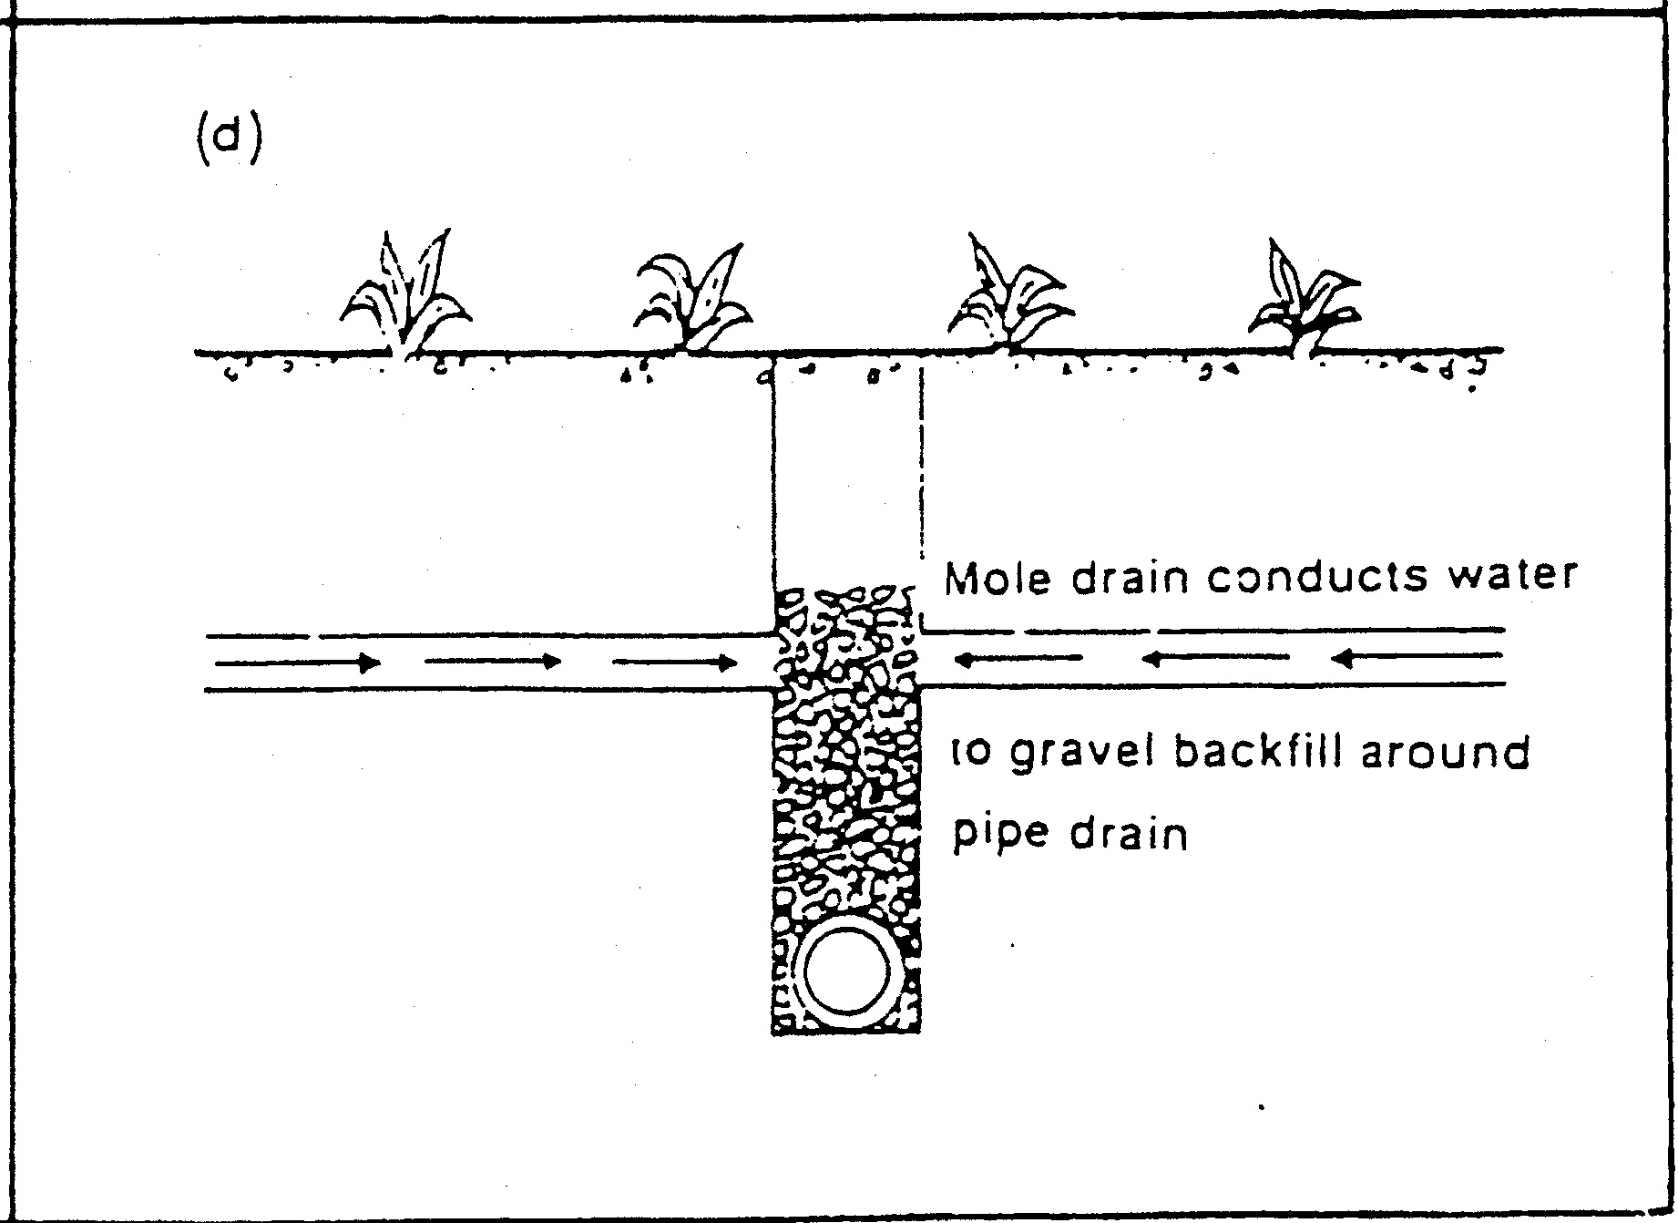
Mole Drains
Novaflo Drains

Draw a diagram showing how it should be designed.

Describe one advantage of this system
Describe one disadvantage of this system

