GORE HIGH SCHOOL
Name _______________________

Livestock

Production
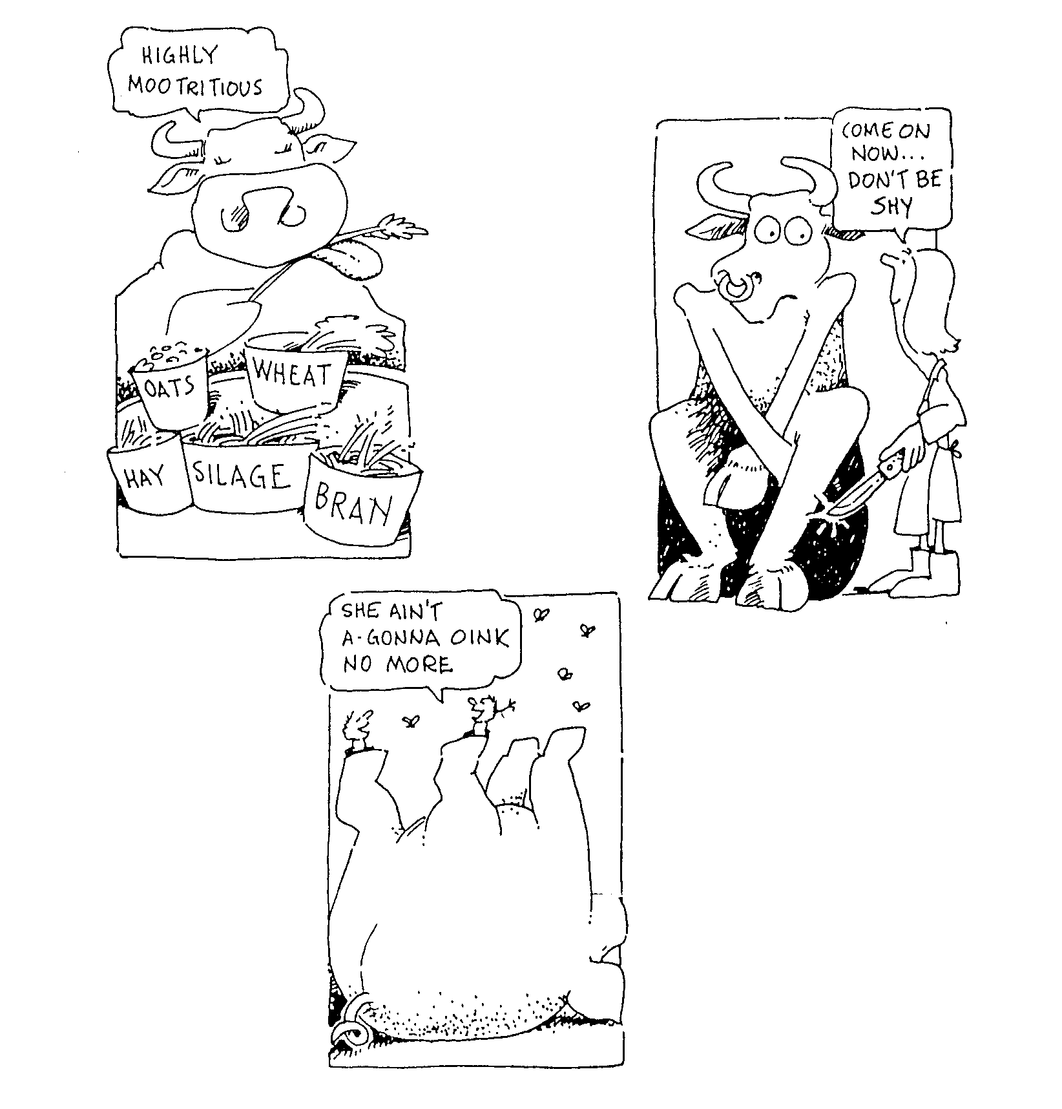

Animal production =

Animal Nutrition

Animal Reproduction

Animal Health

Achieve | Merit | Excellence
- Demonstrate knowledge of livestock management practices. | - Demonstrate in-depth knowledge of livestock management practices. | - Demonstrate comprehensive knowledge of livestock management practices.

- Demonstrate knowledge involves describing livestock management practices and related structural features and functions and/or agricultural concepts.
- Demonstrate in-depth knowledge involves explaining why livestock management practices or steps within practices are carried out. The explanation may require an understanding of relevant structural features and functions and/or agricultural concepts
- Demonstrate comprehensive knowledge involves applying knowledge of livestock management practices to given situations. This may involve comparing and or contrasting, or justifying management practices.
Level 1 Agricultural Science 1.6 Animal production

Achievement | Merit | Excellence
- Describe livestock management practices.  Describe MEANS name the parts and describe what their function is.  - Digestive systems  - Reproduction system  Describe how the management practices are carried out and why  Feeding programmes  - Food components  - Digestibility of food  - Factors affecting digestibility  - Feed quality/quantity needed to meet animal needs in different physiological states.  Breeding practices  - Genetics  - Animal breeding  - Stock identification  - Selection and recording  - AI (collection to insemination)  Health practices  - Actual & predisposing causes  - Prevention  - Breeding disease resistance  - Vaccination  - Drenching  - Animal health programmes | - Explain livestock management practices.  Explain why or how these management practices are used to improve animal production | - Contrast of justify livestock management practices for a given situation.  Contrast or Justify MEANS  Select the best management practice to solve the problem and explain how and why it is the best solution based on  - Effect on animal growth and production  - Cost  - Efficiency- effect on production  AND  Explain why it is better than the other options or explain why the other solutions were not as good based on  - Effect on animal growth and production  - Cost  - Efficiency- effect on production

AIM: Demonstrate knowledge of livestock management practices.

Specific objectives
A Knowledge: - at the end of the unit, students should be able to:

1. Demonstrate knowledge on how nutrition affects animal production.

1.1 Discuss pasture as a source of feed for livestock.
- advantages and disadvantages.
  - Describe animal requirements from feed
- protein, carbohydrates, fats, minerals, vitamins, water, dry matter
1.3 Name the parts of the ruminant and non-ruminant digestive systems and explain their function.
- rumen, reticulum. omasum. abomasum, small intestine, caecum, villi, rumination.
1.4 Describe the factors affecting the nutritional value of feeds
- plant type and stage of growth, treatment of plant material (grinding, cooking),
- animal factors (age, type of digestive system, level of feed intake, health).
- type of feed (roughage, succulent, concentrate)
  - Explain why animal feed requirements vary throughout the year.
- physiological states:- lactation, dry, late pregnancy, flushing, maintenance, growth
1.6 Compare or justify feed management practices for a given situation.

2 Demonstrate a knowledge of animal reproduction and breeding.

2.1 Explain why animal reproduction is important for increasing farm returns.
2.2 Name the organs involved in reproductive and explain their function.
- male and female
2.3 Explain factors influencing reproduction performance.
- nutrition, management at mating, age, health, genetic ability,
2.4 Understand simple Mendelian genetics in terms of being able to discuss hereditary in physical characteristics and productive traits of animals.
- chromosomes, genes, allele's, homozygous, heterozygous, recessive, dominant, punnet squares, ratios
2.5 Discuss "variation is the basis of selection" and explain how it is used in animal breeding
programmes to increase farm production
- national sire selection and recording programmes
2.6 Discuss artificial breeding.
- advantages, collection, dilution, storage of semen, and insemination of animals.
2.7 Compare or justify breeding management practices for a given situation.

3 Demonstrate knowledge on basic animal health principles.

3.1 Discuss the importance of animal health.
- production, product quality, farmer health, cost of production.
3.2 Describe the causes of ill heath.
- direct causes micro-organisms (infectious) Parasites, metabolic, deficiencies
- indirect (predisposing causes) injury, age, hereditary stress, reproduction
3.3 Identify signs and symptoms of good and poor health.
- posture, not eating, coat condition, production level, breathing
3.4 Explain methods used to prevent ill health
- level of nutrition, drenching, hygiene, minimise the effects of predisposing causes, vaccinations, breeding and selection.
3.5 Compare or justify health management practices for a given situation.

Animal Nutrition

- Pasture as a feed

- Animal requirements from feed

- Digestion

- Ruminant and non ruminant digestive systems

- Nutritional value of different feeds

- Measuring digestibility

- Factors affecting digestibility

Animal Nutrition
Digestive System

Ruminant Monogastric

- Identification of each part mouth-anus
- Functions of each part
- Types of digestion in each part
- Significant differences
  - Teeth
  - Rumination
  - Caecum
Pasture as a feed

Advantages | Disadvantages
- Cheap  - low labour  - fed on site, don't have to cut and carry into barns etc  - animal wastes returned naturally  - potentially easily digested and palatable  - potentially has a high nutritional value | - Seasonal variation in quantity and quality.  - Presence of disease causing organisms. E.g. parasitic worm larvae, facial eczema fungi.  - lack some essential elements eg(Ca), (Mg)

Feed components
- Carbohydrate (starch/glucose/sugar)
- Protein (amino acids)
- Fats/oil (fatty acids & glycerol)
- Mineral/vitamins
Digestibility
- What is it?
- Factors affecting digestibility
Animal | Feed
- Type of animal  - Age  - Health | - Fibre content  - Stage of growth

Measuring Digestibility
- Why is it measured?
- How is measured?
- Measure in DM – what is DM
- Why measured in DM

Feed types | Characteristics
Roughages | Fibre/protein  DM  digestibility
Succulents | Fibre/protein  DM  digestibility
Concentrates | Fibre/protein  DM  digestibility
Match feed type
- to animal requirements
- different types of animals
- animals at different stages of production
Feed requirements
- Carbohydrate (energy)
- Protein (muscle growth, production milk, wool, velvet and repair of tissue)
- Fats/oil (energy)
Productive state varies
- Stage of pregnancy/lactation
- Dry
- Growth rate
- Type of digestive system

Pasture as a Feed
Pasture is the main diet of adult ruminant animals. It generally provides them with all the dietary requirements

Advantages of pasture as a feed in NZ
- Cheap
- low labour
- fed on site, don't have to cut and carry into barns etc
- animal wastes returned naturally
- potentially easily digested and palatable
- potentially has a high nutritional value

Disadvantages of pasture as a feed.
- seasonal variation in quantity and quality.
- presence of disease causing organisms. E.g. parasitic worm larvae, facial eczema fungi.
- lack some essential nutrients causing diseases such as milk fever,(Ca), grass staggers(Mg) Bush sickness (Co)

Dry matter
Dry matter is the various mineral and organic material (carbohydrates, protein, fats or oils and vitamins) in feedstuffs. It is measured by drying the material and expressing the weight as a percentage of the wet matter.
All animal feedstuffs are compared in dry matter because
- Water has no nutritional value.
- Feedstuffs vary in the amount of water they have.
Dry matter is not an indication of the nutritional value of the feed. Nutritional value is determined by the digestibility of the feed and the energy contained in it.

Example
Feed | DM % | Digestibility
Fresh leafy pasture | 20 | 85
Hay | 85 | 60

Exercise
- Describe the advantages and disadvantages of pasture as a feed.
- Explain what dry matter is?
- What does dry matter NOT tell you about an animal feed?
- Explain what the nutritional value of feed is determined by?
Animal Requirements from Food

Carbohydrates: Energy Glucose (simple sugar)
Starch
Protein: Growth & production of products (amino acids)

Fats: Energy (glycerol and fatty acids)

Minerals:
Needed to complete healthy functioning of body cells.
Vitamins:

Water: Makes up 80% of animal’s bodies and it is needed for many activities occurring within cells.

A farm animal needs to use food for;
Maintenance: that is to provide energy for breathing, movement, warmth and to maintain body weight.
Production: That is to grow by building up body tissue and to form milk, wool etc.

Exercise
- List the nutritional components an animal requires from feed to remain healthy.
- Describe why each nutritional component is important.
- Explain the difference between maintenance and production.
- List two feeds used as a maintenance feed.

Digestion
There is more to eating than just obtaining the correct chemicals. Other important factors of diet are;
Food should be;
- easily digested but contain roughage & fibre
- taste good i.e. palatable
- provide bulk
- be varied
Most of our food is made up of big molecules, which cannot be used by our bodies. Breaking up these big molecules into smaller ones is called “digestion”. These small molecules can then be used by our bodies for growth, energy and production of products. Such as milk, wool and meat.

Exercise
- What is meant by digestion?
- Describe the factors that affect the digestibility of pasture.
- Describe two factors that would affect an animal’s ability to digest a feed.

Digestive Systems
Animals can be divided into groups depending on their type of digestive system monogastric or ruminant.

Monogastric(non-ruminant) animals have one stomach, examples include pigs, horses, rabbits where as ruminant animals have four parts to their stomach, examples include, cattle, sheep, deer and goats.
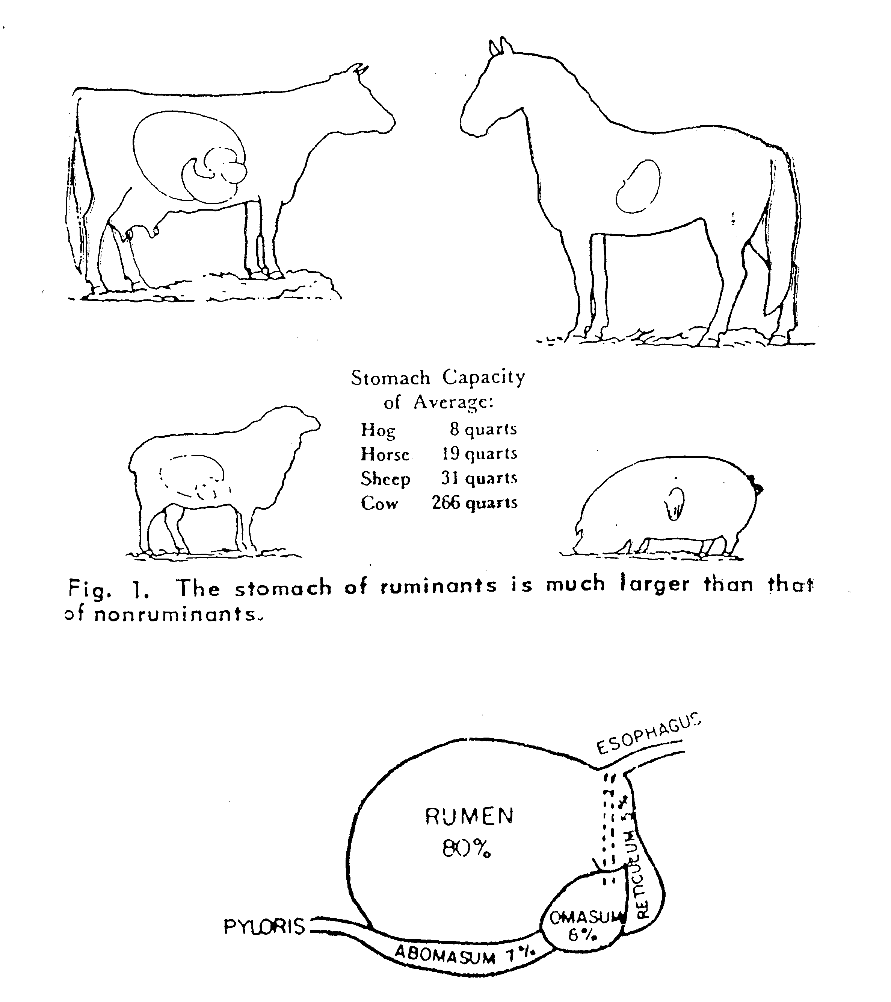

Exercise
- What is meant by monogastric and ruminant?
- Name two monogastric animals you could find on a New Zealand farm
- Name four ruminant animals found in New Zealand
Monogastric digestion
Functions of parts of the digestive tract in a monogastric animal
Teeth Chew food to break it down into smaller pieces.

Saliva Lubricates food for swallowing. Enzymes start the digestive process.

Oesophagus Food moves along the oesophagus & other parts of the gut by muscular process called "peristalsis".

Stomach Lining secretes “gastric juices" containing enzymes and Hydrochloric acid (HCl). Muscular contractions mix the food with the gastric juices.

Small Intestine More juices containing enzymes added continuing digestion. Bile is secreted from the gall bladder; this changes the pH to alkaline for. The wall is lined with finger like projections called" villi". These increase the surface area for absorbing digested products.

Large Intestine Water is absorbed. Undigested food is excreted.

Caecum No function in humans, but in monogastric herbivores (horses, rabbits, pigs) it contains microorganisms that breakdown cellulose. This is not an efficient method of digestion as the cellulose does not stay in the caecum long enough for complete digestion.
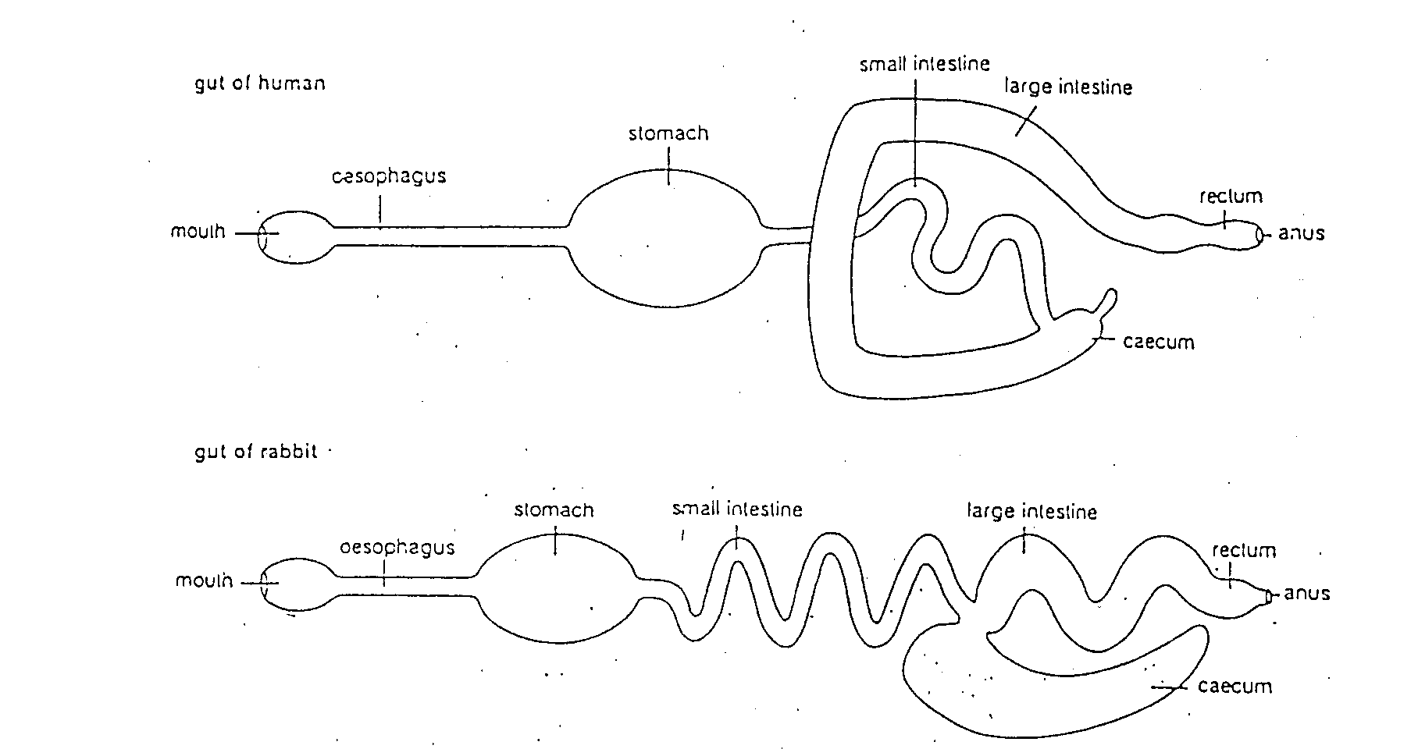
Ruminant Digestion

Functions of parts of the digestive tract in a ruminant animal
Mouth Pasture is torn off, briefly chewed with molar teeth. Large amounts of saliva is secreted
- sheep 6-10 l/day
- cattle 50-80 l/day
Oesophagus Food moves along the oesophagus & other parts of the gut by muscular process called "peristalsis".
Chewing Cud 8hr/day is spent ruminating coarse material. This is brought up, and re-chewed to increase the surface area for rumen microbes to work on and start digestion.
Rumen Largest of the four stomachs. Its inner lining is covered with numerous small projections called "papillae". These increases the surface area. The rumen contains millions of microbes that:
- digest cellulose
- increase the amount of protein
- make vitamin B
- waste gases are produced CO2, CH4 & NH3
- Volatile Fatty Acids are absorbed through the rumen wall == provide energy
Reticulum Small second stomach. The inner surface is "honeycombed". Microbial digestion continues.
Omasum Third stomach. The inner surface has many leaf like structures & is called the "bible". Microbial digestion continues & water is removed from the rumen liquor.
Abomasum Fourth stomach (true stomach). Here, HCl and enzymes are secreted in the gastric juices. Digestion of microbes and proteins takes place.
Small Intestine Has finger like structures called "villi" these increase the surface area for adsorption of digested food.
Caecum In herbivores the caecum is greatly enlarged and serves as a storage organ that permits bacteria and other microbes time to further digest cellulose.
Large Intestine Water is absorbed. Undigested food is excreted.
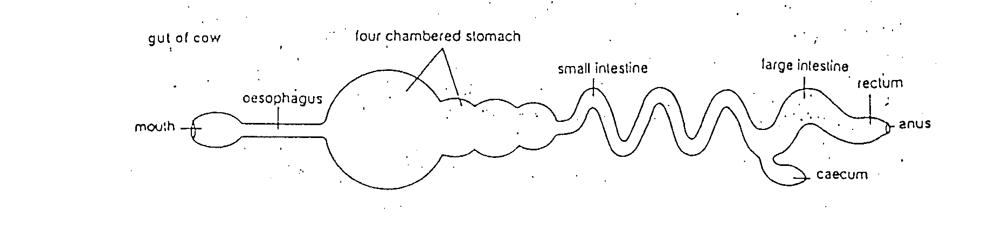
Monogastric Mouthparts

Teeth
Herbivorous monogastics have three types of teeth found in non-ruminants, that is incisors, premolars and molars. The incisors are present in both the upper and lower jaws.
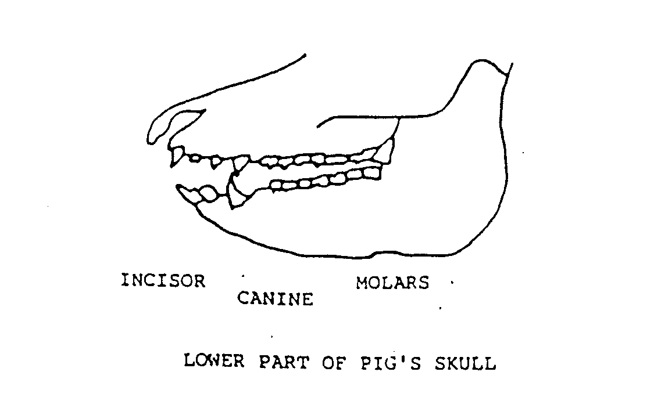 | In omnivorous and carnivorous monogastrics a fourth type of tooth, the canines, are present between the incisors and premolars. The diagram shows their position. These teeth help to tear flesh and in the case of pigs to tear roots as well.

Ruminant Mouthparts Teeth
Sheep and cattle have three types of teeth, starting at the front of the jaw, these are:
Incisors - for cutting and tearing (on the lower jaw only; the upper jaw has a bony pad).
Premolars
}
- for crushing and grinding
Molars
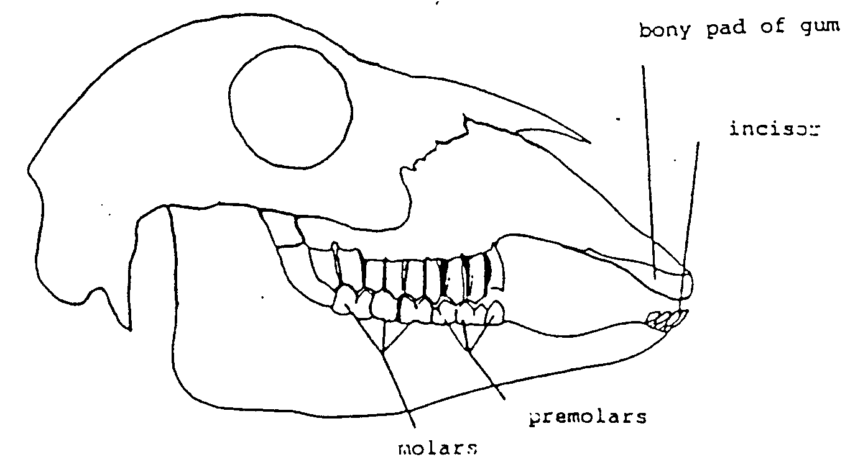

Bony pad of gum

Incisor

Premolars
Molars

Part of sheep’s skull, showing teeth.
The sheep tears off grass by gripping it between its lower incisors and the bony pad. The upper lip is divided, allowing the teeth to graze very closely to the ground. Cattle prefer to eat longer pasture than sheep because they wrap their tongue around a bunch of pasture and break it off between the pad and lower incisors.
Exercise
- Describe the differences between a ruminant and non- ruminant digestive tract.
- Explain how a monogastric herbivore digests plant fibre.
- Draw a diagram of the ruminant digestive system, labeling all parts and listing the functions of each part.
Development of the ruminant digestive system

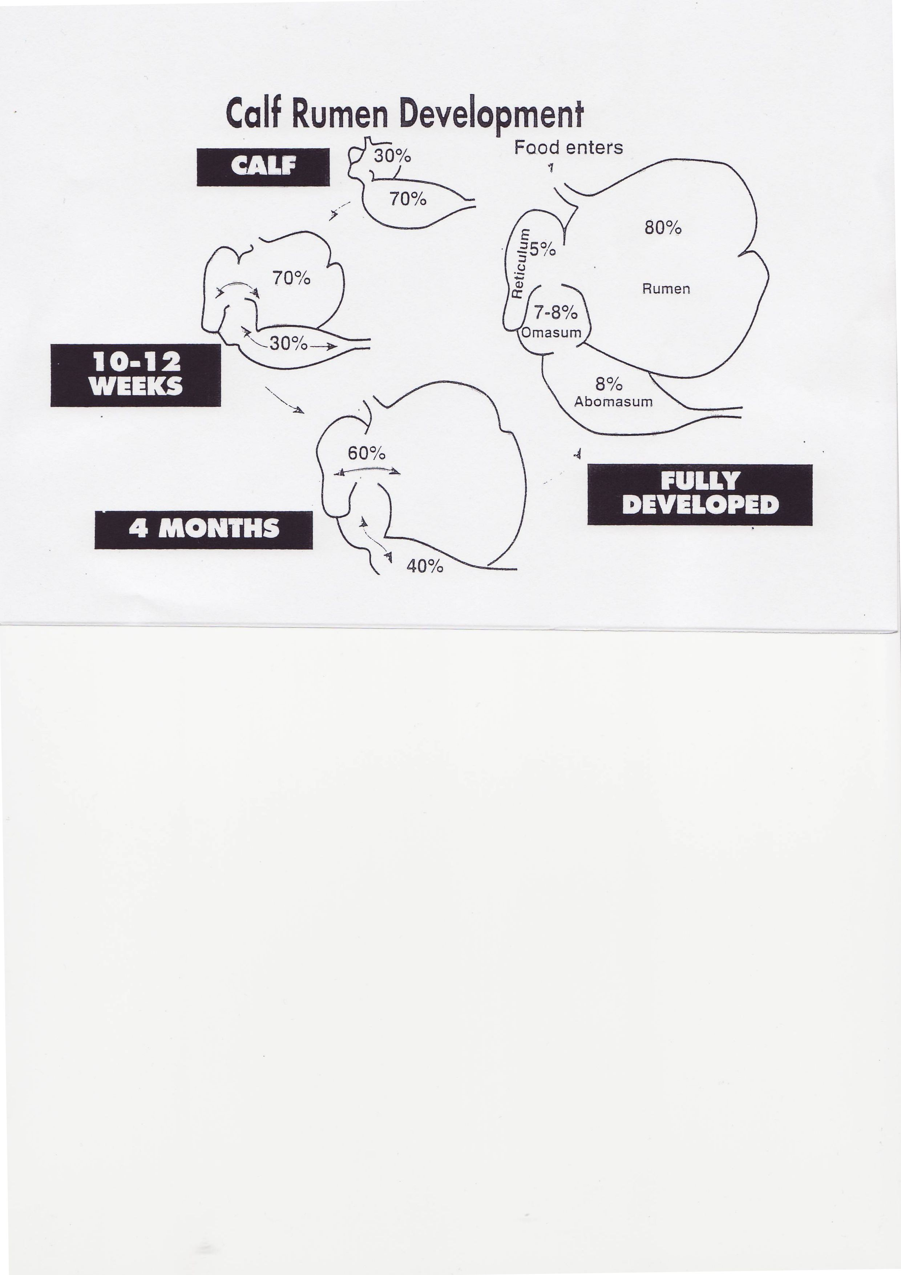

Exercise
- Explain why it is important to feed young ruminant animals the right feeds to develop the rumen.

2 Name these feeds and explain how they help to develop the rumen?

Stomachs
Ruminant digestive systems are complicated because they have four stomachs (sometimes call compartments). They are the
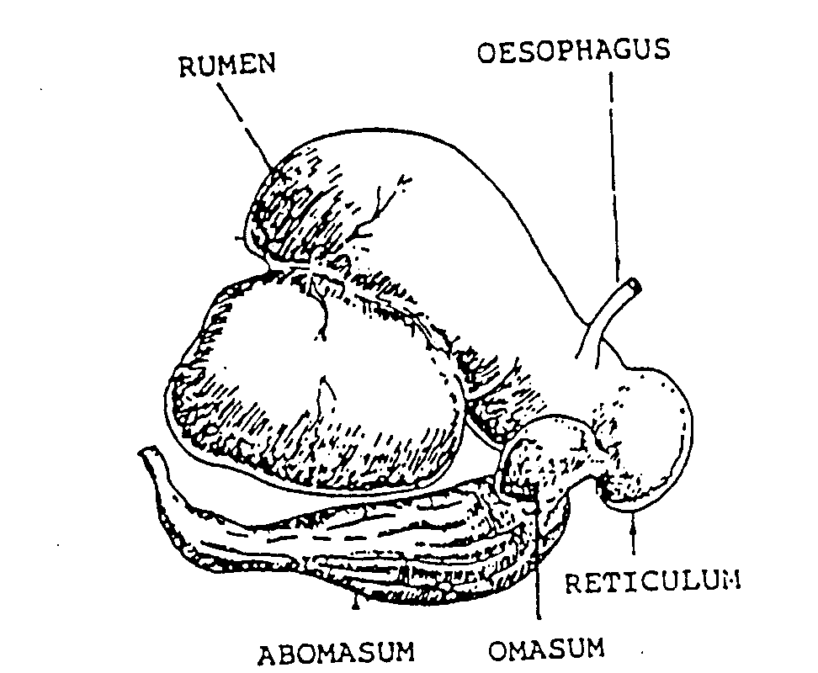

Rumen: First stomach
Reticulum: second stomach
Omasum: Third stomach
Abomasum: Fourth stomach

Rumen Microbes
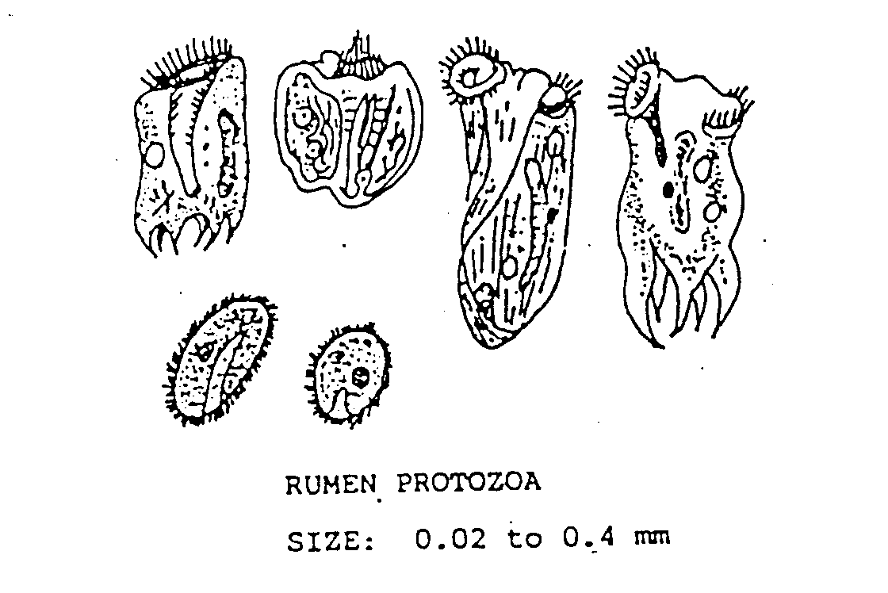
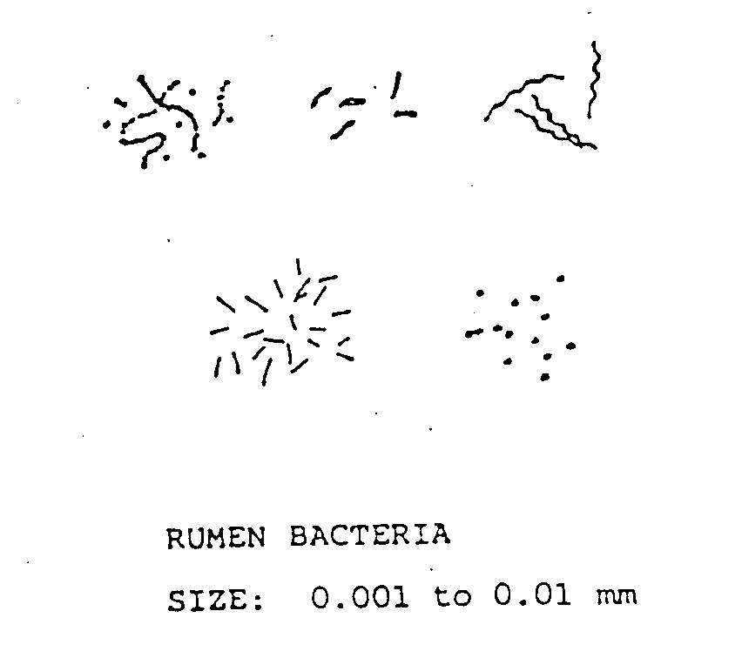

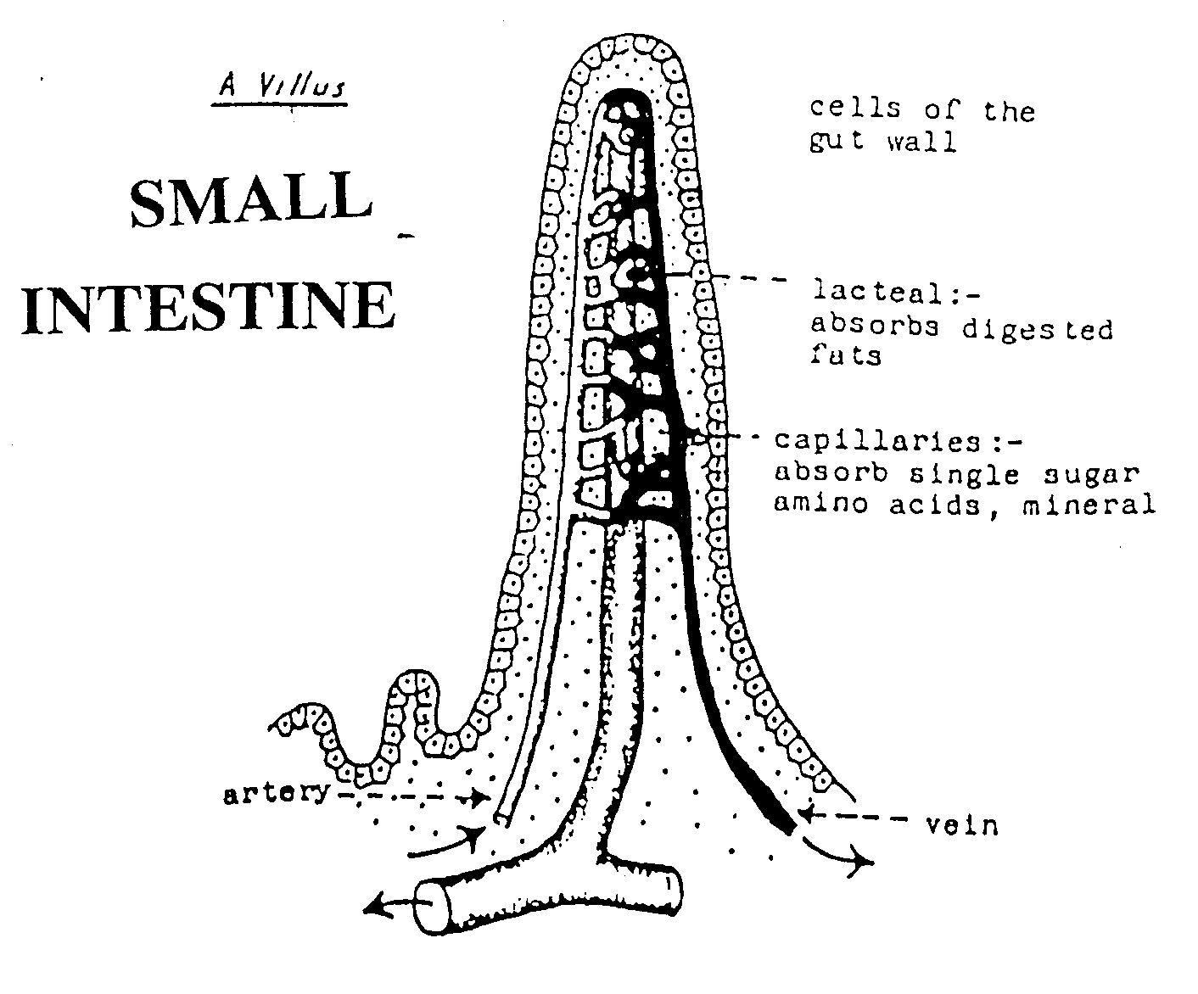
Stomach Linings
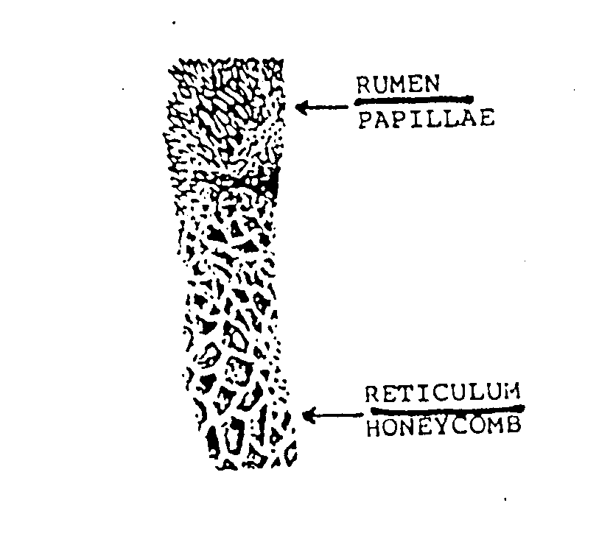

Function of Rumen Micro-Organisms

Rumen bacteria produce the enzyme

Cellulase

This enzyme splits large long-chain cellulose molecules into small short chain fatty acids & gas.

These small short chain fatty acids passes through the rumen wall into the blood system.

The blood system carries them to cells to provide energy.

Maintenance of Stable Conditions in the Rumen
The bacteria and protozoa are able to thrive in the rumen because conditions are remarkably constant. That is:
- A temperature of between 38-40 ⁰C is maintained.
- A pH 7 means the contents are neutral. This neutral pH is maintained by continuous secretions of large amounts of saliva.
- A continual movement of fine rumen contents into the next stomach
- A constant diet

Rumination (chewing the cud)

Aim of rumination: to break food down into smaller particles to speed up digestion.

Ruminant regurgitates food

Food chewed (remastication)

Sailiva is mixed with the feed (resalivation)

Food swallowed

New cud bought up (process starts again)

Exercise

- Name the parts of the ruminant stomach in order from first to fourth stomach.
- Name the two types of microbes found in the rumen.
- Explain the function of the rumen microbes.
- Where are papillae found?
- Where in the ruminant digestive tract is the honeycomb lining found?
- Where in the ruminant digestive tract are villi found.
- Describe the function of villi.
- Describe the conditions needed for rumen microbes to function efficiently.
- Describe rumination.
- Explain the function of rumination.
11 Study the diagram below, and complete it by matching the words in the box below with the numbers 1-5 on the diagram.
protein, cellulose, energy, methane, ammonia
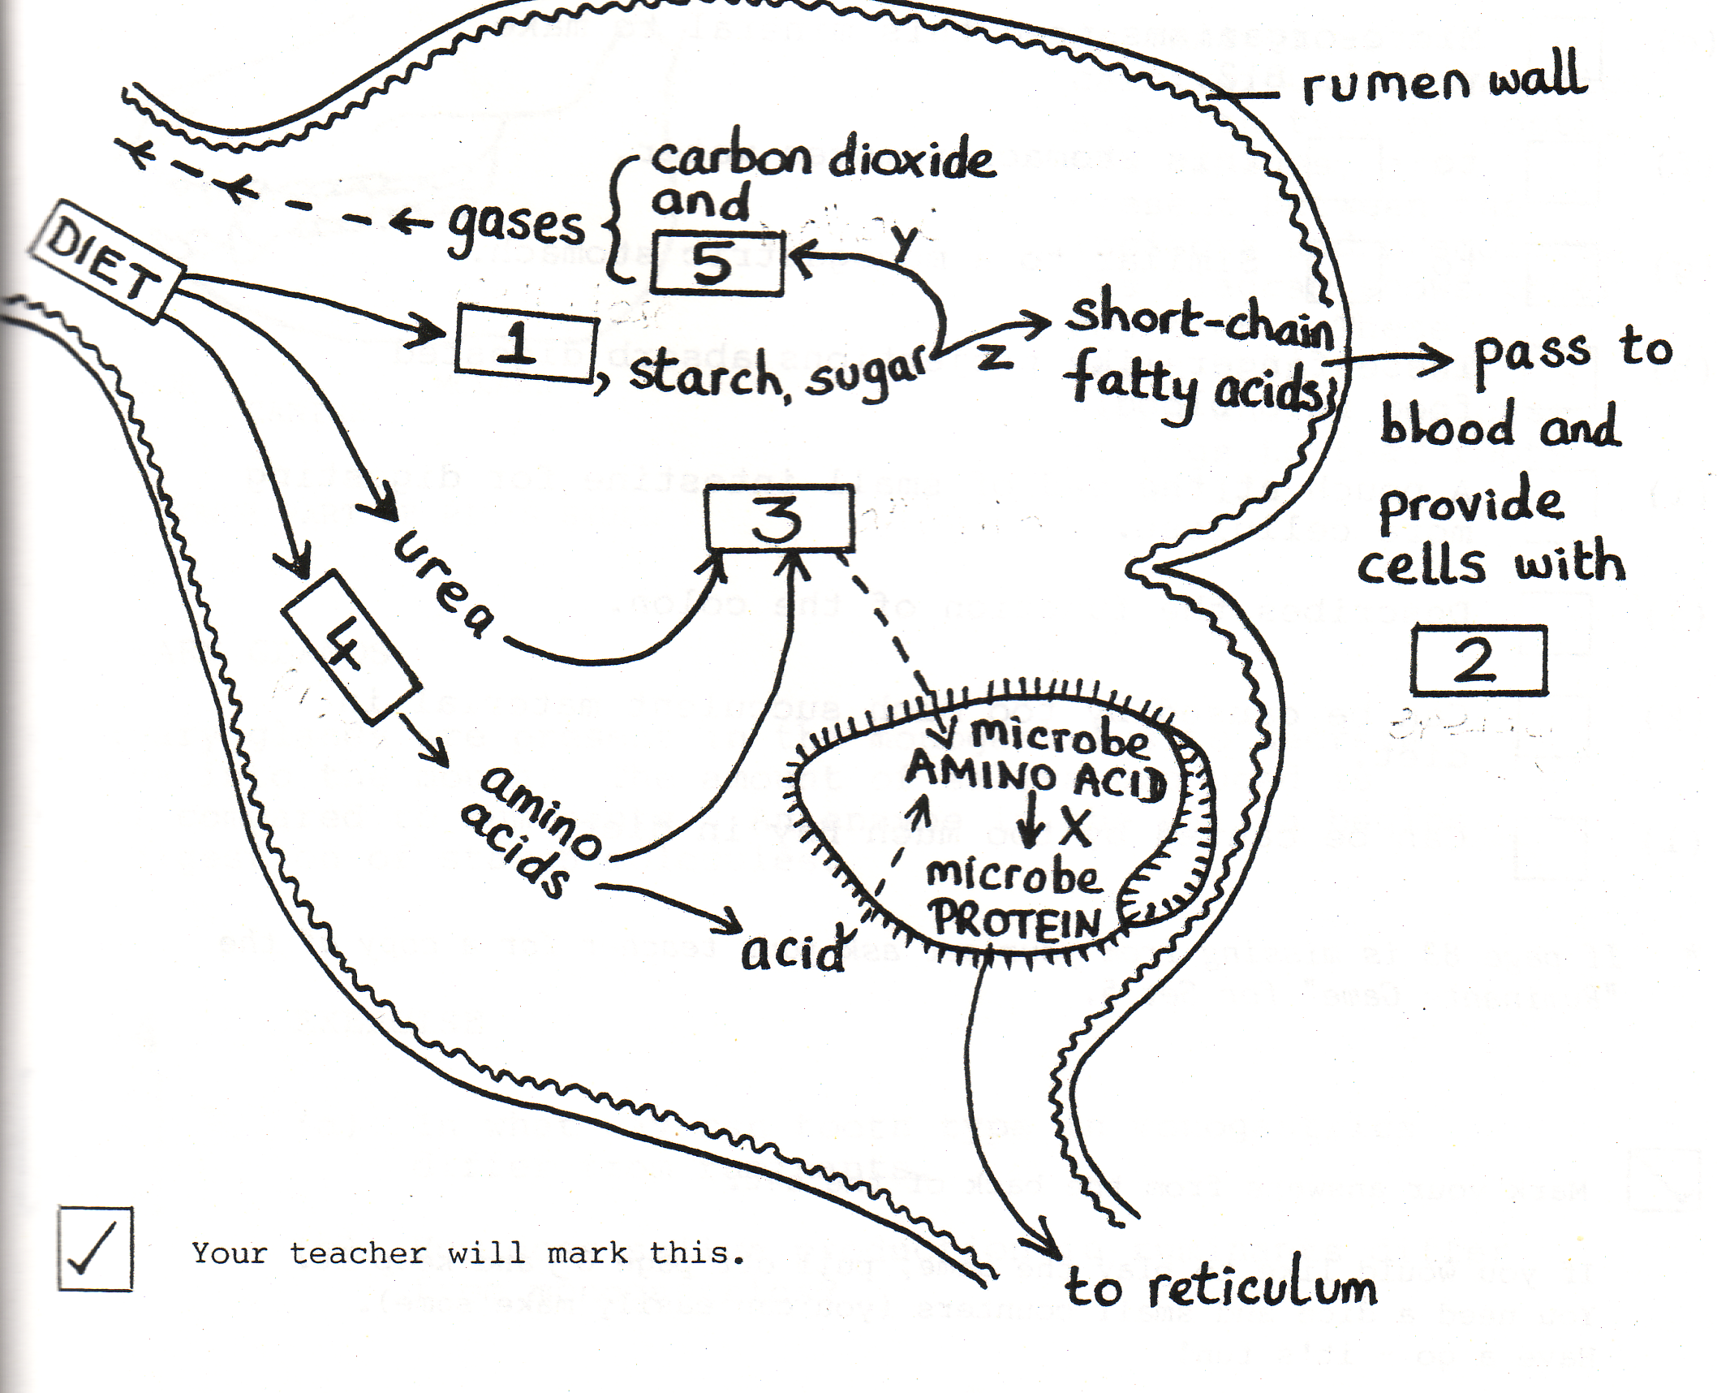

The ruminant digestive system
Chemical aspects when offered fresh pasture.
Salvia has pH 10. When swallowed into the rumen it balances the acids produced in the rumen so that pH 6-7 is maintained therefore bacteria are able to survive.

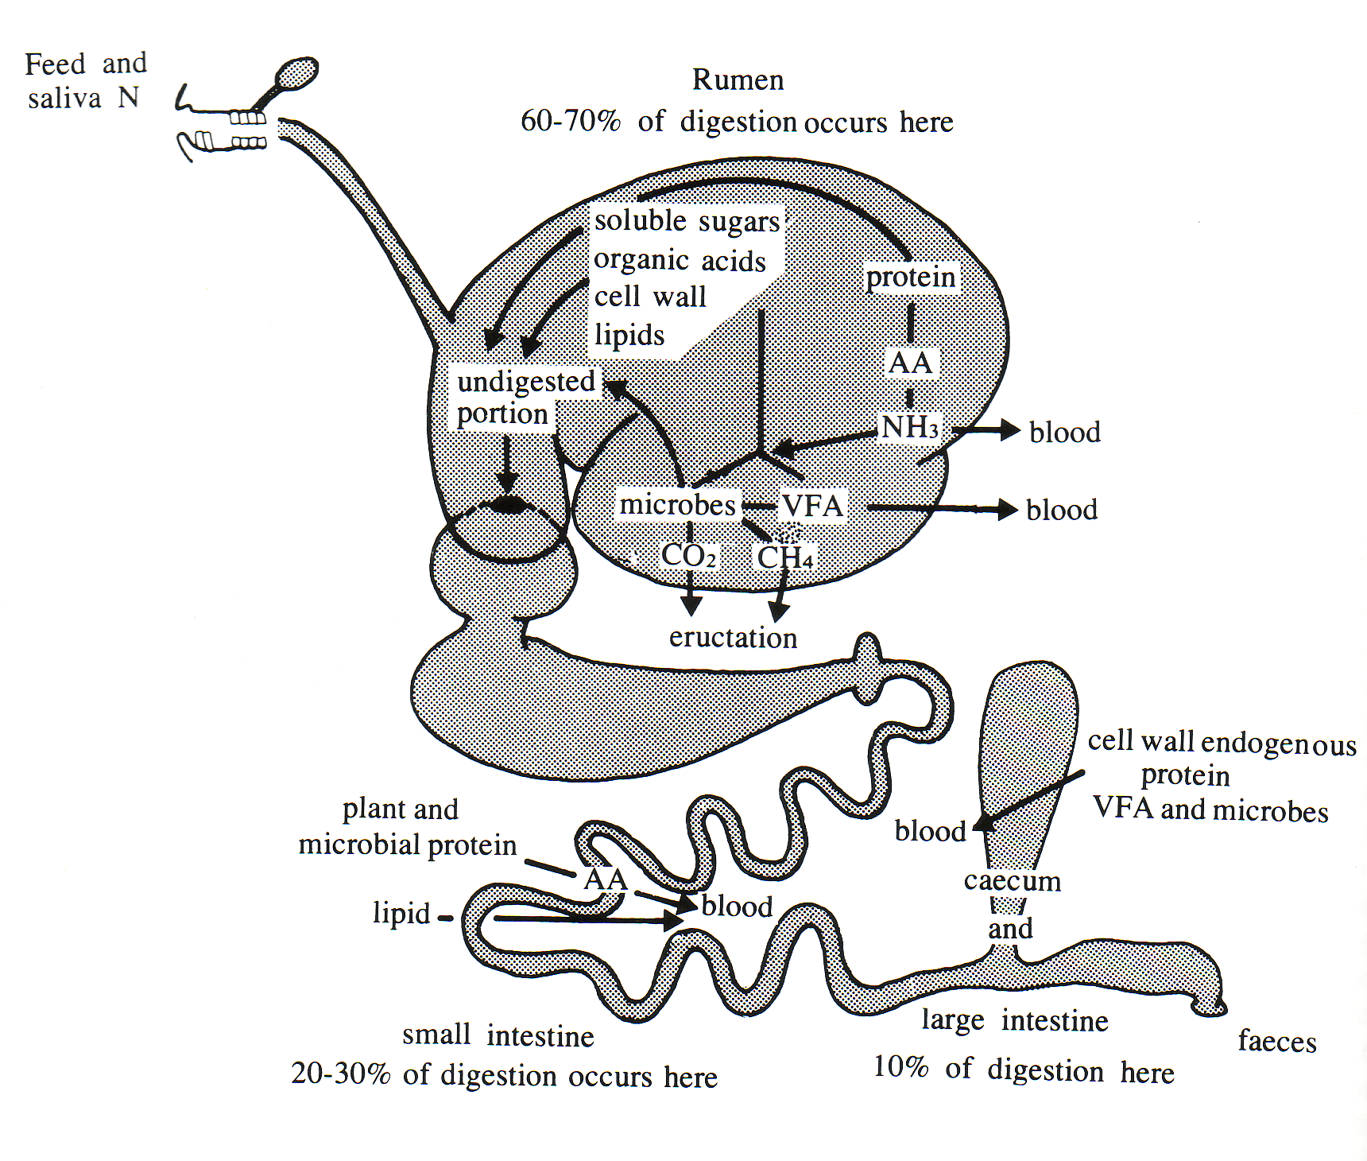

Papilla (projections to increase surface area – towel like material

Provide animal with 70% of energy intake

Bacteria swept down with food material are killed by acid conditions. Enzymes and acids begin acting on bacteria ‘bodies’ and material which escapes bacteria
(belching)

Main site of water absorption – dung gets drier

AA = amino acids
- Minerals, vitamins and water in food do NOT require breakdown but are absorbed in the intestines.
- Methane gas is combustible therefore contains energy which is wasted.
- CO₂ and methane must be belched, if not BLOAT may occur.
Roaming Through the Ruminant Digestive System
SUMMARY

Rumen First compartment
- Fermentation vat
- Bacteria and protozoa grow and work
- Fibre and cellulose is broken down.
- Urea is converted to bacterial protein.
- Feeds are broken down.
- Proteins to amino acids and ammonia.
- Starch and sugars to organic acids (volatile fatty acids).
- Cellulose to organic acids (volatile fatty acids).
- Finger-like projections (papilla) on the surface absorb organic acids (volatile fatty acids).
- Gas accumulates here when bloating occurs.

Reticulum Second compartment
- Also called the honeycomb
- Hold back the long coarser particles
- Fine density particles move through
- Hardware collects and trapped.

Omasum Third compartment
- Called the bible because it contains leave like flaps of tissue.
- Absorbs water (less fluid enzymes).
- Further reduction of food size.

Abomasum Fourth compartment
- True stomach
- Secretion of acid and enzymes
- Digestion of protein begins
- Rumen microbes killed here.

EXERCISE
List the correct number of each compartment of the ruminant stomach that answers the statement below. More than one answer is possible and all must be listed.

1 Abomasum 3 Reticulum
2 Omasum 4 Rumen

_____________________ A. Third compartment

_____________________ B. Hardware is normally trapped here

_____________________C. The true stomach

_____________________ D. Can find live bacteria here.

_____________________ E Papilla are found here

_____________________ F. The honeycomb

_____________________ G. Water is removed here

_____________________ H. Fermentation vat

_____________________ I. Fine particles are found here.

_____________________ J. Contains folds of tissue

_____________________ K. Enzymes are produced here.

_____________________ L. Volatile fatty acids are absorbed here.

_____________________ M. Bacteria and protozoa are killed here.

_____________________ N. Gas accumulates here.

Exercise

- Draw a table into your book to summarise the ruminant digestive tract.

Part of digestive tract | Type of digestion | Special functions | Describe the wall lining.

- Explain what villi are, and why they are necessary?

- Why is the rumen so large?

4. List four ways in which the rumen provides a suitable environment for rumen microbes.

5. (i) What is meant by rumination?

(ii) Explain why rumination is important.

6. Name the two groups of microorganisms found in the rumen.

7. A young ruminant is born without any microorganisms in its rumen. How does the young ruminant get these important microbes?

- What is “eructation” and explain why it is necessary?

Digestion Cross Word Puzzle Clues

Across | Down
2. A mineral needed for strong teeth and bones.  5. Another term for rumination is 'chewing the ---.  6. All animals require a balanced ------.  8. Needed for body building and growth.  10. A mineral needed to prevent anaemia.  12. A liquid produced by the liver, which breaks down fat.  13. The building blocks of proteins are ----- acids.  14. Microbial digestion is carried out by protozoa, fungi and -----------.  15. Faeces are another form of ------ from the body.  17. It is a simple sugar.  18. Pasture and turnips are examples of ------------ feeds.  21. These substances are needed in very minute amounts to maintain health.  22. The process that breaks food down  24. Helps neutralise the contents of the rumen.  25. Another name for fibre in foods is --------.  27. Pine kernel is an example of a -----------.  28. The substances responsible for the chemical breakdown of foods.  29. It is used for energy or stored.  30. ------- supplies the body with energy.  31. The ---------- has a honeycomb lining. | 1. Sheep and cattle are collectively called -------.  3. Liquid waste removed by the body.  4. The name for sugar, starch and cellulose.  7. The role of volatile fatty acids is to supply the body with --------.  9. Grains and potatoes are rich in it.  10. Most absorption of the products of digestion occurs in the small ------------.  11. In the --------- intestine all water is removed from the food material.  12. The omasum is often called the -------.  16. The gland that produces bile.  19. The organ that food enters immediately after a hen swallows it.  20. Nutrients are mostly made up of -----, hydrogen and oxygen.  23. A muscular organ that churns food.  26 Chemical digestion in ruminant animals occurs in the ----------.
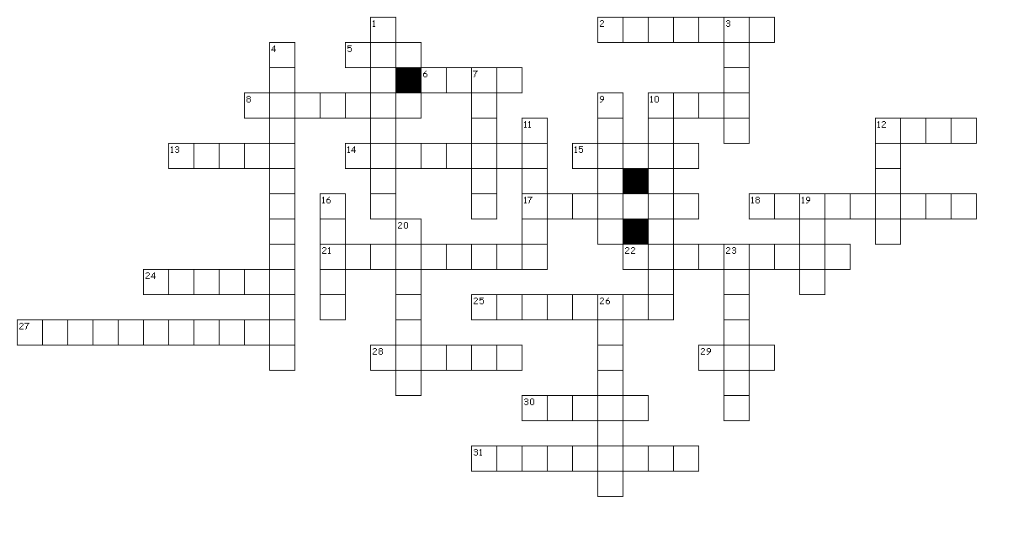
Digestion Cross Word Puzzle

Comparing different animal feeds
Nutritional value of different foodstuffs varies and farmers need to have some way of comparing one foodstuff with another.

There are three ways
- Dry matter least accurate method
- Digestibility
- Metabolisable Energy most accurate method.

Dry Matter (DM)
Dry Matter (DM) content is the amount of feed material left once water had been removed. A high DM% (eg 85% Hay) means the water content is lower so the feed is not very juicy compared with lower DM% like silage 20% or leafy pasture 16%.

FEED DRY MATTER % (DM%)
Good hay 85%
Poor hay 85%
Lucerne hay 85%
Barley straw 85%
Brown summer pasture 60%
Winter pasture 35%
Silage 20%
Leafy pasture 16%
Kale 15%
Swede 12%

High DM% is not necessarily good feed value as DM% does not tell you the protein, nutrient, fibre content of the food so does not tell you about the feed value.

Exercise
1 Foods vary greatly in the amount of water they contain and this must be removed before nutritional comparisons can be made. Explain why?
2 What does DM tell you about feed quality?

Nutritional Value of Pasture at different stages of growth.

Feed | DM% | Fibre % | Protein %
Short leafy pasture | 16 | 18 | 27
Long leafy pasture | 18 | 38 | 21
Flowering pasture | 22 | 55 | 11
Post-flowering pasture | 30 | 60 | 7

Nutritive value of pasture
The nutritive value of pasture is largely dependent on the proportions of protein and fibre (cellulose and lignin) it contains.
%

Fibre

Protein

Vegetative Budding Blooming Full Bloom
Stage Stage Stage

The higher the protein content, and the lower the amount of fibre, especially lignin, the better the value of pasture as a food.
Lignin is indigestible => As the plant matures its lignin proportion increases, so young leafy pasture plants are more nutritious than older ones

Exercise
- At what stage of growth is pasture the most nutritional? Explain why?

Describe what happens to digestibility as pasture goes to seed and explain why?
- Describe two management practices that a dairy farmer could do to prevent pasture quality decreasing.
- Describe two management practices that a sheep and beef farmer could do to prevent pasture digestibility decreasing.
Digestibility

Digestibility is a way of measuring the percentage of the dry matter of a foodstuff that will actually be absorbed into the body and not passed out in the faeces.

Importance of Digestibility in Animal Feeding
If the digestibility of a food is increased, an animal can eat more and obtain more nutrients for production.

Food Intake
Food that has a high digestibility passes along the gut faster than food with a low digestibility. This allows animals to eat greater amounts and so obtain more nutrients for energy and growth.

Small increases in digestibility results in larger amounts of nutrients being available for production.

Exercise
Animal A needs 6 kg of digestible DM for maintenance. The animal’s ration is 16 kg DM of long summer pasture, which is 50% digestible.
16kg DM
digestibility
50%
8kg digestible
DM
6kg maintenance
kg production

Animal B is the same size and need the same amount for maintenance. Animal B is given 16kg DM of pasture that is 75% digestible.
16kg DM
digestibility
75%
12kg digestible
DM
6kg maintenance
kg production

- Which animal will grow faster?

- Explain why?

Measuring Digestibility

This is also called a digestibility trial, the amount of food (DM) eaten is measured and the faeces passed are collected and weighed. The animal is usually put into a “metabolism crate” for easier collection of the faeces. The urine is not required, as it has no nutritive value. The trial is run for 7 to 10 days. The digestibility of a feed is defined, in mathematical form as

(FEED D.M - FAECES D.M) x 100 = PERCENTAGE
FEED D.M. 1 DIGESTIBILITY

Food that results in a lot of dung is of low digestibility and of low value. Food that results in little dung is highly digestible.
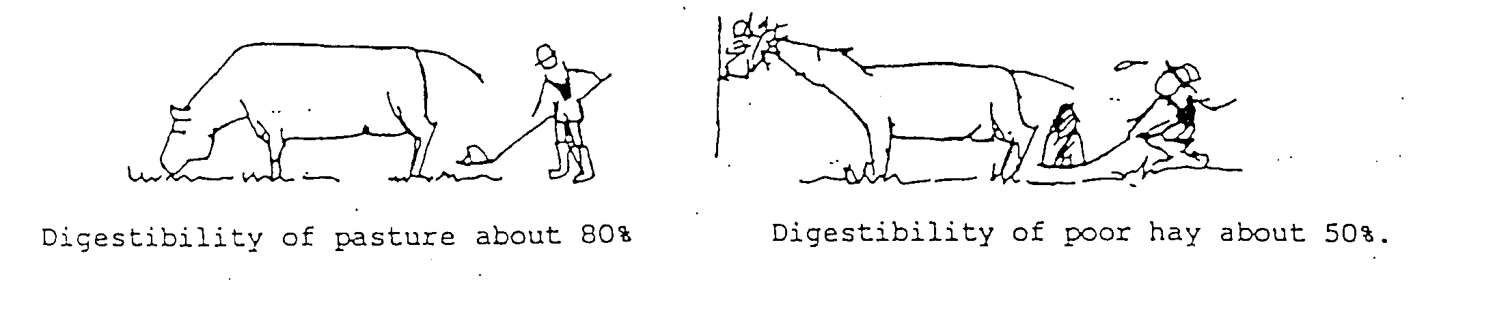

Exercise
- The diagram illustrates a metabolism crate used to measure the digestibility of feeds. The sheep was fed the same feed for seven days and the following figures were obtained. Calculate the digestibility percentage of the feed. Show all your workings.

Feed dry matter eaten = 10,000 grams
Dung dry matter excreted = 6,000 grams

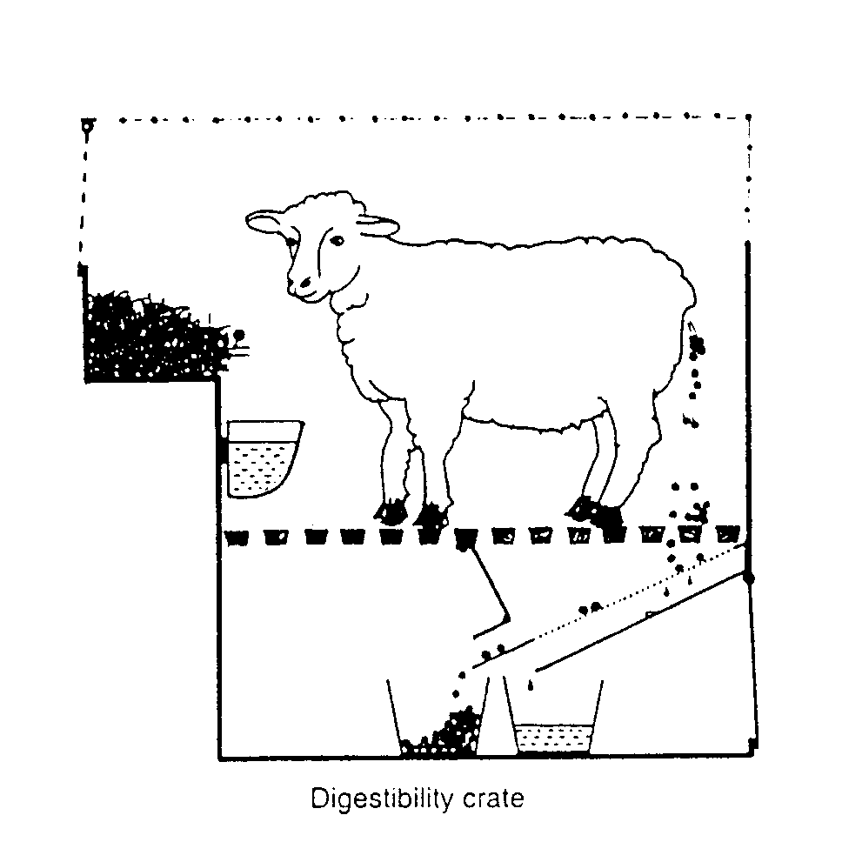

- Based on the digestibility percentage figure you have worked out from 1, suggest the name of the feed fed to the sheep using the table below.

Table of Digestibility of Common Foodstuffs

Foodstuff | %Digestibility
Very good leafy pasture  Silage  Good hay  Barley straw | 83  79  61  39

- Can you suggest why dry matter figures are used instead of wet matter figures?

- Why is the amount of urine produced not measured?

- What is the purpose of the nylon sieve?

- Would the digestibility of the feed be different if a pig rather than a sheep has been fed the feed? Give a reason for your answer.

- How does the digestibility of a feed affect the amount of the feed eaten by an animal?

Digestibility calculations

Exercise1
Three wethers were placed in separate metabolisable crates. They were all fed 1.5kg DM/day. Faeces were collected and the DM calculated. The results are shown in the table below

Wethers | Faeces kgDM
A | 0.6
B | 0.9
C | 0.3

- What is a wether?
- Why are wethers used in digestibility trials?
- Calculate the digestibility of the feeds fed to each wether.
- Suggest the type of feed being fed to each wether.
Exercise 2

A sheep was placed in a metabolisable crate and fed daily. After two days the amount of feed eaten and the faeces excreted were measured for 8 days. The results are shown in the table below.

Day | Feed eaten  DM (g)/day | Faeces excreted  DM (g) /day
1 | 800 | 250
2 | 800 | 250
3 | 800 | 250
4 | 800 | 250
5 | 800 | 250
6 | 800 | 250
7 | 800 | 250
8 | 800 | 250
9 | 800 | 250
10 | 800 | 250

Explain why measurements were not recoded until day 3?

Calculate the digestibility of the feed.

Suggest the type of feed being fed.

Exercise 3

Use the following data collected from sheep housed in a metabolisable crate to:-

1 Calculate the digestibility of the feed.

Day | Feed Eaten DM(g)/day | Faeces Excreted DM (g)/day
3 | 1200 | 350
4 | 1250 | 325
5 | 1250 | 300
6 | 1300 | 350
7 | 1300 | 325
8 | 1300 | 300
9 | 1350 | 300

2 Suggest the type of feed being tested.

Digestibility
Digestibility tells us the proportion of the dry matter of the food that will be absorbed into the animal’s body.

It does not tell us the quantity of energy of the amount of protein available to the animal from the food.

Metabolisable Energy
Metabolisable energy tells us how much energy 1kg of the food will supply for:-
- Heating the body
- Maintenance
- Production

Gross Energy
Faecal Energy
Digestible Energy
Urine Energy
Methane Energy
Heat Increment
Maintenance
Production
Metabolisable Energy
Net Energy, used for
Total Heat Production

Factors Affecting Digestibility

Factors affecting digestibility fall into two groups.

1 Factors affecting plant digestibility
- Species of plant clover is more digestible than grass (less fibre and higher protein) some grasses are more digestible than others.

- Maturity of plant as a plant matures fibre increase and protein decreases digestibility decreases. Plants are more digestible in spring and autumn.

- Season of the year (stage of growth).

- Treatment of material:
- Crushing: increases digestibility. Whole barley grain has a 50% digestibility when crushed it increases to 90%.
- Cooking: increases digestibility.
- Grinding: decreases digestibility as food passes to quickly through the rumen for efficient
microbial breakdown.

2. Factors affecting animal digestion.
- health
- level of intake
- tooth wear
- types of digestive system
- age

Classification and comparison of common foodstuffs

CLASSES | EXAMPLES | CHARACTERISTICS | USES
ROUGHAGES | HAY  STRAWS | - dry (average 85% DM)  - High fibre, (low digestibility)  - Low protein  - Low energy (Supplies maintenance only) | - Maintenance  - For bulk (to fill the animal up)
SUCCULENTS | GREENFEEDS  E.g. leafy pasture, legumes,  Silage,  Chou moellier  ROOTS  E.g. turnips, swedes | - High water content (10-25% DM)  - Palatable  - Laxative action  - High digestibility  - Insufficient protein, high bulk (watery)  - Low energy | - Production  - maintenance
CONCENTRATES | CARBOHYDRATE RICH  E.g. cereals  PROTEIN RICH  For ruminants: peas, linseed meal. For non-ruminants fishmeal, milk powder. | - Low water content  - High digestibility  - High energy content | - Production – mainly overseas. In NZ, cereals are used to feed pigs. If fed to ruminants concentrates need to be accompanied by high quantities of fibrous food e.g. pasture.

Exercise
- Describe the differences between roughages, succulents and concentrates.
- Which type of feed would you feed to lactating cows in spring? Explain why?
- Which type of feed would you feed to dry cows in winter? Explain why?
- Name a feed that is; protein rich
carbohydrate rich
- Which type of feed would you feed to fast growing pigs. Explain why?
- Explain why you would not feed concentrates to ewes in spring?
- When would you feed concentrates to dairy cattle? Explain why?

Table of feed energy values metabolisable energy
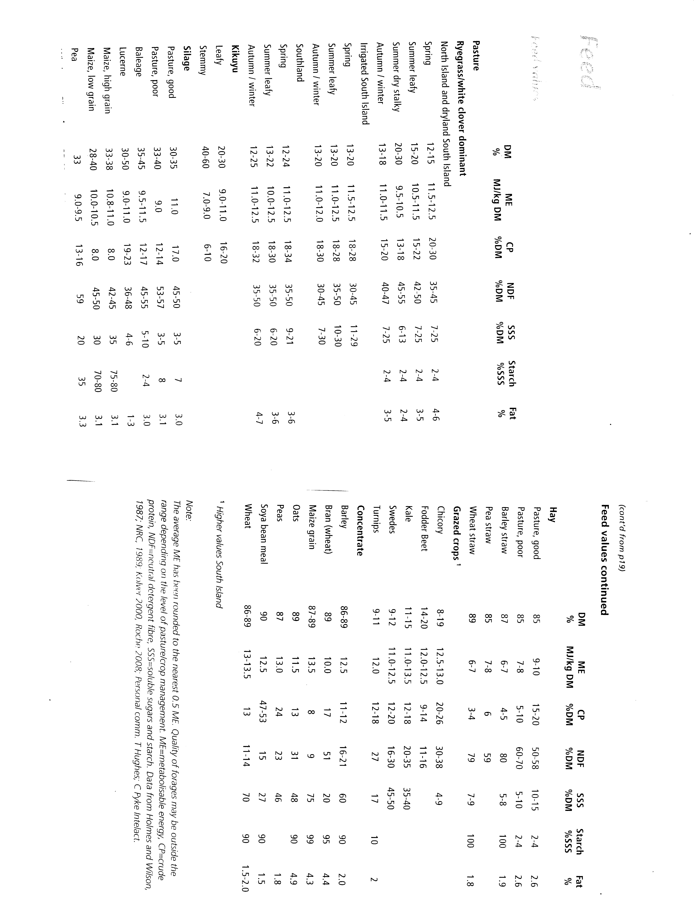
Exercises
1 Using the information on pages 31 and 32 draw and complete the table below to compare feeds into your books
Feed | DM% | Energy Value  MJME | Feed type
Spring pasture
Pasture silage
Meadow hay
Turnips
Kale
Chicory
Balage
Maize
Barley
Barley straw

2 Friesian bull must be well fed to achieve fast growth rates. This usually involves feeding the bulls pasture and forage crops at different times of the year.

The table below shows some information on common feeds
Feed | DM % | Energy Value
Pasture | 15 | 11.2
Turnips | 9 | 11.0
Hay | 85 | 8.0
Pasture silage | 20 | 10.0
Kale | 15 | 11.5

The feeds in the table above are available to a farmer growing spring born Friesian bulls calves from weaning until slaughter at 18 months.
- Describe the feeds the farmer would use and the season the feeds would be used.

(ii) Explain how the feeding programme would results in fast growth rates.

3 The feed requirements of breeding ewes and cows, varies throughout the year depending on their physiological state as shown in the following diagrams. Using the information in these diagrams and your own knowledge:
(i) Explain for both breeding ewes and cows why feeding levels change throughout the year.
(ii) Describe the type of feeds you would feed to each group throughout the year and explain why.

Ewe Body Condition Score and Liveweight (A Guide to Feed Planning for Sheep Farmers)
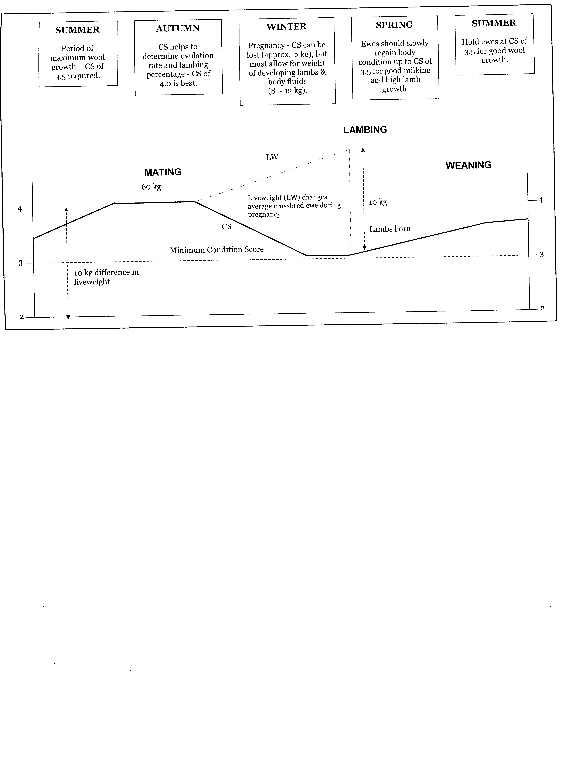
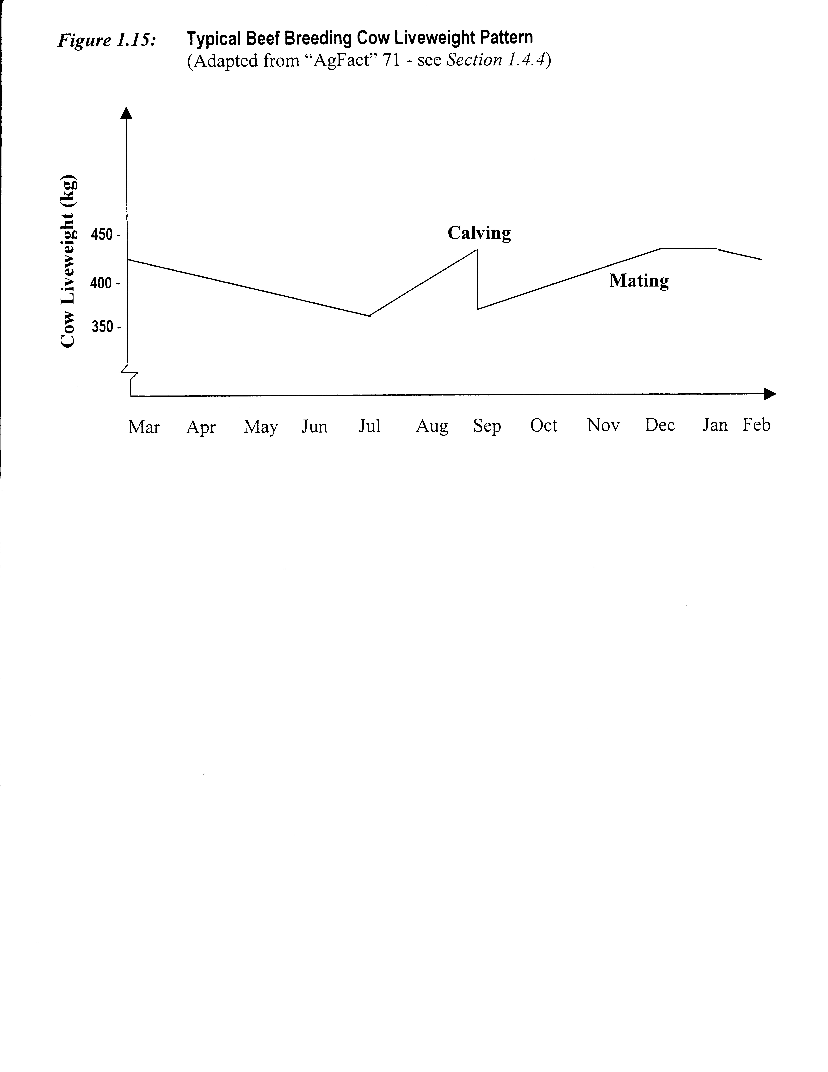

Nutrition Exercises
- Dairy calves are usually removed from their mothers after 24 hours. After this, they need to be fed so that they grow rapidly to reach a weight of 100kg in eight weeks before they can be weaned off milk.
The farmer has the following feeds available to feed calves;
- Leafy pasture
- Calf meal
- Whole milk
- Colostrum
- Give the order in which the farmer would use and combine these feeds so that the calves grow quickly. (More than one feed can be used at any time).

- How does the feed programme ensure the calves grow quickly at a low cost?

- Feed types
barley meal, maize grain, meadow hay, muesli, leafy pasture,
mature pasture, maize silage, milk powder

- Select two feeds that would best suit the needs of weaned calves and explain how the digestive system of weaned calves suits these feeds.

- Select two feeds that would best suit the needs of weaned pigs and explain how the digestive system of weaned pigs suits these feeds.

- Dry cow in late winter versus lactating cow in early spring

- Breeding beef cow and steers growing at 400g/day in autumn

THE SUPPLEMENTARY FEEDINGS OF LIVESTOCK

Feed supplements is the term applied to food other than grazed pasture. Supplements such as, hay, turnips, and green feed cereals are used when there is not enough suitable pasture. They are fed:
- during pasture shortage, mainly in the winter and summer, and
- when a shortage is likely to occur. In this case, supplements are fed in order to save pasture for more critical periods.

The type of supplementary feed fed will depend upon the level of product ion or maintenance required of the animals. Fig. 3 shows the maximum and minimum nutritional needs of the breeding ewe. During times of maintenance feeding requirements, feeds suitable for maintenance only are fed e.g. straw, hay, turnip, swedes and silage. When animal requirements reach double and triple maintenance levels, and pasture quality and quantity are inadequate, then productive feeds such as green feeds, barley, grain and meals are required to supplement pasture.

It is customary that when feeding supplementary feeds in order to increase the nutritional level to animals, the poorer quality feeds, e.g. straws, are fed first, followed by meadow hay, lucerne hay. Any attempt to reverse, this pattern by feeding small amounts of lucerne hay followed by greater quantities of meadow hay and straws is largely rejected by stock or else the stock will take a period of time to adjust to the new diet.

When feed requirements are very high, the quality of supplement must also be high. In such cases, saved pasture is the best and cheapest supplement e.g. immediately before and after lambing. However, on occasions the use of saved pasture is insufficient to allow stock to attain full production. For this reason the use of concentrates especially barley grain, or any other cheap grain deserves comment. In the past concentrates were considered too expensive in comparison with grass or hay, but since the costs of hay and silage making have gone up more rapidly than those of barley and maize and also that such concentrates can be easily and successfully used for sheep and cattle feeding, there is increased interest in this form of supplementary feeding. Barley grain in the case of sheep and barley meal or maize meal for cattle are valuable supplements in the following situations.

On sheep farms, barley grain acts as a "buffer" against high stocking rates and feed requirements. Not necessarily must it actually be fed but the knowledge that barley is stored and available may convince farmers to increase stocking rates and the profit from the extra sheep more than offsets the cost of the barley. If fed it is usually at the critical time just prior to lambing when pasture quality and quantity may be limited.

On dairy farms, concentrate meals are used to boost the low intake of pasture fed dairy cows in early Iactation. Town supply dairy farms hold a unique position in the feeding of concentrates. Because a milk quota must be maintained throughout the winter when pasture growth is minimal, climatic conditions extreme and where there is an upper limit to how much of bulky feeds, such as hay and silage can be consumed, the feeding of concentrate meals is widely practiced especially in the South Island.

Barley meal or rolled barley grain also comes into its own as a fattening feed for finishing beef cattle.

As mentioned in Section 8.4, supplementary feeds especially specialist crops such as swedes and turnips are more important in the South Island. Their importance has decreased in recent years with the increased practice of "all grass farming" in which pasture and conserved pasture are the only sources of food. The advantages of "all grass farming" or "block grazing" as it is known in the North Island are:
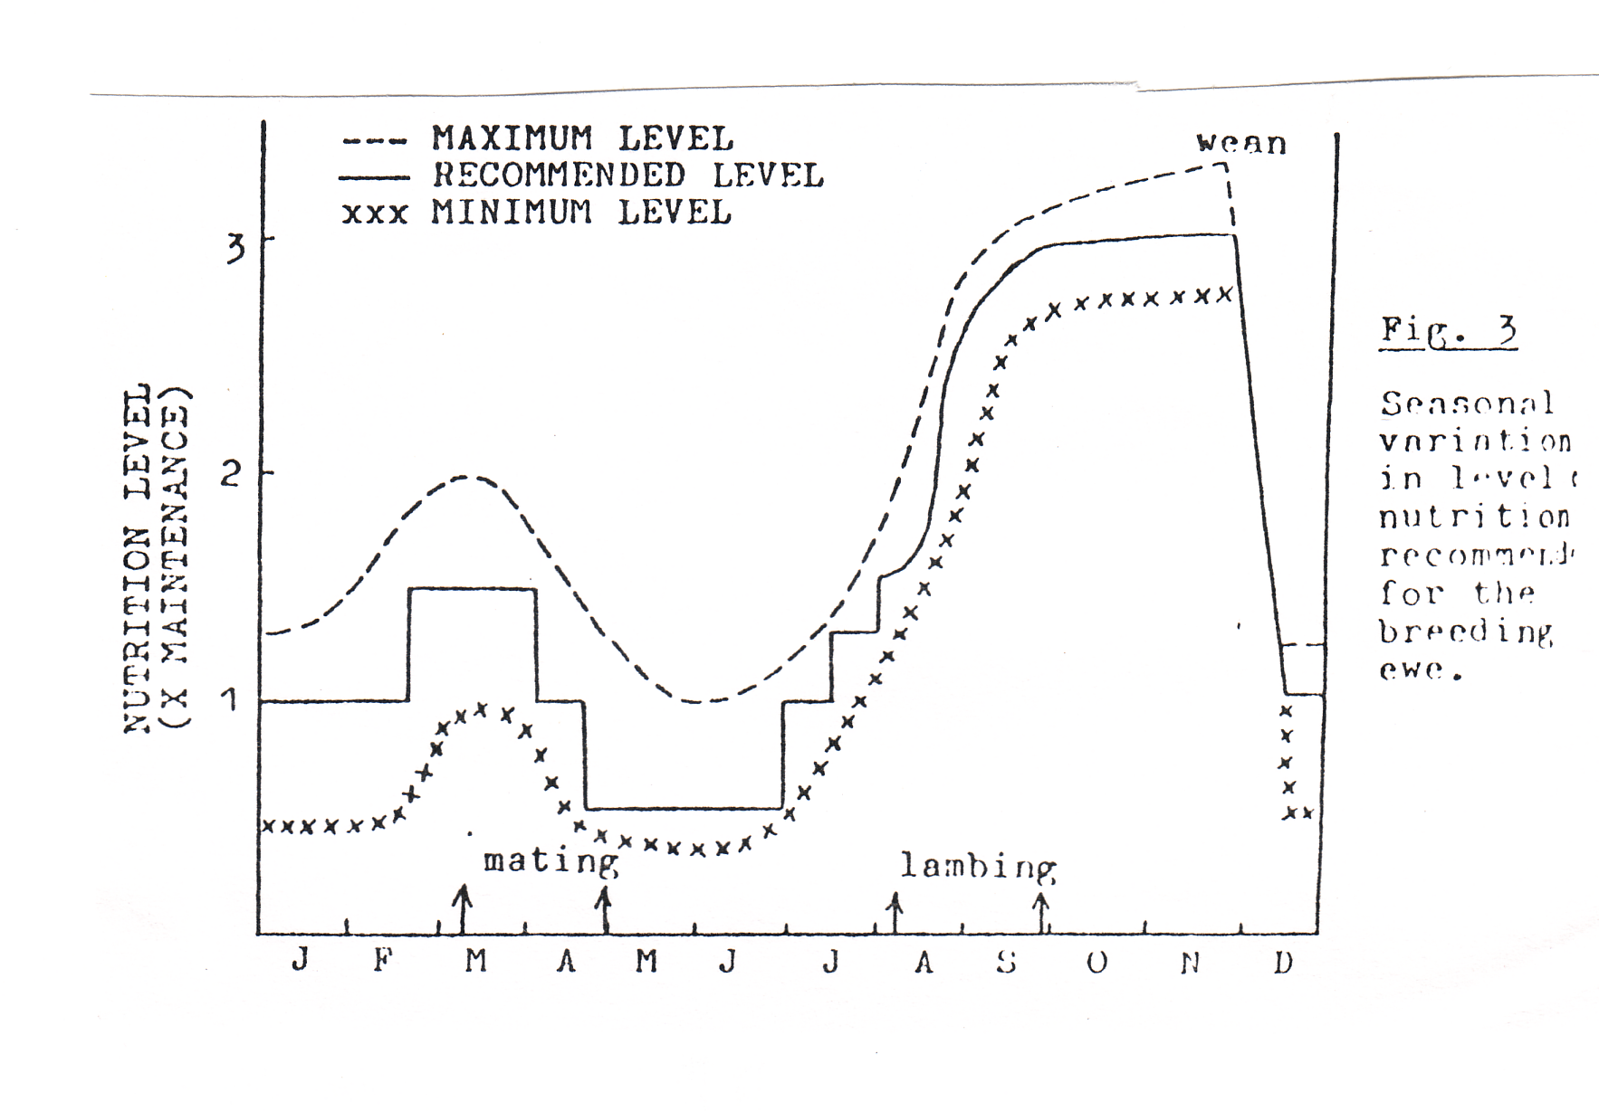
- More feed is available to stock throughout the year. Winter grazing with a high stock concentration for a short time ensures each paddock is well top-dressed with dung and urine, and also, rank growth does not accumulate. With no winter-feed crops and run-off paddocks; there is a greater area of pasture available for grazing in spring.

- The cost of a traditional wintering system based on swedes and turnips is approximately double the cost of an all-grass system.

- Tractor work in preparation for a winter-feed crop is reduced as is the time-consuming task of shifting winter-feed breaks.

- It is easy to control the condition of ewes and to provide adequate pre-lambing feed.

- There is no risk or a crop failure.

- Reduced teeth wear means that ewes should last a
year longer.

- Footrot and foot abscess control is easier.

Supplementary feeding of livestock
Exercise
- Read the above pages on “Supplementary feeding of livestock” and answer the following questions.
- What is meant by “supplementary” feeding of livestock?

- Give 5 examples of supplementary feeds.

- State two reasons why supplementary feeds are necessary?

- What does the type of supplementary feed, fed to animals depend on?

- Using figure 3.
- State when ewe feed requirements are and high and explain why?

- When are ewe feed requirements low, and explain why?

- Explain the term “maintenance” feeding.

- List the feeds suitable as maintenance feeds.

- Describe the type of feed required by high producing animals eg cows at peak lactation.

- List the following feeds in order of highest feed value to lowest feed value.
Turnips, meadow hay, maize silage, lucerne hay,
Barley straw, fresh pasture, grass silage, meal concentrate,

- Explain why there has been an increase interest in the use of concentrates as a supplementary feed?

- Explain what is meant by “all grass farming”?

- Give four advantages of all grass farming.

Nutrition Revision Exercises

Question one
To feed livestock to achieve high production farmers need an understanding of the ruminant digestive system.

a. Explain digestion in the rumen. In your answer, include:
- function of rumen microbes
- conditions needed for rumen microbes to function efficiently
- what happens to the gases and fatty acids produced?

Ruminant animal such as cattle ‘chew the cud’.
b. Explain why ruminant animals ‘chew the cud’

c. A beef farmer has two feeding options for dry cows in late pregnancy.
- fresh leafy pasture
- mixture of fresh leafy pasture and hay

Select the feeding option that is the best for dry cows _______________________________________
Give reasons why the selected option is better than the other option in terms of;
- nutritional value
- time chewing the cud
- availability of feed for cows at calving
Question Two
The diagram below shows the development of part of the digestive system of a newborn calf until weaning.
a. Explain why the rumen of a newborn calf is much smaller than the rumen of a weaned calf.

A dairy farmer provides fresh good quality hay and meal to young calves to help develop the rumen.
b. Explain how feeding fresh good quality hay to young calves helps to develop the rumen.
c. Give reasons why it is important that calves have a well developed by the time they are weaned in terms of:
- growth rate
- future production

Question Three
Many areas of New Zealand have suffered a late summer drought.
a. Explain the effect of a late summer drought on dairy cows body weight and milk production

Two management practices dairy farmers could use to provide feed for cows in late summer and autumn at a time when dairy farmers want their cows to gain liveweight before calving as well as continue to produce milk are:-
- Feed cows a mix of silage and palm kernel
- Dry off cows in poor condition (low body weight)

Select the management practice you consider will increase the liveweight of the cows before calving
and still continue to produce milk. ____________________________

- Give reasons why the selected management practice would maximize farm returns in terms of :
- gaining weight in autumn before calving
- milk production
- farm financial returns.
Question Four
Dairy heifers must be well fed to achieve target weights at mating. This involves feeding them different levels of quality pasture.

Time of Year | Kg DM per head per day
 | Jersey | Friesian
First summer / autumn (5-9 months old) | 3.0 | 4.0
Winter early spring | 4.0 | 5.0
Mid spring / summer (14-17 months old) | 5.5 | 6.5

Explain why different feeding levels of quality pasture are required to meet target weights of dairy heifers. In your answer, you should consider:
- breed
- maintenance requirements.
- effect on the number of in-calf heifers.

Question Five
Breeding ewes require different levels of nutrition throughout the year.
Justify why a farmer provides different levels of nutrition to breeding ewes at different times of the year. In your answer, you should cover:
- weaning to mating
- mating to pre lambing
- lambing to weaning

Question Six
Breeding cows require a different feeding programme at different physiological stage from mating through to weaning.
Justify why different feeding programmes are used for breeding cows at different physiological stage from mating through to weaning. In your answer, you should cover:
- pregnancy
- calving
- lactation

Animal Reproduction and Breeding

- Importance of reproduction
- Male and female reproductive organs
- How the sex organs work
- Reproductive efficiency
- Factors affecting animal reproduction
- Genetics
- Variation, the basis of selection
- Artificial insemination

Artificial insemination
- Advantages
- Disadvantage
- Semen collection
- Dilution
- Storage
- Insemination
Why is reproduction important?
- Initiates lactation
- Sale of surplus stock
- Primary products to sell
- Replacement stock

Function of each part
Male | Female
Testis | Ovary
Vas deferens | Oviduct
Epididymis | Uterus
Seminal vesicles | Cervix
Penis | Vagina
Sheath

Male and Female Reproductive organs
Oestrus Detection
- Why important
- Length of oestrus cycle
  - Sheep: 17 days
  - Cows: 21 days
- Methods
  - Tail paint
  - Kamar
  - Observation

Role of hormones
- Oestrogen
- Progesterone
- Testosterone

Use of genetically superior sires
Animal Reproduction
- Health
- Nutrition: - flushing
Cow condition

Survival
Eggs fertilised
Eggs shed
Factors affecting reproductive efficiency

Gestation
- Ram/ewe ratio
- Bull cow ratio
- Fertility
- Nutrition
- Health
- Oestrus detection
- Technician experience
- Nutrition
- Shelter
- Health

Cow: 282 days 9 months
Sheep: 147 days 5 months
Variation is the basis of selection
Animal identification
- Reason for identification
- Methods
  - Ear tagging
  - Branding:- freeze
hot
  - Tattoo

Increase animal performance
Genetics
- Punnett squares
- Terminology
Performance Recording
- Reason for recording production data
- Type of information recorded
- Use of information

Animal Productivity
Genotype or environment
Animal Reproduction
High reproductive performance is essential to achieving high productivity on farmers. Good reproduction performance is a critical component of a farm being economically efficient. To achieve a reproductive performance a farmer needs to understand
- The Importance of reproduction
- How the reproductive organs work
- The factors affecting reproductive performance
- The management practices that could be used on farms to improve reproductive efficiency.
- Basic genetics
- That variation is the basis of selection
- Artificial insemination

Importance of reproduction
1. Cows cannot produce milk until they have calved i.e. reproduction initiates lactation.
2. Produce as many lambs and calves as possible and raise them to a marketable size.
3. Young animals are needed to replace older animals i.e. maintain the breeding population.
- Surplus stock can be sold for extra income.
- To produce saleable products

Why do we want high birth rates? (ie high lambing and calving %'s)
1. Sell surplus stock
2. More stock to produce saleable products from (wool, meat velvet, venison etc)
3. Initiates milk production.
4. Provides a larger pool from which to select replacements stock.

Reproductive Systems

Female Reproductive System
The reproductive tract of the cow consists of a vagina, a cervix, a uterus, fallopian tubes and ovaries. You should be able to identify these structures and understand their function.
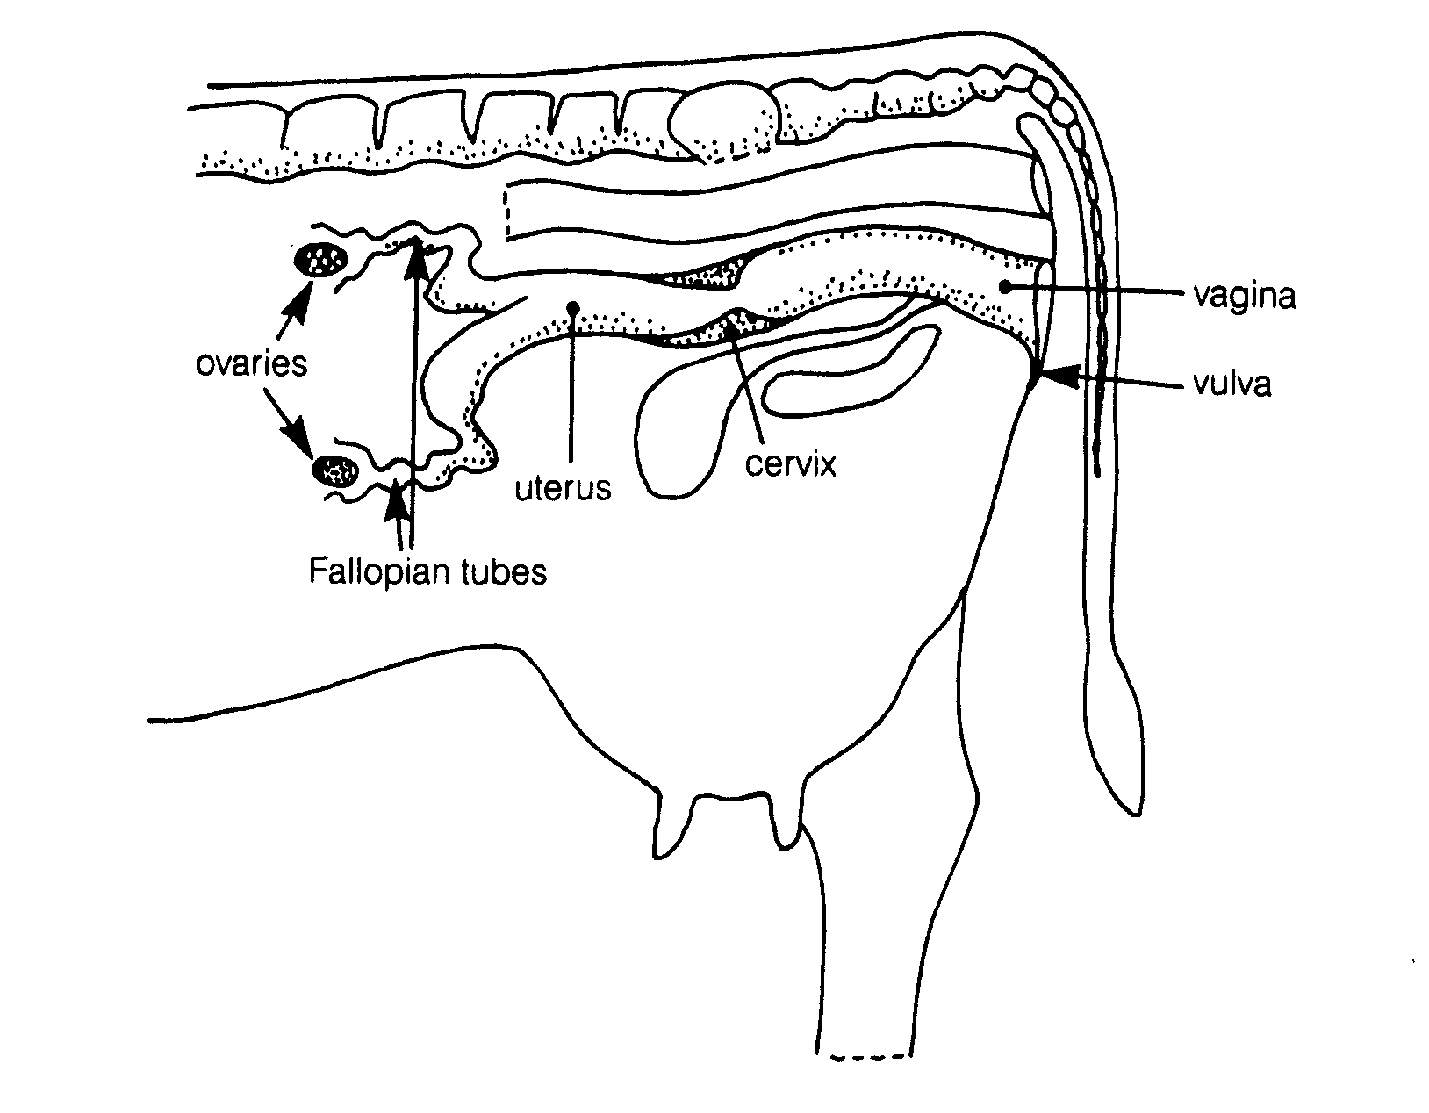
Diagram 1
The reproductive tract consists of two ovaries, which produce the hormones progesterone and oestrogen. Follicles, which develop on the ovaries, may burst and release an egg into the funnel shaped fallopian or uterine tubes, which lead to the uterus. The egg then moves down into the uterine horn and if fertilised implants into the uterus wall.
The uterus is a muscular, expandable organ. Its function is to receive a fertilised egg and to nourish it while it grows into an embryo and then a foetus. The uterus has an opening called the cervix.

The cervix prevents microbes getting into the uterus. When the animal is pregnant, the cervix is tightly closed and sealed with a mucus plug. The cervix projects slightly into the vagina.

The vagina is the birth canal and receives the copulatory organ (penis). Because the vagina receives the penis, it has glands in the walls, which produce secretions that provide lubrication during mating. The vagina holds the semen, which is ejaculated by the male. Sperm from the semen enter the uterus via the cervix. From the vagina, the urethra passes to the bladder. At the opening of the vagina is the vulva. The vulva is the exterior part of the birth canal. It consists of lips, which, cover and protect the vagina.

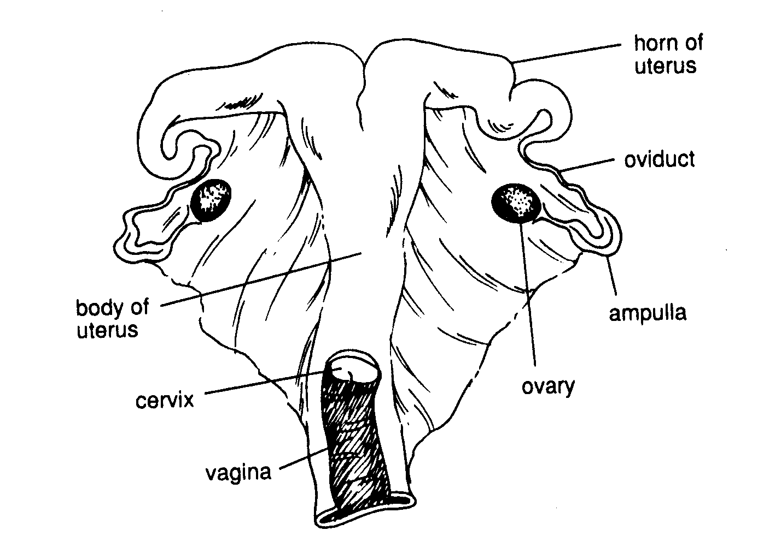
Diagram 2

Male Reproductive System
The reproductive tract of a bull consists of the scrotum, which contains the testes. Leading from these is the spermatic duct, (this is what is cut when you have a vasectomy). The secondary sex glands, (these make the seminal fluid), the penis and its sigmoid flexure, the retractor muscles and finally the prepruce.

Diagram 3

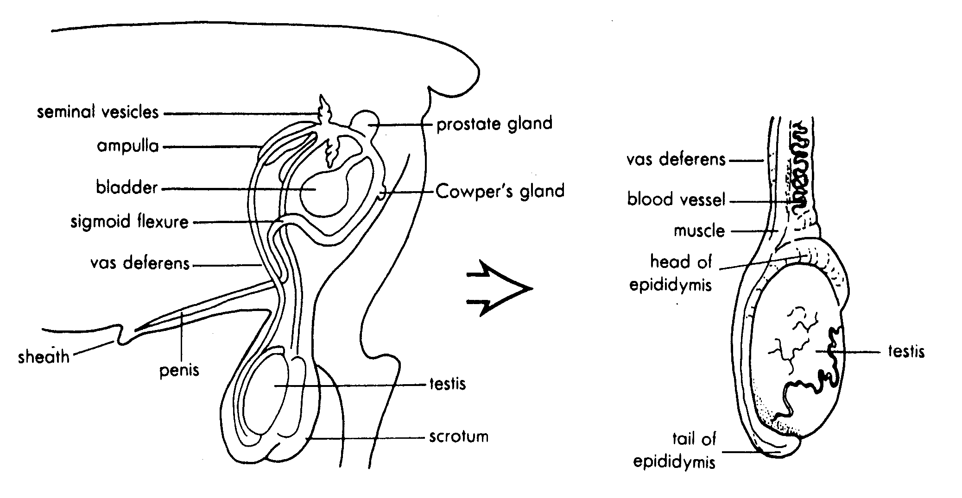

The functions of the parts of the male reproductive organs are;
The testis is where the male sex cells or sperm are produced. Sperm are stored in the tube called the epididymis, which lies alongside the testis.
The scrotum is a bag or sac containing both testes. This enables the sperm to develop at a temperature slightly lower than that of the body.
The sperm ducts carry the sperm from the epididymis to the seminal vesicles.
The seminal vesicles produce a nutritive fluid to sustain the sperm.
The prostate gland produces a fluid that causes sperm to commence swimming as they pass down the urethra. When sperm are mixed with prostate fluid from the seminal vesicles and the small gland to the right of the vesicles the resulting mixture is the semen.
The urethra is the tube, which carries both semen and urine from the bladder to the penis.

Exercise: Reproductive systems

1 Complete the table by describing the function of the reproductive parts listed.
Reproductive tract | Function
Ovaries
Oviduct
Uterus
Cervix
Vagina
Vulva

3 Complete the table by describing the function of the reproductive parts listed.
Reproductive tract | Function
Scrotum
Testes
Epididymis
Spermatic cord
Sex glands
Penis

How the sex organs work

TESTES  The testes  - Form sperm  - Produce a male sex hormone called androgen (testosterone) |  | OVARIES  The ovaries function in repeating cycles called oestrous or Breeding Cycles. In each cycle.  - Eggs are shed  - The female sex hormones, oestrogen and progesterone
Androgen  - Form male body shape  - Causes desire to mate |  | Oestrogen  - forms female body shape  - causes heat helps udder growth  - helps growth of uterus |  | Progesterone  - prevents heat  - maintains pregnancy  - helps udder growth  - helps growth of uterus

The oestrous cycle
The ovaries work in repeating cycles called oestrus (or breeding) cycles. The length of the cycle is different for each species. Each estrous cycle consists of a period of sexual activity called oestrus or “heat” when the female is receptive to mating, which is followed by a period of sexual inactivity. It the female does not become pregnant another cycle will occur. Heat, or oestrus, occurs around the time when an egg is shed from the ovary. After the egg has been shed the female gradually loses the desire to mate. The reproductive organs of the female are still active and she is either pregnant or is undergoing changes ready for the next oestrus.

Female animals that are showing regular heats are said to be cycling.

When to mate
It is important to mate animals at a time, which is as close to ovulation as possible. If this is not done, the sperms may die before the egg is shed and ready to be fertilised.
Ovulation usually occurs near the end of the oestrus (heat)

For each type of animal, the farmer should know:
- the length of the cycle – so that the approximate time of future heat periods can be worked out.
- If ovulation occurs during or after heat – so that the best time for mating can be worked out.

The table below shows this information for sheep and cattle.
Animal | Length of cycle | Length of heat | Ovulation occurs | Best time for service
Sheep  Cattle | 17 days  21 days | 1 ½ days  16-18 hrs | At end of heat  14 hours after heat | Middle of heat (oestrus)  Middle to end of oestrus  (heat)

Exercise
- Name the hormone produced in the testes.

- Describe the function of the hormone found in the testes.

- Name the hormones produced in the ovaries.

- Describe the functions of the hormones found in the ovaries.

- What is meant by oestrus?

- Describe the oestrus cycle?

- State the length of the oestrus cycle in sheep/cattle.

- Explain why it is important that a farmer knows the length of the oestrus cycle?

- What occurs at ovulation?

Pregnancy
During pregnancy, the foetus alters its position as shown in the normal diagram below. If the foetus is in any other position as shown in the abnormal diagrams then the cow will have calving difficulties.
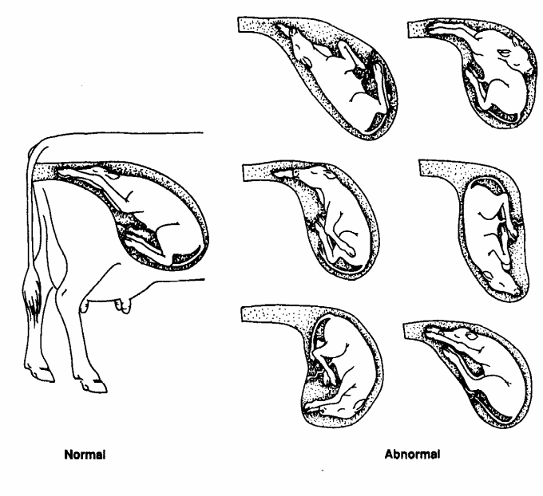

Exercise
- Other than the foetus in the wrong position, what else could cause calving or lambing difficulties?

- How can you tell a cow or ewe is giving birth?

- How can you tell if a cow or ewe is having calving/lambing problems?

- Why would a farmer cull a ewe that has lambing problems?

- Would a dairy farmer cull a dairy cow if she had calving problems? Give reasons for your answer.

- Refer to the diagram below to describe the function of the;
- Placenta

- Amnion fluid

- Umbilical cord

- Uterus
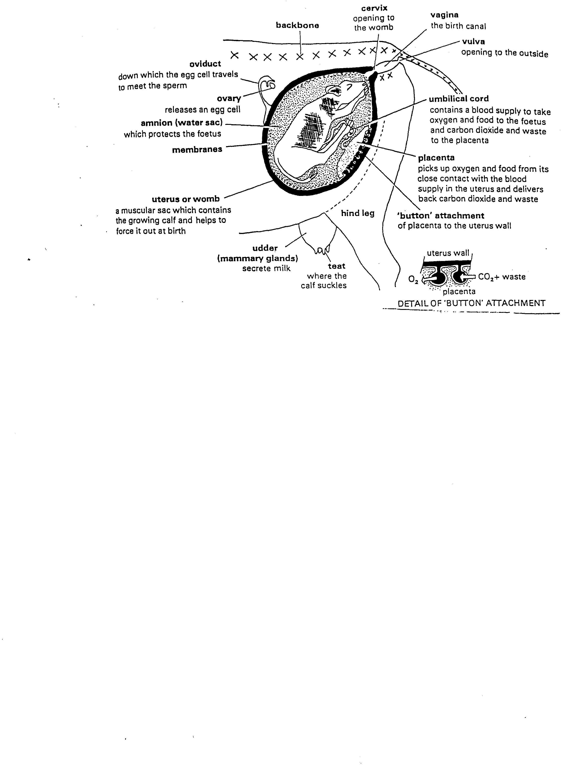

Reproductive Efficiency (lambing & calving %)

Highly fertile animals are those, which reproduce themselves efficiently.
Eggs are shed
Egg(s) fertilised
Young born and reared successfully

Factors affecting reproductive efficiency.
1. The correct level of nutrition prior to and during the breeding season (flushing).
2. Control of diseases.
3. Management techniques associated with ensuring the production of maximum number of fertilised eggs (planning lambing and calving dates therefore mating dates).
4. Suitable management techniques for mating.
- recognise heat (oestrus)
- bring ewes into heat at approximately the same time. Synchronised mating
- good AI technicians
- keep good mating records ie know what animals have been mated.
- using fertile healthy rams/bulls.
- using a sensible ram ratio. 1-100 ewes flat land small paddocks
1-50 ewes hill country large paddocks

bull/cow ratio 1-50 cows.

How do we measure reproductive efficiency? (FERTILITY)

Lambing and Calving %

Fertility or reproductive efficiency is measured as a lambing or calving percentage. That is the number of live lambs/calves born per 100 mothers (dams) in one breeding season.

Lambing/Caving % = Number of live young x 100
Number of ewes/cows mated 1

Example 1
3000 Ewes 3500 lambs 200 died 110%
1500 1550 125 95%
750 1000 25 130%
150 130 4 84%

Examples 2
A flock of 100 ewes consisted of:
5 ewes lost their lambs 0 lambs
65 ewes produced 1 lamb each 65
30 ewes produced twins 60
100 ewes 125

Lambing % 125

Exercise
- Give two disadvantage of underfeeding female breeding stock.

- Give a reason why over feeding of female stock is discouraged?

- Why should the dam be given high quality feed in the last quarter of her pregnancy?

4. Describe the feeding level required by rams and bulls prior to the mating season.
Give reasons.
Animal Reproduction
Planning A Breeding Programme
- Young stock should be born when there is plenty of feed
- Decide lambing and calving dates
- Work backwards to plan mating dates
- Good management/husbandry decisions can be made to ensure the maximum number of fertilised eggs
Correct Nutrition
- the correct level of nutrition before and during the breeding season is necessary if high fertility is to be achieved

Underfeeding Overfeeding
- Poor ovulation Difficulties at birth
- Difficulty at birth
- Weak offspring
- Poor milk production

Rule avoid under or over feeding in female breeding stock infertility problems

Feeding Rams and Bulls
Poor nutrition should be avoided because it results in
- a lower sperm count
- lower sex drive
- higher susceptibility to disease

Rams and bulls should be well feed but not overfat

Factors affecting
Reproductive efficiency

I.e. fertility
Control Of Diseases
Several diseases lower fertility
- Diseases caused by micro-organisms living in reproductive tract
- abnormal offspring
- low fertility
- abortions
- Diseases affecting other parts of the body eg internal parasites, facial eczema toxic plants eg macrocarpa abortions in late pregnancy
Mating Management
- bring animals (ewes) on heat roughly at the same time synchronised mating.
- controlling when oestrus occurs
- successful mating increases if
- recognise oestrus
- mated close to ovulation
- keep records
- healthy rams/bulls
- sensible ram/ewe ratio 1/100
bull/cow ratio 1/50
Exercise
1 Explain why farmers should plan lambing and calving dates? 2 Explain why the level of nutrition is important in animal reproduction?
3 Explain why rams and bulls should be well fed but not over fat? 4 What is synchronised mating?
5 Discuss the advantages of synchronised mating. 6 Name two disease that could result in a decrease reproductive efficiency.
Increasing fertility in dairy cows.

AIM: To have good management techniques that result in successful fertilisation that leads to calving once every 365 days.

Calving Once Every 365 Days
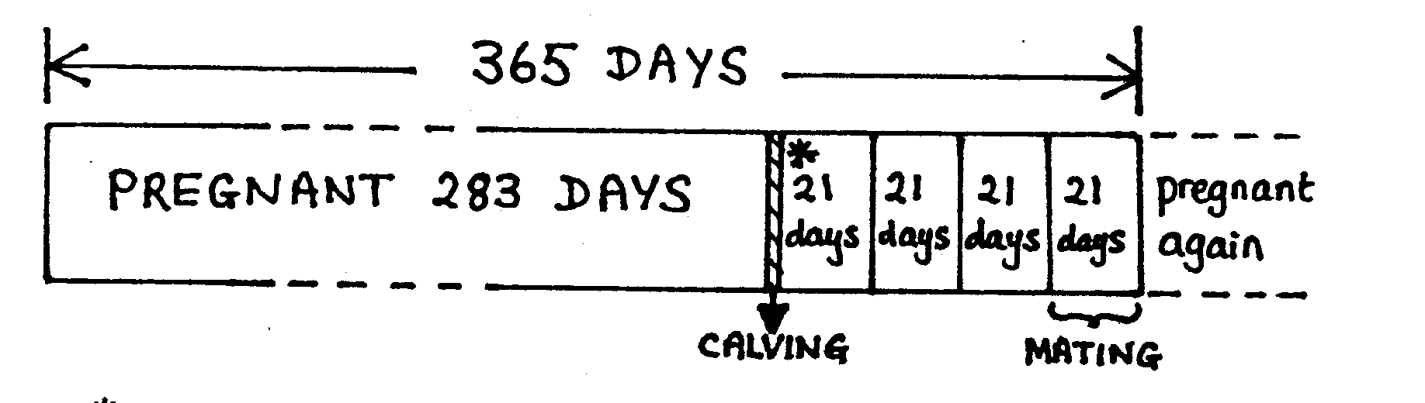

How many heat periods are possible between calving and the next conception (pregnancy) if the cow is to calve at the same time next year?

For this to occur a farmer must have good management techniques.
- Feed cows well before and after calving.
The better the condition cows calve in and the better the nutrition once they have calved the sooner they come into oestrus (heat) again and the better the chances of conceiving.
Conception rate: is the % of cows which conceive after the first insemination/mating. This should be 65-70% in well-managed herds.

- Successful heat detection (oestrus).
Methods of heat detection.
- observe sexual behaviour (bulling) (time consuming)
- observe enlarged vulva mucus discharge. (unreliable)
- tail paint (simple and reliable)
- Kamar heat detectors (simple and reliable)

- Oestrus synchronisation
CDIR hormone implant concentrates calving commonly used in dairy heifers
Concentrated calving == efficient herd management, because most cows are at a similar stage of lactation and will have similar feed requirements.

Aim: each cow calving once every 365 days and 90% of the herd calving within a 6-week period.
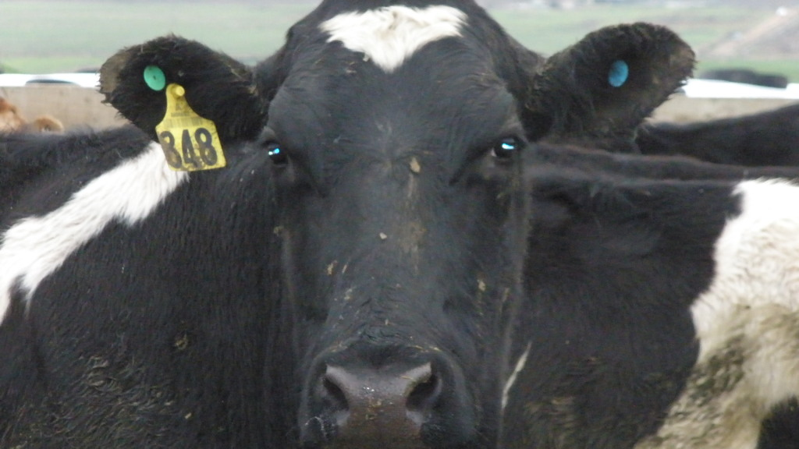
Keep Records
Identify individual cows (ear tags).

Exercise
- Describe how a farmer puts ear tags in?
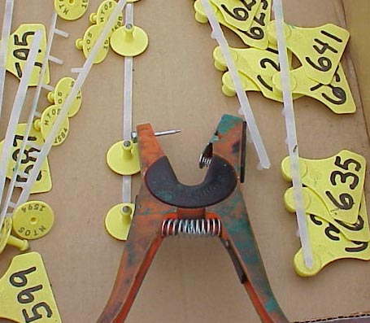

- Describe the information on found on ear tags.

- Explain how ear tags can affect farm returns?

For each cow record
- dates of premating heats
- insemination details eg date, bull sire number.
- those returning to service
- estimate calving date
- identification of empty cows- culling

Reasons for failure to conceive
- cows submitted for mating at the wrong time eg sperm die before egg is shed.
- infection in the reproductive tract
- poor insemination technique
- diseased bull
- stress (inadequate feeding and/or too short dry period)
- failure to
- come on heat
- conceive
- hold embryo

DAIRY CATTLE FERTILITY
Oestrus Detection

Oestrus is defined as that period during which a cow will stand to be ridden by her herd mates of by a herd sire. It occurs every 18-24 days in non-pregnant cows. It has an average duration of 14-15 hours but can vary from 2-30 hours. Cows in oestrus are often referred to as ‘bulling’ cows or as being ‘in heat’.

Oestrus behaviour
With the approach of oestrus, most cows become increasingly restless. They may attempt to mount herd mates, especially those others which are in oestrus. However, when other cows attempt to mount cows coming into heat, they move away. Once cows are in oestrus they will stand when mounted. This is a behavioural characteristic peculiar to cows. In most other species, the sexually receptive female will only receive the advances of the male. Because oestrus cows will stand to be ridden, they can be identified in the herd without the need to use a ‘teaser bull’.

The oestrus cows congregate together forming sexually active groups. (SAGs). These groups of restless cows move throughout the herd, with other cows joining or leaving them. Although an oestrus cow will stand to be ridden by any other cow in the herd, if other cows are in oestrus, they will be involved in most of the riding activity within the group. This riding activity is used by a bull to locate oestrus cows, and these cows will frequently stand when mounted by other cows before they will stand for the bull.

As well as the riding activity, oestrus cows are more active, spend less time grazing and often have a raised body temperature. Some may bellow and many frequently change from their usual order coming into the shed to be milked. Oestrus cows will often lead the herd from the paddock or lag behind. Many hold their milk for one or two milkings.

As astute observer of herd behaviour will note many of these changes in individual cows. He may also check for evidence of riding resulting in hair removal near the head of the tail or mud marks on the flanks of the oestrus cow. Physiological changes which may also occur are a swelling of the vulva, reddening of the vulva and vagina, and a discharge or strands of clear mucus hanging from the vulva.

In many cases, most of these signs are obvious to an experienced stockman. However, some cows frequently display oestrus with less obvious symptoms, or the oestrus may only be of short duration. Some successful owners have used herd observation as their only means of oestrus detection. If it is a large herd, or a stockman who is less familiar with the individual cows has to identify the oestrus cows, then mistakes are frequently made. In these cases, it is better to use one of several methods of Oestrus detection.

Visual observation. Visually observing the cows in the herd. This can be done:
- 15-minute periods before they are brought in for milking twice each day.
- In the yard before milking commences
- At least once (preferably twice) between milkings

This means that most oestrus cows will be detected if the herd owner is an experienced stockman and can readily identify individual cows. Some farmers are rightfully proud of their ability to quickly detect behavioural changes associated with oestrus their lack of ability, or expect other members to their family and farm labour who may be less familiar with the herd to be equally competent.

Tail painting: This involves applying an enamel paint on to the coat to lightly cover those points near the tail which will be rubbed by the brisket of the riding cow when the oestrus cow stands to be ridden. (See Fig .1.)

Fig 1
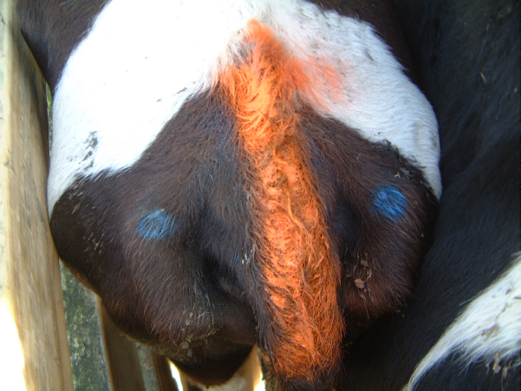

An enamel high-gloss paint in the most suitable form of paint to use in seasonal dairy herds in NZ during the height of the breeding programme in October/November/December. This can be purchased for the purpose. Some enamel paints are not satisfactory. Roof paint may not be rubbed off. Water based paints do not last.

The paint should be applied with a 50mm brush, running forward for 120-150 mm from the tail head. Loose hair must be removed, and the paint should not be applied to thickly. The most suitable colours are red, green and blue, although yellow can be used with Friesians or cross-breds. If a herd is tail painted with one colour the day before the breeding programme is to commence, then a different colour can be used after each cow is inseminated. This allows unmated cows to be readily identified.

The tail paint should last for at least 4 weeks unless the coat hair becomes loose with shedding. In this event the strip should be peeled off and paint reapplied. One litre of paint should be sufficient for tail painting 80-100 cows.

When tail painting is being used the paint strip on each cow should be checked at milking. In almost 90% of cases almost all the paint will be removed when a cow is in oestrus (even though some cows may not have been seen to be ridden); a further 5% of cows will lose some of the paint, and with the remaining 5% experience and judgement will be necessary.

The paint is rarely removed by occasional indiscriminate mounting of non-oestrus cows which may occur in the yard or races. Cows detected in oestrus on one day and inseminated that morning should note be repainted until the next milking, or even the next morning’s milking.

Stick on detection aids: These use the same behavioural characteristics of cows in oestrus as tailpainting and include matemasters (all flex NZ Ltd) and Kamar heat detectors. Both these are preferable to tailpaint with beef cows.

Vasectomised bulls: Here each bull is fitted with a chin-ball making harness. The bull are run with the herd between milkings. It is preferable to have more than one bull in the herd at one time to create some competition. The recommended ratio is 1% at the commencement of the breeding programme when no cows are pregnant. In a large herd of 200 or more cows it is preferable to have two or three bulls with the herd, and two or three bulls ‘resting’. The teams are changed every 3-4 days. While this system was widely used in large NZ herds before 1978, it has now been replaced by tail painting.
Detection insemination sequence

Even if tail painting is used, it is preferable to record in a notebook or on a shed board, the number of all cows detected in oestrus since the previous milking. In most herds, the cows are drafted out for insemination at each morning milking or later that morning.

Cows seen in oestrus at a morning milking can be drafted out and inseminated later that morning.

However, if a cow which is seen in oestrus before one milking is then drafted out, inseminated and is still plainly in oestrus during the next milking, the cow could be re-inseminated next day (i.e. on consecutive days). This is likely to occur with less than 8% of cows in a herd.

Cows drafted out at one milking for subsequent insemination should be held close to the shed with access to water and feed. After they have been inseminated, the oestrus cows can return to the herd. However, it is often less confusing if they remain close to the shed and are milked first so that they can be repainted and not be confused with oestrus cows in the herd.

Exercise
- What is the scientific name for ‘in heat’?

- In cows how often does this occur and for how long?

- Why do farmers want to know when “oestrus is”?

- Make a list of all the ways an experienced farmer can tell a cow is on heat by looking at it.
- When is visual heat detection carried out?
- What disadvantages are there with this method?
- Describe what “tail painting” is, and how it works.
- Once a cow is identified as on heat, what should be done with her?
- Why should she be inseminated so quickly?
- Why do they recommend repainting a cow after it has been inseminated?
11) What is a vasectomised bull?
12) When and why would a farmer use a vasectomised
bull?
13) Describe how a chin-ball harness works.

14) Bulls used in natural mating should be changed
regularly. Explain why?

Raising fertility in sheep
There are several ways of increasing the fertility of sheep. These include:
1. managing the ewe flock so that lambing time in concentrated around one date (lambing date)
2. use fertile rams
3. identify pregnant ewes and cull those failing of conceive.
4. feeding ewes to increase the number of lambs per pregnancy (flushing).
5. avoid deaths near lambing.

Concentrated lambing date
Advantages:-
- lambs benefit from seasonal flush of growth.
- majority of lambs will be ready for the freezing works at the same time.
- management is easier when the majority of lambs are at the same stage of development.

To achieve this, ewes need to come on heat at the same time (oestrus synchronisation)
How can this be achieved?
- Introduce rams before the breeding season. This stimulates silent heat a few days later.
Remove rams 17 days later ewes come into their first active heat together.
- Use hormones CDIR expensive therefore only used on a small scale.

Fertile rams
- Healthy
- Sound feet/ teeth/ reproductive organs.
- Not overfat
- Shorn 2 months before tupping more active and increases sex drive (libido) scrotum is cooler, better sperm development.
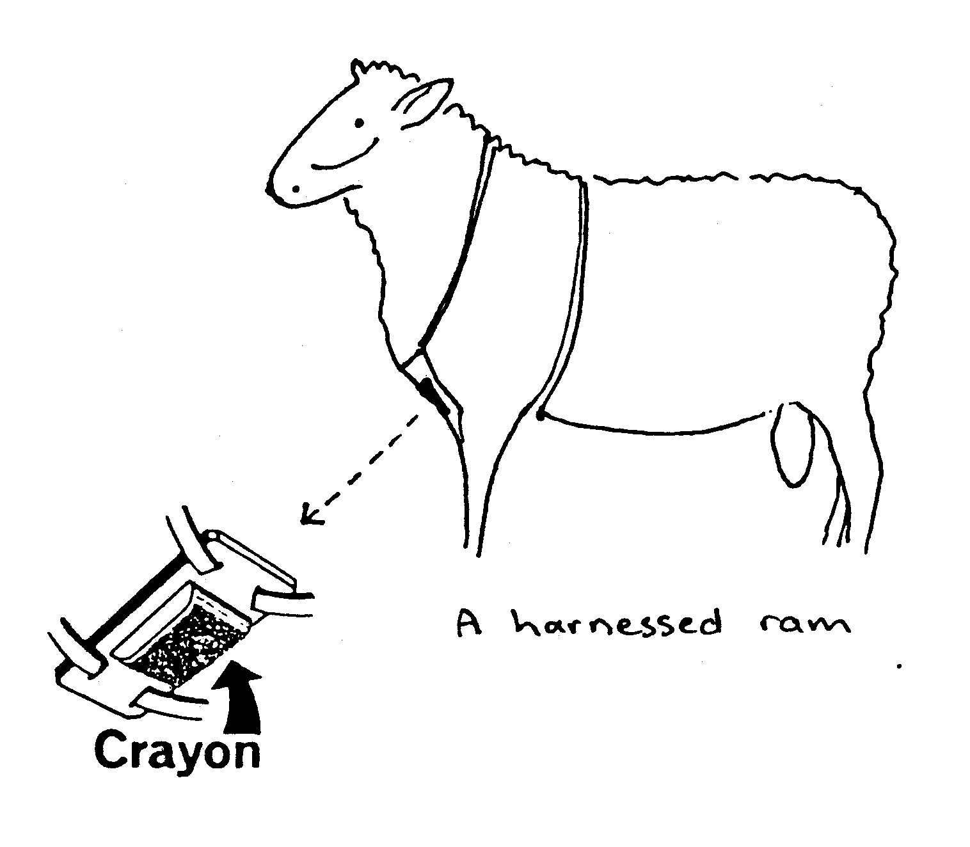
Identifying pregnant ewes
1 Uses ram harnesses at the beginning of the mating season.
Put the same colour into all rams so ewes mated identified.
17 days | change colour | identifies returns and further matings
17 days | another colour | identifies late lambers, barren ewes
Remove rams after 3 cycles.

2 Scan to identify pregnant ewes and whether they are carry a single or twin lambs.
Ewes carrying twins get priority feeding over ewes carrying single lambs.

Flushing
At mating time heavier ewes have a higher % of multiple ovulations (i.e. more than one egg is shed) than lighter weight ewes.

Ovulation rates are increase if the ewes are gaining weight before mating.

Two-tooth. Should be 50kg at tupping (first lambers)

Ewes fed well 3 weeks prior too and 3 weeks during tupping, (gaining weight during tupping) increases ovulation == increasing lambing %.

Feed for flushing
- saved pasture
- silage
- crops eg greenfeed, kale
- purchase concentrates (expensive)

Ovoid deaths near lambing or at lambing
Once mating has been managed successfully, the next major cause of lowered fertility is lamb deaths at birth.

Causes:-
- difficult birth ewe overfed in late pregnancy
- lack of shelter exposure to cold and wind.
- starvation mismothering, ewe only one teat etc
- steep slopes

Other ways to increase fertility
- select ewes for their ability to produce twins /triplets
- super ovulation with hormone treatment - expensive (requires very good management)
- breed with high fertility rams.

NOTE Legumes (red clover) oestrogenic effect upsets the oestrus cycle == barren ewes.

Exercise
- Why do sheep farmers aim for a concentrated lambing?

- Describe a healthy ram.

- How can farmers identify ewes that have been tupped from those that have not?

- What is flushing?

- Explain the effect of flushing ewes on lambing percent.

- Discuss management practices farmers can use to minimise lamb deaths.

- Why do farmer scan ewes?

- Describe two management practices are farmer could consider using to increase fertility resulting in a higher lambing percentage.

Sexual Reproduction

In sexual reproduction each parent passes on only one of each pair of chromosomes to the new offspring

Example
In both sexes, normal body cells carry 54 chromosomes in pairs
(2 sets of 27)

Ram Ewe
54
54

XY XX

In testes sperm are formed by a special cell division and contain 1 set of chromosomes
In ovaries eggs are formed by a special cell division and contain 1 set of chromosomes

MEIOSIS

27
27
27
27

Male gamete (sex cell) Female gamete (sex cell)

In fertilisation, the egg and sperm fuse to form one cell

Female
27
27

54
X X 27 Ewe

Sex Determination 27 Ram

Male

27
27

Y X

Cells will grow and divide to form embryo lamb. All cells in the lambs’ body will carry 54 chromosomes, 27 pairs.

Genetics
No two living things are exactly alike even though they may belong to the same family. This difference in one or more characteristics from their ancestors is known as variation. These differences or variations between living things of the same species are if two kinds
1 Genetics
2 Environmental differences

Inheritance: The science of inheritance (or ancestry of animals) is called genetics.

The Language of Genetics

- Monohybrid cross – this is a straight forward cross involving only one pair of genes (or alleles)

- Homozygous – a pair of alleles that are the same.

- Heterozygous – a pair of alleles that carry the two different forms of a characteristic.

- Dominant – a gene that is stronger than another allele and shows up if it is present.

- Recessive – a gene that is weaker and only shows up if the dominant form is not present.

- Symbols for gene pairs or alleles. Use a capital letter for the dominant and a little letter for the recessive. For example, R for round pea and r for wrinkled – not R and W, because they are still forms of the same gene.

- F₁ – this stands for the first generation, or the first generation of offspring.

- F₂ – this stands for the second generation of offspring.

- Punnet square – is the name given to the grid of squares that may be drawn to show the range of combinations of genes that may occur.

- Genotype – This is the actual pattern of alleles for a particular feature. For example, the genotype for wrinkled seed is rr. If a dominant is present, it may not be possible to tell the genotype. A smooth seed could be Rr or RR.

- Phenotype – This is the actual appearance. For example – round or wrinkled seed.

- Chromosome – structure containing genes found in the nucleus

- Gene – inherited instruction which determines a feature/characteristic/trait

- Alleles – is one pair of genes

- Allele – is one of a pair that makes up a gene

Genetics

Exercise 1
1 Use this information to answer the questions below
Black Angus (BB) X Red Hereford (bb)
A What colour would a cow carrying BB genes be?
B What colour would a bull carrying (bb) genes be?
C. What colour would a cow carrying (Bb) genes be?
D. Which letters represent heterozygous coat colour.
E. What phenotypes would the animal in D have?
F. What letters represent homozygous dominant coat colour?
G. What letters represent homozygous recessive coat colour?

Exercise 2
2. White fleece (W) dominant over Black fleece(w)
Cross WW x ww
A Draw the punnet squares for an F1 and F2 generation.
B For each describe the genotype and phenotype ratios.

3. The allele for white wool (W) is dominant over the allele for black wool. A white ram is mated to three ewes.
- Ewe A white gives birth to white lambs.
- Ewe B black gives birth to a white lamb.
- Ewe C white gives birth to a black lamb.

A What are the genotypes of the ram and ewes?

Exercise 3
In Drysdale sheep, hairy fleece (H) is dominant over normal fleece (h).
- Give the genotype for a sheep that is
- homozygous for hairy fleece.
- heterozygous.

2 What is the phenotype of an animal that is (i) hh
(ii) Hh

A heterozygous ram was crossed with a homozygous recessive ewe.
- Give the genotype and phenotype ratios for their offspring.

- If you were wanting to breed sheep with a normal fleece, would you keep this ram. Give a reason for your answer.

Exercise 4
Baroola Merino sheep have a high fertility allele, which, results in high number of multiple births. This allele is dominant over (f) the recessive allele.

- State the genotype for sheep that are:-
- homozygous for high fertility
- homozygous recessive
- heterozygous.

A homozygous ram for high fertility was breed with Romney ewes that do not have this allele.

- Give the genotype and phenotype ratio for their offspring.

- Offspring from the matings above were crossed. Give the genotype and phenotype ratio for their offspring.

Exercise 5
Gene Homozygous Phenotype Allele Dominant Chromosome Genotype Heterozygous Recessive

Match up the meanings below with the words above
- The basic unit of inheritance
- The genetic make up of the animal
- A genetic feature that only shows up if the dominant form of the allele is not present.
- The alternative form of gene that can make up the members of a gene pair.
- A pair of alleles that are the same.
- A gene that is stronger than another allele and shows up if it is present.
- A pair of alleles that carry the two different forms of a characteristic.
- Thread found in the nucleus carrying genetic information.
- A measurable or physical characteristic

Variation is the Basis of Selection

Natural variation forms the basis of higher producing animals. The major ideas are that;
- Within any group of animals, there are variations in performance.
- Improvement is made by identifying and selecting genetically superior animals to be used (i.e. higher producing animals) in future breeding programmes.

Some characteristics that show variation between individual animals.
Wool weights | Kg/sheep
Milk production | Litres/cow kg MS
Egg production | Eggs/hen
Carcass weight | Kg/animal
Production of offspring (fertility) | Number/animal

Exercises
A farmer herd tested 100 Friesian dairy cows, and recorded the volume of milk each cow produced over a period of two consecutive milkings. The farmer recorded the volume in litres per cow.
The results are shown in the table below.

Number of cows | Milk Yield (litres/cow)
4 | 4.0
6 | 5.0
7 | 6.0
3 | 7.0
8 | 8.0
13 | 10.0
18 | 11.0
12 | 12.0
8 | 13.0
6 | 13.5
5 | 14.0
4 | 15.0
3 | 16.0
3 | 16.5

- Using the information in the table above draw a line graph on the next page to show the variation in milk production per cow.

- Calculate the average production per cow.

3 Explain why there is a wide range of variation in milk yield per cow?

2 Fleece Weight Records

In stud or pedigree sheep flocks records are kept so that stock can be ranked on production ability. Each sheep had its own number on an ear-tag. This number can be typed into a computer, so production information such as fleece weight can be fed in to the computer.

The information in the table below is from a flock of stud sheep.

Ear-tag Numbers | Fleece Weight(kg)
305 | 2.8
6782 | 2.4
5439 | 3.9
476 | 3.1
981 | 3.5
2032 | 3.3
2984 | 2.8
1650 | 3.8
703 | 3.1
3445 | 3.3
4227 | 3.8
4651 | 2.0
432 | 3.6
889 | 3.3

- Sheep with fleece weights of 2.4kg or less, are to be culled. Write down the ear tag numbers of these sheep.

- The top 20% of this sheep flock have fleece weights of 3.6kg and over. Write down the numbers of these sheep.

- Why would a farmer want to know which sheep is ranked in the top 20%?

- List other information a farmer could record about each sheep other than fleece weight.

Productivity: - The result of genotype or environment

The phenotype of an animal refers to its appearance. These characteristics are affected by two things the genotype and environment.
In animal production, the term “improved environment” includes the correct level of nutrition, freedom from diseases and climatic stress. If we want to know whether increased production is due to genetic improvement, or environmental improvement we need to manage the flock or herd in such as a way that all have the same environmental conditions. Then the animals with superior genotypes will tend to produce more.

Identical Twins
Identical twins have the same genotype. For this reason they are used in research to show how the environment can affect the appearance and the production of the animal

Example
Same Genotype + Different = Different
(Identical Twins) Environment Phenotype
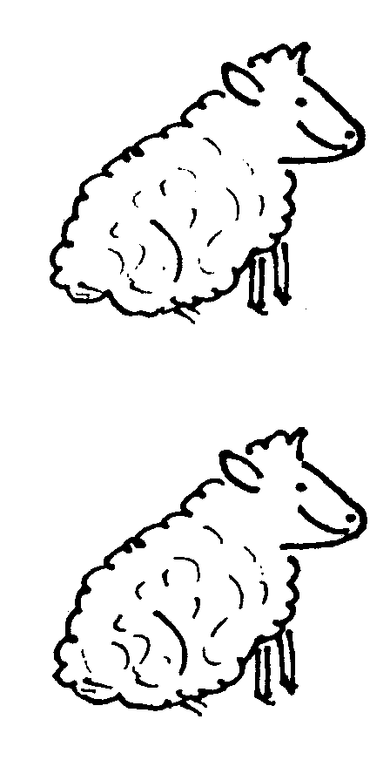

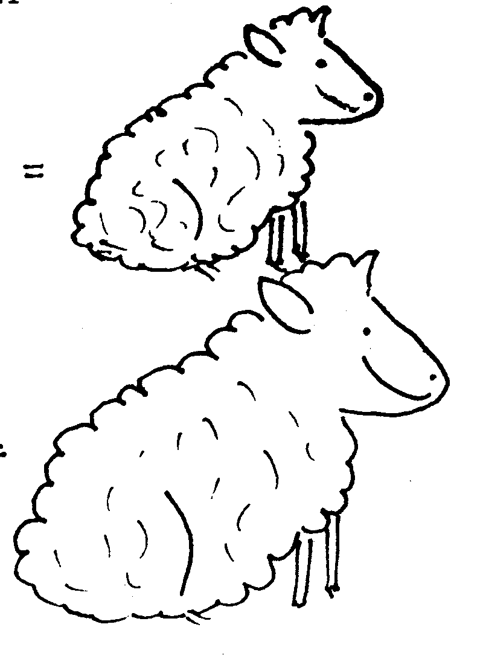

Trace Element
Deficiency

No Trace Element
Deficiency

Exercise:
Explain why researchers use twins in nutritional trials?
Improving Production Characteristics

Young animals have a new combination of genes that they get from their parents.
By influencing the gene input from the parents, we can influence the characteristics their offspring have.
This is done by:
- Carefully choosing sires
- A culling programme, which removes unsuitable parents.
- Environmental factors, like feeding or disease, can affect production by limiting how well animals produce, so their genetic potential is not reached.

There are three parts to successful breeding;

Identification
Record Keeping

Use of superior sires/females

Exercise:
1 Farm animals are generally identified by ear tags. Describe how to put ear tags into cattle and sheep correctly. In your answer
- name the equipment used
- describe where the ear tags are placed in the ear and explain why.
2 Describe the information that would be found on ear tags.
3 Complete this table.

Records kept

Dairy cow
Dairy bull
Sheep meat
Sheep wool
Beef cow
Beef bull

4 Explain why each part of the diagram above is important in successful breeding programmes.
5 Explain the importance of identification in improving herd or flock production.
6 Explain why more emphasis is put on selecting sires in a breeding programme.
Recording Performance

There is variation in performance within any group of animals. Farmers can make improvements by identifying those animals, which will produce greater economic returns and using them in future breeding programmes. A recording system is necessary to identify the genetically superior animals. Each breed association such as Romney, Polled Dorset, Angus, Charolais have sire-proving programmes. The dairy industry also has its own sire-proving scheme for producing genetically superior bulls. The dairy industry also uses herd testing to gather and record genetic information on dairy herds. This programme operates on a national basis.

Sire proving schemes
- Sheep farmers use SIL = Sire improvement ltd
- Beef farmers EBV = Sire evaluation scheme
- Dairy Industry = LIC/ Ambreed sire proving scheme
The objective of progeny testing/sire proving programmes is to consistently produce commercial sires that increases profitability. The critical requirement of this genetically superior sires within a group, which are then used to improve the genetic merit of the herd or flock.

Breeding value terminology
Production value PV is a value based on a cow’s production as measured by herd testing.
Each cow is compared with her herd mates. An adjustment is made for age and stage of lactation.
Breeding value BV is an estimate of a cow’s breeding ability based on ancestry as well as production.

Exercise 1
A herd has a PW of 105
Cow number | PW
24 | 110
7 | 115
67 | 101

- Which cows have a PW above the average for this herd?
- If you wanted to cull one of the above cows on production, which one would you cull?
The BW of a calf is the average of the dam and the sires BW’s.

Exercise 2
- A cow with a BW of 120 is mated to a bull with a BW of 134. Calculate the BW of the resultant calf.
- If the cow in (1) is mated to a bull with a BW of 146. What would be the BW of the calf?
- Why would a farmer be unwise to mate a cow with a BW of 128 to a bull with a BW of 120? Give reasons for your
answer.
Herd Testing

Herd testing is used to identify superior cows, which produce superior heifer calves.
- The other uses of herd testing are to:-
- Show up poor producing cows, which should be culled.
- Provide a checking system on the quality of the bulls being used.
- Provide information on which to base herd management decisions e.g. drying off date.

Provide a check on milking efficiency and milking machine performance.
Exercise
- Explain how herd testing is carried out?

2 Explain why you would recommend a dairy farmer carryout herd testing regularly throughout the season.

Artificial Insemination (Breeding)

Advantages of AI are:
Genetically superior sires that have been proven can be used (the average farmer could not afford to buy these bulls)
Semen can be used from bulls overseas. This saves the cost of buying and shipping them.
- Offers protection from some reproductive diseases.
- Protection against infertile bulls

Disadvantages of AI are:
- Accurate heat detection and the correct timing of insemination are critical for conception.
- There is also a chance of technician error in actually inseminating a cow.

The Semen Story

Artificial Breeding
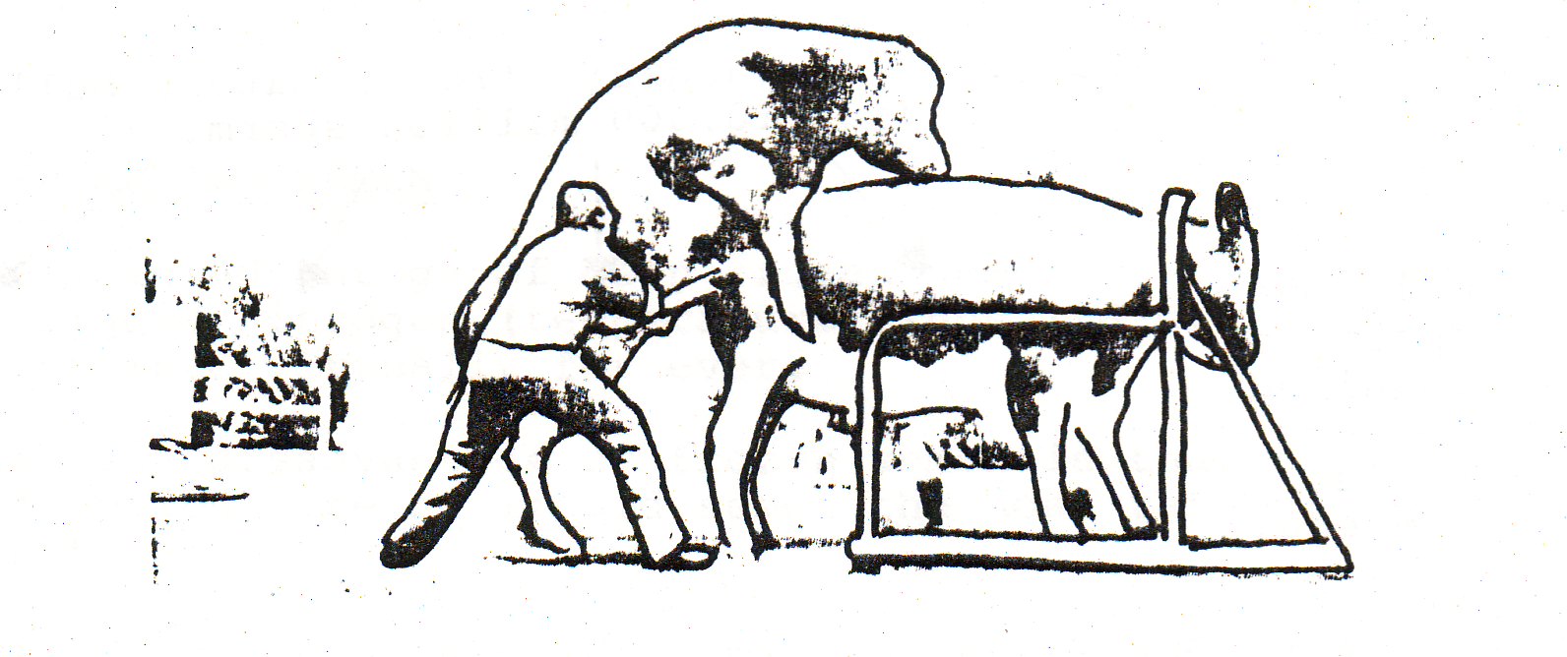

In this section of work, we will look at:
- how semen from proven bulls is collected
and processed
- the types of inseminating services offered
- how artificial insemination is carried out.

Semen is collection with artificial vagina
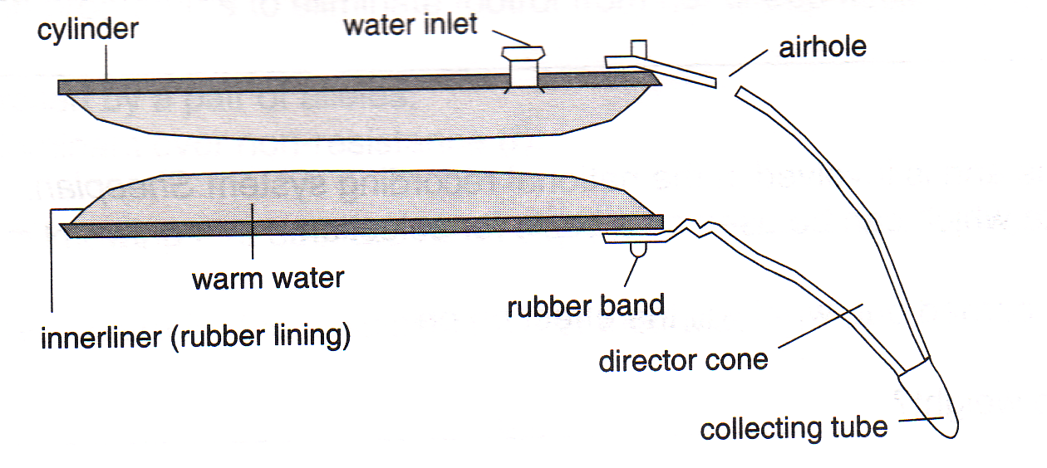

Diagram of artificial vagina

Two collections are taken every three days from each bull. After collection, the semen is tested for liveliness. Each sperm is typically tadpole shaped having a head mid piece and tail. The head contains the genetic material, the mid piece is the energy source, while the tail allows the sperm to swim.
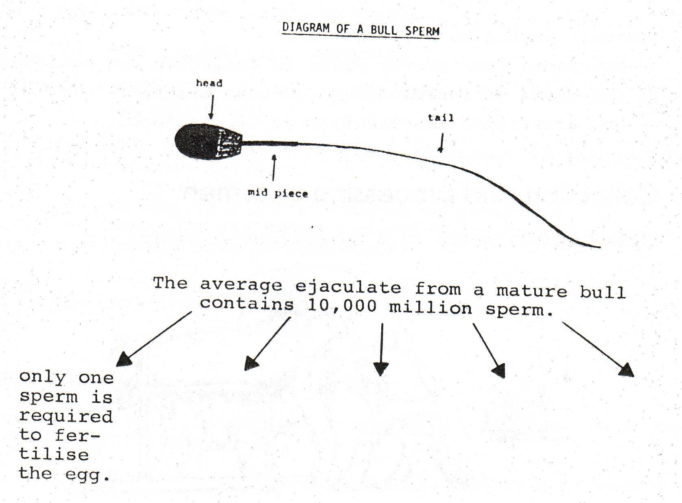

By diluting the semen, artificial breeding can inseminate many cows from one ejaculation. The Dairy Board dilutes and preserves semen in either liquid or frozen form.

Liquid semen
The semen is diluted up to 1000 times with a special mixture. This mixture contains many substances including glucose, egg yolk nutrient, protective agent, and antibiotics to control bacterial growth.

This mixture extends the life of semen from a few hours to several days. The dose rate of this diluted semen is half a ml (about 2 million sperm). Colour is added to the liquid semen to aid identification.

Friesian - red
Jersey - green
The semen is placed in corked test tubes for use. The test tubes are placed next to a water bottle to protect the semen against sudden temperature changes. | 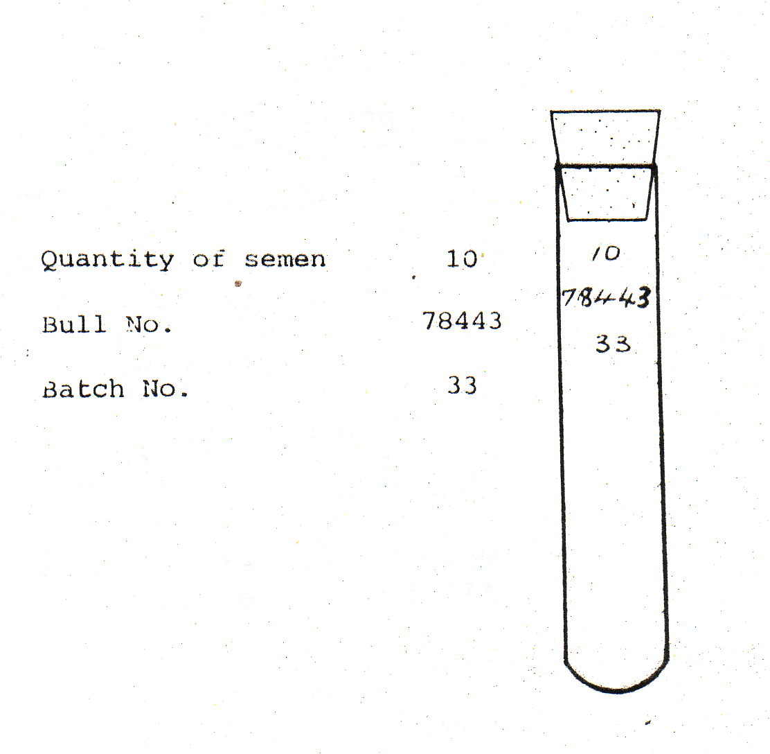

Deep frozen semen
The main advantage of deep frozen semen is that when it is stored in liquid nitrogen (temperature minus 196ºC) its fertility is maintained virtually forever.

The main disadvantage of frozen semen is that to get the same conception rate as liquid semen the dose rate has to be increased ten times.

The normal dose rate is 22 million sperm and this is packaged in a ¼ ml straw.

LIC straw marketing
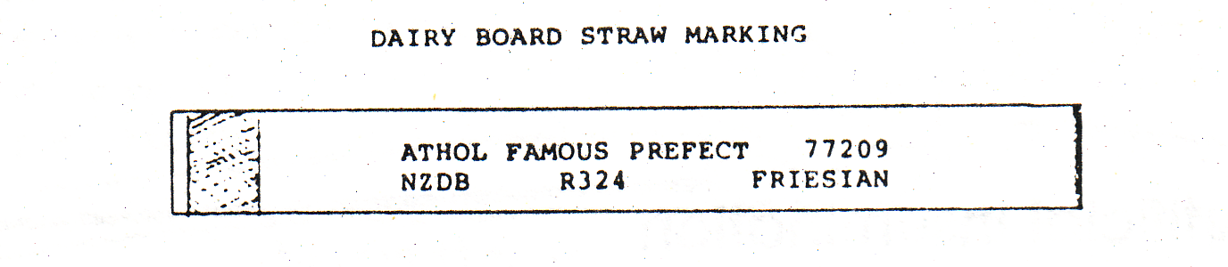

Rediluted deep freeze semen (sem-pak)
Semen can be processed in a bulk-frozen form and rediluted in the field. It is used in much the same way as liquid semen. It overcomes the problem of daily dispatches to remote areas.
Types of inseminating services
Other companies and organisations apart from the LIA are involved in artificial breeding and semen sales. For convenience, we will look at the services offered by the LIA only.

The Premier Sire Service (PSS.) This is also known as “Bull of the Day”.

Here six bulls are rostered from each breed and fresh semen liquid sent out every day. A lower concentration of sperm is required for conception with liquid semen through PSS so the top bulls can sire many more off spring.

It is common for PSS bull to make over 100,000 inseminations each season, but with frozen semen, only 25,000 inseminations would be possible.

Most LIAS charge for PSS by the number of cows inseminated. All bulls are priced the same.

Nominated service
This is a deep freeze service, which enables the farmer to choose individual bulls.

A frozen straw of semen from the chosen bull is purchased. The cost varies from bull to bull.

Do it yourself (DIY)
In this option, the farmer does the inseminating themselves. They are supplied with either fresh or frozen semen.

Exercise
- Semen can be stored as liquid semen or as deep frozen semen. Briefly explain the advantages and disadvantages of each of these methods.

2 What is the advantage of diluting semen once it has been collected?

Artificial Insemination

Equipment
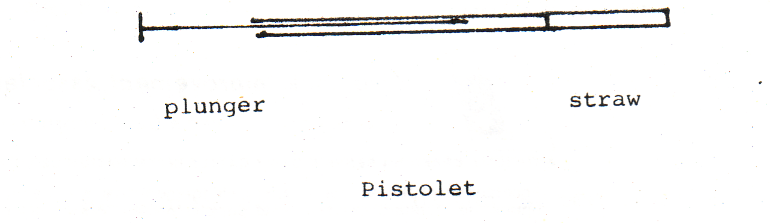
Liquid semen – 0.5 ml of liquid semen is drawn into the pipette by pulling the plunger out on the syringe.

To prevent the spread of disease a new pistolet is used for each cow.

Frozen Semen – The end is cut off the straw of frozen semen. It is then placed in a pistolet

Insemination of the cow
The AI technician (person doing the insemination) places a lubricated rubber glove on one arm. This arm is then inserted into the cow’s rectum.

Through the rectal wall the cervix can be felt.

The pistolet is then placed in the vagina and guided to position just inside the cervix.

It is important that the end of the pistolet is in the correct position.
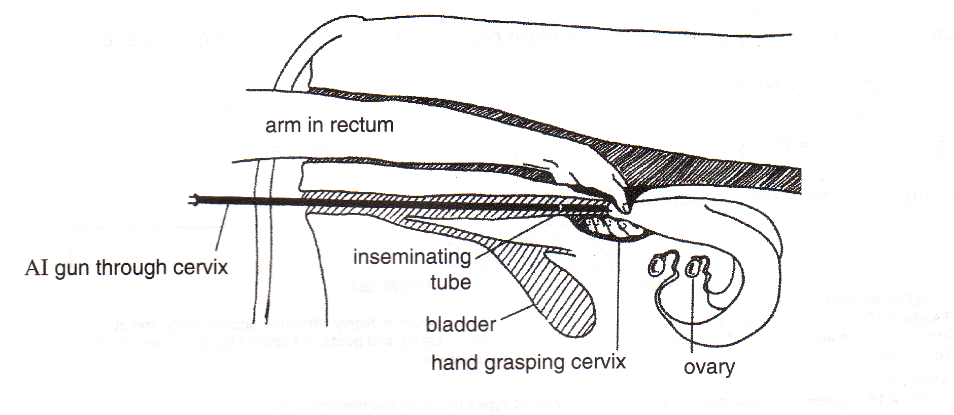

The plunger is pushed in and the semen is released.

Exercise: Artificial Insemination and the Semen Story

- Why do bulls used in AI have their, own artificial vagina for semen collection?

- Draw a diagram of the artificial vagina and label.

- On average how many sperm are in
- one ejaculate?
- liquid semen?
- frozen semen?

- Semen is collected every three days. Explain why?

- Why is semen diluted?

- List the two ways semen is preserved.

- List the advantages and disadvantages of each method of preserving semen.

- List the information found on a semen straw.

- When inseminating a cow, why is it essential for the pistolet to be sterile?

- List the steps involved in inseminating.

- In natural mating, where is semen deposited?

- In AI, where is semen deposited and why?

- When checking semen fertility, what do technicians look for?
Artificial Insemination

Examine the AMBREED A.I MATING CHART to help you answer the questions.

AMBREED A.I MATING CHART
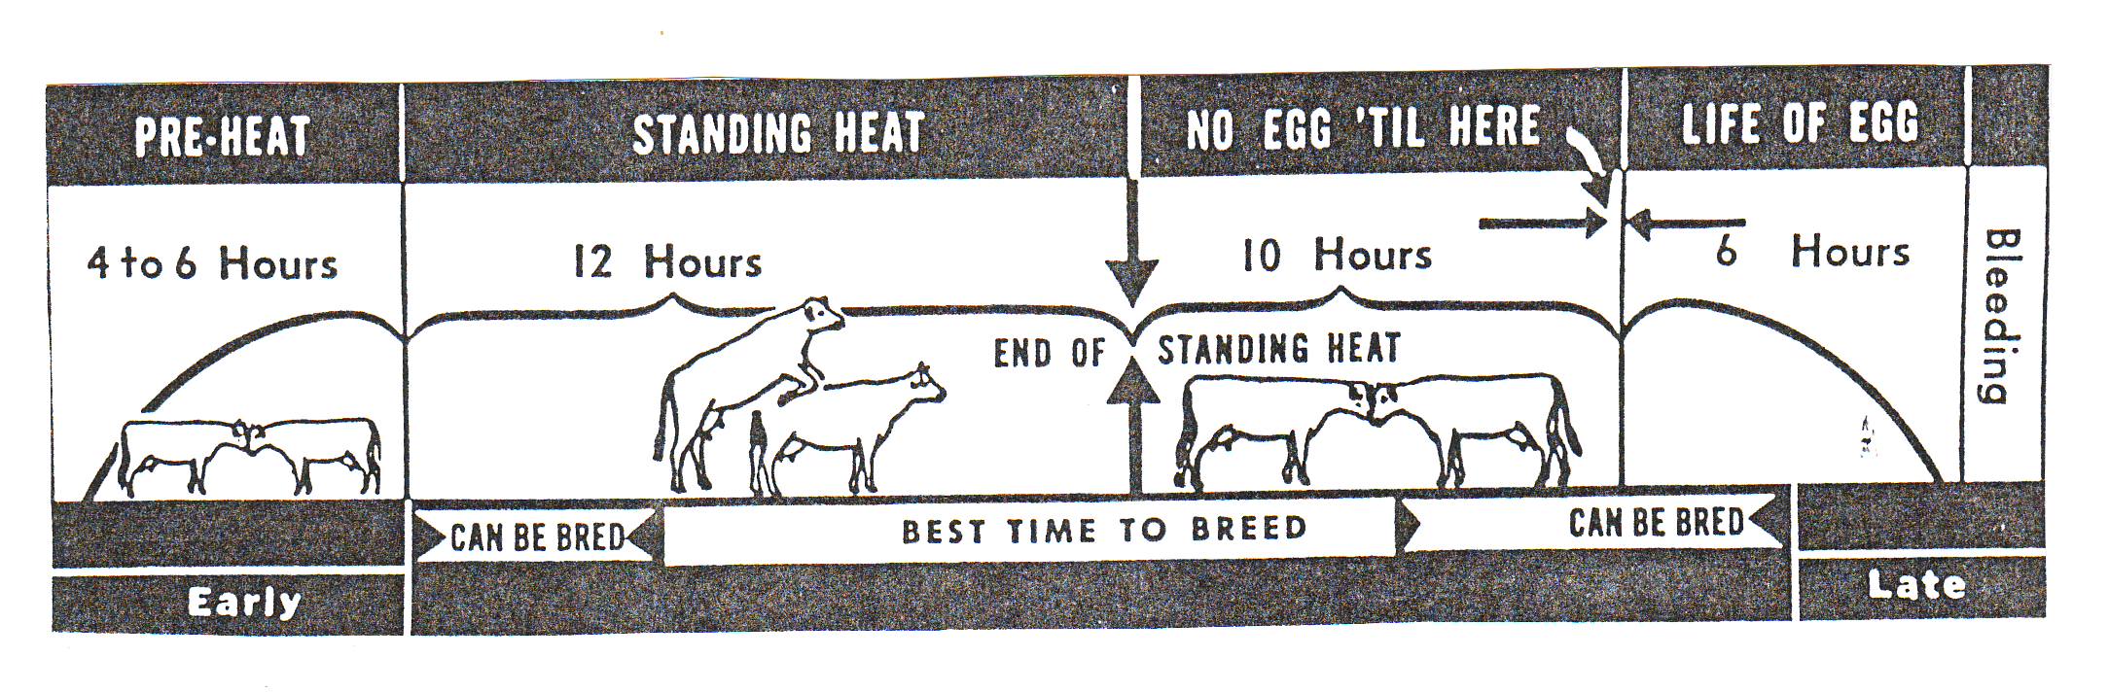

- Describe two ways a farmer could tell if his cows were coming on heat?

- If a farmer was sure that a cow was on heat, how many hours would he have in which to have her artificially inseminated?

- What is meant by “standing heat”?

- How long would it be before the cow came into heat again if she did not get in-calf after the first insemination?

- If a cow does not get in-calf after the first insemination, what would be the economic consequences to the farmer?

- If a farmer wished to keep a calf from a high producing cow, how
- would the farmer identify the calf?
- would he know which cow the calf was from?

- List three things that “herd-testing” tests for.

- Explain the benefits of herd testing to the farmer.

- Explain how milk productivity in dairy cows is recorded?

- Describe two on farm practices a farmer should carry out to ensure the milk leaving the farm is of the highest quality.

- List two advantages of artificial insemination.

- Artificial insemination is commonly used in sheep in UK but not in NZ. Explain why?
Exercise: Animal Reproduction
- What does insemination mean?

- What do the abbreviations AB and AI stand for?

- Describe two ways of detecting a cow on heat.

- What is tail painting? How is it used to detect cows on heat?

- Why is tail painting more reliable and efficient than natural ways of heat detection?

- What is oestrus synchronisation?

  - How is it achieved?

  - When is most often used?

- To maintain a 365 day calving interval, it is important to get cows "cycling" again as soon as possible after calving. What does "cycling mean here?

- What management should a farmer adopt to achieve "cycling very soon after calving?

- What does conception rate mean?

- List four things that are necessary to achieve a concentrated calving.

- To run a successful breeding programme individual cows must be identified and accurate records kept. How are cows identified?

- What records should a farmer keep after a cow has calved?

- What are the signs of stress in a cow due to very high production?

- How can this stress be reduced?

Reproduction and Breeding Revision
Question One
A beef farmer uses a teaser (vasetomised) bull fitted with a chin-ball harness to identify cows in oestrus rather than just observing bulling (cows standing to be ridden).
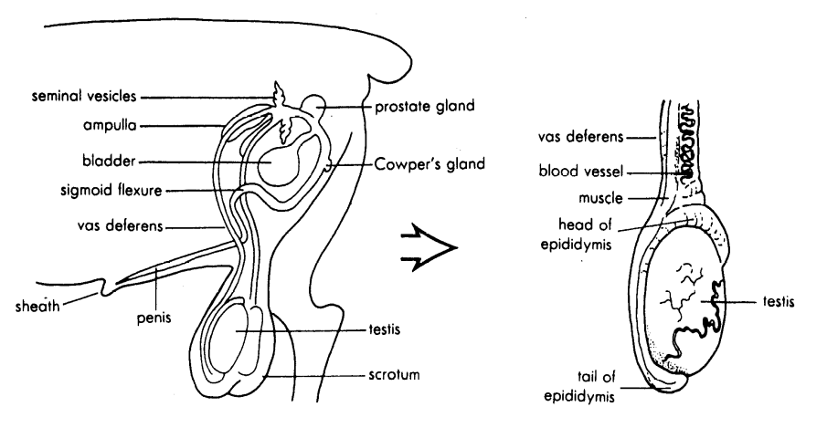

- Explain how a bull is made into a teaser (vasetomised)?

- Explain the role of testosterone.

c. Give reasons why a beef farmer would use a teaser bull to identify cows in oestrus rather than just observing bulling (cows standing to be ridden) in terms of:
- artificial insemination (introducing new genetics)
- cost and time
- Increasing farm financial returns

Question Two
Most of New Zealand dairy farms use artificial insemination over 90 percent of the cows. For artificial insemination to be successfully carried an understanding of the female reproductive system and how to detected cows in oestrus (heat) is needed.
- Describe the function of the uterus and the cervix.

- Explain why when artificially inseminating a cow the semen is release into the uterus.

- Give reasons why most dairy farmers use artificial insemination rather than natural mating in terms of
- faster genetic improvement
- increase farm productivity

Question Three
A large amount of time is put into the selection of male animals in breeding programmes.

a. Explain why more emphasis is put on the selection of males in breeding programmes than females?

An understanding the male reproductive system is needed for collection of semen.
- Explain the function of the testes and why they are found outside the body?

- Explain how semen is collected from bulls to be used in artificial insemination?

Question Four
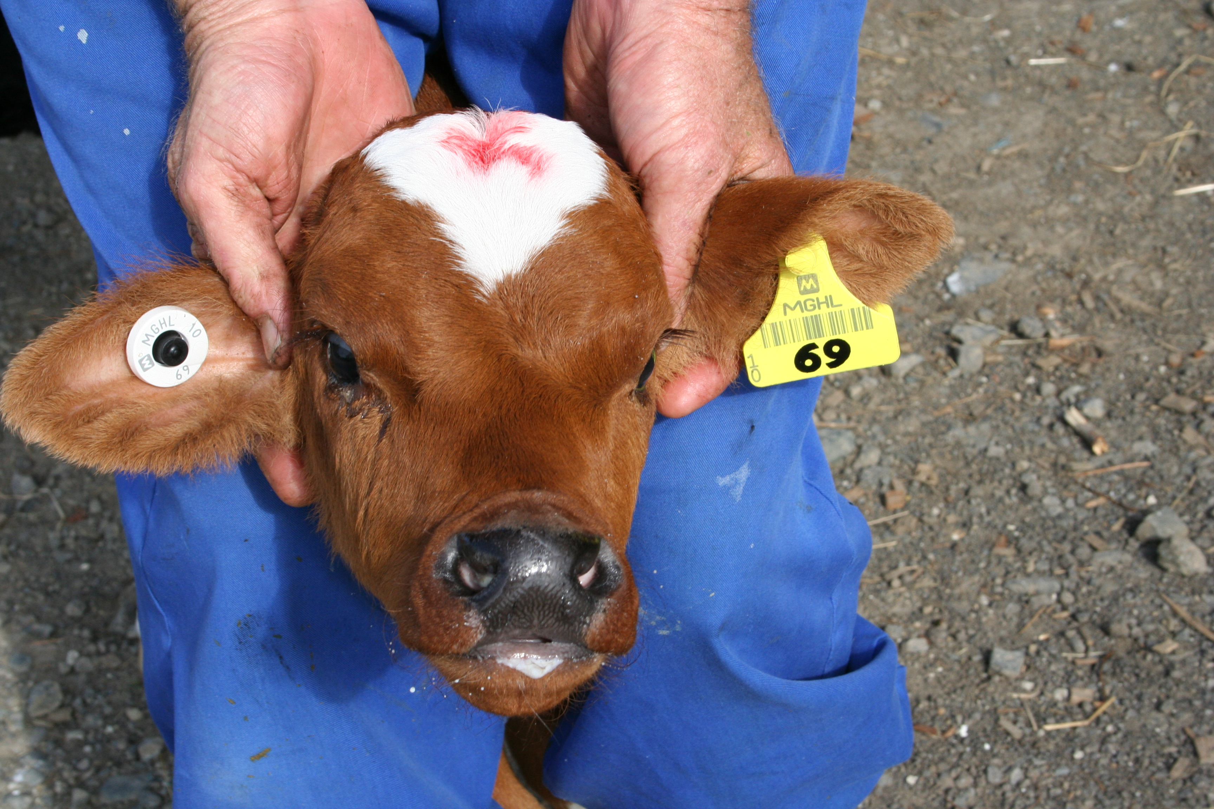
These three components of the successful breeding programme are;
- animal identification
- recording information
- sire selection
(a) Describe the process of putting in an ear tags. In your answer, you should;
  - describe the position of ear tag(s)

- state the information that should be found on ear tag(s).

Another key component the dairy farmer uses in the breeding programme to increase milk production is the use of superior sires by AI.
(b) Explain why more emphasis is put on the selection of sires in the breeding programme?

Question Five
To run a successful breeding programme, individual cows must be identified using ear tags (identification numbers) and accurate production records kept.
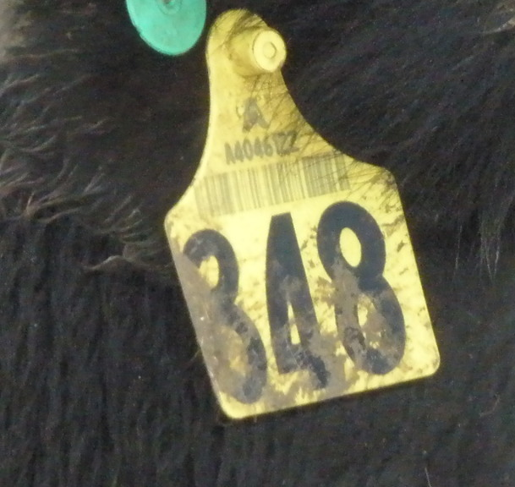

- Describe how a farmer puts tags in the cow’s ears?

- Describe the information found on the ear tags.

- Explain how using ear tags on dairy cows would help to improve milk production?

- Describe the production information a dairy farmer would record about each cow in the herd.

- Explain how the dairy farmer would use the recorded information to increase farm production?

Animal Health
- Importance of animal health
- Classification of diseases
- Symptoms of disease
- Planned approach to animal health
- Vaccination
- Drenching
Importance

- increases production, therefore more animals and or animals products to sell.
- better quality products eg less wool breaks
- reduced deaths
- reduced human illness
- reduced vet costs.

Signs and symptoms of disease
ANIMAL HEALTH

A planned approach to animal health includes
- Vaccination programme
- Drenching programme
- Dipping programme
- Keeping good records of stock management
- Drenching all new stock coming onto a farm
- Keeping new stock separate from others until sure no health problems exist.
- Breed and buy disease resistant stock.
- Buy animals which are not drench resistant
- Quarantine sick animals
- Providing a suitable environment to achieve maximum animal production.
- cleanliness and hygiene are maintained
- NZ quarantine regulations are followed

Predisposing/indirect causes

- bad weather
- poor nutrition
- lameness, injuries
- high level of production
- age
- pregnancy
- hereditary
- sex
- other diseases

Direct causes of disease

- Infectious(fungi, bacteria and viruses)
- Parasitic:
- Metabolic:
- Nutrient deficiencies:

Describe and explain how the management practices prevent diseases

Importance of animal health
There are several reason why farmers need to be concerned about animal health. These include:

- Loss of farm income due to:
1. replacement cost of dead animals.
2. loss of production
3. cost of stopping the disease

- Ill health of the farmer such as:
1. infection from stock
2. stress related to lowered moral because of sick stock.

- Loss of export markets and overseas earnings.

The benefits of good animal health are:
1. Increases production, therefore more animals and or animal’s products to sell.
2. Better quality products eg less wool breaks
3. Reduced deaths
4. Reduced human illness
- Reduced vet costs.

Exercise
- Draw a star diagram to show the importance of animal health.

2. Explain the importance of animal health on farm financial returns.
Classification of diseases

Diseases are usually classified according to the causal agent.

Infectious:
These diseases are contagious and can be passed from one animal to another. They are caused by microorganisms (fungi, bacteria and viruses).
Examples
Fungal diseases: Ringworm, Facial Eczema
Bacterial disease: Footrot, Mastitis, Tetanus
Viral disease: Scabby Mouth, Foot and Mouth, Canine Distemper.

Parasitic:
These diseases are cause from a range on internal and external parasites.
Examples
Internal parasites: roundworms, liver fluke, lungworm, tapeworms, hydatids
External parasites: ticks, lice, fleas, keds, blowfly.

Metabolic:
These diseases upset the normal functions of an animal.
Examples Sleepy sickness, Grass staggers, Milk fever, Bloat

Nutrient deficiencies:
These diseases are caused by a lack of a particular nutrient.
Examples Selenium, Cobalt, Copper, Iron

Exercise
1 Disease can be classified into groups, infectious and non-infectious. Explain the difference.

- List the causes of infectious diseases and give an example of each.

3 List the causes of non-infectious disease and give an example of each.
Causes of ill health
Causes of ill health can be split into two areas. The actual cause and the predisposing cause.

Actual (Direct) causes of ill health include:
1. Injury: cuts, fractures
2. Poisons: ryegrass staggers, ragwort, nitrate toxicity, macrocarpa, chemicals.
3. micro-organisms: fungi, bacteria, viruses
4. Nutrient deficiencies: magnesium, calcium,
5. Parasites: internal and external
6. Metabolic bloat, grass staggers

Predisposing (Indirect) causes
There are many things that make animals more likely to become diseased e.g. under feeding. These factors are called Predisposing causes because they are indirect causes of ill health. These include:
- bad weather
- poor nutrition
- lameness, injuries
- high level of production
- age
- pregnancy
- hereditary
- sex
- other diseases

Exercise
1 Describe the differences between an actual and a predisposing cause of diseases.

2 Draw a star diagram of actual (direct) causes of disease.

3 Draw a star diagram of predisposing (indirect) causes of disease.
Symptoms of disease
Symptoms of a sick animal compared to a healthy animal.
 | Signs of Good Health | Signs of Ill Health
Stance  Skin/Coat  Eyes  Nose  Ears  Appetite  Dung  Movement  Behaviour  Respiratory  system | - stands well and normally  - alert with head erect.  - clear, shinny  - bright, glistening and bold  - alert and watching  - cool  - moist  - erect, listening to sounds  - turns ears and head to follow source of sounds  - interested in food  - good appetite  - firm  - or soft, dung but holds together | - lethargic  - stands abnormally, unnatural, looks uneasy  - if lying down appears uncomfortable may be cast.  - Dull  - swelling or wounds  - sunken and dull  - or widely excited and alarmed.  - dry  - swelling or wounds  - not interested in sounds  - or alarmed and over -reacts  - poor  - or not eating  - diarrhoea  - or staining as if constipated  -unco-ordinated, loses balance reluctant to move  - falls down easily, collapse  - wanders in circles  - trembles and has fits  - stands apart from flock/herd  - lags behind when moved  - surroundings of no interest  - breathing not natural- laboured and heavy  - may have a discharge from nose.  - may be coughing or sneezing

A planned approach to animal health

To prevent diseases farmers need to develop and use a planned animal health programme. A planned animal health programme aims to produce a high quantity of quality products economically.

Prevention is better than cure because there are
- Less losses
- Less animals affected
- More quality products produced
- Less costs involved in prevention than treatment
- Less stress on farmers
- Better labour management
- Planned sale dates can be achieved

A planned approach to animal health includes
- Vaccination programme
- Drenching programme
- Dipping programme
- Keeping good records of stock management
- Drenching all new stock coming onto a farm
- Keeping new stock separate from others until sure no health problems exist.
- Breed and buy disease resistant stock.
- Buy animals which are not drench resistant
- Quarantine sick animals
- Providing a suitable environment to achieve maximum animal production.
- cleanliness and hygiene are maintained
- NZ quarantine regulations are followed

Exercise
- For four of the above, explain how they would help prevent animal diseases?

- Draw a star diagram to show eight management practices a farmer can use in a planned animal health programme.

3 Rearing calves is important to produce productive adult animals. Describe four management practices you recommend calf rearers use to ensure they produce quality animals.

Vaccination

Animals may be vaccinated to protect them from some diseases. A vaccination is an injection of substances, which produces immunity or resistance to disease.

Steps involved in vaccinating.
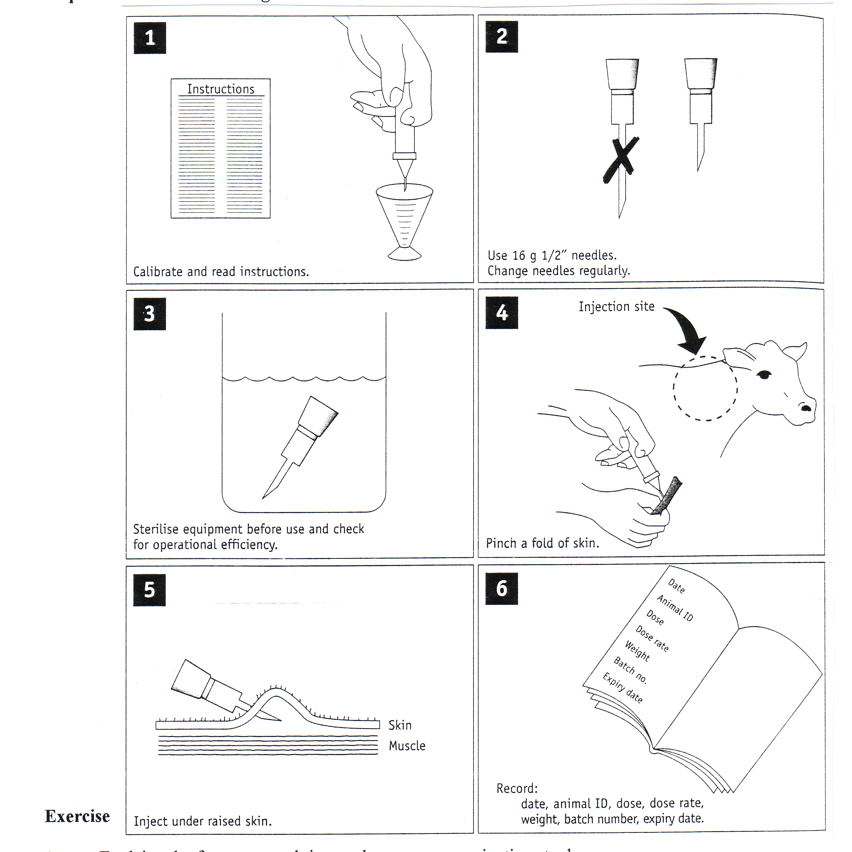

Exercise
- Explain why farmers spend time and money on vaccinating stock?

- Describe the steps involved in vaccinating stock and explain why each step is carried out?
Vaccination Programme

Common diseases sheep vaccinated against
- Pulpy kidney
- Tetanus
- Blackleg
- Malignant oedema
- Black disease

Jan | Feb | Mar | Apr | May | June | July | Aug | Sept | Oct | Nov | Dec
 | Sensitise and boost hoggets. this begins year round protection  Sensitise unvaccinated two-tooth ewe replacements |  |  |  |  | Booster vaccinate for ewes and two-tooths, 2-4 weeks prior to lambing |  | Lambs protected by colostrum for up to 12 weeks after lambing

Note:
- When ewes receive two vaccinations as hoggets they do not need to be vaccinated again until pre-lamb as two-tooths.
- When ewes receive only a single vaccination as a hogget, they should receive a further sensitizing dose pre-tup as a two-tooth and a pre-lamb booster.

Exercise

- What is meant by a sensitising vaccination?

- What is meant by a booster vaccination?

- In sheep, which group should be given a sensitizing vaccination and when should it be given?

- Explain why ewes are given a booster vaccination in July or August?

- List five disease sheep should be vaccinated against.

Drenching
Internal parasites may be controlled by drenching, which is chemical substance given to animals to kill the parasites. The drench is usually administered orally, that is, by the mouth.

Steps involved in drenching
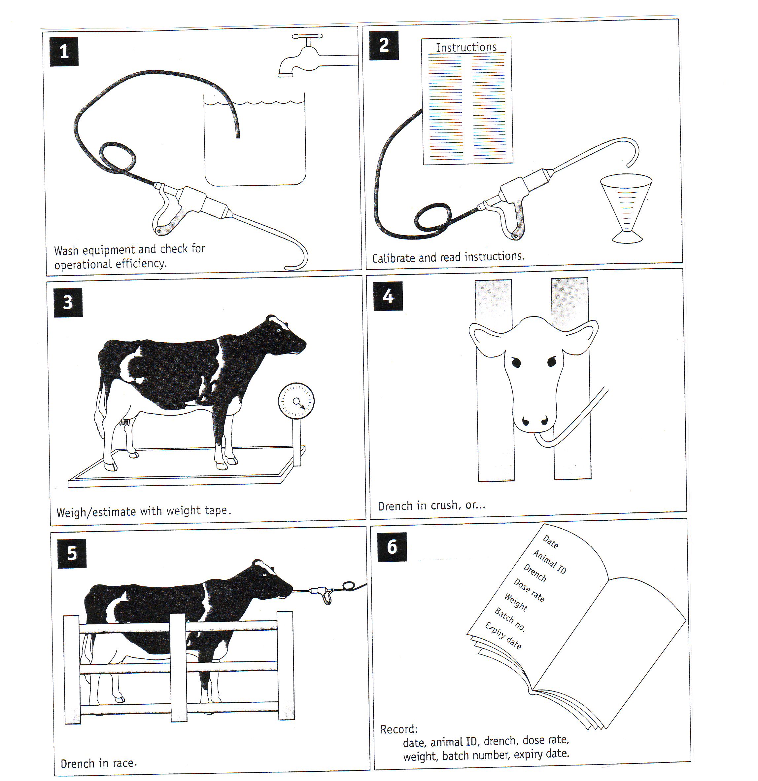
Exercise
Read the information and answer the following questions
1 List the management don’ts concerning drenching.

2 Explain why each don’t is important?

- Describe how to drench sheep and cattle?

- Explain how drenching stock affects farm production?

- Explain how a farmer would check for drench resistance?

- Describe what is meant by a safe pasture?

- Describe management practices a farmer can use to provide safe pasture for young stock.

8 Explain how safe pasture improves financial returns?

Other methods used to control Internal Parasites
Drench resistance cost farmers 20m per year on top of 300m annual cost of internal parasites in lost production and drench use. Therefore understanding how to use different methods to control internal parasites is critical.
Internal parasites can be controlled not only by oral drenches but by pour on and controlled release capsule.

Exercise
Using the information on the diagrams above as well as your own knowledge to answer the following questions.
1 Describe how to drench cattle and sheep using a controlled release capsule?

2 Describe how to use pour on drenches on cattle to ensure they control internal parasites?

3 Discuss advantages and disadvantages of 100 day controlled release capsules to control internal parasites.

4 Discuss the advantages and disadvantages of oral drenches compared with 100 capsules to control internal parasites.
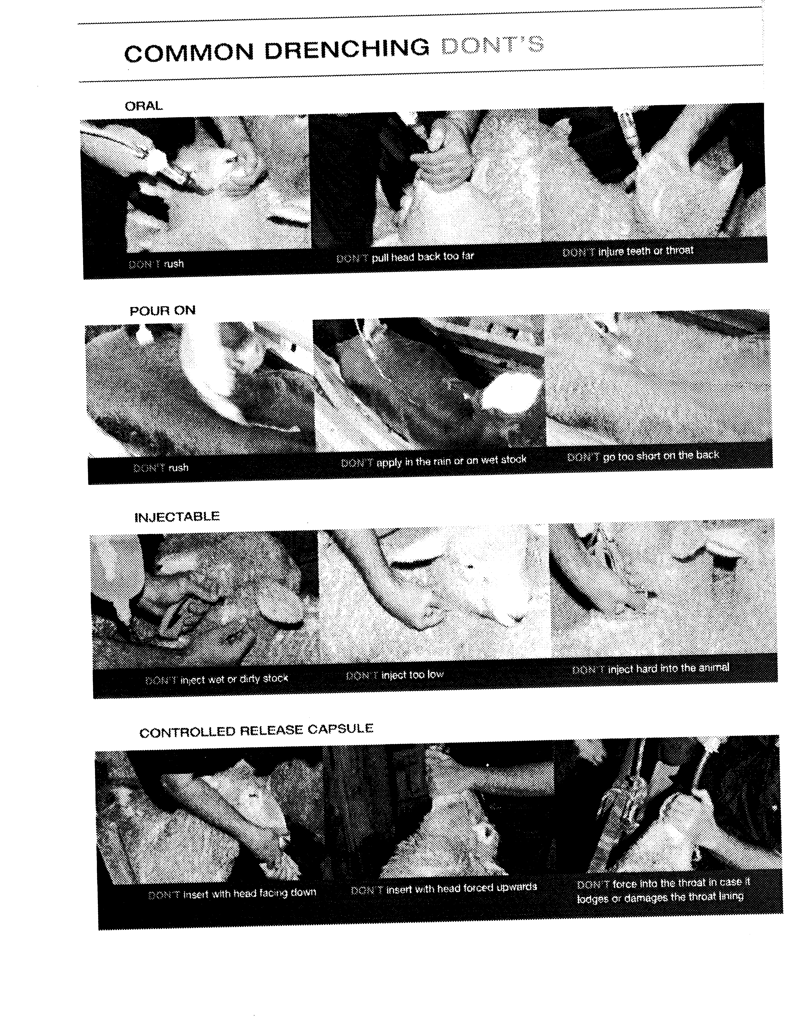
Mastitis
Cause of mastitis
Mastitis is caused by bacteria entering the udder and causing an infection.

Predisposing cause
Environmental:
Wet muddy areas and races soiling the udder, and producing cracks and sores on the teats. These cracks and sores harbour bacteria, which can easily enter the udder when dirty teats are washed.

Rough Handling
Can cause injury to the udder be being knocked. Rough handling can also cause cups to be kicked off during milking, as well as causing cows not to let their milk down.

Poor Milking Techniques
These include over milking, removing caps roughly, and cross infection through not milking mastitis cows last.

Faulty Milking Machines
Milking machines that are not operating efficiently can damage the ends of teats allowing bacteria to enter.

Stress
Any stress is predisposing cause. For example – poor feeding, rapid change in diet, and cold weather.

Hygiene
With dirty cups, hoses, aprons and other surroundings, bacteria are easily transferred to cow’s teats via the milker’s hands.

Symptoms
If the signs of mastitis are clearly visible to the milker, the disease is called clinical mastitis.
If there are no visible signs of the disease but it is known to be present, then the disease is called subclinical mastitis.
- The symptoms of clinical mastitis are:
- swelling, hardening or high temperature
- clots, blood or other abnormalities in the milk

- Subclinical mastitis can be detected only by use of one or more special tests on the milk. The most common one is testing the mix for somatic cell counts. These can be thought of as white cell counts:

White cells in the body rush to sites of infection. In the udder these white cells enter the milk and measurement of the number of these sells give an indication of the degree of infection in the udder.

Treatment
When mastitis is detected in a cow, it is usually in one or two quarters of the udder only. The steps in treatment are:

- Affected cow(s) should be drafted out and milked last to prevent cross infection via the milking machines.
- The milk from the infected quarter(s) should be milked into a bucket and discarded.

Exercise

Using the resource material provided on mastitis

1. Name the causal agent.

2. List the predisposing causes.

3. List the symptoms common to mastitis.

4, Explain how you would treat this disease?

5. Explain methods used to prevent mastitis.

6. Explain its economic importance.

Animal Health Revision Question

Question One
To reduce internal parasites problems sheep farmers use two management practices
- monitor stock and only drench when necessary
- select rams which have proven resistance to internal parasites

a. Explain the correct method of drenching lambs by mouth.

b. Give reasons why a combination of these two management practices is important to achieve good financial returns for farmers in terms of;
- lamb growth rates
- cost
- drench resistance

Question two
The sheep farmer vaccinates pregnant ewes in order to protect both the ewe and the lambs from diseases such as blood poisoning and tetanus – common problems at lambing time.

(i) Describe the timing of, and method used, when vaccinating pregnant ewes.

(ii) Explain how vaccination of ewes protects lambs from diseases such as tetanus.

(iii) Describe TWO actions that a farmer should take to correctly vaccinate sheep in a safe manner.

Question 3
Two dairy farmers were discussing the best method to prevent bloat. Giving cows a rumensin capsule or orally drenching daily with rumensin. Select one of the methods used to prevent bloat:_________________
1 Describe how this method of bloat control is carried out?

2 Explain the cause of bloat and the effect it has in the rumen. In your answer, you should;
- microbial digestion
- pasture quality
3 Compare and contrast the advantages of oral drenching in Friesian beef bulls compared with using a 100-day capsule.

Animal production

- Revision questions
- Practice exam papers
Animal Production

- List the advantage and disadvantages of pasture as a feed.
- What do animals require from food and why?
- What are the feed components in pasture?
- What is digestion?
- Name four ruminant animals.
- Name the parts of a ruminant and non-ruminant digestive tract.
- Explain the function of each part of the digestive tract.
- Recognise the differences in gut linings in each part of the digestive tract.
- Describe the functions of papillae, villi, rumination.
- Why is the small intestine so long?
- What conditions are found in the rumen and why?
- Describe the difference in gut content in each part of the digestive tract.
- What affects the digestibility of a feed?
- What affects the ability of an animal to digest feed?
- Why is feed measured in DM?
- Explain how digestibility of a feed is determined?
- Calculate the digestibility of a feed.
- Feed can be classified into roughage's, succulents, and concentrates, explain the differences.

ANIMAL REPRODUCTION AND BREEDING
- Why is reproduction important?
- List the factors affect reproductive efficiency and explain how?
- How is reproductive efficiency measured? lambing/calving %
- How can reproductive efficiency be improved?
- What is meant by gestation?
- What is the gestation period for a cow and a ewe?
- All animals are different and different production abilities, why?
- What is the meaning of the following terms
- chromosomes
- genes
- alleles
- punnett square
- homozygous
- heterozygous
- genotypes
- phenotypes
- Animals vary, why? How do farmers use this variation?
- List the desirable characteristics required in a;
- dairy cow
- cattle beast
- sheep for wool
- sheep for meat
11 Recording systems. What is their function?
12 A breeding programme involves AI identification and recording. Why?
13 Why is a lot of emphasis placed on the selection of male animals?
14 What happens to production after years of selection?
15 Do animals perform the same in different environments? Explain.
16 Why are twins highly sort after to use in research?
17 List the advantages/disadvantages of AI.
18 Why is AI widely practiced in the dairy industry?
19 What is "oestrus"?
20 Why is it important to be able to correctly identify cows on oestrus?
21 How can a farmer identify cows on heat?
22 If a farmer wants his cows to start calving on the 1st of August, in which month would he start
inseminating his cows?
23 How is semen collect/stored?
24 How is insemination carried out?
25 Where is the semen placed in the reproductive tract?
26 How are animals identified in oestrus?

HEALTH
- Why is animal health important?
- How are diseases classified?
- What are direct causes of diseases?
- What are predisposing causes of disease?
- Describe management practices used to prevent diseases.
- Explain how these methods prevent diseases?
- What are the symptoms of healthy and unhealthy animals?
- What are the principles of immunity?
- Explain the importance of animal health for the farmer and New Zealand.
- Why is prevention of disease so important to farmers?
- What can farmers do to reduce disease problems?
- What is meant by the "predisposing" cause of an illness?
- Briefly describe what;
- A "nutritional" disease is?
- A "metabolic" disease is?
- An "infectious" disease is?
Calendar of Work on a Typical North Island Factory Supply Dairy Farm
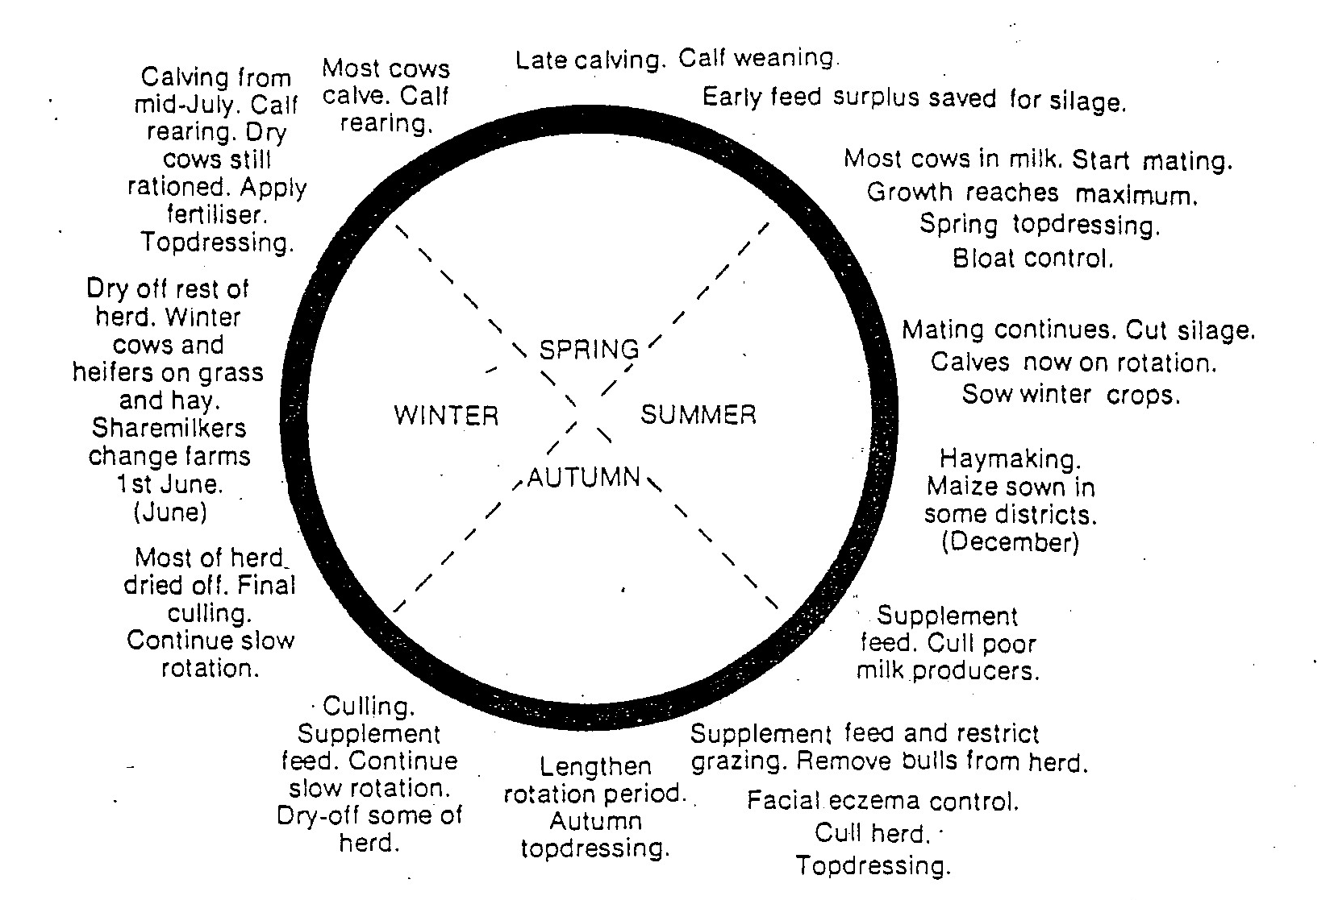
1. What is meant by “calf weaning”?
2. When do the cows start to calve on this type of dairy farm and explain why?
3. What is meant by “drying off and when does “drying off” occur on this farm?
4. What is meant by a “cull cow”?
5. Explain three reasons why a farmer would cull a cow?
6. What is meant by “supplementary feeding” and name two common supplementary feeds used on a dairy farm?
7. Describe what is silage and explain when and why silage is made?
8. When would a farmer feed silage to cows and why?
9. Hay is made in summer. When would a dairy farmer feed out hay to cows and why?
10. Explain what bloat is and what causes it?
11. “Facial eczema” is a disease caused by fungi. At what time of the year is this disease a problem and how does it affect milk production?
12 Explain why most dairy farmers used AI?
13. 95% of NZ dairy farmers herd test. What is herd testing and how do farmers use the information gathered from herd testing?
14. If a farmer had 30 paddocks how do they
- shorten the grazing rotation?
- lengthen the grazing rotation?
15. Explain how farmers apply nitrogen fertiliser and explain when and why it is applied?
Calendar of events on a sheep farm
Pre lamb shearing, drenching, and vaccinating,
Cull dry ewes
Docking/tailing
Drench ewes
Cull dry ewes
Weaning
Draft early prime lambs
Drench lambs
Cull ewes
Flush ewes
Lambing and calving
Main crutch
Scanning
Tupping (rams out)
Remove rams
Dag and dip sheep
Continue drafting prime lambs
Buy rams
Cull ewes

Main shear
Dipping continues
Sell store lambs
Sell wool
Crutch ewes
W
S
A
S

Exercise
- When does lambing start and explain why if starts at this time of the year?
- When are lambs docked and why?
- List the times of the year when sheep are shorn and explain how this would affect feed requirements?
- Give three reasons why a farmer may cull a ewe?
- Explain why farmers
(i) drench lambs?
(ii) vaccinate ewes?
- What time of the year do farmers aim to flush ewes?
- Explain why a farmer would try to flush ewes?
- At what time of the year are ewes tupped and why?
- State the gestation period for sheep.
- What is dipping and when and why is dipping carried out?
- Explain why a farmer would scan ewes?
- Explain the difference between prime and store lambs.
- When selecting rams for producing prime lambs what characteristics would a farmer look for?
- When ewes are lambing, they are set stocked. What is set stocking and explain why farmers use this
grazing system?
15. Explain the difference in feed requirements for a ewe feeding twin lambs and a dry ewe.
Beef Calendar of Operations
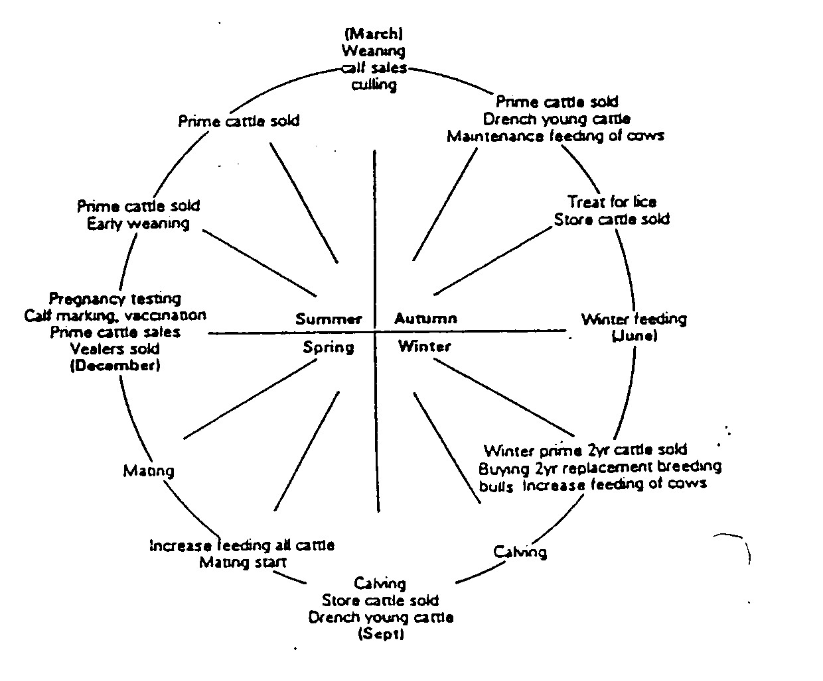
Exercise
1 When does calving start on a beef farm?
2 When does mating start?
3 How long is the gestation length of a cow?
4 What are prime cattle and when are they sold?
5 What is weaning?
6 At what age are beef calves weaned?
7 Describe what drenching is and explain why young stock are drenched regularly.
8 Describe what vaccinating is and explain why young stock are vaccinated.
9 What are store cattle and when and why are they sold?
10 When are new bulls bought and why do farmers buy at least one new bull each year?
11 Explain why famers scan cows to check if they are pregnant (pregnancy testing)?
12. What is meant by maintenance feeding of cows?
13. How do farmers feed cows during winter on a maintenance diet?
14 Explain why feed requirements of cows increases in late winter?
15 What type of feed should a lactating beef cow be fed and why?
Animal Nutrition
- List the advantage and disadvantages of pasture as a feed.
- What do animals require from food and why?
- What are the feed components in pasture?
- What is digestion?
- Name 4 ruminant animals.
- Name the parts of a ruminant and non-ruminant digestive tract.

B and C

B
F
H

I

A
J

G
D and E

- Explain the function of each part of the digestive tract.
- Describe the difference in gut linings in each part of the digestive tract.
- Describe the functions of papillae, villi and rumination.
- Why is the small intestine so long?
- What conditions are found in the rumen and why?
- Explain the differences between ruminant and monogastric digestive systems.
- Explain why the dung of a cow feed a mixture of fresh pasture and hay differs from a cow feed highly digestible spring pasture?

Digestibility Questions
- What affects the digestibility of a feed?
- What affects the ability of an animal to digest feed?
- Why is feed measured in DM?
- Explain how digestibility of a feed is determined?
- Feed can be classified into roughage's, succulents, and concentrates. Explain the differences between these feed types.
- Name two feeds in for each types of roughage's, succulents and concentrates.
- What type of feed would you feed to a
- High producing cow in early lactation?
- A dry beef cow once her calf is weaned?
- A young heifer?
- A beef bull growing at1kg per day?
- A fast growing pig?
- Describe how the feed requirements for a beef cow change from early pregnancy to late pregnancy?
- Explain why you would advise a pig farmer to feed fast growing pigs a high protein diet adlib?
- Explain the differences in growth of a calf and a pig if they are both feed a high quality pasture diet.

ANIMAL REPRODUCTION AND BREEDING
- Why is reproduction important?
Eggs are shed
Egg(s)
fertilised
Young born and reared successfully

- Reproductive efficiency is affected by a number of management practices. Describe two factors that affect reproductive efficiency at each of the above stages and explain how they affect reproduction?

- What is the gestation period for a cow and a ewe?
- Label the parts of the female and male reproductive systems and explain the function of each part.
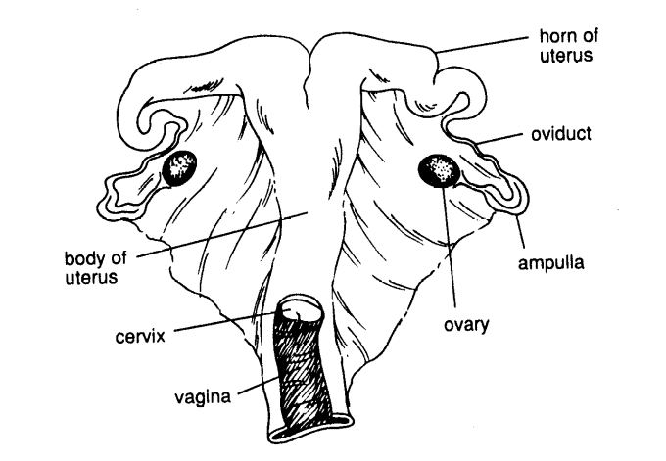
F
E
D
B
A
C
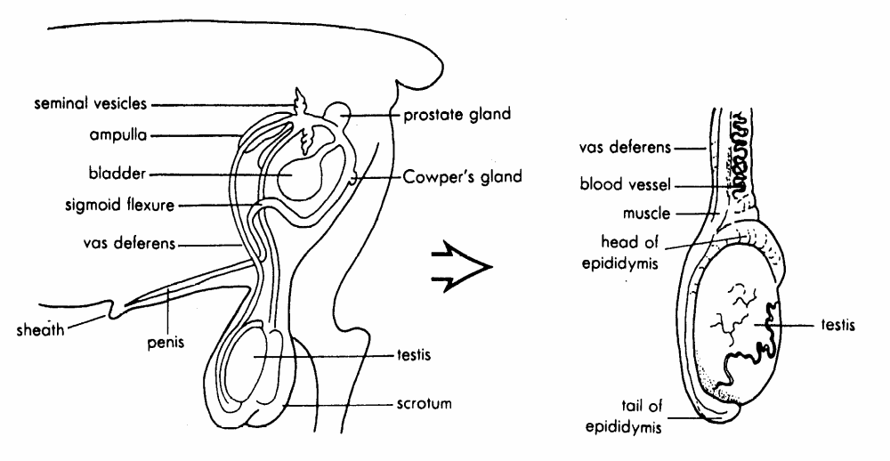

A

B

C
D

E

- Describe where semen is deposited in natural mating and in artificial insemination?

6. When a female animal is giving birth which parts of the reproductive tract need to expand?
GENETICS
1. All animals are different and have different production abilities, why?

2. What is the meaning of the following terms?
- chromosomes
- genes
- alleles
- punnett square
- homozygous
- heterozygous
- genotypes
- phenotypes

3. A farmer wants to breed polled animals. He crosses a homozygous dominant bull with homozygous recessive cows. Give the genotype and phenotype of this cross.

4. Explain why farmers want to breed polled animals?

5. Some breeds such as Jersey and Friesian are horned. Describe how farmers’ get rid of these horns.

- Animals vary why? How do farmers use this variation?

7. List the desirable characteristics required in a the following animal
Dairy cow
Beef cattle
Sheep-wool
Sheep meat

8. What is the function of recording systems?

9. A breeding programme involves AI, identification and recording. Explain why?

10. List the advantages/disadvantages of AI.

11. Describe how farmers identify cows on heat?

12. Explain why a lot of emphasis placed on the selection of males animals in breeding programmes?

13. Describe what happens to production after years of selection?

14. Explain why animals farmed in different environments do not perform the same.

15. Describe how semen is collect/stored?

16. Describe how insemination carried out?

HEALTH
- Explain why animal health is important?

- Describe three direct causes of diseases.

- What are predisposing causes of disease?

- Discuss the predisposing causes of flystrike and outline how it can be prevented?

- Describe five management practices used to prevent diseases.

- Describe how to drench and vaccinate animals?

- Briefly describe what;
- A "nutritional" disease is?

- A "metabolic" disease is?

- An "infectious" disease is?

